

**Department of Primary & Childhood Education**

Principles of Planning 2021/22

Great teaching begins with effective planning and it is crucial that trainee teachers understand its value and purpose. Planning is not a form-filling exercise. Rather, it is the thinking process teachers go through in order to be fully prepared for the lessons they teach. During teacher training, trainees will learn how to plan effectively with the guidance and support of tutors, mentors, class teachers and link tutors. Trainees’ development is carefully scaffolded so that they become more proficient at planning over time.

In the early stages of the programme, trainees will become familiar with Rosenshine’s principles of instruction (2012). The 10 principles are research-based and set out in a clear way what actually works in the classroom. These principles are a guide to how to teach effectively-it’s as simple as that. Trainees should use them to help shape their lesson planning:

|  |  |  |
| --- | --- | --- |
| 1. Begin a lesson with a short review of previous learning 2. Present new material using small steps with pupil practice after each step 3. Ask a large number of questions and check the responses of all pupils 4. Provide models 5. Guide student practice |  | 1. Check for student understanding 2. Obtain a high success rate 3. Provide scaffolds for difficult tasks 4. Require and monitor independent practice 5. Engage in weekly and monthly review |

*Rosenshine’s Principles of Instruction (2012)*

Schools plan in different ways. At Edge Hill, trainee primary teachers will be taught to use 2 planning formats which we recommend they use on professional practice:

1. Lesson Plan
2. Lesson Sequences

Trainees will be shown how to use each template and will have access to a range of examples before they begin professional practice. Each template is carefully structured to encourage trainees to be fully prepared for each lesson and put theory into practice.

1. **Lesson Plan:**

The *lesson plan* template is for planning individual lessons and we recommend that it is used by trainees during their initial and developmental professional practice. We would expect trainees on their consolidation practice to be using the planning format of their placement school (although our templates might be used to support the development of specific trainees).

Trainees should share their plan with their class teacher/mentor, support staff and visiting tutor. Detail should be sufficient so that trainees’ development can be supported. The University is mindful of teachers’ workload and trainees will be supported with ways to address this as they progress, and teaching demands increase. Please note: if trainees are planning 3 or more lessons, then we suggest that they use the *lesson sequences* template instead.

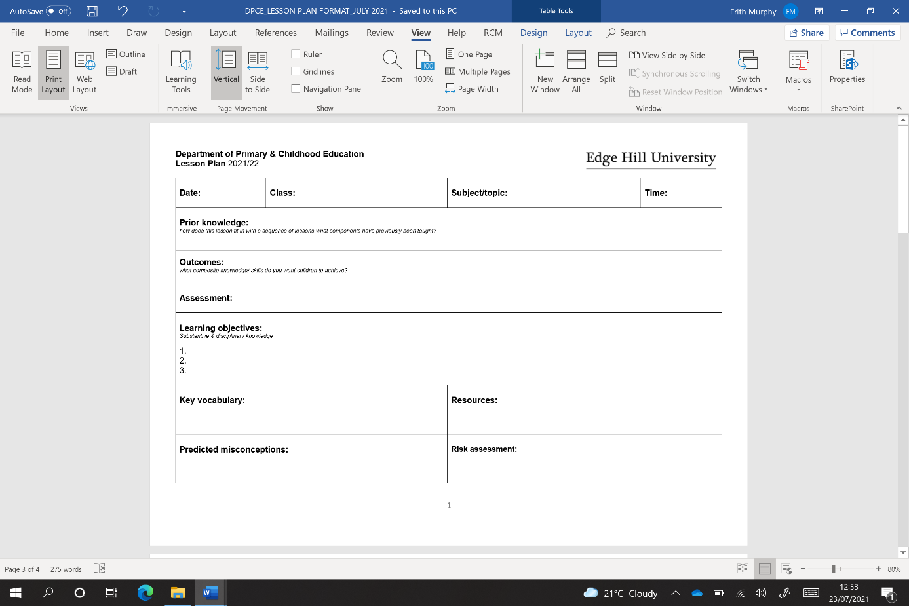

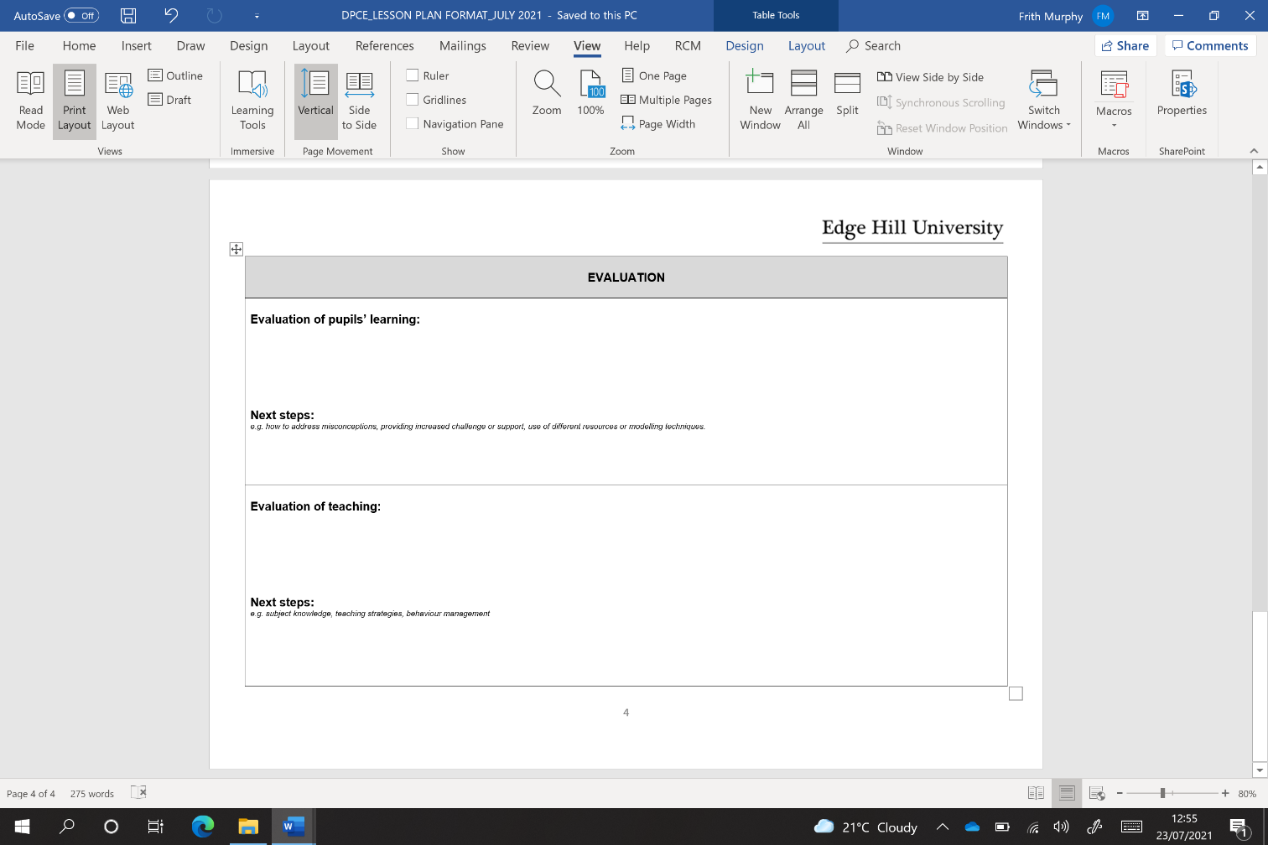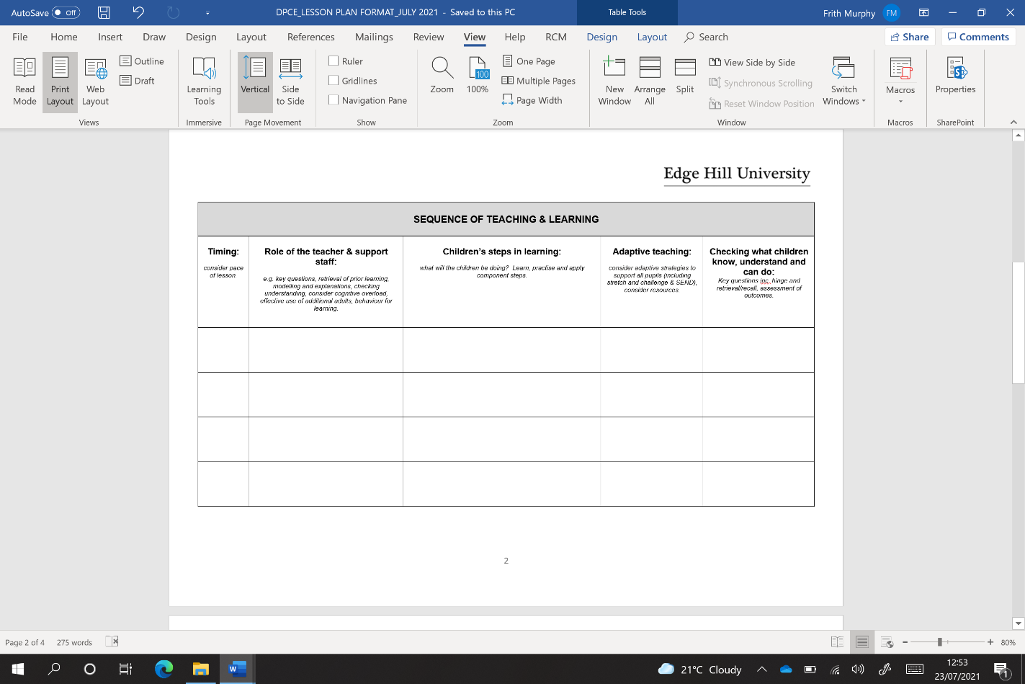

1. **Lesson Sequences:**

We recommend the lesson sequences template is used when trainees are planning for a series of 3 or more lessons. Sequenced planning is very important because it will help trainees to identify the order in which each component of learning is taught for pupils to achieve composite knowledge.

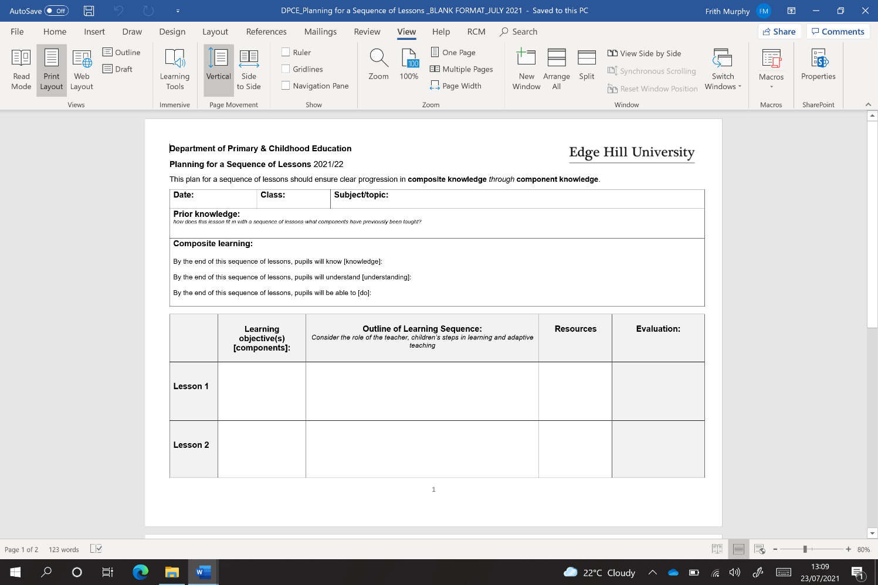

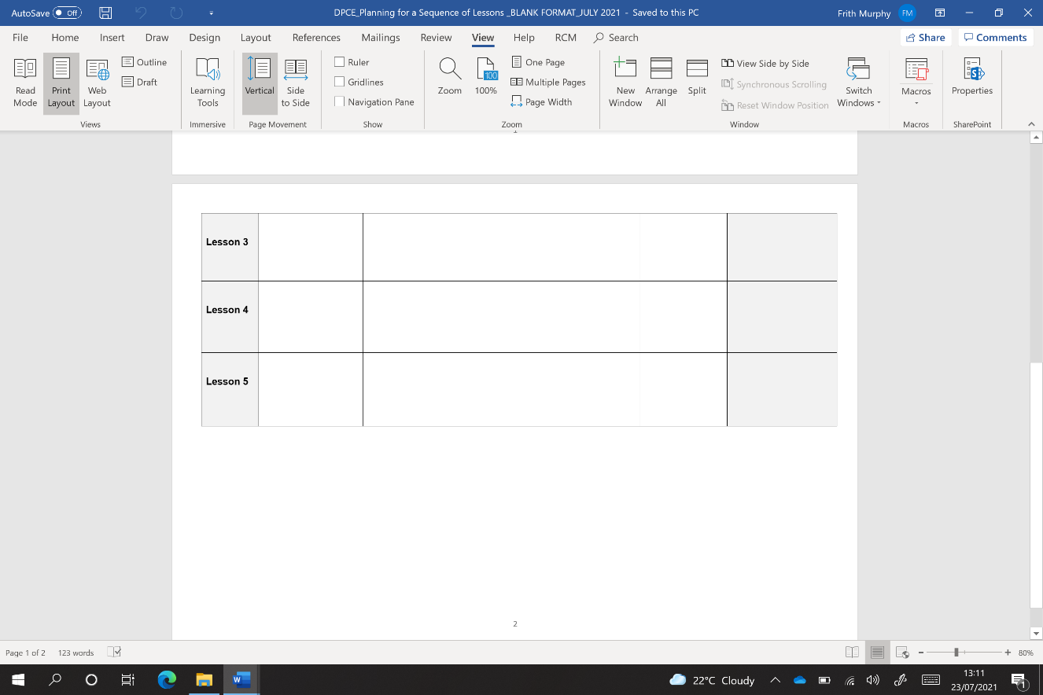

The *lesson sequences* template can be used for a range of purposes. It can be used when planning a subject across a term or half-term (e.g. Vikings in history), when planning a short series of lessons (e.g. 3 English lessons) or as a weekly plan (e.g. when planning for a series of daily mathematics lessons).