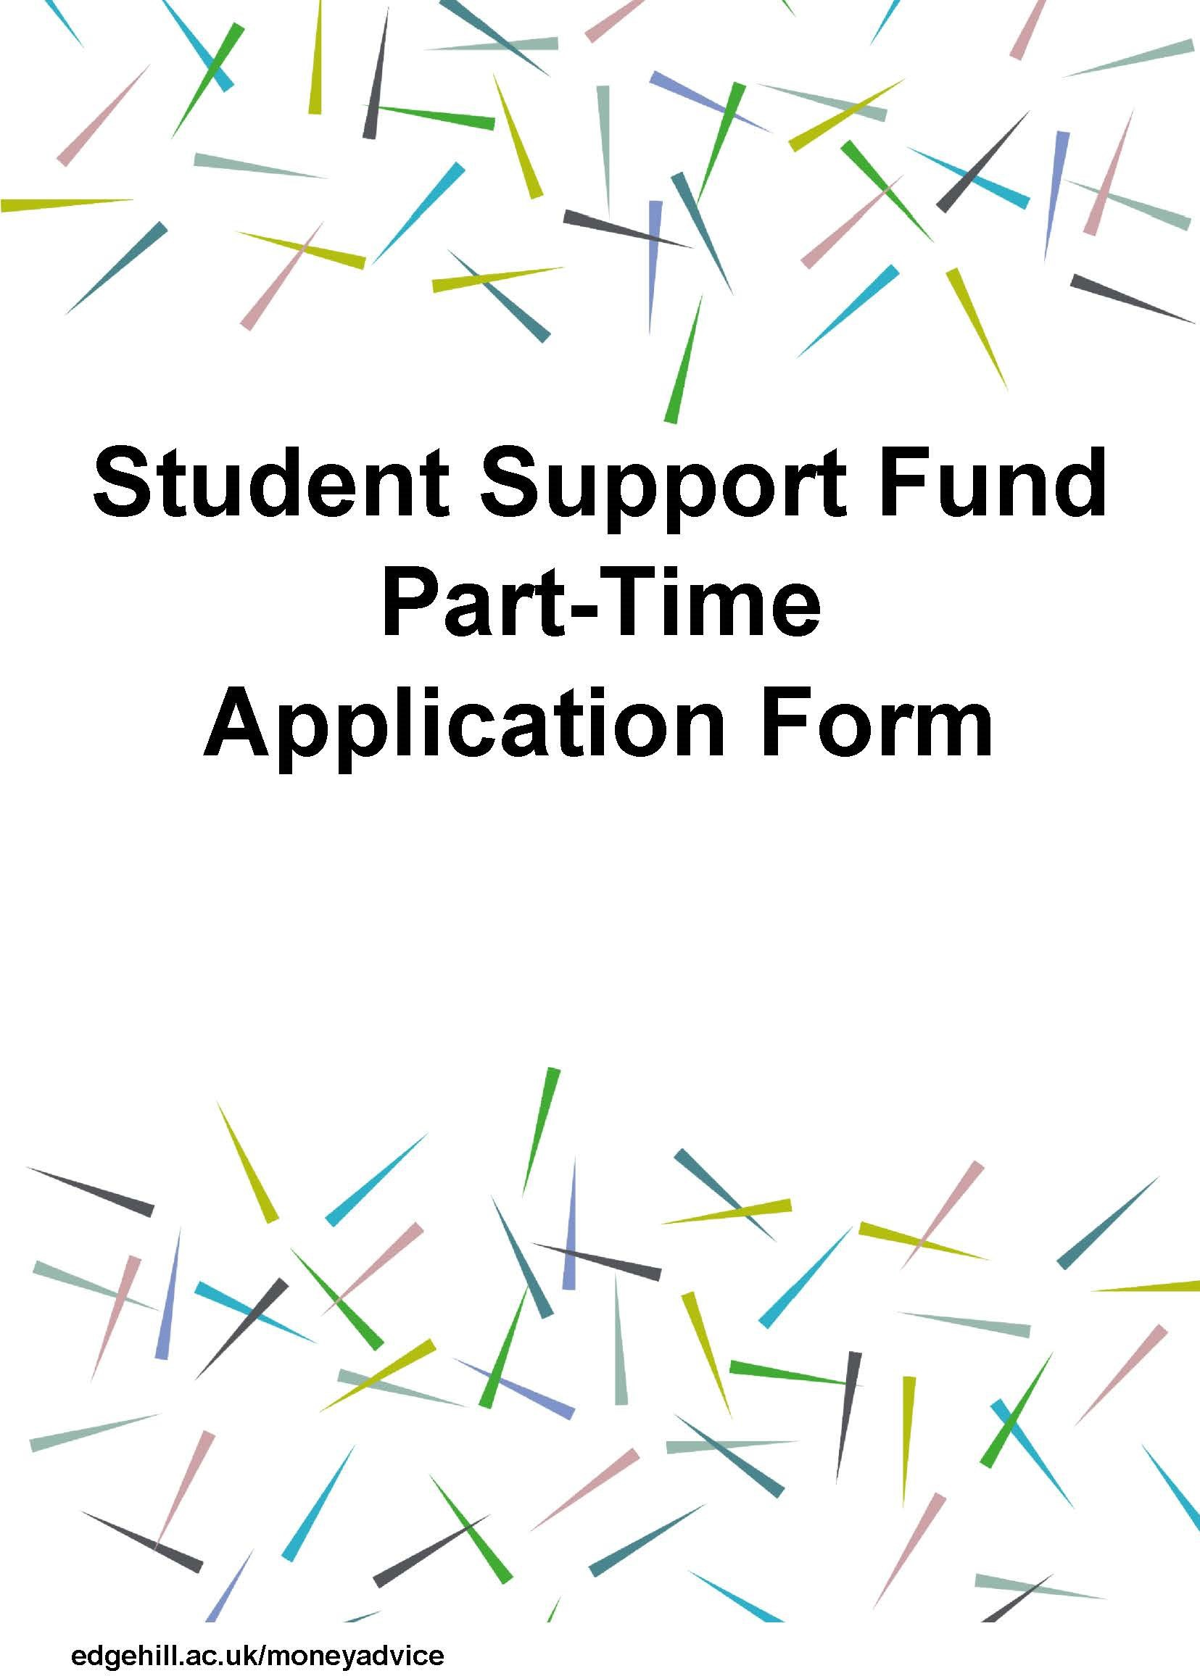

Application only for students who commenced course prior to August 2018

PLEASE READ BEFORE COMPLETING THE APPLICATION

Who is this guidance and application form aimed at?
This application is for Students who commenced part-time study prior to August 2018.
Please note: New students starting a part-time course on or after 1 August 2018 should apply on the alternative application form.

What is the Support Fund 2022/23?
The Student Support Fund enables Student Services to support part-time students who are from a low income household
with certain course related expenses. Expenses can include childcare costs, essential travel into University, and, for lone par- ents, limited support with internet and mobile phone costs. If a student qualifies for a payment from the Fund, it will not usu- ally have to be repaid. To be eligible for an award from the Fund, your household income must be lower than £28,066.
Please be aware that the Support Fund is only intended to provide a contribution towards your course-related costs so we are unable to cover costs in full.

Can you help with the cost of Tuition Fees?
The Student Support Fund cannot be used to assist with tuition fee payments. Students should apply to their student funding
body for support with this cost.

Who can apply?
All UK undergraduate and postgraduate students are eligible to apply. You must also meet the following criteria:
- Be studying at least 25% or more of a full-time course AND
- Receive tuition fee support from your student funding body
- Have a household income of less than £28,066
You must have applied and been fully assessed for your student funding BEFORE applying to the Student Support Fund , so if you are yet to receive notification of your student funding, and are struggling to obtain this, you should contact a member of the Money Advice Team for further advice.

How will you assess my application?
We will calculate your household income and if it is below the given threshold, we will then assess you for assistance with certain course-related costs.

How long will it take for my application to be processed?
Once your application is complete (including all required evidence being received), you should hear back from us by email within four working weeks at this time. If we request additional income evidence from you, you will have four working weeks to provide this. After this period, if we haven’t received the requested information from you, we will be unable to process
your application and your application will be closed down. If we request additional expenditure evidence from you, you will have four working weeks to provide this. After this period, if we haven’t received the requested information from you, we will process your application using the evidence you have provided.

Can I make an appeal?
The request for an appeal should be made in writing to the Money Advice team within 4 weeks (28 days) of the original deci- sion. This is an opportunity to review the original decision, to check the accuracy of the calculations and ensure that all rele- vant information and evidence has been considered. The appeal can also consider any subsequent evidence you wish to pro- vide with the appeal request. You will normally receive a response within 10 working days. It is important that you explain fully why you are requesting an appeal and submit any additional supporting evidence/information with your request(s). The Money Advice team may request additional information at this stage. You should email your appeal request to moneyad-
vice@edgehill.ac.uk

When does the Support Fund Open & Close?

When does the Student Support Fund open and close for my course?

Course you are studying: | Fund opens | Fund closes
PGCE & QTS | 19th Sept 2022 | 30th June 2023
Undergraduate & PostGraduate | 10th October 2022 | 2nd June 2023
Nursing/Midwifery/ODP/Paramedic Practice (Except Final Year) | 10th October 2022 (** or 2 weeks post academic year start date of course) | Academic year end date of course
Final Year Students ( excluding Nursing/Midwifery/ODP/Paramedic Practice final year)  Final Year Nursing/Midwifery/ODP/Paramedic Students | 10th October 2022  10th October 22 (**or 2 weeks post academic year start date of course) | 28th April 2023  5 Weeks Prior to Academic Year end date
** There are several start and end dates for these programmes. If you are a Nursing/Midwifery/ODP/Paramedic student, please click HERE and search under Faculty of Health, Social Care and Medicine to check the start and end dates for your programme BEFORE making an application.

If your official course end date is not as shown above (non-standard term dates), you may apply up to the last day
of your course - if you are not in your final year.
Any applications to the Student Support Fund outside of the dates above must be approved by the Money Advice Team Manager

How do I apply to the Student Support Fund?
Please complete this application form, gather together and scan the supporting evidence listed below, and e-mail to:
moneyadvice@edgehill.ac.uk
You will be notified of the outcome within 4 weeks of receipt of all required information, as per guidance above. Our assessors will contact you if we need to discuss your application further.
If you are unable to supply the application form and required evidence as clear attachments by email, please use the secure postal service and send to:
Money Advice Team, Student Services, Catalyst Building, Edge Hill University, St Helens Road, Ormskirk, L39 4QP

Data Protection Statement
Edge Hill University is committed to respecting and protecting your personal data, all personal data will be processed in ac-
cordance with current Data Protection Legislation and the University Data Protection Policy. All data you provide to us on this form will be used for the purpose of your application and will not be shared with any unauthorised third party. This data may also be used for statistical analysis and audit purposes.

Supporting Evidence Checklist:

Please supply clear attachments or scanned documents of evidence of all of that apply to your circumstances. Please note not everything may apply to you.

- Your Financial Notification Letter from Student Finance for academic year 2022/23
- Car/Bike Insurance Certificate (If you travel to University by car/bike)
- Public Transport Ticket (If you travel to University by public transport)
- Internet bill showing monthly payment (Lone Parents only)
- Mobile Phone bill showing monthly payment (Lone Parents only)
- Evidence of childcare costs. Part 10 should be completed for each child and each childcare provider you wish to include costs for
- Proof of any benefits received by you and your partner/spouse e.g. Universal Credit assessment
- Last three wage slips for you and your partner/spouse
- Proof of any private or state pension for you and your partner/spouse.
- Bank statements covering the last three months for any account held by you and your partner/spouse.
- All debit and credit transactions over £100 must be briefly explained in writing on the statements.

Budgeting is the Key
As part of the Money Advice Team’s commitment to supporting students to manage their finances, we require you to produce a personal budget to help you plan ahead for the term or next 12 months. Please feel free to use your own or select one featured on www.edgehill.ac.uk/studentservices/managing-your-money/ . We also have course specific Excel templates available under Blackboard > Organisations > search Money Advice.

Can I submit my application by post?
In exceptional cases, it may be possible to submit your application by post but you should contact us on 01695 657203 or by email at moneyadvice@edgehill.ac.uk to discuss this.

I have a question about my application.
If you have any questions regarding the Student Support Fund, please contact the Money Advice Team on 01695 657203 or by email at moneyadvice@edgehill.ac.uk.
STUDENT SUPPORT FUND APPLICATION
Part 1: Your Personal Details

Full Name: |  | ID Number:
Contact Number:
Please tick all that apply to you:

Date:

I am living on my own
I am living in a shared house
I am living with my parents/guardians
I am living with my partner/spouse
I am a single-parent living with my child/children
I have a disability/chronic medical condition
I am estranged- if unsure discuss with the adviser
I am an adult carer
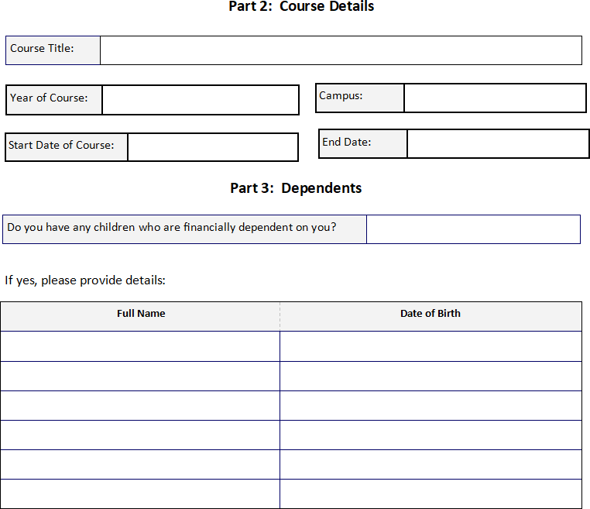

Part 4: Travel

How do you usually travel to University? | Car | Train | Walk | Bus | Cycle
If you travel by public transport, please give the cost of a return journey to University.
How many times a week do you usually attend University?
Do you have to attend a placement during this academic year?
If you answered yes to the above question, please use the space below to provide the dates of this placement and, if known, the placement address. If you will be using public transport, please also provide an estimate of the cost.

Part 5: Childcare

Do you incur childcare costs for the day(s) that you are required to attend University? | Yes |  | No

Section 11 must be completed by the childcare provider for each child.

Part 6: Other Expenditure (this section should only be completed by Lone Parents)

Do you own a mobile phone? | Yes |  | No
If you answered yes to the above question, please use this space to provide your average monthly bill amount.

Do you use the internet at home? | Yes |  | No
If you answered yes to the above question, please use this space to provide your average monthly bill amount.

Part 7: Income
Your Earnings
Gross Earnings per year
Partner’s Earnings
Gross Earnings per year
Welfare Benefits

Housing Benefit | £ | per week | Carers Allowance | £ | per week
Child Tax Credit | £ | per year | Employment Support Allowance | £ | per week
Working Tax Credit | £ | per year | Universal Credit | £ | per week
Income Support/Job Seekers Allowance | £ | per week | Please give details of any other benefits you receive

Part 8: Confirmation of Course Details
Before we can process your application, we require confirmation from a Personal Tutor / Course Leader of the number of days you are required to be in University/placement. Please use the space below to provide the name and contact
details of a member of staff who is able to do this. If you can ask this member of staff to provide proof of this before you submit your application (in the form of an email/letter) this will help us to deal with your application as quickly as possi- ble.

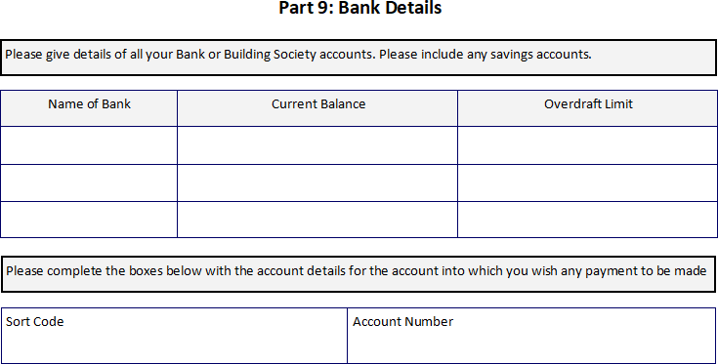

Part 10: Declarations

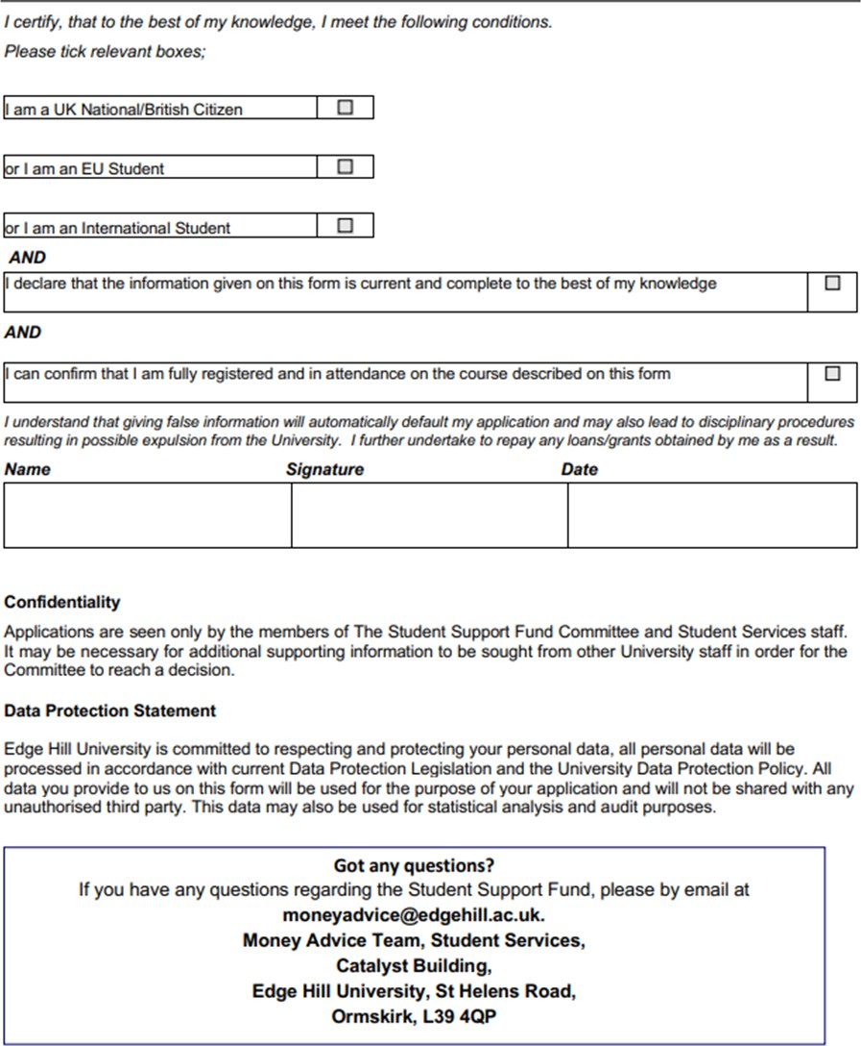

Part 11: Childcare Details

