Faculty of Education (FoE) Safeguarding Guidance for Trainee Teachers and Students 2023-2024

Overview and purpose of this guidance
As a major provider of education and training for the teaching profession and the wider children's/ education workforce; Edge Hill University is committed to safeguarding and promoting the welfare of all children and vulnerable adults with whom with work.

All teachers, including trainee teachers have a responsibility to do all they can to protect children from harm.
The Teachers’ Standards states that teachers, including those who might lead schools and be no longer in the classroom, should safeguard children’s well-being and maintain trust in the teaching profession.
This document provides safeguarding guidance is written directly for all FOE students/trainees who are training to teach and gain QTS (or who wishes to be eligible for QTLS) in the Primary (including Early Years), Secondary and Further Education sector, or engage with work based learning opportunities.
This document should also be used by visiting tutors and mentors to help them understand our collective responsibility in how to keep children and young people safe and in safer working practices. The sections below focus on the expectations and requirements of trainees and staff in relation to safeguarding at university and whilst completing professional practice or work based learning.
Edge Hill University’s Safeguarding Policy can be found here:
https://www.edgehill.ac.uk/safeguarding/
This document aims to explain the processes and responsibilities which enable us to provide a safe environment for all and should be read alongside the University Safeguarding Policy.
Section 1 | Before you start your professional practice
Section 2 | How to ensure that you are working in a safe way according to the school/ setting’s code of conduct for staff and volunteers and the national guidance for safer working practices (whilst on your professional practice)
Section 3 | What to do if you have a concern about another professional’s or volunteer’s behaviour towards children or adults at risk (whilst on your professional practice)
Section 4 | What to do if you have a safeguarding concern about a child or adult at risk (whilst on your professional practice)
Section 5 | What to do if you have a safeguarding concern when you are NOT on your professional practice.
Section 6 | Who to contact at Edge Hill if you have a safeguarding concern
Appendices

Section 1 Before you start your professional practice
Before commencing any professional practice, trainees should:
- Complete the Faculty approved online Safeguarding training (Safeguarding Children – Levels 1 and 2 including Prevent and radicalisation) and upload the certificate of completion to blackboard.

- Ensure you have photographic identification and a copy of the EHU DBS letter on your first day of professional practice. Further to the update in January 2023 from the DfE, the settings have the right to request to see the original DBS certificate (see appendix G)

- Read and understand the DFE guidance:
  - Keeping Children Safe in Education 2023 (part1);
  - What to do if you’re worried a child is being abused and, where appropriate, The Statutory Framework for the Early Years Foundation Stage. (Primary ONLY)

- Read the school or setting’s child protection policy, code of conduct for adults and volunteers together with the national guidance for safer working practices. As set out on page 4 of this document.

- Understand the school or setting’s child protection procedures and how to report safeguarding concerns about a child.

- Read the school or setting’s online safety policy including any guidance for staff or volunteers

- Read the school or setting’s ‘children who are absent from education’ policy.

- Know how to report any safeguarding concerns to the University Designated Safeguarding Officer.

- Familiarise yourself with this guidance together with the appendices.

At the beginning of Professional Practice
- Have received an induction from the school or setting which will include information about safeguarding at the setting and reference the documents and policies outlined in your training.

- Know the name of the school or setting’s Designated Safeguarding Lead. If you don’t know this you can find this out by asking your mentor.

- Know where to find the school or setting’s whistle-blowing policy and managing allegations against staff and volunteer’s procedures.

If you have concerns about the safety or welfare of a child and feel they are not being acted upon by your manager or named/designated safeguarding lead, it is your responsibility to act. You can make a report directly to the NSPCC here: Report abuse to the NSPCC | NSPCC, in addition to contacting the University Designated Safeguarding Officer for further advice.

Section 2 How to ensure that you are working in a safe way according to the school/ setting’s code of conduct for staff and volunteers and the national guidance for safer working practices (whilst on your professional practice)

Trainees should read the national practical guidance on which behaviours constitute safe practice and which behaviours should be avoided - “Guidance for Safer Working Practice for professionals working in education settings.” Reading and understanding this document will support trainees to act in a way that does not harm a child or cause others to question their suitability to work with learners. It will also enable them to consider the behaviours of other professionals or volunteers towards learners. This guidance should be read alongside the school or setting’s code of conduct which aims to keep both learners and adults safe. The school or setting’s code of conduct will set out ‘do’s and don’ts’ so that your behaviour is not inappropriate, harmful or misinterpreted. It will help protect your professional reputation and help you identify safer ways of working.
e.g. The following text is taken from Section 7 on page 8 of the guidance for Safer Working Practices for professionals working in education settings. As students this guidance applies to you.
All staff have a responsibility to maintain public confidence in their ability to safeguard the welfare and best interests of children. They should adopt high standards of personal conduct to maintain confidence and respect of the general public and those with whom they work. There may be times where an individual’s actions in their personal life come under scrutiny from the community, the media or public authorities, including with regard to their own children, or children or adults in the community. Staff should be aware that their behaviour, either in or out of the workplace, could compromise their position within the work setting in relation to the protection of children, loss of trust and confidence, or bringing the employer into disrepute. Such behaviour may also result in prohibition from teaching by the Teaching Regulation Agency (TRA) a bar from engaging in regulated activity, or action by another relevant regulatory body.
This means that staff should not:
• behave in a manner which would lead any reasonable person to question their suitability to work with children or to act as an appropriate role model
• make, or encourage others to make sexual remarks to, or about, a pupil
• use inappropriate language to or in the presence of pupils
• discuss their personal or sexual relationships with or in the presence of pupils
• make (or encourage others to make) unprofessional personal comments which scapegoat, demean, discriminate or humiliate, or might be interpreted as such
This means that staff should:
• inform the head/principal or specified person of any cautions, convictions, or relevant orders accrued during their employment, and / or if they are charged with a criminal offence
• be aware that behaviour by themselves, those with whom they have a relationship or association, or others in their personal lives, may impact on their work with children

Section 3 What to do if you have a concern about another professional’s or volunteer’s behaviour towards children or an adult at risk (whilst on your professional practice)
If you believe a child is in immediate danger you should ring 999 without delay.
The school or setting will have their own local procedures for reporting and managing allegations against staff and volunteers, so you should always follow these in the first instance.
Once you have reported concerns to the school or setting you should also raise the concern with a designated safeguarding officer in the Faculty of Education. Safeguarding - Edge Hill University
You report concerns by either:
Completing the FOE Safeguarding incident form on the EHU webpage here: Safeguarding - Edge Hill University
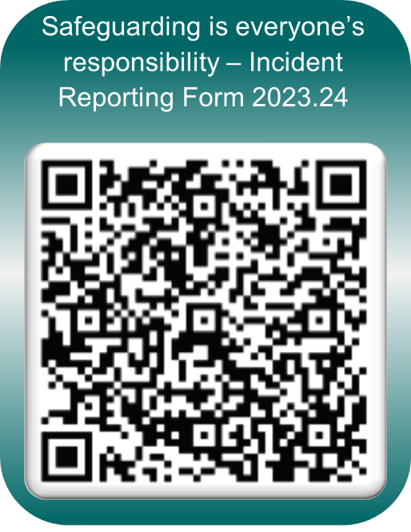

Or Emailing FOESafeguarding@edgehill.ac.uk
Or by calling 01695 584314 or 07738801725
If after doing so, you remain concerned about a professional or volunteer’s behaviour towards a child you may need to report your concerns directly to the NSPCC Report abuse to the NSPCC | NSPCC
If appropriate, the DSO may direct you to the student complaints procedures to let us know https://www.edgehill.ac.uk/document/complaints-procedure/.

Section 4 What to do if you have a safeguarding concern about a child or an adult at risk (whilst on your professional practice)
If you believe a child is in immediate danger you should ring 999 without delay.
The school or setting will have their own local procedures which you should follow. This will involve reporting your concerns immediately without delay to the Designated Safeguarding Lead, or in their absence any member of senior management or another member of the safeguarding team.
Once you have reported concerns to the school or setting you should also raise the concern with a designated safeguarding officer in the Faculty of Education. Safeguarding - Edge Hill University
You report concerns by either:
Completing the FOE Safeguarding incident form on the EHU webpage here: Safeguarding - Edge Hill University

Or by Emailing FOESafeguarding@edgehill.ac.uk
Or by calling 01695 584314 or 07738801725

If you remain concerned or believe appropriate action may not have been taken then you can report your concerns directly to the NSPCC Report abuse to the NSPCC | NSPCC

Section 5 What to do if you have a safeguarding concern when you are NOT on your professional practice.
The Edge Hill University website details the action which needs to be taken if you identity a concern. https://www.edgehill.ac.uk/safeguarding/ :
- Contact a Designated Safeguarding Officer (DSO)
You can report concerns by either:
Completing the FOE Safeguarding incident form on the EHU webpage here: Safeguarding - Edge Hill University

Emailing FOESafeguarding@edgehill.ac.uk
Or by calling 01695 584314 or 07738801725
- The DSO will then review the information

- The DSO will seek advice from a Senior DSO (plus representative from HR where concerns relate to a member of staff)

- The Lead Safeguarding Officer and Prevent Lead makes the decision to refer the concern to the relevant Safeguarding Board/ Police/ Social Services/Channel and records any action taken.

Section 6 Who to contact at Edge Hill if you have a safeguarding concern

Faculty of Education
Department of Secondary and Further Education
Heather Marshall (Faculty Senior Lead for Safeguarding) marshalh@edgehill.ac.uk 01695 650991
Department of Early Years Education
Amanda Casey (Designated Safeguarding Officer) Caseya@edgehill.ac.uk 01695 650774
Department of Primary and Childhood Education
Ian Shirley (Designated Safeguarding Officer) Shirleyd@edgehill.ac.uk 01695 650998
If you are unable to contact a DSO in your Faculty you can use the contact details for other staff at the University as listed online here https://www.edgehill.ac.uk/safeguarding/

Appendices

Appendix A: Mechanisms of reporting

You report concerns by either:
Completing the FOE Safeguarding incident form on the EHU webpage here: Safeguarding - Edge Hill University
Emailing FOESafeguarding@edgehill.ac.uk
Or by calling 01695 584314 or 07738801725

Safeguarding is everyone’s responsibility – Incident Reporting Form (2023/24)
We understand that you have experienced/witnessed an incident that may be described as safeguarding.
In FoE, we define safeguarding as protecting children and adults at risk from abuse and neglect.
We define children as young people under the age of 18. This will be the majority of school/nursery/college pupils you come into contact with.
We define adults at risk as anyone other than a child who:
- has needs for care and support
- is experiencing or is at risk of abuse and neglect and
- is unable to protect themselves against abuse and neglect.
This might be because of a mental or physical illness or disability, or because of their age.
In FoE, incidents may have come through the following:
- A staff member or student/trainee directly observing an incident involving a child in any educational setting
- A staff member or student/trainee directly observing an incident involving a vulnerable adult, e.g., in a college setting
- A disclosure from a child or vulnerable adult to a member of FoE staff or an FoE student
- An observation by a third party who subsequently reports the account to and FoE staff member or an FoE student
- A referral from an external third party, e.g., the police, social services, or a member of the public.
In our experience, most safeguarding incidents occur in a partnership setting and involve students/trainees having witnessed something which might suggest a concern (harm or injury – physical or psychological to a pupil).

Appendix B – Example of a completed Safeguarding incident reporting form

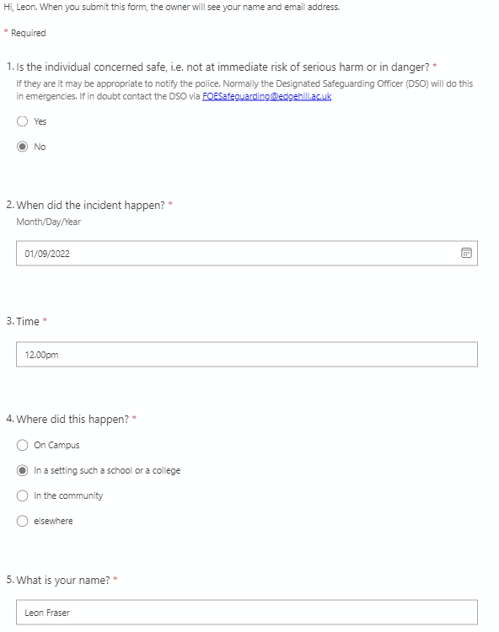

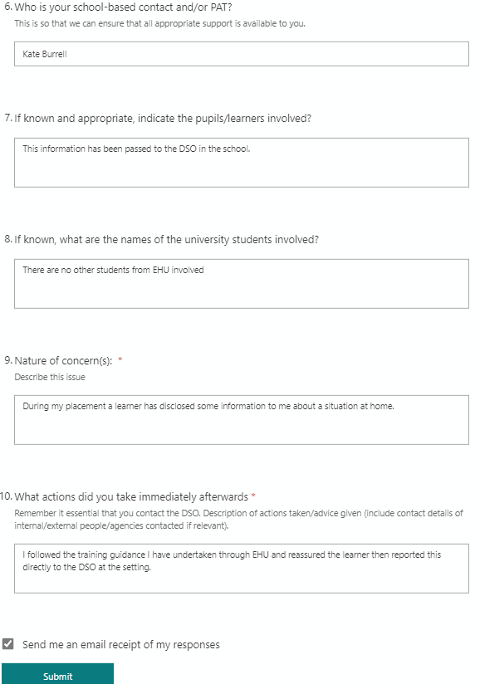

Appendix C: Recording outcomes of reported incidents

Designated Safeguarding Officers records the outcome of a cause for concern in the assigned column of the Incident Reporting Summary Sheet. The formal FoE casework log is held in an restricted access folder on the Y drive for the appropriate length of time as dictated by the University document retention schedule.
Record of outcome of cause for concern | Designated Safeguarding Officer | Date

Appendix D: Further guidance in the case of disclosure

You may recognise a safeguarding issues/concern through:
- direct observation
- information disclosed from a child or vulnerable adult
- observation by a third party

When responding to information that has been disclosed to you must:
- Stay calm
- Listen carefully and don’t interrupt
- Do not interview them or press them for details
- Ask questions only for clarification
- Reassure them
- Clarify that any information you receive must be passed on.
- If non- recent abuse is disclosed (from the past or about alleged victims’ perpetrators) this should be acknowledged but not discussed but communicated to the *DSO.

You must report / pass on the information immediately:
- inform the DSO of setting/school/College.
- if there is immediate danger to an individual, your priority is to call 999
- provide an outline of the incident using the online form incident form on the EHU webpage here: Safeguarding - Edge Hill University
- FoE DSO will follow up via email / phone call to the setting/school/college.
- the FoE DSO will signpost you to further support if required via the Welllbeing Team
- this concludes your involvement and must not be discussed unless requested.

Things to Remember
• Remain Calm Do not quiz for more information
• Do not speculate or make assumptions
• Do not voice negative judgements about the situation or the abuser
• Do not make any judgements or jump to conclusions on the basis of what you have heard or seen.
Judgements in such cases can only be made by professionals in the field.
• Do not make promises that you cannot keep
• Do not promise that ‘everything will be alright’
• Do not offer or promise to keep it confidential
• In the case of you directly observing an incident(s) record your observations as accurately and as quickly after the event as possible, including dates and times, where appropriate.
• Do not try to investigate yourself;
• Report your observations as soon as possible to one of the Designated Safeguarding Officers;
• Do not discuss this with anyone else. If you require some reassurance yourself, tell the Designated
Safeguarding Officer or request a confidential interview with the University’s Student Support Service;

It is important that everyone in the organisation is aware that the first person who encounters a case of alleged or suspected abuse is not responsible for deciding whether or not abuse has occurred. In the case of a child, that is a task for the professional child protection agencies following a referral to them.

Appendix E: University guidance for dealing with concerns over radicalisation

The duty to protect children, young people and adults from harm extends to protecting them from involvement in groups which set out to radicalise individuals. Radicalisation refers to the process by which a person comes to support terrorism and forms of violent extremism leading to terrorism. Within the government’s Prevent Strategy 11, universities have been identified as potential sites for radicalisation and university leaders have been asked to work in partnership with the regional B.I.S. Prevent co-ordinators, local authorities and the Police to minimise the risks of individuals becoming radicalised. Whilst it is recognised that no single measure will reduce radicalisation, it is believed that the only way is to target potential at risk vulnerable groups and individuals and try to re-assimilate them into society.

If a member of university staff is concerned that an individual may be becoming radicalised, s/he should speak to his/her line manager who should contact a Designated Safeguarding Officer, who in turn, will contact the Lead Designated Safeguarding Officer.

If a student is concerned that an individual may be becoming radicalised s/he should discuss this with their Head of Department or other senior member of staff who will contact a Designated Safeguarding Officer.

Your FOE safeguarding training (Level 1 and 2) also contains a section on radicalisation. Further Guidance can be found in the University Safeguarding Policy. https://www.edgehill.ac.uk/document/safeguarding-policy/

What might be the indicators of radicalization?
Spotting signs and getting help
Radicalisation can be difficult to spot. Signs that may indicate a child is being radicalised include:

- isolating themselves from family and friends

- talking as if from a scripted speech

- unwillingness or inability to discuss their views or a sudden disrespectful attitude towards others or increased levels of anger
- increased secretiveness, especially around internet use.

Children who are at risk of radicalisation may have low self-esteem or be victims of bullying or discrimination. Extremists might target them and tell them they can be part of something special, later brainwashing them into cutting themselves off from their friends and family.

However, these signs don't necessarily mean a child is being radicalised – it may be normal teenage behaviour or a sign that something else is wrong. If you notice any change in a child's behaviour and you're worried, you can call the NSPCC helpline on 0808 800 5000

Further guidance can be found at:
https://www.nspcc.org.uk/keeping-children-safe/reporting-abuse/dedicated-helplines/protecting-children-from-radicalisation/
http://educateagainsthate.com/
https://www.support-people-vulnerable-to-radicalisation.service.gov.uk/

Appendix F: University guidance in respect of FGM

Female Genital Mutilation (FGM) refers to procedures that intentionally alter, mutilate, or cause injury to the female genital organs for non-medical reasons. FGM is medically unnecessary and can have serious health consequences, both at the time it is carried out and in later life.

FGM is a violation of the body and of the individuals’ human rights. It is an act of violence and gender discrimination against girls and women. FGM is a child protection concern - it causes significant harm and is classed as physical abuse. Specific FGM and child protection legislation and policy exist to protect
children and young people from being subjected to the procedure. FGM is also a health concern - there are no medical benefits to the individual following FGM procedure and it is harmful because of the various gynecological, obstetric and psychological health complications for mother and baby.

FGM is prevalent in 28 African countries and areas of the Middle and Far East, but it is increasingly practiced in the U.K. in communities with larger populations of first-generation immigrants, refugees and asylum seekers.

FGM is deeply embedded in some communities and is performed for cultural and social reasons. It is usually carried out on girls before they reach puberty, but in some cases, it is performed on new-born infants or on women before marriage or pregnancy. It is often justified by the belief that it is beneficial for the girl or woman, but FGM is an extremely harmful practice which violates basic human rights.
The most significant risk factor for girls and young women is coming from a community where FGM is known to be practised and/or where a mother, sister or other female family member has been subjected to FGM.
Practitioners should be aware of this and provide families with advice and information which makes it clear that FGM is illegal.
https://www.nspcc.org.uk/what-is-child-abuse/types-of-abuse/female-genital-mutilation-fgm/

Appendix G: Guidance in respect of checks necessary to work with children and young people
- As you will be aware schools and colleges are under a legislative duty to safeguard and promote the welfare of children and must have regard to Keeping children safe in education statutory guidance see https://www.gov.uk/government/publications/keeping-children-safe-in-education--2

- Whilst it is the responsibility of the initial teacher training provider to carry out the necessary checks, many schools and colleges have for many years routinely requested DBS certificates from individuals, to satisfy themselves that they are meeting its wider statutory safeguarding obligations.

- Schools and colleges are legally entitled to and can insist to see a student’s DBS certificate if they wish to do so. In most cases this will mean that the individual will need to be prepared to present their certificate on request. If an individual is unwilling to do so, the school or college is legally permitted to turn them away (without further reason).

- Information about the retention of documents including copies of DBS certificates can be found at paragraphs 276-278 (KCSIE 2023).

Appendix H: Additional guidance

- Guidance (non-statuatory for schools) which details how local authorities identify children missing education.
https://www.gov.uk/government/publications/children-missing-education

- Useful guidance directed at staff in higher education.

The Prevent Duty in higher education (HE): training and guidance for practitioners.

The Prevent Duty - Level 6/7 Learners - YouTube – 7 Videos produced by Educate against Hate.

- In very specific circumstances in which matters which cannot be raised by any other procedure, it may be necessary for individuals within a organisation to raise concerns via a Whistleblowing Policy/Procedure. Schools and settings will host their Whistleblowing Policy/Procedure on their main website policies page.

Appendix I: Safeguarding in the Curriculum

- Curriculum maps including safeguarding and supportive readings are contained on BB:

  - Early Years Education
  - Primary and Childhood Education
  - Secondary and Further Education

https://www.edgehill.ac.uk/document/safeguarding-policy/

