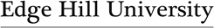
Department of Primary & Childhood Education Lesson Plan

Date: | Class: Year 2 | Subject/topic: Maths addition | Time:
Prior knowledge:
how does this lesson fit in with a sequence of lessons-what components have previously been taught?
Number Bonds to ten
Addition of three numbers (addends) can be described by an aggregation (putting the numbers together) story with three parts. Addition of three addends can be described by an augmentation (counting on) story with a “first, then, then now” structure.
The order in which two addends (parts) are added or grouped does not change the sum (associative and commutative laws).
Outcomes: what composite knowledge/ skills do you want children to achieve?
When we are adding three numbers, we choose the most efficient order in which to add them, including identifying two addends that make ten (combining).
Assessment:
- Observation of tasks
- Targeted questioning
- Completion of tasks
Learning objectives:
Declarative, procedural and conditional knowledge

- I know that adding three numbers in any order will always give the same total.
- I know how to use different representations to demonstrate the associative law of addition.
- I know when to add two numbers that make ten to help me be more efficient in adding three numbers.
Key vocabulary:  Addend  Augmentation – when a quantity is increased by another (adding on) Aggregation - combining 2 or more quantities  Addition Equals Add Sum Total  Commutative law Associative law |  | Resources:  Tens frames Counters  Blank number lines  Part-part-part-whole models Missing number sequences
Predicted misconceptions:  Confusion of augmentation and aggregation. Inability to use augmentation to add 3 numbers. Misunderstanding of the = symbol |  | Risk assessment:

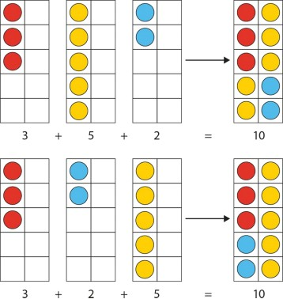
SEQUENCE OF TEACHING & LEARNING
Timing:  consider pace of lesson. | Role of the teacher & support staff:  e.g. key questions, retrieval of prior learning, modelling and explanations, checking understanding,  consider cognitive overload, effective use of additional adults, behaviour for learning. | Children’s steps in learning:  what will the children be doing? Learn, practise and apply component steps. | Adaptive teaching:  consider adaptive strategies to support all pupils (including stretch and challenge & SEND), consider resources. | Checking what children know, understand and can do:  Key questions inc. hinge and retrieval/recall, assessment of outcomes.
10 mins | - “In my toy-box, I have three red cars, five yellow cars and two blue cars. I have ten cars altogether.”  - Model this as 3+5+2 and 3+2+5 using tens frames and different coloured counters. | - Children to respond in full sentences.  - Can they identify number bonds to 10 ie 3+2=5, 5+5=10?  - What can they see that is the same/ different about each representation? | Use of different representations, pictures and contexts. | - What does the 3 represent?  - What does the 5 represent?  - What does the 2 represent?  - What does the 10 represent?
5 mins | - Keeping the pictorial representation now  demonstrate the use of the part- part-part-whole model. | - Children identify what is similar and different about the two representations. |  | - What does the 3 represent?  - What does the 5 represent?

 | 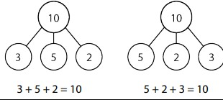 |  |  | - What does the 2 represent?  - What does the 10 represent?
10 mins | - Model the three ways of symbolically calculating, 2,4,3.  2+4+3=6+3=9  2+4+3=2+7=9  2+4+3=5+4=9  - Introduce term “associative law”. | - Children to practise similar examples.  2+1+4  1+3+2 | Children to use tens frames, part-part-part-whole models or go straight to symbolic representations.  To promote depth use a magic square scenario.  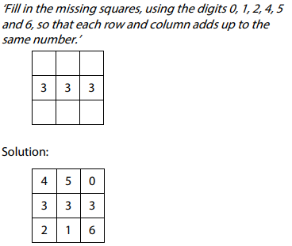 | Teacher/ adult to assess understanding of associative law by asking whether answer would be different if order were changed.
15 mins | - Introduce a context of 3 addends totalling more than 10. “There are three birds on the wall, five birds on the ground and seven birds in the tree. How many birds are there altogether?” | - Encourage children to look for number bonds to 10.  - Children to complete some examples.  5+6+5=  3+3+7=  7+4+3=  8+4+2=  2+8+6 | - Children work at own pace using tens frames if required.  - To promote depth use a sorting activity  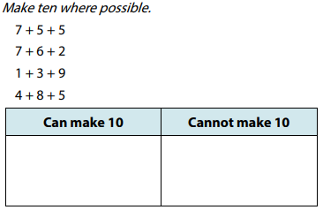  - To further promote depth  use questions with 4 addends where 2 pairs | Teacher to assess if children can use augmentation to add on from 10.  Explain to me why these can/cannot make 10.

 | - Model, using aggregation, using pictures, tens frames, encouraging children to look for number bonds to 10.  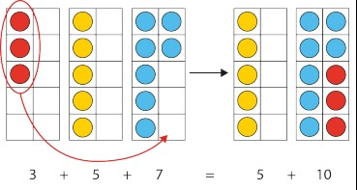 |  | make number bonds to 10 or three addends sum to 10.  2+4+6+8  8+3+6+1
10 mins | - To reflect variation, represent information in a pictogram.  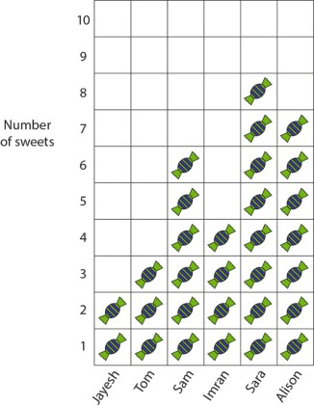 | - Encourage the use of stem sentences such as ‘ plus is equal to ten, then ten plus  is equal to .’ | - Children choose how to represent and calculate answers.  - Have a blank stem sentence on the board for children to complete. | How many sweets do Jayesh, Sam and Sara have altogether?

EVALUATION
Evaluation of pupils’ learning:
- Some children (x,x,x,x,x,x,x,x) did not use their declarative knowledge for partitioning and were still using augmentation (counting on), ie.3+7=10
- Pupils working on challenge questions completed with ease.

Next steps:
e.g. how to address misconceptions, providing increased challenge or support, use of different resources or modelling techniques.

- Reinforce use of tens frames with (x,x,x,x,x,x,x,x) to support declarative knowledge of number bonds to 10 and model this is in worked addition examples. Could also use Numicon.
- Plan more challenge – worded problem examples to demonstrate transfer of skills, or picture stories to illustrate an addition of 3 or more addends.
Evaluation of teaching:
- Modelling of part- part- whole and tens frames and symbolic calculation could be overloading some cognitively.
- Spent too long modelling use of tens frame, more time needed modelling associative law in symbols to ensure understanding.
- Stem sentences worked really well, all children able to access either written or verbally.

Next steps:
e.g. subject knowledge, teaching strategies, behaviour management.

1 & 2. Mrs X (TA) to write the symbolic version of calculation on board whilst I model the use of visuals representations ie part – part - whole and tens frames. This will reinforce how they are all different ways of representing the same calculation.
3. Pre-print stem sentences to be stuck in books.
Move on to subtraction as difference – taking all above points into account.

