Primary Initial Teacher Education: Curriculum Plan

Systematic Synthetic Phonics (SSP): Undergraduate Programmes

NB – this curriculum plan identifies when trainees will ‘meet’ content for the first time – the intention is that at each phase, university and school-based colleagues will support trainees in recalling, refining, applying and discussing content from the previous phases.

Curriculum Intent:

Through our Initial Teacher Education Curriculum, it is our intention that trainees will understand that systematic synthetic phonics is the route to developing both accurate and fluent word reading skills. They will understand that this approach is supported by robust evidence and that it should therefore be the prime ‘time-limited’ approach to word reading. We intend that all trainees will develop an enthusiasm and passion for systematic synthetic phonics. Our trainees will know that all children can learn to read when they are taught well, regardless of social background or other circumstances and that this is their moral purpose as educators.

Phase | Learn that… | Learn how to…
Phase 1 | Trainees will know: | Trainees will be able to:
 | - that reading comprises two elements: word reading and language comprehension and that this is represented in the ‘simple view of reading’ (Appendix 1). (LT3.9) | - enunciate phonemes correctly (LT3.2)
 | - that SSP is the most effective approach for teaching children to decode print (LT3.9) | - split words into their constituent phonemes (phoneme counting) (LT3.2)
 | - the skills associated with phonological awareness. | - identify the grapheme that represents each phoneme in a word (LT3.2)
 | - the pre-requisite auditory skills that children need to support auditory discrimination (LT3.3). | - use letter names appropriately to discuss graphemes and spelling patterns (LT3.2)
 | - the visual skills that underpin word reading, including visual discrimination, visual memory and visual sequential memory (LT3.2). | - identify or produce words / phrases / sentences / texts that are phonically decodable for a particular group of children i.e. that match their level of phonics knowledge
 | - the definitions of phoneme; grapheme; adjacent consonant; digraph; consonant digraph (LT3.2) | - plan a phonics lesson for a simple code ‘phase’ in an SSP programme using a tightly defined ‘standard’ structure (Introduce > Review > Teach > Practise > Apply)
 | - the definition of common exception words and their place in a systematic synthetic phonics programme (LT3.2) | - plan and teach a ‘stand-alone’ phonics lesson for a simple code ‘phase’ in an SSP programme to a small group of children with support from an expert colleague
 | - that English uses a complex alphabetic code (LT3.2) | Composite knowledge/understanding/skills  By the end of this phase trainees will know:  How systematic synthetic phonics is defined and the key indicators of quality teaching in an SSP approach  By the end of this phase trainees will understand:  Why SSP is identified as the most effective approach for teaching children to word read / decode print  By the end of this phase trainees will be able to:  Plan and teach a stand-alone phonics lesson for a simple code ‘phase’ with support from an expert colleague
 | - That an SSP programme will teach a ‘simple’ code first, i.e. one grapheme for each of the 44 phonemes in English (LT3.3, LT3.7).
 | - the principles of high quality SSP teaching
 | - that the DfE uses essential criteria to identify an effective SSP programme and that all programmes must be validated against these criteria
 | - That the National Curriculum programme of study for English includes expectations for word reading through decoding (LT3.1).
 | Trainees will understand: | Formative assessment  Trainees to be given a multiple-choice quiz on the simple code at the end of phase 1
 | - the underpinning research that supports SSP including that identified in the Rose Review of Early Reading (DfES, 2006) and the Core Content Framework for ITT (DfE, 2019) (LT3.2)
 | - the simple view of reading (Appendix 1) (LT3.2)
 | - the factors that define written English as a complex alphabetic code (LT3.2).
 | - that reading involves visual discrimination of graphemes, mapping of graphemes to phonemes, and blending phonemes together (LT3.2)
 | - that spelling involves segmenting the phonemes in a spoken (or ‘thought’) word, mapping the phonemes to an appropriate grapheme, and recording the graphemes in the right order either by typing or handwriting (LT3.2)
 | - that blending for reading and segmenting for spelling are reverse processes (LT3.2)
 | - why it is important to use letter names to discuss graphemes and spelling patterns
 | - the importance of ‘maintaining fidelity’ to a validated SSP programme
 | - the importance of ensuring that all text that children encounter should be phonically decodable for them i.e. closely matched to their level of phonics knowledge (LT5.3)
Phase 2  *Trainees will maintain the knowledge, understanding and skills developed at Phase 1 and will add the following… | Trainees will know: | Trainees will be able to:
 | - all the grapheme/phoneme correspondences usually included in the ‘simple’ code phases of an SSP programme (including c / k / ck; doubled letters; z / zz / s) (LT3.2) | - confidently and accurately explain the Simple View of reading; ‘phoneme’; ‘grapheme’; ‘adjacent consonants’; ‘digraph / trigraph’; blending and segmenting as reverse processes; ‘encoding’; ‘decoding’ (LT3.2)
 | - to know the ‘complex’ code i.e. alternative graphemes for each phoneme and alternative phonemes for each grapheme the most common alternative phonemes / graphemes included in the first stages of the ‘complex’ code phases of an SSP programme (e.g. ee / ea; ai / ay / a_e) (LT3.2) | - plan a phonics lesson for a complex code ‘phase’ in an SSP programme using a tightly defined ‘standard’ structure (Introduce > Review > Teach > Practise > Apply) (LH3.4, LH3.6)
 | - the age-related expectations for children’s reading development (LT3.1) | - plan a sequence of SSP lessons that demonstrate progression in children’s learning over time (LH2.4)
 | - that children make progress in their reading development at different rates and may be assessed as working below age-related expectations at formal assessment points e.g. Year 1 Phonics Screening Check (LT5.1) | - assess children’s learning in SSP by observing their reading and analysing their independent writing (LH6.3)
 | - that an early reader’s reliance on phonics to decode is time-limited as they develop fluency in word reading (LT3.3) | - teach a stand-alone phonics lesson for a complex code ‘phase’ in an SSP programme to a whole class or whole teaching group of children (LH3.4, LH3.6)
 | - that the cognitive load associated with learning and applying correct letter formation i.e. handwriting fluency has an impact on children’s ability to spell accurately even when their phonic knowledge is secure (LT2.4) | - (*if placed in KS1 for PP) trainees must plan and teach a sustained sequence of SSP lessons, adjusting plans in response to assessment (LT6.4)
 | - that SSP is the prime approach for supporting word reading / decoding and spelling for children who are working below age-related expectations in early reading and spelling development (LT3.9) | Composite knowledge/understanding/skills  By the end of this phase trainees will know:  That children make progress in their reading development at different rates  By the end of this phase trainees will understand:  The factors that influence children’s reading development  By the end of this phase trainees will be able to:  (If in KS2 for PP) Plan and teach a stand-alone phonics lesson for a complex code ‘phase’ or plan and teach an intervention lesson (or sequence of lessons) for children in KS2 working below age-related expectations with support from an expert colleague  OR  (If in KS1 for PP) trainees must plan and teach a sustained sequence of SSP lessons, demonstrating the elements of good practice indicated in the EHU ‘Lesson Observation Prompts’, and adjusting plans in response to assessment
 | - that the most effective assessment of phonics is simple, rigorous and purposeful, i.e. it leads to adaptive teaching (LT6.3, LT6.4)
 | - strategies for assessing children’s learning in SSP, including the design and implementation of the Year 1 Phonic Screening Check (LH6.1, LH6.2)
 | - approaches to intervention, including SSP intervention schemes, for children who are working below age-related expectations in early reading development, including those in Key Stage 2. (LH6.2)
 | Trainees will understand: | Formative assessment  Trainees to be given a multiple-choice quiz on the complex code at the end of phase 2
 | - the expanded version of the Simple View of reading and the connection between word reading and language comprehension (Appendix 2) (LT3.2)
 | - the processes involved in the word recognition system including vocabulary stores containing meanings and sounds of words and the links between items in these stores (Appendix 3) (LT3.2)
 | - that effective SSP teaching provides children with fluency in making ‘phonically plausible’ attempts in their spelling which then supports confidence and success their early writing development (LT3.9)
 | - the cognitive and biological factors that can impact a child’s ability to word read / decode text and to develop fluency and automaticity at the expected rate (LT5.1).
 | - The role of a multi-sensory approach to systematic synthetic phonics in high quality teaching for all children.
Phase 3  *Trainees will maintain the knowledge, understanding and skills developed at Phases 1 and 2, and will add the following… | Trainees will know: | Trainees will be able to:
 | - that children’s families and wider social groups and communities (including siblings, grandparents, wider family and friends) play an important role in their reading development (LT8.4) | - communicate effectively with children’s parents / carers about their reading development and progress (LT8.4)
 | - that teachers should collaborate with families as equal, respected partners in supporting children’s reading development (LT8.4) | - plan a class reading initiative to build collaborative links between children’s school and home communities (LT8.4)
 | - a range of approaches to home / school collaboration to develop children’s early reading enjoyment, confidence, fluency and competence (LT8.4) | - Plan and teach a sustained sequence of spelling lessons that build on from SSP principles (LT3.3, LH3.4, LH3.6)
 | - that phonic knowledge, understanding and skill support early spelling and writing development but are not enough for children to acquire competency and accuracy with the complex code of English orthography (LT3.3) (LT2.2) | - plan and teach a sustained sequence of intervention lessons for children working below age-related expectations (LT5.7, LH5.8)
 | - approaches to developing children’s spelling confidence and accuracy | - (*if placed in KS1 for PP) trainees must plan and teach a sustained sequence of SSP lessons, demonstrating the elements of good practice indicated in the EHU ‘Lesson Observation Prompts’, and adjusting plans in response to assessment (LT3.3, LH3.4, LH3.6)
 | Trainees will understand: | Composite knowledge/understanding/skills  By the end of this phase trainees will know:  How to build collaborative relationships with children’s families to support their reading development  By the end of this phase trainees will understand:  The environmental factors that influence children’s reading development  By the end of this phase trainees will be able to:  (If in KS2 for PP) plan and teach a sustained sequence of intervention lessons for children working below age-related expectations  OR  (If in KS1 for PP) trainees must plan and teach a sustained sequence of SSP lessons, demonstrating the elements of good practice indicated in the EHU ‘Lesson Observation Prompts’, and adjusting plans in response to assessment  Summative assessment:  Trainees assessed by the mentor through tutorial discussions and observations of their teaching plus scrutiny of lesson plans.
 | - the environmental factors that can impact children’s early reading development, including their ability to word read / decode text and to develop fluency and automaticity at the expected rate e.g. the home language environment (LT3.3)
 | - the role of cultural and linguistic capital in reading development
 | - brain plasticity and the relationship between environmental and biological factors in reading difficulty e.g. environmental factors can change the structure of the brain; biological impairment in brain structure can be alleviated by environmental factors.(LT5.1, LT5.3)
 | - The connection between difficulties with early reading and difficulties with spelling
Research | Rose, J. (2006) Independent review of the teaching of early reading. Available: https://www.education.gov.uk/publications/standard/publicationDetail/Page1/DFES-0201- 2006  Johnston, R. & Watson, J. (2005) [PDF] The effects of synthetic phonics teaching on reading and spelling attainment. Available: www.scotland.gov.uk/Resource/Doc/36496/0023582.pdf  Johnston, R., McGeown, S., and Watson, J. (2011), ‘Long-term effects of synthetic phonics versus analytic phonics teaching on the reading and spelling ability of 10- year-old boys’ and girls’, Reading and Writing, 25, 1365-1384.  Stuart, M. (2006), ‘Teaching Reading: why start with systematic phonics teaching?’, The Psychology of Education Review, 30, (2), 6-17.  Watson, J.E., and Johnston, R.S. (1998), ‘Accelerating Reading Attainment: the effectiveness of synthetic phonics’, Interchange, 57, Edinburgh, SEED.
APPENDIX 1

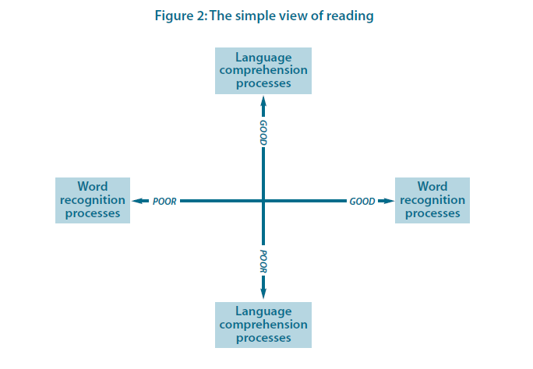
(Rose, 2006: 77)

APPENDIX 2
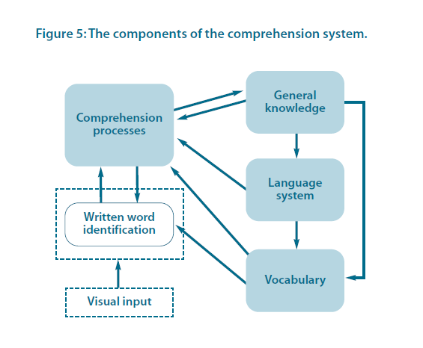
The expanded Simple View of reading (from Rose, 2006: 89 – from Perfetti (1999))

APPENDIX 3

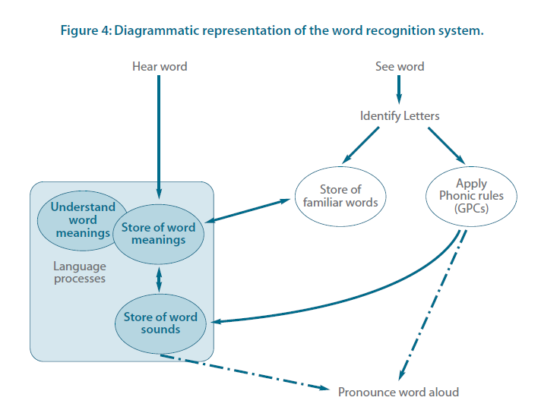
(Rose, 2006: 86)

