Primary Initial Teacher Education: Curriculum Plan

Physical Education: Undergraduate Programmes
University – University and School

Curriculum Intent:

At Edge Hill University we strongly believe that physical education should be at the heart of the school curriculum. We aim to show students that PE is the only primary school subject whose focus is on the development of physical competence. PE provides opportunities for pupils to be creative, competitive and to face up to different challenges. PE also promotes positive attitudes towards active and healthy lifestyles and will ensure that children can move efficiently, effectively and safely. Through our developmental curriculum we aim to provide students with a wide range of practical tools and pedagogical approaches to enable them to teach a high-quality PE curriculum which can contribute to children’s confidence, self-esteem, self-worth and enhance social development. Curriculum primary physical education is the most effective and inclusive means of providing all children with the skills, attitudes, values, knowledge and understanding for lifelong participation in physical activity.

Phase | Learn that… |  |  |  | Learn how to…
Phase 1 | Trainees will know: |  |  |  | Trainees will be able to:
 | • physical activities that develop fundamental movement skills (FMS). LT3.2  • that motor development in physical education is split into three categories. (Stability, Object control and Locomotor)  • children develop schemata for motor skills and use them to guide development. LT3.7 |  |  |  | • observe the developmental stages of key fundamental movement skills. LT3.3  • adapt a fundamental movement skill activity so ALL children achieve success. LT5.1
 | • a broad range of physical activity specific skills and practical activities that meet national curriculum requirements and beyond. LT3.5  • how to plan a sequence of learning to a specific end point in PE.  - a method to assess and monitor children’s progress in an activity area in National Curriculum PE. LT6.1 |  |  |  | • plan and teach a sequence of learning in PE in an activity area. LT3.7  • assess children’s learning in a planned sequence of learning in PE. LT5.3
 | • the basic principles of attacking and defending strategies in a range of modified competitive games. LT3.7  • the principles of linking actions and sequences of movement. For example, dance and gymnastic type activities. LT3.7 |  |  |  | • adapt an activity focusing on an application of a skill so ALL children achieve success. LT5.3
 | Trainees will understand: |  |  |  | Composite knowledge / understanding / skills  By the end of this phase trainees will know:  • a range of practical activity specific skills and how they can be applied in a unit of work.  By the end of this phase trainees will understand:  • the difference between physical education and school sport.  • that activity specific skills are built on the foundation of children’s mastery of fundamental movement skills  By the end of this phase trainees will be able to:  • make informed observations of children’s performance in a range of object control fundamental movement skills.  • with support plan a sequence of learning in a specific PE activity.
• the statutory requirements of National Curriculum Physical Education. LT3.1
• the differences between physical education, physical activity and school sport.

• inclusive principles within PE for ALL learners.
• what is meant by safe practice and how to manage it within PE lessons. LT7.1

 | • that fundamental movement skills relevant to physical education are made up of three stages.
 | • that sport specific skills build on fundamental movement skills. LT 4.2
 | - the importance of modelling FMS and sport specific skills to the children. LT 4.3
Assessment |  | Research, literature and resources supporting the curriculum design of Phase 1.
Phase 1 Assessment: · Trainees will take part in an exercise to explore personal attitudes to PE  Trainees will take part in frequent in-session retrieval activities that tutors will respond to and provide support where necessary. ·  Assessed via subject-specific feedback from mentors on professional practice.  Assessed through PED1024 reflective journal and trainees’ reflections in portfolio from professional practice. |  | - National Curriculum 2014  - QCA PE Core Task videos  - Gallahue et al (2019) Understanding Motor Development: Infants, Children, Adolescents, Adults  - Griggs, G, (2012) An Introduction to Primary Physical Education  - Lawrence, J, (2020), Teaching Primary Physical Education.  - Howells K, et al, (2018) Mastering Primary PE  - Doherty and Brennan (2014), Physical Education and development 3-11  - Pickard and Maude (2020, 2nd /edition) Teaching PE Creatively  - Vickerman, P and A. Maher (2018) Teaching Physical Education to Children with Special Educational Needs and Disabilities (2nd Eds).  - Swindlehurst, (2008) Ch 3 in Lavin, J. Creative Approaches to teaching PE.  - Paul Rainer & Stuart Jarvis (2020) Fundamental movement skills and their relationship with measures of health-related physical fitness of primary school children prior to secondary school transition: a Welsh perspective, Education 3-13, 48:1, 54-65,
Phase 2  . | Trainees will know: |  |  |  | Trainees will be able to:
 | • a range of skills to teach outdoor and adventurous activities and swimming and water safety. LT3.2 |  |  |  | • plan a sequence of learning to a specific end point using PE in a thematic approach. LT3.7
 | • how to use PE activities in a cross curricular theme |  |  |  | • Use proactive and reactive behaviour management strategies in PE.
 | • a range of methods to assess and monitor children’s progress in the activity areas in National Curriculum PE. LT 6.5 |  |  |  | • adapt an activity in a cross-curricular/thematic approach so ALL children achieve success.
 | Trainees will understand: |  |  |  | Composite knowledge / understanding / skills  By the end of this phase trainees will know:  • a range of practical activity specific skills and how they can be applied in a thematic unit of work.  By the end of this phase trainees will understand:  • how inclusive PE can be used to enhance learning across the curriculum.  By the end of this phase trainees will be able to:  • with some support confidently plan a sequence of learning using PE activities in a cross-curricular/thematic approach.
 | • a range of practical activities designed to support cross-subject and cross-curricular learning.
 | • how to use International events and athletes (inc BAME and SEN/D) to enhance learning across the curriculum.
 | - the importance of cultural capital in children’s educational development.
Assessment |  |  | Research, literature and resources supporting the curriculum design of Phase 2.
Trainees will take a short multiple-choice assessment to identify areas where additional support is required. This support will be provided during an intervention week via in-person and asynchronous sessions. ·  Trainees will take part in frequent in-session retrieval activities that tutors will respond to and provide support where necessary. ·  Assessed via subject-specific feedback from mentors on professional practice |  |  | - National Curriculum 2014  - QCA PE Core Task videos  - Swim England UK  - TOP Swimming YST  - TOP Challenge YST  - Lavin, J. (2008) Creative Approaches to Physical Education: Helping children to achieve their true potential.  - Webster, M and S. Misra (2015) Teaching the Primary Foundation Subjects. Vickerman, P and A. Maher (2018) Teaching Physical Education to Children with Special Educational Needs and Disabilities (2nd Eds).  - Griggs, G, (2012) An Introduction to Primary Physical Education  - Lawrence, J, (2020), Teaching Primary Physical Education.  - Howells K, et al, (2018) Mastering Primary PE
Phase 3 | Trainees will know: |  |  |  | Trainees will be able to:
 | • the importance of a developmental physical education curriculum. LT3.1  • the benefits of physical education to children LT3.1 |  |  |  | - explain the key characteristics of a physical educated child.
 | • what constitutes high quality physical education. LT3.2 |  |  |  | • plan, teach and assess a sequence of learning in PE in an activity area to an end point. LT3.7
 | • a range of methods to assess and monitor children’s progress in the activity areas in National Curriculum PE.  - the Association for PE Guide to National Curriculum Progression in Physical Education can be used to aid assessment of children’s progress |  |  |  | • adapt teaching strategies so ALL children achieve success. LT5.3
 | • how PE/PA/SS can be used outside of the classroom. |  |  |  | • plan an out of hours activity session
 | - how to plan a PE curriculum to a specific end point.
 | - that the association for PE is key in identifying CPD opportunities during their ECT career. LT8.1
 | Trainees will understand: |  |  |  | Composite knowledge / understanding / skills
 | - the barriers to learning in PE. |  |  |  | By the end of this phase trainees will know:  - the importance of a high-quality physical education curriculum to the physical development of children.
 | - that identifying areas for their own CPD in PE is crucial. LT8.1 |  |  |  | By the end of this phase trainees will understand:  • how inclusive PE can be used to enhance learning across the curriculum.  By the end of this phase trainees will be able to:  • Plan, teach and assess a sequence of learning in a physical education activity area which is inclusive so All children achieve success.
Assessment |  |  |  | Research, literature and resources supporting the curriculum design of Phase 3.
Trainees will take a short multiple-choice assessment to identify areas where additional support is required. This support will be provided during an intervention week via in-person and asynchronous sessions. ·  Trainees will take part in frequent in-session retrieval activities that tutors will respond to and provide support where necessary.  Assessed via subject-specific feedback from mentors on professional practice |  |  |  | - National Curriculum 2014  - QCA PE Core Task videos  - Gallahue et al (2019) Understanding Motor Development: Infants, Children, Adolescents, Adults  - Lawrence, J, (2020), Teaching Primary Physical Education.  - Howells K, et al, (2018) Mastering Primary PE  - Doherty and Brennan (2014), Physical Education and development 3-11  - Pickard and Maude (2020, 2nd /edition) Teaching PE Creatively  - Vickerman, P and A. Maher (2018) Teaching Physical Education to Children with Special Educational Needs and Disabilities (2nd Eds).  - Assessment in PE, Association of PE (afPE)
PE Specialism  . | Trainees will know: |  |  |  | Trainees will be able to:
 | • a range of teaching strategies, model-based practice and use of technology in PE |  |  |  | • plan and teach a sequence of learning in PE in an activity area to enhance learning across the curriculum.
 | • the key areas on which subject leaders in PE should focus to improve attainment and standards of teaching and learning. |  |  |  | • adapt teaching strategies so ALL children achieve success.
 | • how to plan a PE curriculum to a specific end point. |  |  |  | • plan and deliver an intervention in PE, PA or SS in school.
 | • how PE can promote cultural capital through the curriculum and activities beyond the curriculum – out of hours learning, school sport, competition and leadership.
 | • about current issues in policy and curriculum development.
 | • creative PE teaching and learning activities
 | Trainees will understand: |  |  |  | Composite knowledge / understanding / skills  By the end of this phase trainees will know:  • A wider range of PE teaching strategies and models-based practices and how to use these within a unit of work.  By the end of this phase trainees will understand:  • The importance of a physical literacy approach to physical education, school sport and physical activity in school.  By the end of this phase trainees will be able to:  • Plan, teach and assess a sequence of learning in a physical education activity area which is inclusive so All children achieve success.
 | • motor development and movement concepts in children aged 5-11.
 | • the role of the subject leader in PE.
 | • the barriers to learning in PE.
 | • the difference between health, fitness and well-being and how to promote them in primary schools.
 | • the concept of physical literacy and its influence on the school curriculum
 | • how to use PE to enhance learning across the primary curriculum.
Assessment | Research, literature and resources supporting the curriculum design of PE Specialism.
Trainees will take part in frequent in-session retrieval activities that tutors will respond to and provide support where necessary.  Assessed via subject-specific feedback from mentors on professional practice | - National Curriculum 2014  - Gallahue et al (2019) Understanding Motor Development: Infants, Children, Adolescents, Adults  - Lavin, J. (2008) Creative Approaches to Physical Education: Helping children to achieve their true potential  - Griggs, G, (2012) An Introduction to Primary Physical Education  - Lawrence, J, (2020), Teaching Primary Physical Education.  - Howells K, et al, (2018) Mastering Primary PE  - Doherty and Brennan (2014), Physical Education and development 3-11  - Pickard and Maude (2020, 2nd /edition) Teaching PE Creatively  - Vickerman, P and A. Maher (2018) Teaching Physical Education to Children with Special Educational Needs and Disabilities (2nd Eds).  - Whitehead, M (2010) Physical Literacy Throughout the Lifecourse.  - Casey, A and D. Kirk (2020) Models-based Practice in Physical Education.  - Dyson, B and A. Casey (2016) Cooperative Learning in Physical Education and Physical Activity: A practical introduction.  - Ennis, C. D (2017) Routledge Handbook of Physical Education Pedagogies.  - Meltzler, M. W. (2015) Instructional Models in Physical Education.  - Capel, S., and Blair, R. (eds) (2020) Debates in Physical Education. 2nd Edition.

KS1 Example
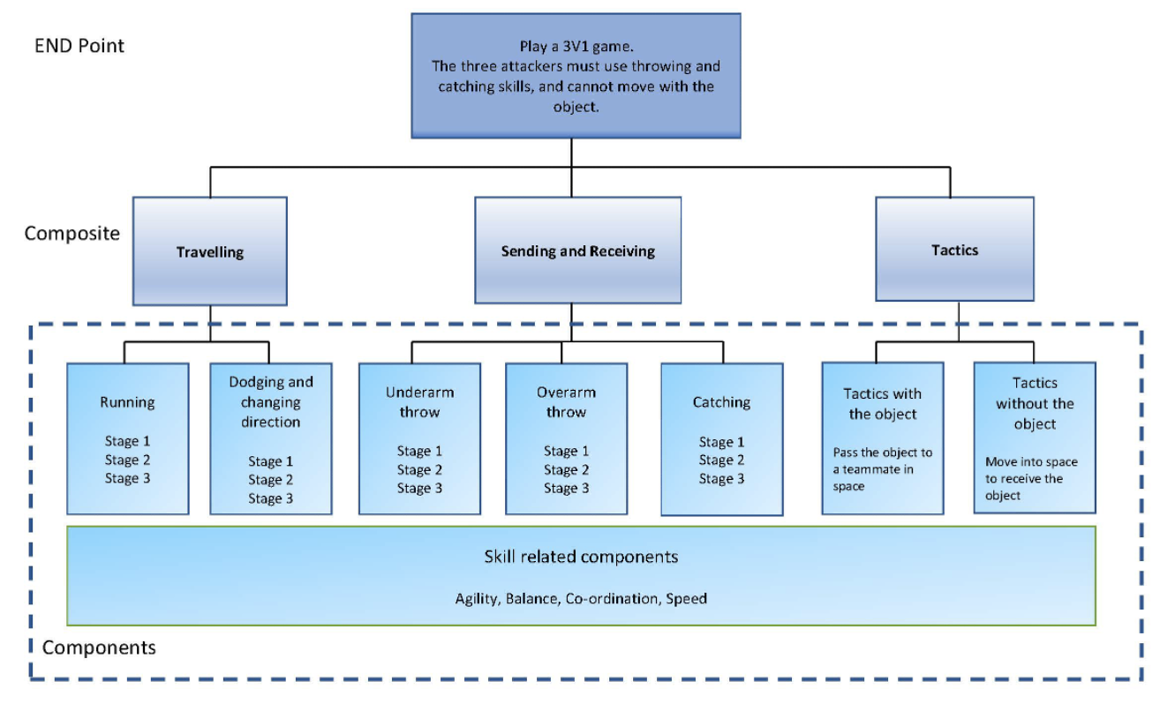

Key Stage 2
