Staff Guide to

Personal Tutoring

Personal Tutoring at Edge Hill University
This guidance for staff accompanies the student guide and is complimentary to the Personal Tutor Training materials and resources.

Contents

Preamble: Context
The Personal Tutor System Policy at Edge Hill University
Principles
Edge Hill University arrangements for Undergraduate and Postgraduate Personal Tutoring
Code of Practice for the Personal Tutoring System at Edge Hill University
The Early Intervention Model
Roles and responsibilities

Suggestions for Delivery
Overview of Support
Additional Sources of Support

Preamble: Context

This Personal Tutoring System at Edge Hill University is aimed at addressing its form and function in relation to recent student data trends at the University, risks, and expectations embodied within the regulatory functions of the Office for Students (OfS).

Fundamentally, we are committed to providing the highest quality student experience, support and success and will continue to do so. It is the right thing to do.

The current policy and regulatory environment and core messages in the recent consultation on the B Conditions, TEF and student outcomes measures each provide us with the opportunity to reflect on the efficacy of current policy and practices and how they may be enhanced. Important, contemporary, considerations and challenges related to the above include:

Current trends in retention and completion data, graduate outcomes data and resulting PROCEED measures (our current vulnerabilities lie in areas of retention after year 1, completion of programmes and progression to graduate level employment or further study)

The next iteration of the NSS and the focus on the student experience as an ‘Aspect’ of the emerging reiteration of the TEF (with particular focus on student voice, personalisation, teaching and support, sense of belonging and communications)

The aim is to retain TEF Gold status, which will be dependent on success on the above measures

The importance of avoiding intervention by the OfS regulator and any potential reputational damage

These are arguably aligned towards ensuring the best possible student experience and success, which is what we value. Irrespective of the policy climate, we can use this review point as an opportunity for further enhancements.

The intention of this policy is to focus on principles related to ‘what works’ not to offer an absolute prescription. In this way, compliance will ensure that diversity of UG, PG, PT and CPD provision is recognised.

Whilst the suggestions for revision of the policy appear demanding, our current data sets on students’ retention, satisfaction and progression indicate that we need to be very focused in our approaches if we are to make the improvements that are necessary. We need to maintain ourselves, deservedly, as a highly successful university with a positive, externally recognised brand.

It follows that excellence in teaching, learning, student support and success result in optimised retention, progression, and subsequent reputational growth; recruitment is enhanced, and we progress in a virtuous cycle of development. The significance for the TESOF and OfS B conditions is thus quite obvious.

The Personal Tutor System Policy at Edge Hill University
Edge Hill University is committed to high quality guidance and support for all students. This consists of central support through Student and Learning Services, support from academic staff through teaching and assessment and through the role and functions of Personal Tutors.

Personal Tutoring is to sit within an architecture of wider support and occurring at appropriate frequency as to ensure that the policy is enacted.
The role of the Personal Tutor is of primary importance and represents a ‘stable point of reference’ and an ‘anchor’ for students during their university experience. The role is key to successful transition into Higher Education and throughout their programme of study to graduation, employment, or further study. The role is acknowledged to be influential in enhancing the student experience, supporting the process of induction, positively impacting on a sense of belonging, retention, achievement, and satisfaction.
Personal Tutoring should be inclusive, providing ongoing support and challenge with academic, social, and pastoral issues, acting as a principal point for referral and communication with the wider University community.
Personal Tutors are thus central to aspects of academic and pastoral support and guidance and are a key interface with central services for students. They should be the point of regular contact for students within an organised system in departments/areas within each Faculty.
As such, Edge Hill University will provide a well-planned, high quality, monitored, and evaluated Personal Tutor system which impacts upon:
- Students’ sense of personal belonging
- Cohort identity, and personal development
- Academic success
- Health and wellbeing
- Career aspirations, personal/professional development, employability, and positive graduate outcomes
All students will be expected to participate in planned, scheduled, engagements with tutors as part of taking responsibility for their own learning, to complement their attendance at timetabled teaching sessions. This will be delivered to a schedule determined by the department to ensure that the principles and components below can be fully attended to, and a high-quality experience ensured.

Principles
The Personal Tutor system is a fundamental element of a network of support services and is underpinned by the following:
- Respect for every student as an active learner and an individual with personal learning needs
- Commitment to a sense of belonging, cohort identity, individual and group development
- Focus on Monitoring of students’ academic, pastoral, and personal/professional development using appropriate data
- Focus on general wellbeing
- Provision of support from highly trained tutors with triage to expert specialist services
- Support for induction of students into the academic community and their transition through academic study, towards positive graduate outcomes
- Recognition of the importance of equality of opportunity, diversity, and inclusion
- A shared responsibility for each student’s learning, development, and achievement

Edge Hill University Undergraduate Personal Tutoring will comprise of the following components:

- All students having a named, fully trained, Personal Tutor (assigned during the pre-arrival phase and/or induction week). Students will be given the name and contact details of their personal tutor, whenever possible in advance of arrival, at the beginning of a new academic year and be provided with an opportunity to meet their tutor in a group session during the first week, and to meet on an individual (one-to-one) basis within two weeks of starting University
- The expectation that students should attend all Personal Tutor sessions scheduled
- Retain the same person throughout the programme of study (although changes may be necessary/unavoidable and in this instance will be clearly communicated)
- Scheduled group sessions at regular intervals throughout the academic year
- Sessions will have a planned focus on aspects that might include academic, social, pastoral and group support and eliciting feedback from students (‘Student Voice’). Individual support may be made available in the latter part of each session if needed
- Individual tutorials in addition to, and to compliment group sessions. These should occur a minimum of 1 per semester/teaching block (or as required/requested). It is expected that, in most cases, this minimum frequency will be exceeded. The frequency and its fitness for purpose will be a key aspect of validation and review
- Tutors having access to appropriate monitoring data for the student cohort and individuals (including attendance at teaching and Personal Tutor sessions; assessment data; online engagement analytics; referrals to central services with appropriate notes to inform individual, personalised sessions). This may be achieved in collaboration with departmental administrators
- Fully trained tutors, conversant with the services that are available within the University and the processes and procedures relevant to progression and specialised support – academic, professional, and pastoral
- Respect for the student's right to confidentiality, only disclosing information with the student’s consent or if the student presents as ‘at risk’ of harm to self or others or raises professional concern, in line with university policies
- Write references if appropriate
- Personal Tutor support for student engagement with an online portfolio, including evidencing employability, graduate outcomes, and career readiness. This will be in collaboration with a designated Careers Advisors in each department
- A Code of Practice for staff and students (see appendix)
- Consideration of Personal Tutoring as a legitimate part of Peer Observation, as a developmental approach and a way of surfacing best practices for dissemination
- Recognition of specific excellence in Personal Tutoring incorporated into the University Learning and Teaching Fellowship. This will include those from specialist support services demonstrating excellence
- Annual review within faculties, with formal reporting to the Student Experience Sub-committee, to promote enhancements and surface best practices for dissemination through the Centre for Learning and Teaching

Postgraduate and CPD Students

Given the nature of these students and acknowledging that such study can be at whole programme or at module level, such as in accredited CPD, the following are the key expectations of personal tutoring:

All students will have a named Personal Tutor, which may the module leader in certain CPD contexts. The functions of support, monitoring and triage to services will be similar to that of provision for undergraduates.

All Personal Tutors will:
- Contact tutees to share contact details (email, extension number, availability times)
- Disseminate information regarding scheduled meetings (this will be dependent upon the course length and delivery mode so will vary across programmes)
- Remain the same person throughout the postgraduate study (although changes may be necessary/unavoidable and in this instance will be clearly communicated)
- Act as a principal contact for pastoral, professional and/ or academic concerns or advice
- Meet regularly with their tutees
- Arrange/conduct individual tutorials to provide tailored academic advice, support, and guidance as appropriate
- Arrange group tutorials where applicable and/or necessary (dependent upon the nature and duration of the course)
- Assist students with professional development
- Be fully trained and conversant with the services that are available within the University and the processes and procedures relevant to progression and specialised support – academic, professional, and pastoral
- respect the student's right to confidentiality, only disclosing information with the student’s consent or if the student presents as ‘at risk’ of harm to self or others or professional concern, in line with university policies
- write references if appropriate

Quality Management and Enhancement
Validation will include an articulation of the specific approach to Personal Tutoring, related to the expectations above, so as to acknowledge the situated contexts and variety of programmes.

Departments will produce staff/student guides for each programme, describing their local implementation of the Personal Tutor system. This will be based upon consideration of the approach approved in validation and review processes. These arrangements will be subject to annual review and considered in relation to student feedback, tutors’ reflection, and local evaluation processes. All personal tutors will undertake mandatory training and will be expected to engage in continuing staff development relevant to the Personal Tutor role. Briefings and professional development support will be coordinated through the Centre for Learning and Teaching.
Faculties will engage in the enhancement and dissemination of good practice related to the personal tutor role internally. This information will be reported to the Student Experience Sub-committee annually and used to inform the further enhancement of the Personal Tutor system, in the form of a short annual review of lessons learned and emerging good practices.

Code of Practice for the Personal Tutoring System at Edge Hill University
The Code of Practice for Personal Tutoring provides clear expectations on behalf of both the student and the Personal Tutor. A successful Personal Tutoring system is based on a shared responsibility between the student and the tutor, supported by the department/area, Faculty, and the University’s services.

It is required that:
- The system of Personal Tutoring and the role of the Personal Tutor will be clearly defined, for students, in a handbook/VLE
- It is a shared responsibility for both the student and their Personal Tutor to proactively engage with the personal tutor process and to communicate effectively
- Personal Tutors will provide general guidance on academic and support issues and will signpost or refer the student to other sources of advice and guidance
- Students will be given the name and contact details of their personal tutor, whenever possible in advance of arrival, at the beginning of a new academic year and be provided with an opportunity to meet their tutor in a group session during the first week, and to meet on an individual (one-to-one) basis within two weeks of starting University
- Continuing students will be given the name and contact details of their personal tutor and be provided with an opportunity to meet their tutor in a group session and to meet on an individual basis (one-to-one) within two weeks of enrolment
- If the Personal Tutor is absent, departments/ areas will provide an alternate/alternative point of contact and information as appropriate in a timely manner
- Personal Tutor sessions will be clearly scheduled, and this will be clearly communicated to students
- It is the student’s responsibility to attend, to participate and engage with their personal portfolio development where appropriate to their study

During the working week, the personal tutor will respond to informal emails and telephone enquiries normally within two working days. Each department will have a system in place to address urgent issues.

The Early Intervention Model
Personal tutors should be familiar with the institutional ‘Early Intervention Model’ which incorporates a new approach to the withdrawals process. They should follow the process, and procedures required by their faculty, to ensure early intervention and support for students identified at risk is timely. Any requests for withdrawal must follow the new process.
For further information please contact Lana Orr (Lana.Orr@edgehill.ac.uk)

Roles and responsibilities:

Students will:
- Ensure that the name and contact details of the Personal Tutor have been noted
- Keep in regular contact with their personal tutor and attend all scheduled meetings
- Notify their personal tutor (or departmental administrator or Programme Leader) in the event of illness or other reason for non-attendance at the University
- Notify their personal tutor where there are academic or personal/medical problems which are affecting attendance or impacting on academic progress
- Contact their personal tutor as soon as possible if performance in forthcoming examinations or assessments is going to be affected by ill health or other personal circumstances

Personal Tutors will:
- Personal Tutors will contact their personal tutees, whenever possible in advance of arrival, at the beginning of a new academic year and schedule an opportunity to meet their tutor in a group session during the first week, and to meet on an individual (one-to-one) basis within two weeks of starting University
- Provide regular, scheduled group sessions and individual sessions (with additional personal sessions on request, as appropriate)
- Provide academic advice, guidance and support and assist students with their academic development and achievement
- Support student transition
- Act as a key contact for pastoral, professional and/ or academic concerns or advice
- Point students towards other sources of more specialist support – academic, professional, and pastoral
- Facilitate personal/professional development and achievement as part of a structured process (including a portfolio in UG provision)
- Be trained and fully conversant with the services that are available within the University and the processes and procedures relevant to student progression and support
- Respect for the student's right to confidentiality, only disclosing information with the student’s consent or if the student presents as ‘at risk’ of harm to self or others or raises professional concern, in line with university policies
- Provide contact details (e-mail address, extension number, availability)

Personal Tutoring: Faculty requirements
Faculties will determine their own specific processes for the operation of personal tutoring. This will be agreed in preparation for validation of curricula. As a minimum Faculties must:

- Have an agreed schedule for personal tutoring that is consistent across programmes that includes when and how tutors are allocated
- Retain a register of staff in Personal Tutoring roles and a record of their training
- At departmental level regularly review distribution of personal tutors to maintain appropriate and manageable allocation
- Have a clear process for the reallocation of personal tutees in instances of staff illness or departure
- Signpost and refer staff (via line managers) to mandatory personal tutor training sessions to ensure that all staff have completed mandatory training
- Have systems for capturing feedback on personal tutoring and reporting these to HoDs, with a particular focus on good practice and dissemination
- Have mechanisms for reporting generic and specific professional development needs for action by the CLT that will feed into the personal training sessions provided
- Ensure that the approach to Personal Tutoring is clearly articulated in validation and review.

Suggestions for delivery
The Personal Tutoring policy at Edge Hill University has been designed specifically to be flexible to accommodate the needs of all programmes of study.
Working within the spirit of the Personal Tutoring policy areas and departments should design and be explicit in communicating their distinct (bespoke) arrangements to both their staff and their students.
This model is offered as an aid to help areas and department in their preparations. It is not exhaustive and serves to offers indicative timings and potential topics based on a traditional undergraduate 3-year mode of study team may find useful in developing their bespoke offer.

Year One
Students should have no less than the minimum number of meetings as specified within the Personal Tutoring policy
This table provides a guide of when those meetings may take place and the type of topics you may discuss

Agenda: During first week
During first week students must be provided with an opportunity to meet their tutor. This may take the form of a group tutorial where general expectations can be shared, and the first formal one-to-one meeting can be arranged
Individual meeting - suggested 20 minutes Group meetings – suggested 60 minutes

Year One: Semester 1: By the end of First Week
Agenda | Resources and Prompts
Confirmation of contact details (staff and students), office whereabouts, email, phone number, and availability
Staff Guide: The Role of the Personal Tutor | Student Personal Tutoring Guide
Ground rules: be explicit, share clear expectations, share group tutorial dates and schedule of individual meetings | Share specific area/department arrangements and processes
Attendance and engagement | Share student timetable and attendance information and expectations (if appropriate)
University Life:  Information about your area/department  Library and Learning Services  Student Services  Careers | Student’s charter  Key signposting page: Catalyst - Edge Hill University  Student Union Overview of support  Careers: www.ehu.ac.uk/graduates  Supporting Staff to Support Students Toolkit: www.ehu.ac.uk/sssstoolkits

Year One: Semester 1: By the end of Week 4
Agenda | Resources and Prompts
Settling in; access to services | Re-share (re-signpost) relevant resources e.g., student services, learning services, IT
Sharing students’ self-expectations (e.g., degree classification; employability) | PDP, portfolio; self-assessment tools; Maximising the development of graduate attributes through employability; Part-time work and/or volunteering; Signpost and encourage early contact with Careers: www.ehu.ac.uk/graduates
Assessment processes and support (e.g., Turnitin, late submissions, EMC policy) | Departmental arrangements. Share (signpost to) Handbooks, marking criteria, Study Support and Learning Services workshops.
Evaluating the student experience | Departmental arrangements for module and programme evaluation, procedures and processes, Course rep role and activity, share/signpost links to evaluations (e.g., NSS).

Year One: Semester 2: By the end of Week 9
Agenda | Resources and Prompts
- Academic progress and performance  - Experience of assessment  - Attendance and engagement.  - Employability – personal capital  - Transition to year 2 – action planning  - Employability  - Learning and support services helping students to continue with their studies | - Projected academic profile; tracking; referrals; signpost wider support  - Handbook; marking criteria; previous assessment feedback  - Update on progress – action planning; careers; PDP, volunteering; work experience  - Dates of Transition events; Module choice – link to Academic registry; Student’s action plan  - SU website  - Supporting Staff to Support Students Toolkit: www.ehu.ac.uk/sssstoolkits  - Key signposting page: Catalyst - Edge Hill University  - Encourage early contact with Careers: www.ehu.ac.uk/graduates

Year Two
Students should have no less than the minimum number of meetings as specified within the Personal Tutoring policy
This table provides a guide of when those meetings may take place and the type of topics you may discuss

Year Two: Semester 1: By the end of Week 5
Agenda | Resources and Prompts
Welcome back  - Action plan – share performance objectives, expectations, attendance and engagement  - Discuss Degree Classification, Assessment process – levelness  - Employability – personal capital  - Evaluation – module/SSCF/ISS  - Learning and Support Services: Helping students to continue with their studies | - Review of year 1 performance; tracking data – results; feedback  - Marking criteria; classification profiles; links  - CV; departmental employment strategies; extracurricular activities  - PDP: Graduate attributes workbook on Pebble Pad and ask students to reflect on their levels of confidence. Add in link to Pebble Pad https://v3.pebblepad.co.uk/login/Login/ChooseInstall  - Ask what their career goal is (set at enrolment) and discuss how to achieve this, refer to careers for additional support as appropriate.  - Encourage contact with careers via: www.ehu.ac.uk/graduates  - SU website  - Supporting Staff to Support Students Toolkit: www.ehu.ac.uk/sssstoolkits  - Key signposting page: Catalyst - Edge Hill University

Year Two: Semester 2: By the end of Week 9
Agenda | Resources and Prompts
- Academic progress, attendance and engagement.  - Employability – personal capital  - Transition to year 3 – action planning | - Semester 1 assessment feedback; student profile tracking  - Update on progress – action planning; careers; PDP (Please see year Two: Semester 1 for prompts and links)  - Dates of Transition events; Module choice – link to Academic registry; Student’s action plan – summer plan; reading lists/work

Year Three
Students should have no less than the minimum number of meetings as specified within the Personal Tutoring policy
This table provides a guide of when those meetings may take place and the type of topics you may discuss

Year Three: Semester 1: By the end of Week 5
Agenda | Resources and Prompts
- Welcome back; Action plan - performance objectives; expectations; attendance and engagement  - Degree Classification; Assessment process – levelness  - Employability – personal capital  - Evaluation – module/SSCF/NSS  - Learning and Support Services: Helping students to continue with their studies | - Review of year 1 performance; tracking data – results; feedback  - Marking criteria; classification profiles; links  - Departmental/ area programme evaluation (e.g., SSCF and the NSS)  - Encourage students to update their PERSONAL email, phone, address and contact details on SID Admin for their graduation information and to access on-going Careers support.  - PDP: Encourage students to update their CV; access departmental employment strategies; extracurricular activities; job applications – references etc…  - PDP: Graduate attributes workbook on Pebble Pad and ask students to reflect on their levels of confidence. Add in link to Pebble Pad https://v3.pebblepad.co.uk/login/Login/ChooseInstall  - Ask what their career goal is (set at enrolment) and discuss how to achieve this, refer to careers for additional support as appropriate.  - Bespoke direction from department  - Supporting Staff to Support Students Toolkit: www.ehu.ac.uk/sssstoolkits and key signposting page: Catalyst - Edge Hill University

Year Three: Semester 2: By the end of Week 9
Agenda | Resources and Prompts
- Academic progress; attendance and engagement.  - Employability – personal capital  - Transition – postgraduate | - Semester 1 assessment feedback; student profile tracking  - Update on progress – action planning, CV and PDP  - Career: Students to register with the alumni network to keep in touch and get support from the alumni community by joining Edge Hill Connect www.edgehillconnect.co.uk They can continue to access EHU resources such as the library which is free of charge, get support through Careers for three years after graduation, and might be eligible for fee remissions on some further study. More information can be found at www.edgehill.ac.uk/alumni  - Final exit interview: capture graduate destination or contact careers /direct the student to access bespoke careers support

Overview of University Support
For use by both staff and students we have created two guides with interactive links to all of the University support services.
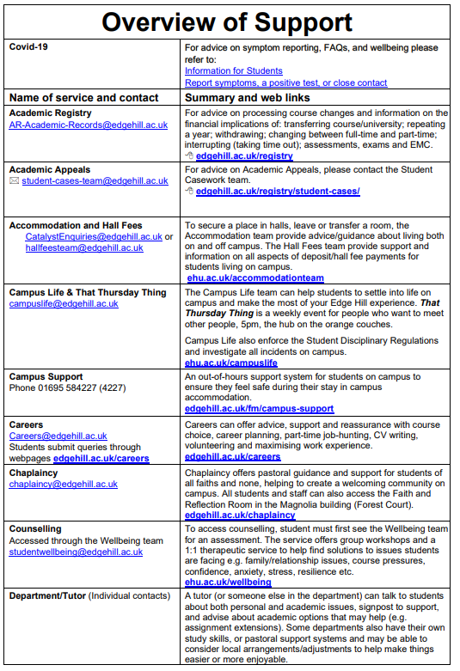
To view these guides in full:
Overview of University Support: doi.org/10.25416/NTR.16652050
Student Union: doi.org/10.25416/NTR.19947800

Direct links to all of these services can also be accessed via the Student Homepage. A tab to these links is also available via BB/VLE.
If appropriate you may present directly, in person at the Catalyst Building (Ormskirk campus).

Supporting Staff to Support Students
The Supporting Staff to Support Students online toolkits provide guidance for staff on how to support students with a range of different issues including mental health, dealing with sexual assault disclosures and disability and inclusion. The aim of the toolkits is to help staff to support students at Edge Hill University and to provide a single resource which can be used by all university staff to increase knowledge, understanding and confidence, in order to help students, maximise their academic potential.

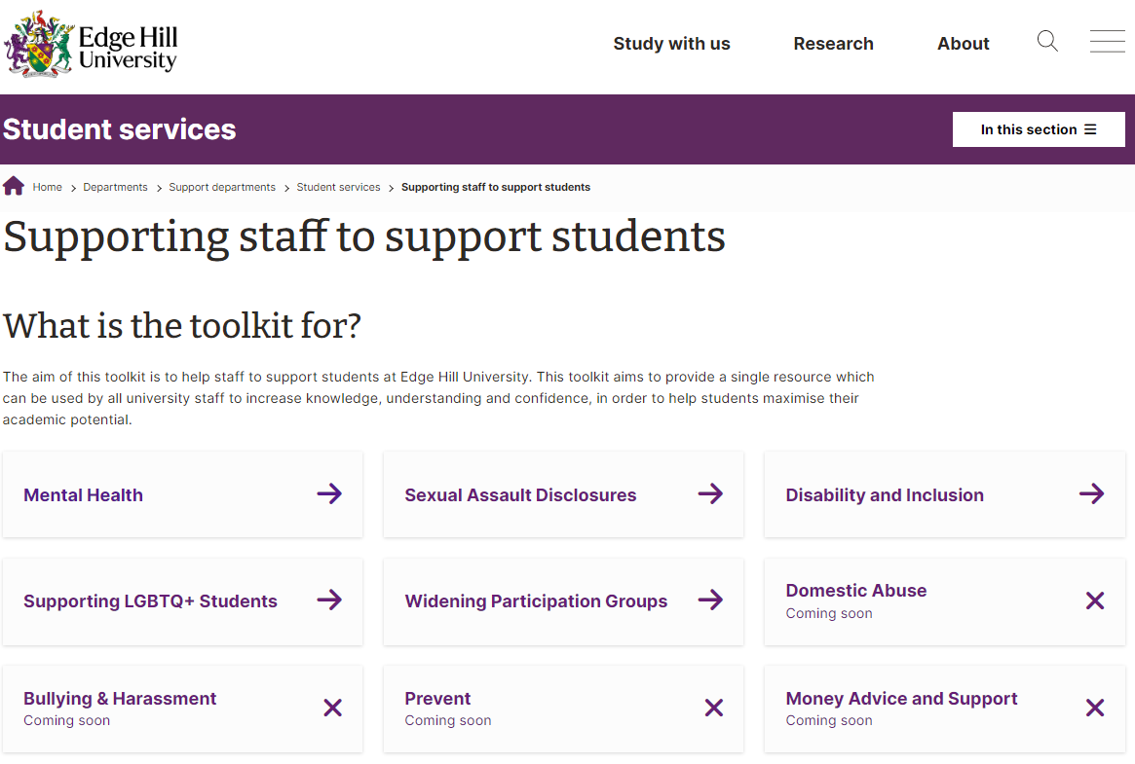

You can access the toolkit here: www.ehu.ac.uk/sssstoolkits

Support and Guidance for Personal Tutors
In addition to following advice and guidance in this booklet, one of the best ways to prepare for the role of Personal Tutor is to talk to your colleagues. They have a wealth of information and advice to help you smoothly integrate into the role so that both you and your students will enjoy and get the most out of the experience.

Helping students in difficulty
While a large part of your role as a Personal Tutor will be concerned with the overall wellbeing and development of your tutees, there will be times when some of them will experience difficulty. The better the relationship you build with your tutees, the earlier and more comfortable they will feel approaching you if they do run into problems. However, it is important for tutors to know the boundaries and as such be aware of and know the referral points to access help and support from other referral services for themselves and in order to effectively support their tutees.

Common Problems
While much of a Personal Tutor’s job is reactive and cannot be prescribed in terms of preconceived tasks, there are certain problems that are fairly common. We have identified some of these problems and offer some advice on how they might be tackled:

Students who are demanding of your time
If a student demands a lot of your time this could signal an underlying problem that needs to be explored. Try to get to the heart of that issue so that you can work through a solution or direct them to someone better able to help them. You do need to be firm with your students and make clear what they can reasonably expect from you. Set clear expectations from the start and utilise the student support available (please see the overview of support sheet) as appropriate. Signpost them to student services for additional support if appropriate.

Students who are upset or crying
The best way you can help students who are upset is to provide them with a private space, be friendly and listen to them. It is often a good idea to arrange a follow up meeting soon after to check that they are ok and so they know someone cares. As appropriate during this meeting you could explore further what it is that has upset them and move onto discuss, as appropriate, utilising the student support services, ongoing support. Signpost them to student services for additional support if appropriate.

Specialist Support for Personal Tutors
Edge Hill University has a network of institutional colleagues in place to support Personal Tutors and look after their wellbeing in addition to that of their students. It is important to note that, having dealt effectively with a significant personal issue with a student, the Personal Tutor may indeed need support for themselves. This may be particularly relevant when managing situations linked to significant mental health issues. It is important to note that, whilst each Faculty may well have a relevant colleague who is available to discuss the issue with, the following services are also there to help.

Additional Resources and Support
The current version of this guidance, along with guidance for students and Personal Tutoring materials can always be accessed here:

Policy: https://doi.org/10.25416/edgehill.12619148
Staff Guide: https://doi.org/10.25416/edgehill.12592178
Student Guide: https://doi.org/10.25416/edgehill.12594185
Training materials: https://doi.org/10.25416/edgehill.12594152

For details of scheduled staff development workshops: https://www.edgehill.ac.uk/departments/support/clt/
Or to arrange bespoke training and development for your team please email: clt@edgehill.ac.uk

External Resource
UKAT Resource: United Kingdom Advising and Tutoring Association
https://www.ukat.uk/media/1465/top-10-tips-for-personal-tutoring-at-a-distance.pdf

