Initial Teacher Education Partnership Handbook

Date published | Sept 2023
Review date | Sept 2024

Table of Contents
Contents
1 Vision 3
2 The Edge Hill University ITE Curriculum 4
3. Rationale 6
4 Trainee Entitlement and Responsibilities 7
4.1 Safeguarding 8
4.2 Contacting the Placement School/Setting 9
4.3 Recording the Evidence of Progression 9
5) Mentor Role and Responsibilities 10
5.1) Inducting the Trainee 10
5.2) Monitoring the Trainees’ Progress and Achievement 10
6) Lead Link Tutor/Link Tutor Roles and Responsibilities 13
6.1) Developing the Mentor 16
6.2 Quality Assurance of Assessment 16
7 Organisation and Management of the Partnership 18
7.1 Partnership Governance 18
7.2 Partnership Resources and Funding 21
7.3 Partnership Selection and Deselection 21
7.3.1 Selection 21
7.3.2 Deselection 22
7.3.3 Adverse Inspection 23
8 Equality and Diversity 24
8.1 Partnership Development Officers 25
Quality Assurance of Placement 25
8.1.1 Liaison, Training and Support 25
8.1.2 Arranging the Placements 25
8.1.3 Accommodation Assistance 25
8.1.4 Distance Placements 26
8.1.5 Duty of Care 26
8.1.6 Prevent Duty 26
8.1.7 Religious Observance 26
8.1.8 Health Concerns 27
9 Professional Practice Provision 28
9.1 Professional Practice Phases 28
9.2 Process During Professional Practice 29
10 Mentor Development and Support 33
11 Summary List of Key Documents and Forms 37
11.1.1 EHU ITE PROFESSIONAL PRACTICE INFORMATION AND DOCUMENTS (INCLUDING PP FORMS) 37
11.1.2 Further Education and Skills 37

VISION

The Faculty is focused on advancing the discipline and practice of education achieved through, and measured by, high quality teaching and research and through its support for schools and colleges in collaborative research and training partnerships.

Our vision is of producing graduates and professionals who are capable, reflective, and ethical practitioners distinguished by their intellectual engagement, professional acumen, and commitment to the communities in which they work.

We are committed to supporting and progressing research practice and scholarly output that is recognised for its originality and impact and in providing an intellectual and physical environment that promotes and challenges public debate on professional practice and on educational policy.

The Edge Hill University ITE Curriculum

Our EHU ambitious curriculum exceeds the full entitlement described in the ITT Core Content Framework as a baseline and is designed around the three faculty pillars of:

1. Personal and professional attitudes, values, and beliefs.
2. Subject and curriculum knowledge.
3. The craft of teaching and pedagogy.

These faculty pillars are informed by our philosophy of education, created, and enhanced further when our partnership and our students are engaged in an ethos of debate, research and educational curiosity based on reflection and professional enquiry.

This ambitious ITE curriculum includes our values of social justice, inclusion, learning outside the classroom and sustainability as key features to support our local and national communities. For those training to teach in the FES sector, the curriculum is aligned to the ETF Professional Standards (2022) and the Minimum Core (2022).

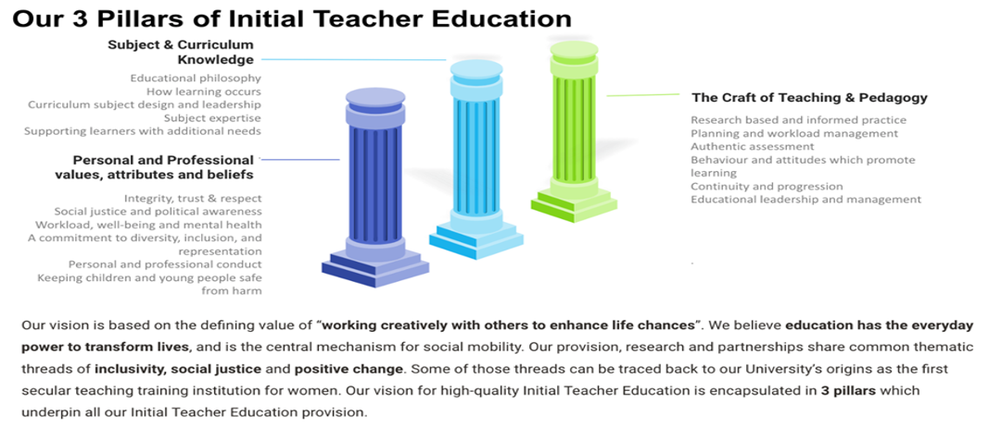

IMPACT
Our curriculum provides trainees with the skills to engage, motivate and inspire learners across the teaching profession. The training equips trainees with the depth of knowledge, skills and understanding required to become an ambitious teacher able to teach in a diverse range of settings and age phases.

In designing our curricula, we have together, carefully crafted the experiences and activities trainees will undertake at university alongside their setting-based training into a coherent sequence that draws upon the expertise of our partnership and supports trainees to succeed in the classroom. We have encompassed the full entitlement described in the ITT Core Content Framework, as well as integrating additional analysis and critique of theory, research, and expert practice. The ITE curriculum for each course detailing specific university and placement-based components content and delivery can be accessed on the Mentor Space.

CORE CONTENT FRAMEWORK
The ITT Core Content Framework (CCF) (DfE 2019) sets out a minimum entitlement for trainee teachers and places a duty on providers of initial teacher training – and their partner schools – to meet this entitlement. The CCF has been designed to support development across 5 core areas –behaviour management (TS1 & TS7), pedagogy (TS2, TS4, TS5), curriculum (TS3), assessment (TS6) and professional behaviours (TS8 as well as Pt2). Within each area, key evidence statements – Learn that… have been drawn from current high-quality evidence from the UK and overseas. These are then accompanied by practice statements – Learn how to… these are categorised into two groups; the entitlement to practise key skills as well as an opportunity to work with and learn from expert colleagues as they apply their knowledge and understanding of the evidence in the classroom. There is a key emphasis in the knowledge that the quality of teaching is the most important factor in improving outcomes for pupils – particularly pupils from disadvantaged backgrounds and those with additional needs. To accompany and secure high quality teaching there is an emphasis on ensuring that trainee teachers have access to training and support for behaviour management. There is a strong emphasis on the need for training to be subject and phase specific throughout the framework. For those teaching early reading and early mathematics, they are required to have a clear understanding of systematic synthetic phonics and appropriate maths teaching strategies.
The Core Content Framework can be accessed here

EDUCATION AND TRAINING FOUNDATION (ETF) PROFESSIONAL STANDARDS
Trainees training to teach in the FE phase are not recommended for QTS at the end of their course, instead their course enables them to embark on the QTLS process once they are employed in post. Accordingly, the design of their course enables them to amass 100 solo teaching hours in their subject and 8 lesson observations. Their curriculum is informed by the ETF Professional Standards (2022), the Minimum Core (2022), and the ITT CCF evidence base.

ADMISSIONS POLICY FOR INITIAL TEACHER EDUCATION PROGRAMMES
The admissions procedure provides an excellent way for colleagues across the ITE Partnership to collaborate in the shared exercise of recruiting and selecting the very best trainees for our partnership. A summary of our recruitment policy is as follows:

- The process for admissions is co-ordinated by the university but relies on setting representatives and their involvement.
- Any changes to policies and procedures are agreed at Strategic Partnership Board and discussed at admissions tutor training sessions or departmental meetings.
- Bespoke inductions will be provided for admissions tutors new to the process. We ask settings to nominate colleagues who can take part in this process.
- Interviews are completed on a weekly basis by the university.
- Candidates are selected on the basis of their potential to teach based on our selection criteria and compliance checks including DBS.

RATIONALE

This partnership handbook has been written in consultation and collaboration with our partnership, the Faculty leaders and tutors, professional practice leaders, mentors, and trainees. Additionally, key documents regarding trainees’ support and guidance through the initial teacher training (ITT) and early career teacher (ECT) period have been referred to, for example; Initial teacher training (ITT): core content framework (CCF), Early career framework (ECF) and National Standards for school-based initial teacher training (ITT) mentors. As a Higher Education provider, we are also regulated by the Office for Students (OfS) and are therefore complaint with their Conditions of Regulation pertaining to quality of provision and student experience.
The aim of this handbook is to clearly set out the roles and responsibilities of all stakeholders in providing:

- High-quality trainee support and guidance
- High-quality mentoring
- Rigorous and robust quality assurance (QA) of assessment and the mentoring process
- Rigorous and robust QA of the placement processes
- Equity between the programmes and across the departments
- Consistency in process, procedures, and documentation across the partnership.

This handbook supports trainees, mentors, and link tutors to achieve the high standards and expectations held for Edge Hill University ITE provision. It acts to provide supplementary guidance to the Partnership Agreement.

At Edge Hill University Initial Teacher Education (ITE) Partnership, we believe professional practice mentors at schools and settings play a crucial role in developing the trainees’ knowledge, understanding and skills in teaching, as well as preparing them for their future careers in a variety of educational settings. Similarly, our link tutors (LTs) and lead mentors (LM) play an important role by quality assuring the trainees’ ongoing formative and summative assessments. During the professional practice (PP), at schools and/or settings, it is fundamental that trainees learn how educational theory relates to practice. Working collaboratively, school-based mentors and centre-based tutors make deliberate connections and ensure the trainees receive an integrated curriculum and are well prepared for the realities of teaching.

We provide our trainees with a 3-phase professional practice experience namely, introductory, developmental, and consolidation phases. In accordance with the compliance criteria set out by the Department for Education (DfE), the PP experience is offered as 120 days in design. For those training to teach in the FE sector, the PP experience affords trainees opportunity to amass 100 teaching hours and 8 lesson observations as per the requirement for the QTLS process. Expectations at these phases increase progressively and the trainees are informed about them within PP lectures, PP Curriculum Handbooks /Plans as well as through LTs and personal academic tutors (PATs) prior to the placements. LTs, mentors and trainees meet at four quality assurance points for different purposes; 1) Initial meeting 2) Week 2 check in and QA of first Weekly Development Summary 3) Progress meeting and 4) End of placement meeting which are explained in detail in section 5. These timescales and activities differ across the phases considering the unique nature of the phase and the placement pattern in place.

PLACEMENT ALLOCATION PROCESS
This placement allocation process demonstrates how compliance is checked and quality assured at multiple points throughout training. We gather information from each trainee about their personal circumstances on the student allocation profile, we use this information together with previous professional practice in schools to ensure compliance and breadth of experience. We allocate to appropriate schools using our rigorous quality assurance processes, see section 8.1.

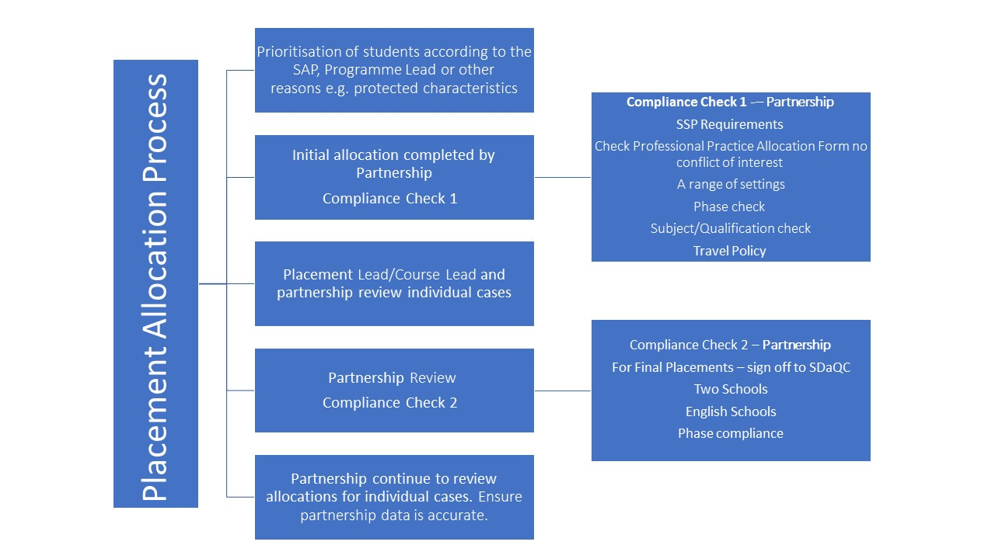

TRAINEE ENTITLEMENT AND RESPONSIBILITIES

Edge Hill University ITE trainees are provided with high-quality mentoring and supervision from their mentors and Link Tutors. Within the minimum entitlement of the ITT core content framework (CCF), trainees at all phases are entitled to receiving clear, consistent and effective mentoring and structured feedback from their mentor, expert colleagues and their link tutor.

Throughout the professional practice, trainees are supported by their allocated mentor at school and/or setting and by their link tutor at the university centre. Additionally, trainees are encouraged to communicate with their personal academic tutors (PATs) and to draw upon further support when needed. PATs provide guidance as appropriate and signpost trainees to wider university support services, resources, and facilities.

Trainees are expected to attend PP information lectures and make suitable preparations before a placement starts. They are provided with a Professional Practice handbook which explains the expectations and roles and provides in depth information about the curriculum and professional practice processes. Professional practice information, guidelines, handbooks, documents and forms are published on the Mentor Space, and it is the trainees’ responsibility to make themselves familiar with them as soon as possible. Additionally, trainees are required to upload the weekly development summary (WDS) forms, the final weekly development summary on our Faculty placement management system ‘InPlace’ within the given timescale. Trainees can seek further guidance from their link tutor, mentor, and PAT as they progress through the curriculum and to understand the process for obtaining QTS or QTLS for those training to teach in the FET phase.

Throughout PP, trainees should refer to the ITE curriculum to improve their subject/specialism knowledge and understanding, as well as reading academic and up-to-date and pertinent research papers suggested by their tutors/mentors/LTs from their reading lists. It is the trainees’ responsibility to make themselves familiar with the curriculum which includes National Curriculum, religious education, age-appropriate relationships and sex education and as appropriate, the Statutory Curriculum for the Early Years Foundation Stage. They should also be familiar with the EHU ITE curriculum, and key official documents such as the ITT Core Content Framework and the National standards for school-based initial teacher training (ITT) mentors.

Further Education trainees should make themselves familiar with the Education and Training Foundation (ETF), Professional Standards and understand the process of being recommended for Qualified Teacher Learning and Skills (QTLS) status. They should refer to ETF Guide for Mentees to understand what to expect from the mentoring process and their mentor.

We expect our trainees to demonstrate consistently high standards of personal and professional conduct while studying our programmes. Trainees are required to adhere to the EHU ITE Code of Conduct (See Appendix A) at all times and in partnership settings.

There are three main responsibilities of the trainees for professional practice prior to practice commencing;
- safeguarding,
- contacting the school
- recording information and progression evidence.

SAFEGUARDING

The University has ensured that every trainee enrolled on an Initial Teacher Education programme will have:

- completed an application form.
- completed a declaration of health questionnaire (in order to meet the DfE's standard for physical and mental fitness to teach).
- had references checked.
- been interviewed.
- the necessary qualifications
- had an enhanced DBS check, including a check of the children’s barred list and a prohibition order check, and where the applicant has lived outside of the UK, provided a DBS check from the country, or provided a good conduct reference.
- If there are any issues that occur from DBS applications, a DBS panel is convened to consider issues raised on the DBS, which includes an Associate Dean, Departmental colleagues, and an external partner, usually a Headteacher. Once a decision is made this is communicated to student of whether they can proceed on course or not.

Before commencing professional practice, all trainees must complete compulsory safeguarding provided by the Children’s Safeguarding Assurance Partnership (CSAP) at: https://blackburn.melearning.university/course_centre alongside reading and understanding the DfE Guidance: Keeping Children Safe in Education (Part 1), What to do if you’re worried a child is being abused and the, The Statutory Framework for the Early Years Foundation Stage. They should also complete and pass the university safeguarding and Prevent online training modules.

All our partnership settings are expected to provide trainees with an induction, this will include:
    - information about their local safeguarding and child protection procedures
    - Understanding how to report a safeguarding concern.
    - Identifying the settings Designated Safeguarding Lead and sharing their contact details.
    - reference to relevant document and policies including:
        - Local online Safety Policy
        - the setting’s child protection/safeguarding policy
        - the setting’s staff behaviour policy (sometimes called a code of conduct)
        - the setting’s whistleblowing policy
        - Children missing from education policy.

Further information for trainees including additional resources can be found in the FoE Safeguarding Guidance for Trainees 2023-24 in “Learning Edge”.

Any questions of concerns around Safeguarding should be directed to:

Faculty of Education
Leon Fraser (Faculty Senior Lead for Safeguarding) fraserl@edgehill.ac.uk
01695 584314 or 07738801725

Kate Burrell (Designated Safeguarding Officer) burrellk@edgehill.ac.uk
01695 657920

If you are unable to contact a DSO in the Faculty you can use the contact details for other staff at the University as listed online here.

Prior to attending professional practice, trainees must obtain their Enhanced Disclosure and Barring Service (DBS) check letter from Edge Hill University and take this to their school/ setting along with a photo ID. The DBS check letter is provided by the university and trainees can access this via InPlace. Trainees may be asked to produce their DBS certificate by the partner setting, although should they choose to refuse, the placement may be withdrawn by the setting.

CONTACTING THE PLACEMENT SCHOOL/SETTING
Trainees contact their placement school and introduce themselves as soon as they are informed of the allocation. They send their trainee profile with a photo to their mentor prior to starting the placement. In providing the best opportunities for success, it is expected that trainees visit the schools’/settings’ website and find out about their vision and values, key information, and current events. They should familiarise themselves with local and regional educational priorities such as learners with SEND, learners eligible for free school meals (FSM) and safeguarding matters. Trainees must inform the school/setting, LT, and PAT tutor on the first and subsequent days of absence and LTs inform professional practice quality leaders or Course Leaders who track absence. For significant absences a DPM is arranged to address suitability to continue with the placement or requirements to extend the placement. At the end of a placement the trainee submits an attendance record to InPlace. Secondary and FET trainees are expected to familiarise themselves with any planning documents (such as available Schemes of Work or examination specifications) prior to placement.

RECORDING THE EVIDENCE OF PROGRESSION
Trainees collate the evidence of their professional progression throughout all three phases of development. Every week, after the WDS meeting, trainees upload their WDS forms and any accompanying lesson observation forms on InPlace within the week for the LT to review. Similarly, the final WDS is uploaded on InPlace by trainees after the end of placement meeting. This will include, for example a summary of feedback towards development targets, progress through the ITE curriculum, trainee strategies for workload and wellbeing and future practice development targets. This is a key document which will be discussed at QA Review point 4 with the mentor, link tutor and trainee. It will feedforward to inform the trainee progress and targets, including the review during Professional Reflective (exit) Viva (PRV) at the end of the programme.

MENTOR ROLE AND RESPONSIBILITIES

ITE Partnership Mentors provide high-quality mentoring to our trainees during the professional practice. Working closely with the LTs, our mentors support and guide our trainees effectively throughout their training process. Our partnership trainers and mentors are consistently skilful at drawing on the taught curriculum during their interactions with trainees, particularly during mentoring sessions and feedback following observations. Secondary and FET trainees are only placed with mentors who are specialists in the subject the trainee is training to teach.

There are three main aspects of the role of the mentor: 1- Inducting the trainees, 2- Monitoring the trainees’ progress and achievement through the curriculum, 3- Supporting the trainee.

INDUCTING THE TRAINEE
The mentors carry out meetings/sessions with the trainees to introduce them into their school’s/setting’s life/day. The expectations should be made clear at the start and the timetable should be shared with the trainees in a timely manner. Mentors should provide the trainees with access to all key documents such as the safeguarding policy, behaviour policy and teachers’ code of conduct. Additionally, mentors provide access to teaching resources such as the curriculum plans and online materials. Both mentors and trainees are provided with checklists to support them both in their induction responsibilities.

MONITORING THE TRAINEES’ PROGRESS AND ACHIEVEMENT

Mentors play a crucial role in developing trainees’ knowledge, understanding and skills to become teachers. They monitor the progress continuously through the weekly lesson observations and WDS meetings, where they provide the necessary support and guidance as to how to consolidate what has been learnt and move onto further progress. Mentors carry out their monitoring progress role in three key areas which are set out below:

Formative Assessment: Mentors assess the progress of the trainees formatively throughout the introductory, developmental, and consolidation phases. They refer to the key official documents on a weekly basis, when judging if the trainee is making appropriate progress, such as; the EHU ITE Curriculum (which covers the ITT Core Content Framework and more), The trainee teacher behavioural toolkit: a summary, our ITE curriculum communication documents, subject curriculum plans, and phase expectations as outlined in the PP curriculum handbooks. As set out below, they use a variety of sources to assess. All of these are captured in the WDS and weekly assessment tracker which provides systematic and progressive statements for the mentors to ensure consistency across placements.

- Observation of group or class teaching.
- Observation of learners’ progress and the work they produced.
- Discussions with the trainer/class teacher, LT, and PAT.
- Discussions with other adults and professionals.
- Discussion with the trainee and the learners.
- Trainee’s planning and assessment records.
- Observations of interaction with parents.
- Observations of engagement with wider professional responsibilities.
- Observation of professional conduct.

When a trainee is not making appropriate progress and is at risk of not completing the training phase successfully, mentors provide additional support and inform the Link Tutor. The mentor utilises the Progress Support Plan form and highlights the additional support provided and the actions the trainee is required to complete. If sufficient progress is not being made with regards to the area of concern after additional support, mentors can refer the case back to the Link Tutor who will follow it up with the Professional Practice Leads organise a departmental progress meeting. If at the end of the determined period, the trainee has not made sufficient progress, the AHoD reviews the situation with a view to scheduling a DPM. Here, relevant colleagues and the trainee discuss the situation and put effective systems in place to further support the trainee and, if necessary, address suitability to continue on a programme of ITE.

In all phases, a week-by-week sequential curriculum enables mentors to know what progression looks like on a weekly basis for which the trainee is training to teach. Trainee progress through the curriculum is captured in the weekly meeting in which the mentor records progress on the WDS. In addition, the form asks that mentors indicate each week if the trainee has made sufficient progress through the curriculum, if they have required additional support to make progress, or if despite additional support a Progress Support Plan should be considered. Where the mentor has identified the trainee needs additional support the Link Tutor contacts the mentor to discuss next steps and the necessary support is put in place such as a Progress Support Plan.

Written and Verbal Feedback: Mentors’ feedback is extremely important for trainees’ progression and therefore, it should be linked to the curriculum and evidence base, focused and clear. Feedback is provided in the form of a weekly lesson observation and a weekly development summary.

Using the Weekly Development Summary as a record, the trainee and the mentor review the EHU curriculum content for the week, this provides a focus and is sequenced incrementally to manage cognitive load. For Secondary mentors, the Weekly Development Summary includes questions that the mentor can use to review prior learning and assess that the student has the relevant knowledge to benefit from opportunities to practice in each week.

TARGET SETTING:
During the WD meetings, mentors clearly explain to the trainee their next steps in progression and set a maximum of 3 high-quality targets. Mentors refer to our ITE curriculum and evidence base in the Professional Placement Curriculum Handbook when setting the targets. Targets should be subject specific where appropriate, linked to the weekly curriculum and include a clear statement of what the trainee needs to focus on to improve and make progress, including what actions the trainee needs to take to improve and make progress. Targets should focus sharply on subject-specific dimensions.
Mentors are provided with exemplar and subject-specific targets to assist mentors in identifying appropriate opportunities for development via the mentor space. They may refer to the ITT Core Content Framework and supporting materials when deciding on the actions to achieve the targets and discuss this with the trainee. Trainees should be given focused and deliberately chosen opportunities to observe expert colleagues and analyse what they have seen throughout their teaching practice. Vitally, these observations should be planned and selected by the mentor as instructional opportunities or actions related to targets. This could include observation of planning or assessment for example too.

Mentors assess and monitor trainees’ progress through the curriculum continuously and help them improve their achievement by providing them with focused/clear feedback, as well as setting effective targets. They ensure verbal and written feedback are consistent and can evidence cohesive and consistent progression (or lack of it) between the lesson observation forms and weekly development summary forms.

Supporting the Trainee: This is a vital part of the mentoring role. It provides effective support for achieving the targets to address the identified development areas. It is important that the trainees receive focused feedback and guidance at their weekly development summary meetings. During the meetings, mentors refer to the targets set. They make the plan for the week ahead and how targets can be met. Below are some examples of key official documents supporting trainees to achieve their targets.

Using our ITE curriculum communication documents and subject curriculum plans mentors;

- Provide opportunities to discuss and analyse with expert colleagues how to sequence lessons and identify possible misconceptions.
- Arrange subject specific focus lessons or teaching episodes trainees can observe delivered by expert colleagues and discuss and analyse with expert colleagues how they balance exposition, repetition, practice of critical skills and knowledge.
- Provide opportunities to discuss / experience the teaching of learners with EAL and SEND.
- Provide opportunities to discuss / experience in action about how to incorporate diversity, inclusion, race, equality, and discrimination matters into their teaching.

Referring to ‘The trainee teacher behavioural toolkit: a summary’, mentors support trainees in developing effective behaviour management strategies.

TRAINEE WORKLOAD MENTAL HEALTH AND WELL-BEING
Another important part of supporting trainees is ensuring that their workload is appropriate. Referring to Addressing teacher workload in Initial Teacher Education (ITE) Advice for ITE providers document, mentors ensure the tasks required from the trainees are related to supporting learner progress or their own development. Trainees should be provided with the schools’/settings’ planning proforma, schemes of work, textbooks, and curriculum resources to plan their lessons.

Trainee and Mentor workload is explicitly addressed within mentor training and through the role of the Link Tutor. Specific strategies within Primary and Early Years placements to manage workload include, avoiding unnecessary tasks; clearly setting out increasing teaching percentages for each week of the placement; 20% Planning, Preparation and Assessment time weekly; no mandatory planning proformas, with less emphasis on EHU planning proformas as placements progress. Lesson Observations and WDS avoid repetition and provide succinct feedback and quality targets. Mentors training informs mentors about EHU wellbeing services and trainees are signposted to support and resources throughout their programme. On Secondary programmes and those related to teaching in the FE phase, suggested teaching hours are provided for each phase of the placement to ensure trainees have adequate opportunities to practise and receive feedback on what they know and can do in addition to PPA time to assist trainee's in managing their workload. Mentor training additionally includes strategies and guidance for mentors on how to support trainees with their well-being. Mentor training, the weekly curriculum, and mentor comms all include messages and resources around supporting trainees with their workload. This is reviewed weekly on the Weekly Development Summary document, asking the mentor if and how trainee wellbeing and workload has been considered.

LINK TUTOR ROLES AND RESPONSIBILITIES

ITE Partnership link tutors (LT) have a distinct role of connecting the centre-based training with the schools and settings to ensure the correct procedures are followed as set out in the respective Partnership Agreements. We have rigorous and robust quality assurance systems in our provision and both LTs and lead mentors have regard for quality assurance elements when assessing the judgments made at schools and/or settings.

For school direct, each alliance will be allocated a ‘cluster lead’. The Cluster Lead will coordinate closely with the School Direct Alliance Lead, act as Link Tutor for trainees assigned to that cluster and quality assure enhancement provision delivered across the alliance. In the Secondary phase, a named contact at the setting acts as a single point of contact for SD provision but all link tutor responsibility is retained by the centre-based Secondary Subject Tutor. An additional colleague retains QA oversight of all SD provision. An academic liaison tutor oversees all QA activity for delivery of our ITE via our franchise with Wirral Metropolitan College.

All full-time and part-time tutors and associate tutors are expected to engage with the regular LT training sessions. New members of staff receive a high-quality induction to the role of the LT. Arrangements are made for them to shadow an experienced LT conducting all QA points with the mentor and the trainee. We aim for all LTs to complete this process of induction, attend the training sessions and wherever possible, shadow an experienced LT prior to being assigned supervision.

There is an expectation that LTs communicate with the relevant colleagues regularly when carrying out their role. This includes liaising with the personal academic tutors (PATs), partnership development officers (PDOs), year/subject and programme/course leaders. They monitor the trainees’ progress weekly, ensure the trainees are set effective targets and appropriate support is planned to achieve them. And if/when problems arise, they communicate their concern to the relevant Faculty leaders immediately. In all phases, LTs have responsibility for updating the weekly tracking of trainee progression and ensuring appropriate interventions are put in place (and logged) to ensure trainee progression and/or mentor support. This process is overseen by, and quality assured by the lead mentors and AHoD.

LTs are required to check all the necessary information regarding the trainee and the placement specifics, and all guidance is available through the Mentor Space

There are three main aspects of the role of the Link Tutor:
1) Developing the mentors, 2) Quality assuring the mentoring process and assessment of the trainees, 3) Supervising the trainees.

Course and Professional practice quality leaders have oversight of all assessment and progression guarding measures on their course. This Course Lead is an expert in their subject at the Secondary level. On our FE ITE programme this individual is a specialist in the FET phase. Course and Professional practice quality leads have oversight of all forms of assessment and have responsibility for ensuring trainees progression. They have oversight of and responsibility for Link Tutor allocations, trainee progression and QA on that course.

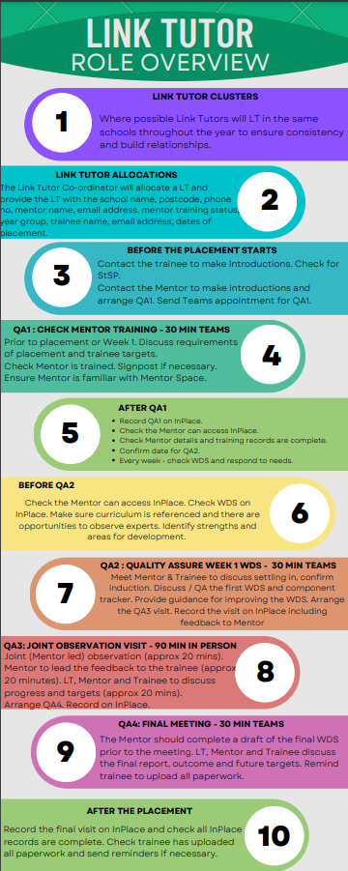

DEVELOPING AND QUALITY ASSURING THE MENTOR

The LTs carry out regular development meetings with the mentor to communicate the Faculty’s vision and Initial Teacher Education Pillars. Additionally, where deemed appropriate, the LTs provide explanations to the mentor about how to support the trainees regarding the most recent DfE expectations such as the CCF and our curriculum intent, implementation, and impact elements. An essential element of this process is to ensure that the schools/settings have adhered to the partnership agreement and use the correct procedures and the documents alike. LTs ensure mentors have access to the training opportunities the Faculty offers as well as the policies, required documents on the website including the processes during the professional practice. Additionally, LTs refer to Addressing teacher workload in Initial Teacher Education (ITE) Advice for ITE providers document about the workload of trainees on professional practice to ensure mentors consider the workload concerns and only necessary tasks are required to be completed by the trainee and that they are appropriately staggered. Link Tutors also provide support for mentors in managing their workload when supporting a trainee.

6.2 QUALITY ASSURANCE OF MENTORING
Our link tutor's quality assure the mentoring in the placement settings. To quality assure the judgment, link tutors carry out and/or moderate the pre-planned observations with the mentor. They scrutinise the evidence provided and moderate the mentors’ assessment outcome ensuring that students’ needs are met in a timely and supportive manner for them to make the appropriate progress through the phases. LTs quality assure the three key areas below;

6.3 QUALITY ASSURANCE OF ASSESSMENT
Our Link Tutors quality assure the professional practice assessment at placement schools and/ or settings. To quality assure the judgment, Link Tutors generally carry out and/or moderate the mentors’ assessment outcome ensuring that trainees’ needs are met in a timely and supportive manner for them to make the appropriate progress through the phases. LTs quality assure the three key areas below;

Formative Assessment: Link Tutors assure the quality in trainees’ assessment. They regularly scrutinise the weekly development summary (WDS) forms and ensure the trainees are formatively assessed against our curriculum objectives which are outlined in the curriculum sequence communication documents and subject curriculum plans which are communicated to the partnership. LTs quality assure mentors’ use of our phase expectations as set out in the PP Curriculum Handbooks when carrying out the weekly lesson observations and filling in the WDS form. Link Tutors moderate the evidence gathered/observed to make the judgment that trainees have met the objectives in the curriculum and achieved the progression targets set for them. Where the mentor has identified the trainee needs additional support (via the WDS) the Link Tutor will support discussion of next steps and ensure that the necessary support is put in place.

In the Secondary and FET phase the formative assessment of trainee progression is enabled via a weekly curriculum and a system of tracking and monitoring at the centre. The WDS forms are checked each week meaning contact with the mentor and the requisite support happens with 2-3 days of the mentor indicating support is needed. Any interventions made to assist with trainee progression are logged on a progress tracker. Mentors identifying on the WDS that despite additional support, the trainee is not making progress is the predominant way that that the Progress Support Plan process is started. An academic liaison tutor oversees the QA of Link Tutor and mentor feedback for trainees studying our franchised FE ITE provision at Wirral Metropolitan College.

When a trainee is not making appropriate progress and has been identified by the mentor as at risk of not completing the phase successfully, link tutors ensure that the trainee has been provided with appropriate additional support and required to complete effective actions in the Progress Support Plan. The Link Tutor supports the mentor and monitors the progress the trainee makes within the agreed timeframe. If the mentor refers the case as not making sufficient progress with regard to the area of concern, the link tutor consults the Professional Practice Quality Lead who determines the need for a departmental progress meeting (DPM).

Written and Verbal Feedback: Link tutors quality assure the feedback provided to the trainee. The verbal feedback must be consistent with the written feedback that was recorded on the lesson observation forms, WDS forms and progress reports. During the lesson observation feedback, first the trainee should be given a chance to reflect on their lesson. After that, the mentor should communicate the strengths of the lesson and discuss the progress made since the previous meeting and the impact on the pupils’/students’ learning. Similarly, during the WDS and progress meetings, trainees should be provided with focused and clear feedback when discussing how to improve their practice and progress through the curriculum successfully. These discussions must be consistent with the written comments on the WDS.

Using the Weekly Development Summary as a record, the trainee and the mentor review the EHU curriculum content for the week, this provides a focus and is sequenced incrementally to manage cognitive load. For secondary, the Weekly Development Summary includes questions that the mentor can use to review prior learning and assess that the student has the relevant knowledge to benefit from opportunities to practice in each week.

Target Setting: LTs quality assure the targets set for the trainee. The targets should match the feedback provided and should be at an appropriate level of challenge for the trainee, considering the placement phase; introductory, developmental and consolidation. It is vital to set targets that focus on the direct impact on pupils’/ students’ learning. In all PP phases, there is a recommended maximum of 3 targets, some of which may need longer periods to achieve such as meeting the needs of all pupils/students. Targets should be set using our key documents such as the ITE curriculum, subject curriculum plan overviews, phase expectations as set out in the PP Curriculum Handbook and the Faculty’s formative assessment guidelines. Additionally, LTs ensure targets are clearly explained to the trainee as well as the guidance as to how to achieve them. The actions to achieve the targets should consider the ITT CCF as well as our values and pillars. These should be clearly outlined in the WDS forms.

Along with school-based trainers and mentors, LTs support the trainee to achieve their set targets in a timely manner.

As well as the above, LTs support those training to teach in the FE phase utilise the ETF Professional Standards to quality assure assessment and set targets.

Supervising the Trainee: Link Tutors monitor and track the progression of the trainee throughout the duration of the professional practice and provide appropriate and timely support. Trainees will be allocated a LT for their PP. This allows LTs and trainees to make initial meeting arrangements at the beginning of PP. In the first instance, LTs contact the trainee to make arrangements for their meetings and from then on, trainees can contact their LT for any questions and concerns related to PP. LTs supervise the progression of the trainee until PP finishes.

ORGANISATION AND MANAGEMENT OF THE PARTNERSHIP

PARTNERSHIP GOVERNANCE

ITE Strategic Development and Quality Committee (Constituted January 2023)

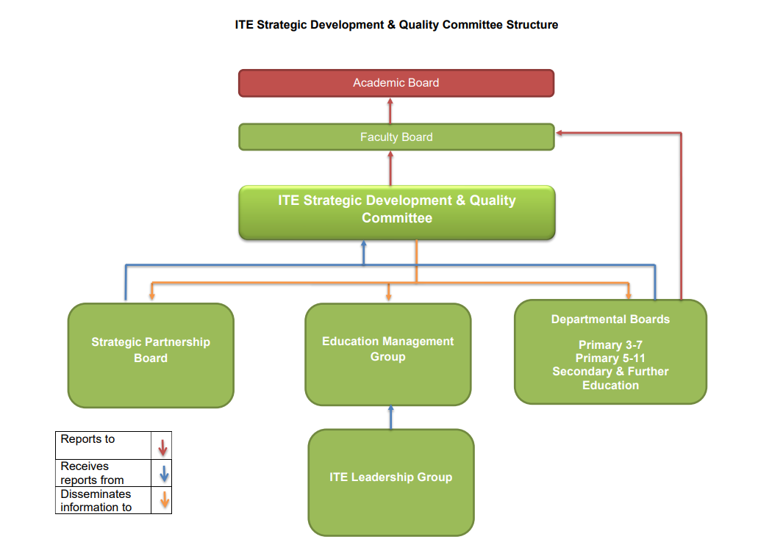

PURPOSE

The purpose of the ITE Strategic Development and Quality Committee is to provide strategic guidance and overall quality assurance across the Initial Teacher Education provision at Edge Hill University.

TERMS OF REFERENCE

- To receive and discuss minutes of the Strategic Partnership Board.
- To challenge the programme teams on the self-evaluation documentation, the improvement plan, and respective data sets.
- To receive, via the Associate Dean (Teacher Education), an overall report from the Strategic Partner Board on professional and subject mentor feedback and to scrutinise such reports and underpinning data sets.
- To receive, via the Associate Dean (Teacher Education) and Head of Partnership Development an overall ITE report on availability, suitability and effectiveness of placements, the profile of partnership including new partners and an update on the outcomes of any Ofsted inspections and associated risk and to scrutinise such reports and underpinning data sets.
- To receive, via the Associate Dean (Teacher Education), and other standard University channels, overall reports relating to ITE trainee feedback. To consider such reports and underpinning data sets.
- To receive, via the Heads of Department, an overview report on placement quality (including quality of mentoring), curriculum quality and impact and to scrutinise the same and underpinning data sets.
- To monitor compliance with the requirements of the ITT Core Content Framework, the ITT Criteria (2021—2024), the Ofsted inspection framework and Early Career Framework.
- To monitor progress towards ITT Accreditation for 2024, and the incremental implementation of the requirements relating to such accreditation where such are consistent with current provision.
- Via the Associate Dean (Teacher Education) to report its findings to the University Faculty Board. (The Associate Dean will sit, ex officio, on that Committee).
- To recommend to the University Faculty Board any matters for action that require formal department and/or University level approval.
- To monitor the Improvement Plans as being fit for purpose, effective and under continuous review.
- To quality assure appointments of external examiners for Teacher Education and to confirm to Faculty of Education Faculty Board that such examiners meet the professional requirements of the role.

B. DECISION-MAKING

- To approve Self Evaluation Documents during the first meeting of each new Academic Year
- To approve Improvement Plan Documents during the first meeting of each new Academic Year and review progress in subsequent meetings
- To approve the curricula for mentor training where such does not carry University credit.
- To confirm that the ITT Accreditation 2024 action plan is fit for purpose, effective and under continuous review.
- To approve recommendations arising from the Strategic Partnership Board; or to recommend such approval to Faculty of Education Faculty Board where such is required by wider Faculty/University QA policy.
- To approve recommendations for action arising from the report of the Associate Dean (Teacher Education); or to recommend such approval to Faculty of Education Faculty Board where such is required by wider Faculty/University QA policy.

STRATEGIC PARTNERSHIP BOARD

PURPOSE
Our Strategic Partnership Board (SPB) involves school leaders from across the Faculty of Education partnership and the Faculty Management Group in helping to frame our partnership’s response to the national agenda, and in ensuring that strategic decisions are strongly influenced by partnership perspectives and needs.

The remit includes (but is not restricted to):

- considering performance data, and to inform and implement responses to these.
- considering, reviewing, and informing local policy
- leading responses to national policy changes
- steer improvement across the Faculty of Education Partnership
- advocating for the work of Faculty of Education Partnership and professional learning in the education sector and beyond

QUALITY ASSURANCE IMPROVEMENT PLANNING AND SELF-EVALUATION

The University recognises that effective, risk-based monitoring and action planning activity takes place on an ongoing basis and is not limited to annual processes. The University therefore employs a continuous Monitoring Framework to ensure the continuing standards and quality of its academic provision. In ITT this takes the form of a self-evaluation document and improvement plan for each phase. These are completed on an annual basis by the HoDs and AHoDs drawing on range of internal and external data as well as subject curriculum conversations. Progress is monitored by the Education Management Group and the SDaQC on a regular basis. Subject Leaders also produce improvement plans relating to their subject that are monitored by HoDs and the Associate Dean (Teacher Education). Subject Leaders also produce improvement plans relating to their subject that are monitored by HoDs and the Associate Dean (Teacher Education).

All ITT activity undertaken is subject to scrutiny by evaluation systems, quality assurance and examination and reported to development committees, the Strategic Development and Quality Assurance Committee (SDaQC) and the University Academic Board. These systems ensure that trainees receive training that exceeds the minimum entitlement as set out in the ITT Core Content Framework and that trainees are assessed consistently and accurately. Information gathered from quality assurance processes supports course development through the annual review process and progress boards.

PARTNERSHIP RESOURCES AND FUNDING

PARTNERSHIP SELECTION AND DESELECTION

SELECTION
Any school, college or setting that submits an offer for a placement is agreeing to accept the terms and conditions of the partnership agreement and is confirming that they will adhere to the roles and responsibilities detailed within. Quality assurance processes are in place to ensure new and existing partner settings are suitable for trainee teachers to undertake ITE training.

Any setting within the Edge Hill University (EHU) ITE Partnership should be able to demonstrate:

- A recent Ofsted inspection report or equivalent that enables the setting to be considered as a partner.
- A commitment to the Edgehill vision and values.
- A commitment to work together in partnership with EHU in designing and delivering a high quality ITE curriculum to trainees through the provision of mentoring and support from expert colleagues.
- A commitment to ITE within their setting policies and procedures relating to the placement offers made, and a commitment to update school/mentor information and to communicate with the Partnership Development Team and academic colleagues.
- A willingness to designate appropriate experts with specific responsibilities in relation to ITE.
- A commitment to engage in on-going training and professional updating for mentors, allowing them to work within the roles and responsibilities described in this handbook.
- An understanding of the roles and responsibilities identified in this handbook.
- A commitment to quality assurance and enhancement and the process of feedback, evaluation, monitoring and the critical review of placement and partnership activities.

DESELECTION

Edge Hill University has strong links with Partnership Schools/settings and supports them to fulfil the requirements and expectations of the Partnership Agreement. It would be very unusual to consider deselection of a Partner Setting and would be a rare occurrence and only if after additional support a school is unable to fulfil their responsibilities in accordance with the Partnership Agreement. However, if a concern is identified at the school, the Partnership Development Officer (PDO) will meet with key school staff, the Edge Hill Link Tutor and the trainee to discuss any concerns and to identify any necessary support or training needs to achieve a positive resolution. The PDO will liaise with the school, the ITE lead, and the year group lead to ensure that support is in place for the school and that the trainee receives their training entitlement.

In the Secondary and FET phase, where a concern is raised about the quality of the mentoring provision the LT identifies and addresses the support needed. Where issues remain, the Course Leader is informed, and support is provided/actions are taken involving the lead in that setting. Where issues persist, this is then raised to the level of AHoD who, in liaison with the relevant PDO takes all necessary action to address the concerns raised. This may include the temporary suspension of the placement until the mentoring concerns have been addressed.

In the case where all support mechanisms have failed and where serious issues remain unresolved, then formal withdrawal of partnership is an option. It may be that a key stage or a department is identified for removal from the partnership. The Head of Partnership Development will review any decisions annually. Schools can appeal the decision by contacting the Dean of Education via FOE-Deans-Office@edgehill.ac.uk

The below diagram demonstrates the process of deselection.

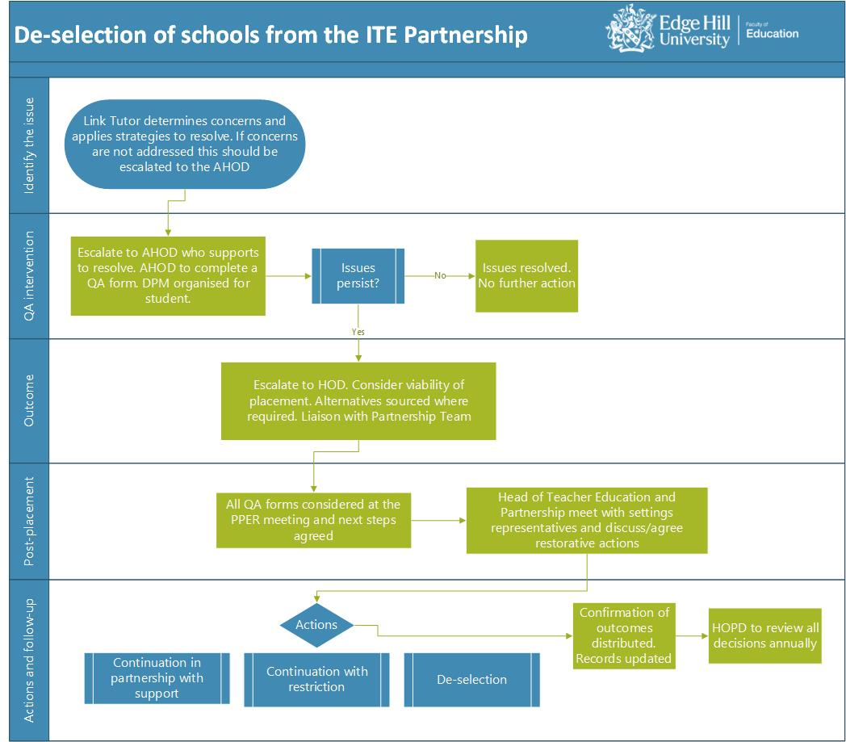

ADVERSE INSPECTION

If a school has been judged as ‘inadequate’ by Ofsted, a quality assurance risk assessment takes place to ensure the school/year group or department are able to provide the appropriate support for trainees. The flowchart below demonstrates the process that takes place in these instances.

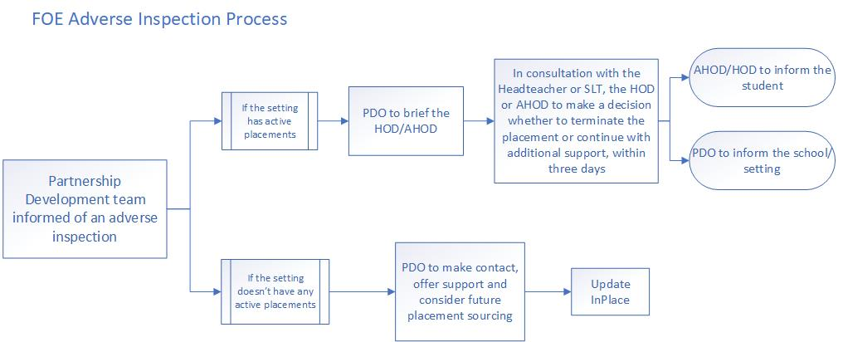

EQUALITY AND DIVERSITY

Edge Hill University is committed to equal opportunities. All trainees are expected to promote equal opportunities in their teaching and to value diversity fully. The University has an Equality, Diversity and Inclusion Strategy which ensures that there is equality of opportunity for all members of its community. In pursuit of this goal, the University is committed to eliminating both direct and indirect discrimination to ensure that no-one is unfairly disadvantaged, either through individual action or through its policies or procedures, on the basis of the protected characteristics as set out in the Equality Act 2010. Partners will agree to employ all means possible to ensure that the University’s trainees are not disadvantaged, harassed, offended or insulted by anyone on the basis of the protected characteristics. Trainees also have a responsibility not to disadvantage, harass, offend or insult anyone else within the schools they are placed, on the same basis. https://www.edgehill.ac.uk/wp-content/uploads/documents/equality-diversity-and-inclusion-strategy.pdf

It is recognised that Partner Settings will have their own policies designed to ensure and safeguard equal opportunities for all staff, pupils and trainees that work there. All partners will share with their trainees any equal opportunities policies and procedures. A trainee must know what to do if they or a pupil experience any form of discrimination or harassment. Any trainee who acts in a way which is contrary to the Equality and Diversity policies at the school, or the University must be referred to the placements’ Link Tutor.

For ITT students, it should be noted that they may be placed in a range of schools, including faith schools. Trainees cannot refuse a placement on the grounds of faith; however, trainees can choose to opt out of any collective worship.

SUPPORTING TRAINEES

The Equality Act 2010 requires educational establishments to provide for all trainees without discrimination. This includes making anticipatory adjustments to include disabled learners. Trainees that have disclosed a disability are offered support through the University’s Inclusion Team, within Student services.

The Faculty aims to create a welcoming and inclusive environment for all, encouraging all trainees, from the applicant stage through to enrolment and for the full course of their studies. This is because disclosing disabilities or health conditions enables us to work together with trainees and partners to make reasonable adjustments and provide support. Where a trainee requires reasonable adjustments to be made regarding a placement, the University will communicate these to the school and the PAT will ensure that these are carried out appropriately.

In addition, trainees are asked to complete a Student Allocation Profile (SAP) in advance of Professional Practice commencing, providing a further opportunity for the university to consider if reasonable adjustments need to be made to travel expectations, disability, mobility issues and carer/childcare responsibilities.

There may be trainees who, for a number of reasons, have not disclosed a disability. In practice this means being ready and willing to provide extra support or to adjust practice to accommodate the needs of student teachers even when these needs have not been made explicit at the outset. If a trainee discloses a disability or medical condition to the school whilst on placement, they should be advised to contact their personal tutor and the inclusion team as soon as possible. This will result in creation of either student needs assessment or student support plan.

The inclusion team can be contacted on inclusionteam@edgehill.ac.uk

PARTNERSHIP DEVELOPMENT OFFICERS

Our partnership development officers (PDOs) have an important role to play in supporting the schools and educational settings within the partnership. They work very closely with mentoring leads at schools and act swiftly to resolve any issues as they arise. There are two aspects to this role:
1) Liaison between schools/settings and the university providing support to schools prior, during and post placement
2) Sourcing and allocating the placements.

QUALITY ASSURANCE OF PLACEMENT

LIAISON, TRAINING AND SUPPORT

PDOs respond to any concerns that have been raised by the schools, LTs and/or the trainees during PP. They ensure that all stakeholders are aware of any problems and how they have been dealt with in a timely manner.

PDOs and centre-based staff provide mentor support both in terms of processes, and the use of the documents and forms. EHU colleagues arrange and deliver virtual mentor training prior to each placement. They also offer drop-in sessions to answer specific questions at key points during PP. Additionally, LTs and Lead Mentors deliver bespoke in person mentor training to individual or to clusters of schools upon request or if a training need has been identified by a LT. If a school has an adverse Ofsted inspection, before or during placement, an additional monitoring meeting will take place in order to ensure the school can meet the needs of the trainee. The progress of the students at those schools will be closely monitored by both the LTs and PDOs with timely support provided.

Our PDOs establish effective working relationships with our ITE partners and introduce them to the EHU Partnership Agreements, the placement offering/accepting process and the trainees’ placement due diligence process and documents.

After each placement, a professional practice evaluation and review meeting (PPER) is completed. This includes representatives from across the department including data management, partnership, professional practice quality lead, year heads and lead mentors. The outcomes and data from the placement are considered and recommendations for development are recorded and actioned.

ARRANGING THE PLACEMENTS

PDOs manage the placement allocation process for all programmes, aiming to allocate trainees to their school three weeks in advance with course/professional practice quality leader approval before confirmation is sent to schools. This gives time for all stakeholders to prepare themselves before the trainees’ placements commence and ensures the initial meeting can take place in the first week. Once the PDOs inform the departments about the trainee-school allocation, the ITE A/HoDs oversee the allocation of the LTs. In the Secondary and Further Education phase allocation of the LTs is overseen and the responsibility of the Course Leader.

For School Direct, professional practice schools are allocated by the alliance and trainees are placed within the alliance cluster of schools.

For trainees placed in Northern Ireland we have Partnership Quality Officers based locally whose responsibility is to quality assure schools and provide support for mentors and trainees during professional practice.

Trainees studying the PGCE/UHD franchised programme at Wirral Metropolitan College have their placement allocated by the Programme Lead at WMC. This is done in conjunction with, and quality assured by the PDOs.

ACCOMMODATION ASSISTANCE

Edge Hill University provides opportunities for trainees to return home or to an alternative address (such as that of family/ friends) to undertake their PP in an area that they are familiar with and have additional support from family or friends. This also supports trainees in making employment connections in areas where they are likely to be seeking employment upon their graduation.

Accommodation Assistance is the name given to the financial support provided to enable students to access placement settings that could not otherwise be accessed by commuting from their registered term time address. This consists of a weekly contribution towards living and travel costs and the university also covers the cost of all travel to and from the location at the beginning and end of PP and for any school holidays that fall within the PP period.

For trainees returning to a home address in Northern Ireland (NI), the university ensures our Public Liability Insurance is extended to cover PP in Northern Ireland, to cover the university for its own legal liability, as ‘trainees’ are not explicitly covered under NI schools' public liability insurance.

DISTANCE PLACEMENTS

Edge Hill University provides opportunities for trainees to volunteer to undertake their PP at a distance from the university, and if this is not commutable within the parameters of our Travel Policy, the university sources and pays for appropriate accommodation for the duration of the PP. Accommodation is provided for two nights prior to commencement of PP and for a day following the end of PP, to allow trainees the opportunity to familiarise themselves with the environment, the PP school and to be ready to commence PP. The university also covers the cost of all travel to and from the location at the beginning and end of PP, for any school holidays that fall within the PP period and for the trainee to attend interviews for employment. These opportunities are available to all trainees.

For trainees placed in the Isle of Man, the university is responsible for ensuring adequate overseas personal accident and travel insurance to and from the island is in place and organises travel on ferries at the beginning and end of PP, for school holidays that fall within PP and enables trainees to claim expenses for travel to the mainland for interviews. For all Distance Placements trainee's emergency contact details are provided to Campus Support, and procedures regarding who to contact in the case of an emergency are provided to trainees.

DUTY OF CARE

The university has a duty to demonstrate reasonable care for trainees undertaking placement and will inform partners of events which may adversely affect the quality of the partnership.

PREVENT DUTY

The Prevent Duty from 1 July 2015 all schools are subject to a duty under section 26 of the Counterterrorism and security act (CTSA 2015), to have due regard to the need to prevent people from being drawn into terrorism. Partnership settings should therefore have due regard to statutory guidance issued under section 29 of the CTSA 2015 (the Prevent Duty Guidance)

RELIGIOUS OBSERVANCE

All trainee teachers can expect schools to be sensitive to religious beliefs in respect of wearing religiously and culturally appropriate dress, having a place to pray and being able to observe religious festivals which require them to be absent from school. It is anticipated that trainee teachers will require no more than two days religious observance during a professional placement. It is the responsibility of the trainee teacher to inform the school and their Link Tutor as far in advance as possible of the need to be absent from placement due to religious observance.

HEALTH CONCERNS

When a trainee has a medical condition that may impact on their role in the classroom, we advise them to inform all those working with them in university and in schools aware of these conditions. If trainees need to take medicines onto a school placement, either for a permanent or temporary condition, they must notify their Mentor and any other staff as required by the school’s procedures. Medicines should be used and stored in compliance with the school’s Health and Safety rules and with due regard to the safety of pupils and other staff.

A Student Support Plan (SSP) is produced by the university inclusion team with students who have declared a disability. These plans are shared with the inclusion lead or professional support team within each department and any relevant information relating to placements is shared with the partnership development team, and LT.

FACULTY OF EDUCATION STUDENT PREGNANCY, MATERNITY, PATERNITY AND ADOPTION GUIDANCE

Edge Hill University values the diversity of its student population and is committed to ensuring equality of opportunity for its students and trainees. The University believes that becoming a parent should not in itself prevent any student from succeeding in their studies and recognises its legal and moral obligations to students who are new and expectant mothers and fathers, and those who are adopting.

The Equality Act 2010 significantly strengthened the legal responsibility of all higher education institutions to protect students from pregnancy and maternity related discrimination and the University will take all reasonable steps to ensure that no student is disadvantaged due to pregnancy and maternity including whilst on placement. This involves the university ensuring that the placement provider is aware of this guidance and their responsibilities with regard to conducting risk assessments, making reasonable adjustments where necessary.

Students will be provided with reasonable academic support throughout the period of pregnancy and maternity or adoption and, wherever practicable, will not be unreasonably prevented from successfully completing a course. Risk assessment and required adjustments are put in place and monitored by the Link Tutor in collaboration with the trainee and mentor.

Maternity is defined as including all stages of pregnancy and up to 26 weeks after the birth of a child.

PROFESSIONAL PRACTICE PROVISION

PROFESSIONAL PRACTICE PHASES
Our partnership provides the trainees with three phases of professional practice experience, namely;

- Introductory phase,
- Developmental phase,
- Consolidation phase.

These are carefully designed considering the trainees’ level of knowledge, understanding and skills gained through our curriculum. Progression expectations progressively increase through the phases and are clearly outlined in the Professional Practice Handbooks.

At each PP phase, wherever possible settings are expected to provide the trainees with the opportunity to work with learners with special educational needs and disability (SEND) and English as additional language (EAL). Additionally, all primary/early years trainees should be given the opportunity to observe/experience high-quality systematic synthetic phonics (SSP) and secondary trainees should be provided with the opportunity to observe/experience the teaching of phonics and reading fluently to older students. Across the Professional Practice 3 phases, trainees will have the professional practice experience of teaching at two different schools/settings and two consecutive key stages. These will be recorded on our placement management system InPlace and monitored by the AHoD. Trainees training to teach in the FE phase typically undertake all three phases within a single FE setting.

At all three phases, where possible, LTs make the arrangement to meet with the mentor and the trainee as soon as possible to the commencement of the PP and ensure that both the trainee and mentor are aware of the expectations and completed the required tasks.

Introductory Phase: This is the first experience at schools/settings for many of the trainees and we take extra care to ensure that trainees are supported and guided effectively so that they have a positive professional practice experience. Trainees are introduced to school/setting life and expected to teach to groups of pupils/students in their timetable as set out in the PP Curriculum Handbooks. Mentors and LTs carry out one or two joint observations of the trainee teaching a group of pupils/students and the mentor provides constructive feedback however this may vary depending on the placement pattern or phase requirements.

Developmental Phase: After completing the introductory placement, trainees carry on working on their targets from the previous phase. An interim progress observation takes place by the mentor and quality assured by the Link Tutor. LTs ensure all the information is recorded/updated and WDS are uploaded on InPlace by the end of the placement.

Consolidation Phase: This is the final placement we offer to our trainees at the end of the programme. Trainees consolidate what they learnt at the previous PP and centre training. As above, this stage consists of joint lesson observations both or either at interim and/or end of practice meetings. LTs ensure all required information is recorded/updated and compliance documents uploaded on InPlace by the end of the stage.

FET: there is a single placement model. The trainees are allocated to their setting starting in October/November and remain in that placement until end of May/beginning of June. Throughout the placement, trainees are expected to progress from observing expert teachers to sharing team teaching with expert teachers and then onto taking sole responsibility for learning. They amass 100 teaching hours and evidence eight lesson observations, so they are eligible for QTLS once employed in post. Trainees undertake an enhancement placement to ensure that receive experience in a contrasting environment. This may be within a different setting or a different department within the same setting.

PROCESS DURING PROFESSIONAL PRACTICE
The link tutor has four opportunities across a placement to conduct quality assurance activity. Thes are carried out between the LT, trainee and mentor across the PP experience including the progress meeting and joint observations and/or meetings. The first purpose of the initial meeting is to check that the mentor has undergone core mentor training and follow up on any identified mentor development and training needs, providing training where necessary. LTs also ensure that the trainee has carried out their responsibilities as set out in section 1. The second purpose is to ensure that the trainee is appropriately inducted for the placement and has access to:

- documents e.g., safeguarding policy, code of conduct (breaches of which may result in an investigation into a trainee's suitability to practice under the fitness to practice regulations)
- correct Faculty documents e.g., PP Curriculum Handbook and
- has been provided with an effective timetable.

Initial Meeting (QA1): At the earliest opportunity, before the start of a placement, Link Tutors should verify that a mentor has been fully trained through having engaged with the EHU Core Mentor Training Package. They should ensure that any identified training needs are met. On the allocation of a trainee to the setting, an initial visit of around 30 mins takes place (generally on Teams) to discuss settling in, confirm induction has taken place and that the trainee has been provided with the necessary documentation such as the safeguarding policy, curriculum and planning resources. and timetables etc.

QA 2 Meeting: This contact is an opportunity to discuss/QA the first WDS and provide support for any identified needs. The Link tutor will also provide feedback for mentors at this point on the quality of their mentoring and signpost them to further support or training.

Progress Meeting (QA3): This will be approximately mid-point for undergraduate programme year 1, 2 and 3 for all three phases. The mentor, LT and trainee meet for the purposes of discussing the mentor conducted lesson observation, quality assuring assessment, feedback, and target setting. On this visit trainee progression, support, wellbeing and workload for mentor and trainee will be discussed. This QA visit is a further opportunity for link tutors to provide feedback to mentors on the quality of their mentoring and signpost resources. Where there is a persistent concern LT can refer the mentor for additional support and training with the Lead Mentorship team.

End of Placement (QA4): At the end of all phases in all programmes there is a final quality assurance meeting. The outcome of the meeting determines if the trainees have made appropriate progression through our ITE curriculum and successfully achieved the PP expectations for that phase. It is the responsibility of the link tutor to close the placement by marking it as complete.

Further Education and Training (FET) trainees. Trainees on the FET course do not seek to be awarded QTS but instead are eligible to apply for QTLS once in post as appropriate for those teaching in the FET phase. The placement trainees undertake provides opportunity for trainees to deliver a minimum of 100 teaching hours and to evidence 8 observations of teaching practice as per the requirements laid out by the ETF. All FET trainees are placed in settings which enable them to train to teach in their subject (at the FET level) and to be mentored by specialist in their subject.

FET Link Tutors work in partnership with the relevant Partnership Development Officers prior to placement to ensure trainees are placed with a subject-specific mentor. Where a subject-specific mentor is not available the placement is not viable, and another placement is sourced. 2-3 weeks prior to the placement starting, mentor training begins for any mentors who have not completed their Core mentor training for that academic year.

FET trainees undertake a single placement throughout their course. This is structured in line with the rest of the faculty into an introductory, developmental and consolidation phase. Such a sequence is reflected in the weekly curriculum FET trainees follow.

Link Tutors visit trainees and mentors four times throughout the placement. This may be online but is often in person as part of our quality assurance process and mentor support. Link Tutors undertake at least 2 joint lesson observations with the mentor. At the end of the consolidation phase mentors complete a final WDS which confirms progression through the ITE curriculum and indicates targets for development in the next phase. Regular meetings act as a quality assurance mechanism that the trainee has made sufficient progress through the curriculum and has met the requirements for the for the QTLS process once in-post (on condition of a successful Professional Reflective Viva). To enhance our quality assurance, on occasion these final meetings with the mentor and trainee include the PRV, thus involving the mentor the PRV process and enabling us to make use of their expertise.

9.3 PROCESS AFTER THE PROFESSIONAL PRACTICE (VIVA AT UNIVERSITY CENTRE)

When the trainee’s complete PP consolidation phase, they are invited to a Professional Reflective (exit) Viva (PRV) by their PAT or LT. On Secondary and FE programmes mentors are invited to attend PRVs so we have partnership involvement and for QA purposes.

During the PRV, trainees are asked several questions that are related to the Teachers’ Standards or the ETF Professional Standards (FET). Trainees respond to questions which demonstrate their understanding, drawing on their WDS collection. The tutor conducting the PRV ensure trainees are aware of their professional strengths and areas for improvement and have provided sufficient written and verbal evidence to pass the Viva and be recommended for qualified teacher (QTS) status, having met the Teachers’ Standards.

For those training to teach in the FE phase, QTLS Eligibility Guidance and ETF Professional Standards are utilised.

EDGE HILL UNIVERSITY APPROACH TO ASSESSMENT
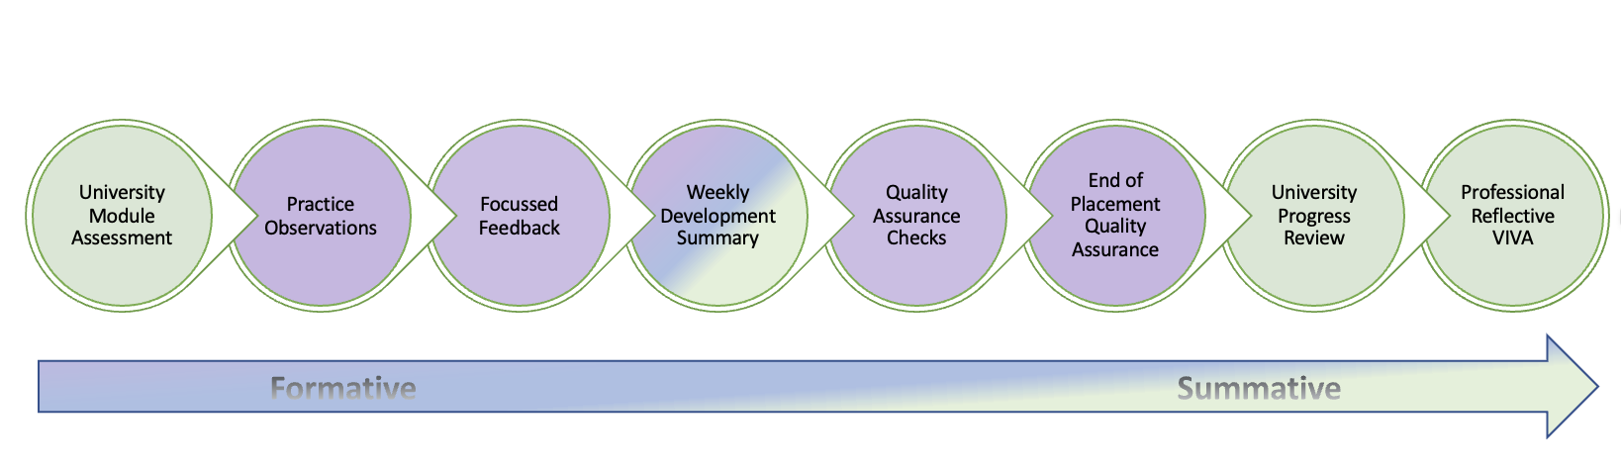

Quality Assurance of ITT Primary Students’ Professional Development
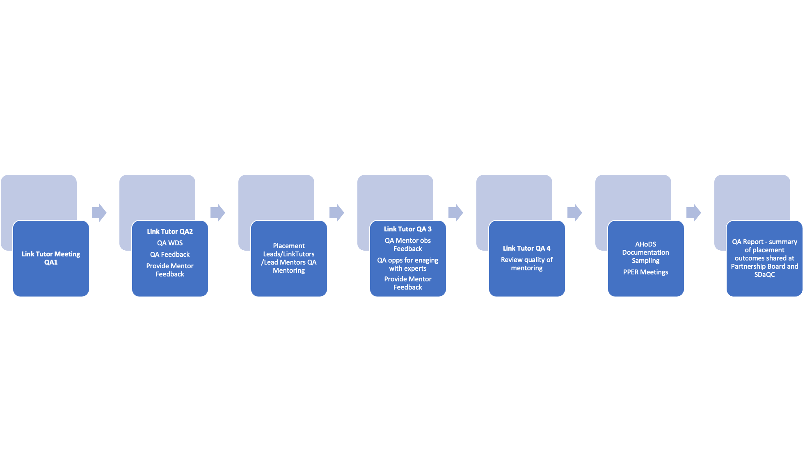

MENTOR DEVELOPMENT AND SUPPORT
The Faculty offers a comprehensive and flexible package of mentor training and development opportunities. The Edge Hill University Core Mentor Training for 2023/24 comprises three elements. All mentors hosting a trainee must complete all three elements of mentor development training.

- Core mentor development (Online units 1 and 2)
- Phase/subject specific mentor development
- Self- study mentor development

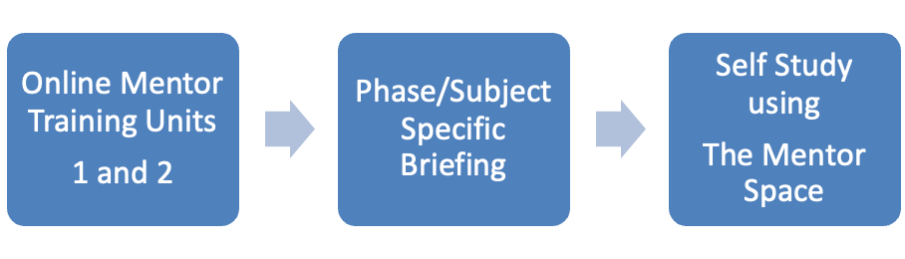
UNIT ONE – PRINCIPLES OF MENTORING
This unit provides mentors with the research evidence and underlying principles for mentoring at Edge Hill University. It considers the evidence base for mentoring drawing on the Sims et al., 2021 characteristics of effective teacher professional development.
UNIT TWO – MODELS OF MENTORING
The Edge Hill models of mentoring unit moves the mentoring of our trainees away from a model of internship (where trainees learn ‘on the job’ by receiving feedback based on naturally occurring experiences) and towards one of instructional coaching. This unit also introduces mentors to the Edge Hill University vision and values, our approach to the core content framework and the Weekly Cycle for Mentoring approach.

The phase and subject specific briefings revisit the EHU ITE values, our ‘pillars’ and wider curriculum context. Mentors receive input about key expectations regarding the use of the ITT Core Content Framework, its evidence base and our own more ambitious curriculum aims. Aspects covered include observation of students whilst on professional practice, supporting students through dialogue and questioning at the weekly mentor meeting, formative assessment processes, setting targets and tracking progress. The key principles and processes of mentoring and coaching are considered.

These development sessions also provide an opportunity for mentors to receive detailed input about any forthcoming placements. Tailored to the specific placement phases, (Introductory, Developmental and Consolidation) mentors will receive guidance about the curriculum appropriate to the phase, the content of centre-based training to date and expectations whilst on professional practice. This will ensure that there is join-up between centre-based input and follow-up task for trainees whilst on placement. The key principles and processes of mentoring and coaching are reinforced, together with the use of phase specific key documentation such as lesson observation forms, weekly development summary forms and progress reports.

In addition, departments will host a series of subject specific development opportunities and sessions which address current key priorities for specific age phases.
Mentor Development Self-study - Using the Menor Space mentors familiarise themselves with the partnership agreement, curriculum documentation and professional practice forms.

The department also offers advanced mentor development includes opportunities for colleagues to acquire a more complex and in-depth mentoring skills set. Keeping abreast of the most contemporary research and working with key evidence bases, sessions will unpick mentoring and coaching practice, including instructional coaching. Areas covered will include for example, mentoring and coaching conversations, coaching dilemmas, formative feedback, leading mentoring, recruiting, and keeping mentors etc. Additional sessions are specifically targeted for those supporting early career teachers through the Early Career Framework. Many of the areas covered within the advanced mentor development provide a bridge to a more formal series of accredited qualifications such as the advanced mentoring.

MENTOR INTERVENTION

Mentors play a crucial role in developing trainees’ knowledge, understanding and skills to become teachers. They monitor the progress continuously through the weekly WDS meetings and lesson observations, where they provide the necessary support and guidance as to how to consolidate what has been learnt and move onto further progress. Link Tutors and Lead Mentors quality assure mentoring and provide individualised additional support and guidance. Where additional measures and interventions have not resolved concerns the Assistant Head of Department will review all evidence and discuss alternative and additional actions. If mentors are still unable to fulfil their responsibilities, then deselection of a phase within a setting may be considered.

MODERATION OF PLACEMENT PRACTICE

At Edge Hill University ITE provision we have 3 different quality assurance processes related to professional practice;

Quality assurance of assessment and mentoring process conducted by LTs.
Quality assurance of Link Tutor QA processes and feedback conducted by lead mentors.
Quality assurance of professional reflective (exit) viva conducted by PATs, including both centre-based and school-based colleagues from our partnership.

To ensure our quality assurance processes are rigorous and robust we conduct either or both internal and external reviews and/or moderation.

Quality assurance of PP assessment, mentoring and outcomes are moderated periodically. Senior leaders conduct internal reviews of introductory, developmental and consolidation phases of all programmes in all departments. Additionally, to gain an objective view, we conduct moderation with external examiners (EE) and utilise the specialism and strengths of our EEs during the process.
As above, QA of placement processes is moderated internally by senior leaders periodically.
PRVs are moderated by experienced colleagues within the partnership, for example our headteachers from the partnership and senior leaders at the centre.

QUALITY ASSURANCE AND EXTERNAL EXAMINATION

EXTERNAL EXAMINERS
External examiners are expert assessors whose authority is derived from their knowledge of, and qualifications in, their subject disciplines and their experience of teaching and assessing students at higher education level.
External Examiners’ main responsibility is to confirm that academic standards are appropriately set and maintained. This is carried out by:

- Reviewing and approving examination papers that contribute to a student’s final award, and any other assessment material as agreed between themselves and the programme team for which an annual time allowance is provided31.
- Moderating samples of student work that have been marked and internally moderated in order to be satisfied that students have been graded fairly in accordance with Intended Learning Outcomes, marking criteria and the University’s Academic Regulations.
- Reviewing and approving the content, learning outcomes and assessment of negotiated learning modules leading to the award of Student Initiated Credit.
- Sampling the assessment of portfolios.
- In their annual reports, confirming that sector recognised standards (FHEQ) are being met or exceeded, content is in broad alignment with other external reference points (e.g., Subject Benchmark Statements) and that students have achieved the Intended Learning Outcomes for the award of credit and qualifications.

SUMMARY LIST OF KEY DOCUMENTS AND FORMS

EHU ITE PROFESSIONAL PRACTICE INFORMATION AND DOCUMENTS (INCLUDING PP FORMS)

- Addressing teacher workload in Initial Teacher Education (ITE) Advice for ITE providers Early Career Framework
- Early career framework reforms: overview
- Keeping Children Safe in Education 2023
- Initial teacher training (ITT): criteria and supporting advice ITT Core Content Framework
- Information for ITE Partnership
- National Standards for school-based initial teacher training (ITT) mentors National Curriculum
- Teachers’ standards: overview
- The trainee teacher behavioural toolkit: a summary Qualified teacher status (QTS): qualify to teach in England.

Further Education and Skills

- Education and Training Foundation Professional Standards
- Qualified Teacher Learning and Skills (QTLS) status ETF Mentoring: Framework and Guides
- ETF Guide for Leaders and Managers ETF Guide for Mentees
- ETF Guide for Mentors

Appendix A - Faculty of Education

Edge Hill University Code of Conduct

All Initial Teacher Education (ITE) programmes leading to a recommendation for the award of Qualified Teacher Status (QTS), or eligibility for the relevant Post 14 qualification such as QTLS, are programmes of professional training and education.

As a trainee studying on an ITE programme you are expected to demonstrate consistently high standards of personal and professional conduct and be expected to maintain and model the highest standards of ethics and behaviour.

You are entitled to expect that your placement settings mirror the professional experience of a teacher, and settings are entitled to expect that you will present and conduct yourself in a way that is consistent with the professional expectations of a teacher in that phase.

This Code of Conduct is additional and complementary to the Edge Hill University Student Disciplinary Regulations: https://www.edgehill.ac.uk/wp-content/uploads/documents/student-disciplinary-regulations-2021-22.pdf and the Student Charter 2023 Student Charter 2023/24 - Edge Hill University

You are therefore both bound by, and protected by, the entitlements included in the Academic Student Regulations in force at the time of your enrolment and study. These were issued to you at the point of enrolment and subsequent updates are accessible via the EHU website. Academic Regulations 2023/24 - Edge Hill University

Behaviours and attitude

As a trainee following an ITE programme at Edge Hill University, you will exhibit high standards of personal and professional conduct, honesty, and integrity, in keeping with those expected in the teaching profession. At all times you should:

- Demonstrate professional behaviours to all pupils/learners in all settings, and others, including fellow trainees and all staff in the Edge Hill University Partnership.

- Not engage in any conduct, poor or irresponsible behaviour outside of your studies that could bring the profession or the university into disrepute.

- Use language appropriate to the situation and the people involved. Communicate professionally in all contexts including your online and electronic communications such as email.

- Show respect and due regard for the ethos and values, processes, and procedures of the university both in the setting where the programme is delivered and at any other setting in which you are placed.

- Embrace the principles of equality, diversity and inclusion and bring them to life in all you do each day to work with children, staff, and parents. Equality, Diversity, and Inclusion (EDI) Strategy - Edge Hill University

- Acquire an understanding of working with diversity, including gender, race and culture and ensure that any personal prejudices and stereotypical views do not influence your judgements or actions.

- Be aware of the requirement to promote equal opportunities and to provide reasonable adjustments for learners with disabilities, as provided for in current Equalities legislation.

- Take responsibility for adhering to all key policies and procedures: this includes, but is not restricted to, child protection and safeguarding policies, staff conduct, SEND code of practice, children missing in education, Health and Safety and fire evacuation procedures.

- Demonstrate professional behaviour and relationships in both formal and informal contexts. You will observe boundaries in line with a teacher’s professional position and responsibilities.
  - For those on programmes of QTS, trainees must adhere to expectations as outlined within Part Two of the Teachers’ Standards: Personal and professional conduct which may be accessed at :https://www.gov.uk/government/publications/teachers-standards .
  - For those training to teach in the FE sector, you should have due regard for the ETF Professional Standards (2022) https://www.et-foundation.co.uk/professional-standards/teachers/

- Take care with confidential personal information that you will have access to.

Training responsibilities

In addition to the behaviours and attitudes above, as a trainee teacher you are required to:

- Take responsibility to engage professionally and positively in all aspect your course. This means engaging with, listening to, and acting on feedback and advice from Mentors and Link Tutors across the Edge Hill University Partnership.

- Commit to attending all university based and practice-based training opportunities and contribute fully to the life of the setting when on professional practice. You will notify the relevant staff members of any absence in advance noting that in some instances this may affect any bursary which you may receive. Academic Programme Engagement Policy (APEP) details the faculties expectations of you https://www.edgehill.ac.uk/documents/academic-programme-engagement-policy-faculty-of-education/

- Take responsibility for your own learning and development, ensuring a professional and accountable approach to all aspects of the programme adhering to high standards of academic integrity.

- Take responsibility for managing the demands of the profession by looking after your personal health, wellbeing as well as actively developing resilience strategies. Self-help resources and ideas and support to help your wellbeing can be found in Student Services

- Ensure the welfare and safeguarding of all children, young people, and vulnerable adults, by reporting all safeguarding concerns to your setting DSL and foesafeguarding@edgehill.ac.uk as instructed in your training and our guidance documents.

- Keep your personal academic tutor aware of all relevant matters likely to impact on you making good progress.

- Inform the university should you become subject to a criminal conviction or caution after your application for DBS enhanced disclosure has been submitted.

- Commit to actively reflect on your learning and teaching experiences to set targets, plan actions, improve, achieve, and attain highly.

- Participate and actively engage in all learning and teaching experiences, and activities; and engage with the full range of feedback mechanisms, such as trainee surveys, trainee consultation and focus groups.

- Maintain an appropriate standard of dress and appearance as required by your setting and university guidance.

- Adhere to all Data Protection and data handling rules including the use of mobile devices when travelling to and from settings, ensure that any digital images are acquired under the terms of the location they are taken at.

- Ensure that if social media sites are used, details are not shared with learners and young people and privacy settings are set at maximum and that conduct is professional at all times. A professional approach should be taken at all times, with no detrimental mention of any educational settings (including EHU), colleagues, peers, pupils/learners, parents/carers. Trainees should not engage with any learners/parents/carers through social media channels.

- Maintain positive, appropriate professional relationships with learners, parents and staff which always adhere to child protection and safeguarding legislation. In addition to whilst in settings this includes after school clubs, sports days, and residential activities.

Breaches of Conduct

Breaches of conduct, may occur if you are unable to meet the professional and personal standards expected, this may include poor attendance and engagement, inappropriate behaviours, or attitude and dishonestly in the assessment process (malpractice) and may result in one or more of the following actions:

- The requirement for a Progress Support Plan.

- A placement being temporarily suspended by a setting pending an investigation.

- A placement being concluded early by a setting.

- A recommendation to attend a Fitness to Practice Panel

- A referral to a University Malpractice Panel

- A referral to the University Fitness to Study process

- A referral to Student Disciplinary Regulations

End note
This code of conduct is informed by the following:
- Consultations with head teachers and school-based staff including ongoing consultations with members of the Edge Hill University Strategic Partnership Board
- The standards of behaviour expected of teachers and statutory guidance documents including:
  - the National Conditions of Service for School Teachers in England and Wales. (The Burgundy Book) https://www.local.gov.uk/our-support/workforce-and-hr-support/education-and-young-people/school-teachers/conditions-service or respective arrangements for Wales, Northern Ireland and the Isle of Man .
  - Education Act 2011
  - Working Together to Safeguard Children, July 2018
  - Children and Families Act 2014
  - Keeping children safe in education, Sept 2023
  - Equal Opportunity and Discrimination (Equality Act 2010)
  - Special educational needs and disability code of practice: 0 to 25 years
  - Protecting children from radicalisation: the prevent duty DfE (August 2015)
  - ETF Professional Standards: Professional Standards for Teachers and Trainers (et-foundation.co.uk)

Edge Hill University ITE Courses Overview

Undergraduate Programmes

Primary Education with QTS BA (Hons)

Inspiring and nurturing young minds is one of the most rewarding careers you could have. Build your experience teaching children aged 5-11 and choose a focused subject to study. Gain recommendation for Qualified Teacher Status on our primary education degree.

There’s a strong focus on values and social justice throughout the course to help you learn how to change lives. Out on placement, you’ll work together with schools and their pupils to uncover solutions to challenges they might face.

You’ll learn professional skills that will last your whole career as a teacher. You’ll look at different theories of education, examine the curriculum, explore your own choice of subject, and carry out your own research project. As well as learning from your lecturers here at Edge Hill University, you’ll have opportunities to learn from experienced teachers in the schools you train at.

Successful completion of the programme leads to recommendation for Qualified Teacher Status (QTS).

Primary Education with QTS (Part-Time) BA (Hons)

This part-time initial teacher training programme is suitable for those who have experience of working in a school, such as higher-level teaching assistants (HLTAs) or learning mentors. It is delivered through fortnightly evening campus-based sessions which you can attend at either Edge Hill University or Wigan & Leigh College. These fortnightly sessions are complemented by two full-time study weeks per year, school-based tasks to enhance your knowledge and skills and assessed professional practice.

You will gain practical experience and develop your own individual teaching personality and personal principles, along with the essential professional skills, knowledge and understanding required for a career in primary teaching. You will study in a dynamic teaching and learning environment where expert university and school-based colleagues work side by side to ensure that you have the best possible initial teacher training experience. Successful completion of the programme leads to recommendation for Qualified Teacher Status.

Primary Early Years Education with QTS BA (Hons)

With creative teaching and structured activities, you could inspire young children to learn and develop. On this course, you’ll specialise in education in early years settings and primary schools, from ages 3 to 7.

We’ll help you develop your own expertise and understanding of how children learn. You’ll study both the national curriculum and the EYFS statutory curriculum and build up your knowledge in the subjects you will be teaching.

You’ll gain experience by working in a variety of schools and other settings, alongside experienced teachers. You’ll also undertake your own research projects to build up your specialist subject knowledge.

Successful completion of the course leads to recommendation for Qualified Teacher Status (QTS).

With your recommendation for Qualified Teacher Status (QTS), on graduation you could teach in early years foundation stage (EYFS), key stage 1, and key stage 2.

Secondary Religious Education with QTS BA (Hons)

We’ll look at religion as a modern, living phenomenon. You’ll visit centres representing all six major world faiths and study their beliefs, practices, and texts. As you progress through the course, you’ll reflect on these in greater depth, gaining expert knowledge in the subject.

Our experienced tutors at Edge Hill, and the expert teachers in your practice placement schools, will support you to become an outstanding RE teacher. You’ll learn creative teaching techniques and develop your own imaginative ways to communicate impartial and considered views on religion.

Successful completion of the programme leads to recommendation for Qualified Teacher Status (QTS).

Secondary English Education with QTS BA (Hons)

As well as in-depth modules where you’ll study everything from Shelley to sociolinguistics, you’ll spend lots of time in schools. You’ll help with classes and see how the theory you’ve learned applies in real-life settings. Gaining inspiration from your mentors, you’ll start to develop your own teaching style and form your own ideas about the role of education.

Our experienced tutors at Edge Hill and the expert teachers in your placement schools will support you to become an outstanding professional teacher.

Successful completion of the programme leads to recommendation for Qualified Teacher Status (QTS).

Secondary Mathematics Education with QTS BSc (Hons)

Help pupils grasp the basics of geometry. Deliver calculus masterclasses to gifted young mathematicians. Show students how statistical techniques can have real-world applications. At Edge Hill, you’ll learn how to become a great maths teacher, while on your school placements you’ll put your ideas into practice.

We’ll cover branches such as calculus, discrete mathematics, inferential statistics, statistical modelling, and linear algebra. You’ll learn about educational theories and policies. You’ll discover ways of incorporating technology and mathematics software into lessons. And you’ll gain valuable experience in the classroom, planning and delivering sessions and reflecting on your work.

Our experienced tutors at Edge Hill and the expert teachers in your placement schools will help you succeed. We’ll support you throughout your degree and as you take your first steps as a newly qualified teacher. Successful completion of this course leads to recommendation for Qualified Teacher Status (QTS).

Postgraduate

Primary Education with QTS PGCE

Successful completion of the programme leads to recommendation for Qualified Teacher Status (QTS).

Inspire young minds and ignite their love for learning through two professional placements. You’ll be guided by school-based mentors and Edge Hill tutors. They’ll check you’re making good progress throughout your teacher training.

With support from tutors and school professionals, you’ll sharpen your professional subject knowledge for teaching the primary national curriculum. You’ll discover creative approaches to teaching all primary school subjects. We’ll encourage you to think of inventive ways to inspire lifelong learning.

By studying with us, you’ll also unravel contemporary issues in primary education and choose an aspect of learning to examine in great detail. You can study our primary education PGCE at our Ormskirk campus, or at Holy Cross College & University Centre in Bury.

Primary Early Years Education with QTS PGCE

Successful completion of the programme leads to recommendation for Qualified Teacher Status (QTS).

This early years teaching degree covers the essential skills and knowledge you’ll need for teaching children aged 3-7. This includes primary schools, nurseries, and children’s centres.

We’ll provide you with training for covering the entire early years foundation stage and key stage one. You’ll also spend time in schools learning how to teach and you’ll learn how to help primary age children to flourish. You can study this course at our Ormskirk campus, or at Holy Cross College & University Centre in Bury.

Primary Mathematics Specialist with QTS PGCE

Successful completion of the programme leads to recommendation for Qualified Teacher Status (QTS).

Every school needs a mathematics expert. That could be you. Our PGCE Primary Mathematics Specialist with QTS course provides a high-quality teacher training experience. You’ll learn how to educate children aged 5-11 in all primary curriculum subjects, and craft specialist knowledge in teaching mathematics.

You’ll spend lots of time on placement in schools, where we’ll support you in meeting the Teachers’ Standards. You’ll gain the essential professional skills and knowledge for a two-year induction as an early career primary teacher and mathematics specialist.

Primary Physical Education Specialist with QTS PGCE

Successful completion of the programme leads to recommendation for Qualified Teacher Status (QTS).

Everyone needs a healthy lifestyle. The earlier we learn how to be fit and active, the easier it becomes to maintain these habits in adulthood. As a PE specialist, you’ll show children aged 5-11 how to be physically active in fun and engaging ways and learn how to teach the national curriculum for all key stage 1 and 2 subjects.

By spending time in placements in schools, you’ll become a confident practitioner who meets Teachers’ Standards. You’ll gain the essential skills, knowledge, and attitude for a two-year induction as an early career teacher, teaching the entire primary curriculum.

Secondary Computer Science and Information Technology with QTS (11-16) PGCE

You’ll explore a range of questions to help you become the best teacher you can be. How do you create a lesson plan to inspire and motivate your pupils? What are the current challenges in secondary education? How do you pass on your computer science expertise – and continue to grow that knowledge throughout your career?

Learn to lead in the classroom.
You’ll develop your reflective and analytical skills, as well as boosting your own subject knowledge. To prepare for teaching computer science and IT at key stage 3 and 4, you’ll also get lots of hands-on experience in the classroom.

During your placement, you’ll work alongside your computing tutor and school-based mentor. They’ll help you apply your university learning to your own teaching and be there for you whenever you need support.

Successful completion of the programme leads to recommendation for Qualified Teacher Status (QTS).

Secondary English with QTS (11-16) PGCE

You’ll learn to reflect on your own philosophy of teaching English, develop analytical skills and boost your own subject knowledge. With plenty of practical experience in planning effective lessons, you’ll also get lots of hands-on experience. At Edge Hill, our experts will introduce you to a range of exciting and interactive teaching methods, including the use of drama and ICT.

You’ll spend up to 26 weeks on placement in a secondary school focusing on 11-16 teaching. Although you’ll only observe at the start, you’ll gradually get more opportunities to take the lead, helping you become more confident and more competent in the classroom.

Throughout your placement, you’ll be supported by your English tutor and school-based expert mentor. Listen to their advice about how to apply what you’ve learnt in seminars to the classroom. Turn to them whenever you need support or feedback.

Successful completion of the programme leads to recommendation for Qualified Teacher Status (QTS).

Secondary Geography with QTS (11-16) PGCE
Our programme will equip you with all the academic, professional, and vocational skills you need to succeed. You’ll also have the opportunity to develop your RE and history subject knowledge so you can teach key stage 3 humanities.

You’ll develop your reflective and analytical skills, as well as boosting your own subject knowledge. To prepare for teaching geography at key stage 3 and 4, you’ll also get lots of hands-on experience in the classroom.

During your placement, you’ll work alongside your geography tutor and school-based mentor. They’ll help you apply your university learning to your own teaching and be there for you whenever you need support.

Successful completion of the programme leads to recommendation for Qualified Teacher Status (QTS).

Secondary History with QTS (11-16) PGCE

You’ll develop your reflective and analytical skills and have the opportunity to explore different aspects of your subject knowledge. With plenty of practical experience in planning effective lessons and learning strategies, you’ll also get lots of hands-on experience in the classroom.

Throughout your placement, you’ll be supported by your history tutor and school-based expert mentor. Listen to their advice about how to apply what you’ve learnt in seminars to the classroom. Turn to them whenever you need support or feedback.

Secondary Mathematics with QTS (11-16) PGCE

Learn from leading experts in mathematics teacher training. Strengthen your subject knowledge and sharpen your skills in teaching with technology. As well as mastering the subject, we’ll help you become confident managing a classroom and assessing your students’ progress.

With 26 weeks of placement, you’ll experience life in the classroom. Not only will you learn more about the subject, but also get to test out different teaching approaches, perfect lesson planning and understand learning strategies.

Training as a teacher can be equally rewarding and challenging, but we’ll be there to support you every step of the way. You’ll be able to get advice from your Personal Tutor and ask for feedback from an assigned mentor at your placement school.

During this course, you’ll take time to reflect and work towards becoming the best teacher you can be. You’ll also reflect on your classroom experiences with different types of learners to help you throughout your career.

Successful completion of the programme leads to recommendation for Qualified Teacher Status (QTS).

Secondary Physical Education with QTS (11-16) PGCE

Our PGCE Secondary Physical Education course will prepare you for the rigours of teaching physical education in secondary settings. You’ll already have an undergraduate degree in a related area, so we’ll focus on helping you develop the skills you need to engage young people with the subject.

We’ve designed this course so you can combine learning on campus with practical experience in the classroom. You’ll spend 26 weeks on placement in school settings. Whenever you need support or feedback, you can turn to your subject specific tutors and school-based expert mentor. We’re here to help you become the best teacher you can be.

Discover the most effective ways of delivering your lessons and captivating your students. At the same time, develop your understanding of subject specific approaches, classroom management, adaptive teaching and the different ways pupils learn.

Successful completion of the programme leads to recommendation for the Qualified Teacher Status (QTS).

Secondary Religious Education with QTS (11-16) PGCE

Our PGCE Secondary Religious Education delves into the values and academic skills you’ll need. Get to grips with contemporary teaching styles and methods, and further your knowledge of this fascinating subject.

We’ve designed this course so you can combine learning on campus with practical experience in the classroom. Whenever you need support or feedback, you can turn to your subject specific tutors and school-based expert mentor. We’re here to help you become the best teacher you can be.

This course equips you for your future career, offering hands-on experience in planning RE lessons. You’ll also get the chance to meet and build connections with representatives from a range of world views including Humanism and Veganism, alongside members of traditional faith communities.

Successful completion of the programme leads to recommendation for Qualified Teacher Status (QTS).

Secondary Science (Biology) with QTS (11-16) PGCE

You’ll develop in-depth subject knowledge in your specialism of biology. We’ll also make sure you’re prepared to support with teaching chemistry and physics, especially at key stage 3. Throughout the course, we’ll encourage you to reflect on your learning to help you become the best biology teacher you can be.

Boost your skills in lesson planning, managing the classroom, teaching methods, and more. Then put what you’ve learnt into practice in a real classroom. During your 26 weeks on placement, you’ll plan, teach, and assess biology lessons with support from your school-based mentor.

We’ll be there for you every step of the way as you work towards taking the lead in the classroom. Turn to your Personal Tutor whenever you need advice or help overcoming hurdles.

Successful completion of the programme leads to recommendation for Qualified Teacher Status (QTS).

Secondary Science (Chemistry) with QTS (11-16) PGCE

Our one-year Postgraduate Certificate in Education (PGCE) prepares you to teach the secondary science chemistry curriculum for the 11-16 age range. We’ll be there for you every step of the way as you work towards taking the lead in the classroom.

Our team will introduce the teaching methods and theory you need to develop into a competent, confident secondary school chemistry teacher. You’ll get support from your Personal Tutor whenever you need it, as well as guidance from your expert mentor and placement Link Tutor on placement.

What does it take to plan a lesson? How do you manage a classroom? Which teaching methods are most effective? Learn from our experts then apply what you’ve learnt to practice. During your 26 weeks on placement, you’ll plan, teach, and assess chemistry lessons with support from your school-based mentor.

Successful completion of the PGCE Secondary Science (Chemistry) with QTS (11-16) programme leads to recommendation for Qualified Teacher Status.
Secondary Science (Physics) with QTS (11-16) PGCE

Train to teach in one year with our PGCE Secondary Science (Physics) course. We’ll make sure you develop the academic, professional, and vocational skills you need to become a competent and confident physics teacher. Turn to your Personal Tutor whenever you need extra advice or help overcoming hurdles.

Planning lessons, managing a classroom, and understanding different teaching methods will all be key for your future career. Learn from our experts then apply what you’ve learnt out on professional practice in schools. During your 26-week placement, you’ll plan, teach, and assess physics lessons with support from your school-based mentor.

We’ll be there for you every step of the way as you work towards taking the lead in the classroom. You’ll leave us ready to pique young people’s interest in the world around them as they develop practical and analytical scientific skills.

Successful completion of the programme leads to recommendation for Qualified Teacher Status.

Post-14 Education PGDE

How can you use educational philosophies in the classroom today? What influences do social justice and inequality have on learning? And how important is research and self-evaluation for teachers and trainers? We’ll answer these questions and more to help you make a difference to the people you teach.

This programme carries eligibility for Qualified Teacher Learning and Skills (QTLS) status. Since April 2012, QLTS has been approved by the Department for Education as being equivalent to Qualified Teacher Status (QTS) for schools and therefore there is the possibility of teaching in a school if your specialist subject is part of the curriculum for the given age range.

PGCE Further Education and Training (Wirral Metropolitan College)
The PGCE is ideal, if you have a degree already and wish to work as a lecturer in Further Education. This course will provide you with a comprehensive knowledge and understanding of current theory and practice in Further Education, you will be meticulously prepared for your transition to a career in teaching.

You will be supported in acquiring the knowledge, skills, and professional confidence to ultimately take control of your own classes within FE colleges and settings. Through the clear training curriculum, you will be able to chart your own developing knowledge and confidence and be able to put into practice in supportive and familiar settings the knowledge and skills you have acquired on this PGCE.

Following graduation, you will be ideally placed to pursue your QTLS certification from the Society for Education and Training. This is the most desirable professional certification for those teaching within the Further Education sector.

University Higher Diploma in Further Education and Training (Wirral Metropolitan College)
The University Higher Diploma Further Education and Training supports your career progression into teaching your specialism in Further Education colleges. This University Higher Diploma is ideal if you are working in industry and wish to take up a role as a trainer in your profession.

You will be supported in acquiring the knowledge, skills, and professional confidence to ultimately take control of your own classes within FE colleges and settings. Through the clear training curriculum, you will be able to chart your own developing knowledge and confidence and be able to put into practice in supportive and familiar settings the knowledge and skills you have acquired on this University Higher Diploma.

You will have the opportunity to experience all aspects of teaching practice in one setting. For example, English, Mathematics, SEND, and Community Learning, adults and 16-18 curricula. Wirral Metropolitan College has links with a wide range of third sector, NHS and Social Services which offers opportunities for you to work with a broad range of students including those engaged in the probation service.

Following graduation, you will be ideally placed to pursue your QTLS certification from the Society for Education and Training. This is the most desirable professional certification for those teaching within the Further Education sector.

