Log a Job to FM

We recommend Google Chrome when using My Jobs via a Desktop PC.

Select the Log a Job icon and enter your User Name and Password, this is your Edge Hill University User Name and Password, click Login.

You will see a screen of available tiles like the below.

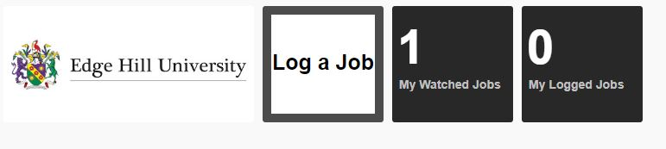

Click this tile.

The tile will open, and you will see the following.

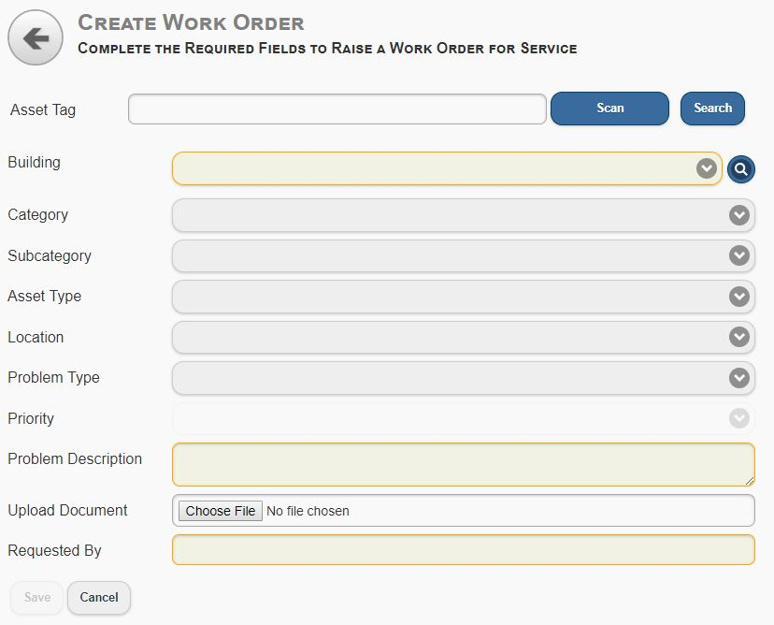
To Log a Job, if you are using a mobile device – phone or tablet; you can scan the asset tag barcode by clicking the Scan button.

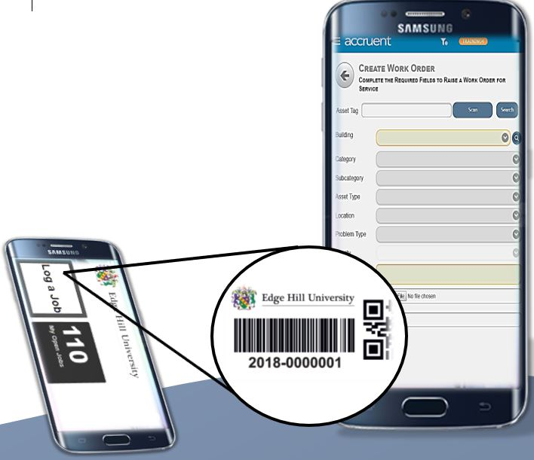
An example of a barcode is below.

Once you scan in the barcode several fields will automatically populate.

If you are using a PC, click the dropdown arrow next to Building field and select your building.

Any fields remaining in yellow will require input from you before you can save the Job.

Please see the below example.

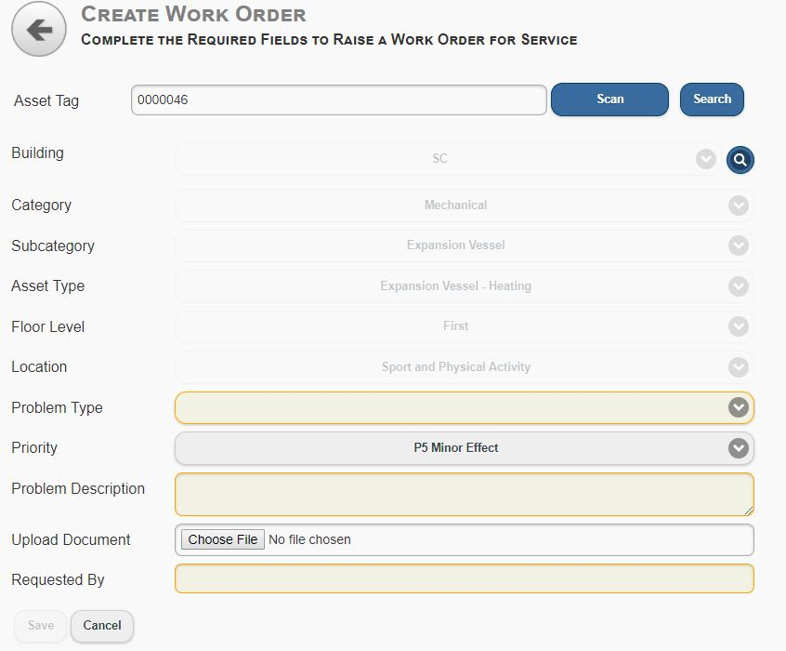
Next you will need to select the Problem Type.

This type will vary depending on the Job you are logging.

In this example Service has been selected from the Problem Type options.

Depending on the Problem Type selected you may have additional required fields to complete.

Required fields are highlighted in yellow.

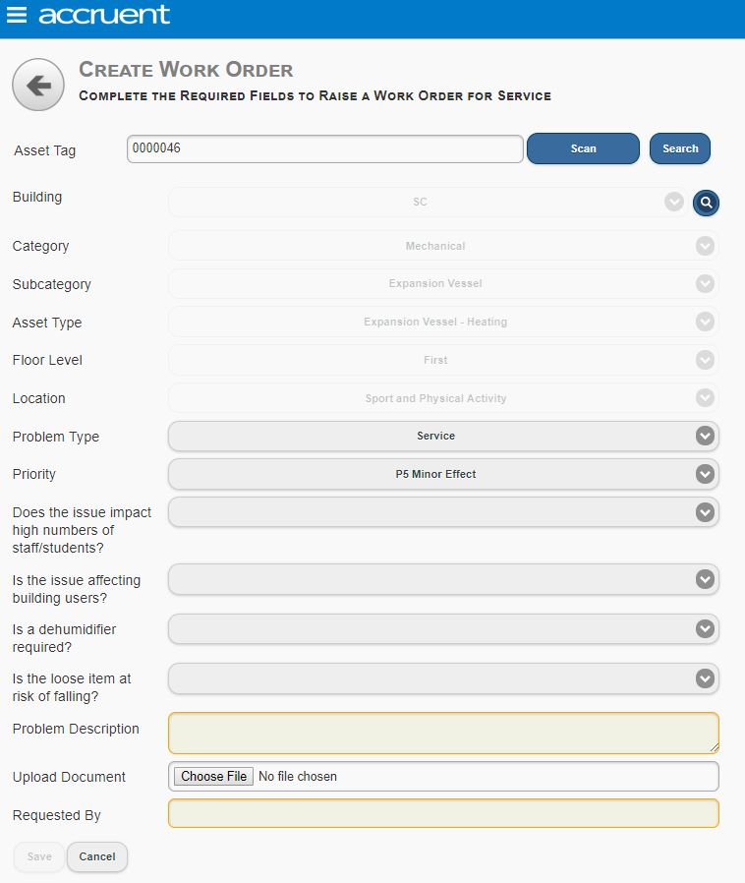
Add in a brief description of the problem into the Problem Description field.

Once you have added text into the description, you have the option to upload an image via the Upload Document field (this is not a required field).

If you do wish to upload an image if you are logging a Job via your mobile device by clicking Choose File your camera will open, and you will be able to take an image via your camera.

If you are logging a Job via a desktop device, a folder within your PC will open when you click Choose File, if you have the image on your PC you will be able to upload the image this way.

Finally, you need to type in your name into the Requested By field once all the required fields have been completed you can click Save.

Once your Job has been logged a message will appear similar to the below.

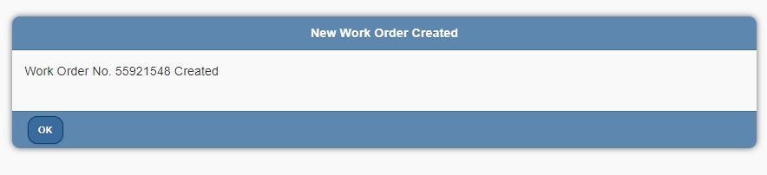

You have now logged a Job, click ok and you will be returned to the page below.
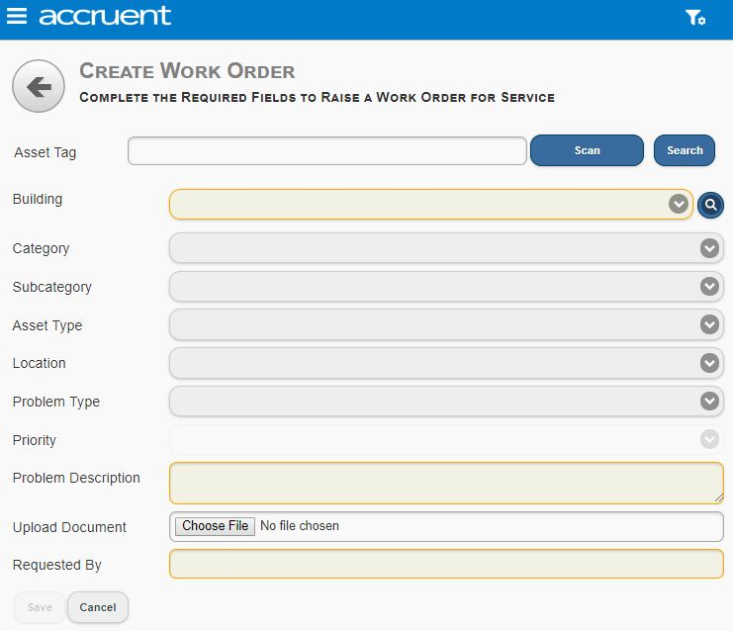

Click the three lines, which are on the top left of this screen and select Dashboard, this will return you to the home screen.

My Watched Jobs

When you Log a Job, you may be shown that a similar job already exists on the system. If you are you will see a screen like below.

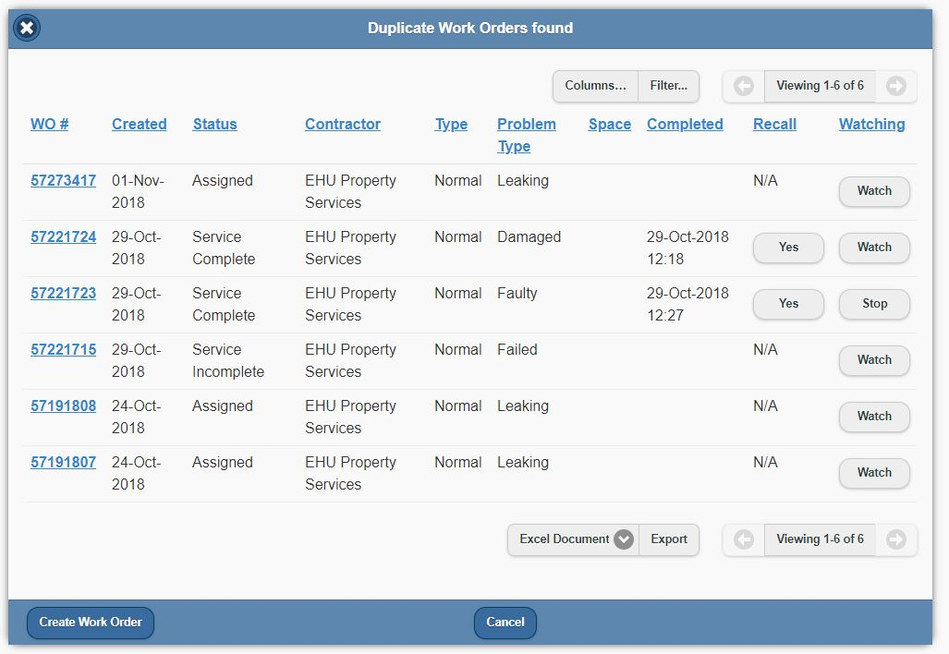

You can see further details on any of these logged jobs by clicking the blue eight-digit number. If this is the same job as you are reporting, you can select to Watch this job. Selecting Watch will ensure you receive updates on this job as it progresses through to completion.

If you select to Watch a Job you DO NOT need to create a new work order. If you select Watch and then Create Work Order you will duplicate the job. Instead select Watch and then Cancel, this ensures you do not create a duplicate Job but will receive updates on any Job you are watching.

Once you press cancel you will be returned to the Log a Job screen from here click the three lines, which are on the top left of this screen and select Dashboard, this will return you to the Home screen.

Once you are Watching a job, on your Dashboard you will see in the My Watched Jobs Tile a number, this is the number of jobs you are currently watching.

Select this tile.

You will be taken to a new screen which gives you an overview of the jobs you are watching and the status of the Job, a description and other relevant information like the below.

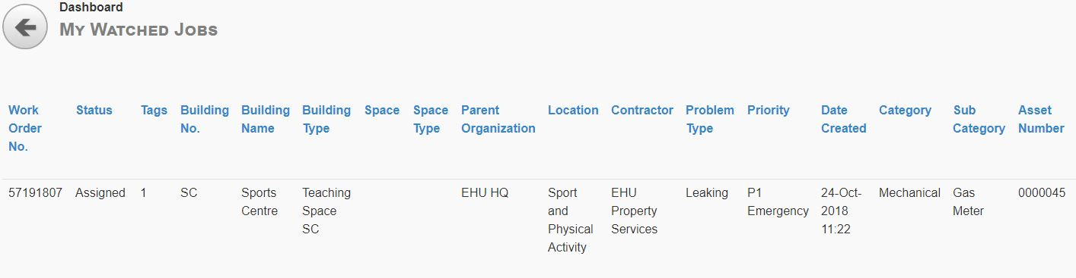

If you wish to stop watching a Job, click the Job and you’ll see a screen like the below.

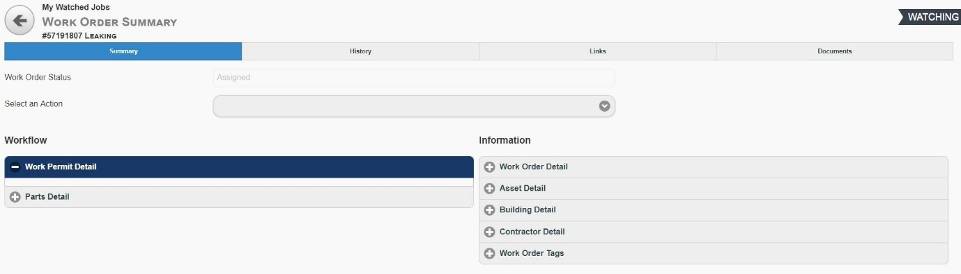

Select from the dropdown menu against Select an Action and click Stop Watching Work Order. Then click the back arrow and you will be returned to My Watched Jobs Dashboard.

My Logged Jobs

On the main dashboard you can check your logged jobs by selecting the My Logged Jobs Tile.

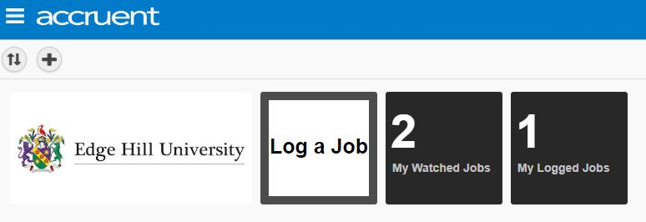

Once you click this tile you will be taken to a new screen which gives you an overview of the jobs you have logged and the status of the Job, a description and other relevant information like the below.

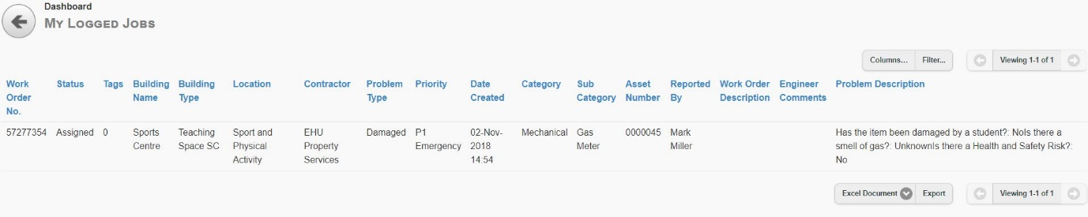

Click the Job and you will be taken to a new screen where you can select more information under Summary, History, Links, Documents.

To return to the Dashboard click the three lines on the top left of the screen and select Dashboard.

Set Default Location

If you are in one building and will only be Logging a Job to that one building you may wish to default your location to that building, to do this on the main dashboard click the three lines situated at the top of the screen.

Select Actions from the drop-down list and select Change Location.

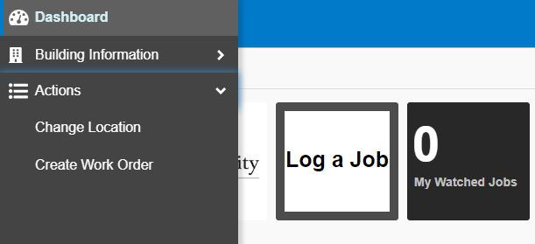

Select your building from the list.
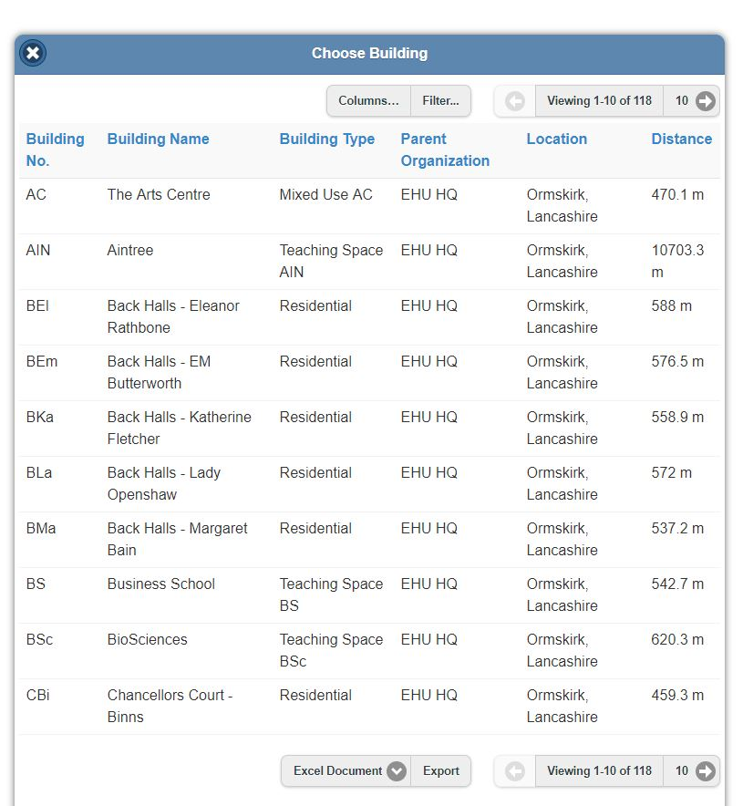

Once you click against your building, this will become your default location, when you next Log a Job your location will automatically be populated.

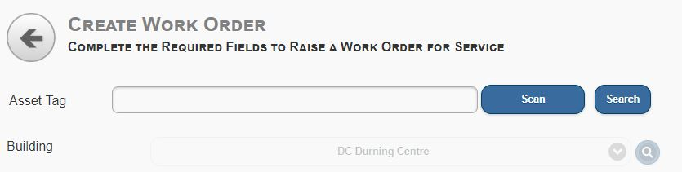

Defaulting your location, automatically applies a filter so you will only see jobs logged against that building.

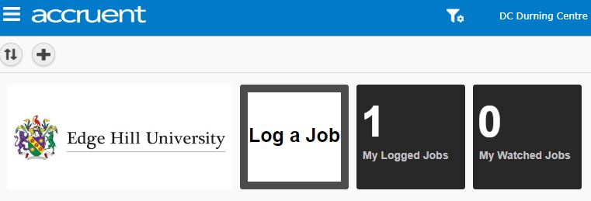

To change your default location, go back to Change Location and click unfiltered this will remove the Building location from your Log a Job screen.

