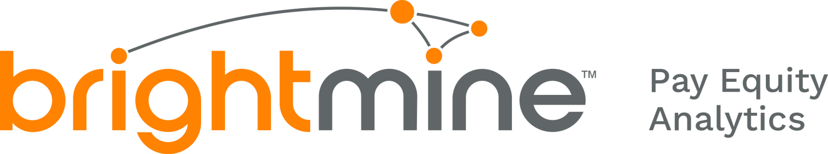

# Edge Hill University

# Gender Pay Gap Reporting

# for dataset: GPG March 2024



This report has been produced for your organisation. It includes all the figures required for Gender Pay Reporting under the Employment Equality Act 1998 (Section 20A) (Gender Pay Gap Information) Regulations 2022.

It also provides a detailed analysis of all your datapoints mapped in the Gapsquare app. This allows your company to break down your organization-wide metrics into smaller groups of employees - for example, you could look at employees by age, job level, business unit, or any other custom label.



## Headline Figures

#### Hourly remuneration

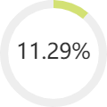Women's **mean hourly rate** is 11.29% less

Mean pay per hour for men: 23.09 Mean pay per hour for women: 20.49

Difference in pay: 2.61

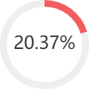Women's **median hourly rate** is 20.37% less

Median pay per hour for men: 20.38 Median pay per hour for women: 16.23 Difference in pay: 4.15



## Headline Figures

#### Quartiles

**Bonus**

| Group | Mean Pay Ms | Mean Pay Fs | Pay Gap (mean) | Pay Gap (median) | Percentage of Ms | Percentage of Fs | Contribution to Pay Gap |
| --- | --- | --- | --- | --- | --- | --- | --- |
| Lower quartile | 12.63 | 12.41 | 1.74% | 3.84% | 26.80% | 73.20% | -4.42% |
| Lower middle quartile | 15.59 | 15.46 | 0.78% | 0.48% | 31.91% | 68.09% | -1.82% |
| Upper middle quartile | 22.42 | 22.12 | 1.34% | 0.58% | 37.58% | 62.42% | 3.57% |
| Upper quartile | 36.12 | 34.81 | 3.63% | 2.9% | 41.90% | 58.10% | 13.97% |

Women's **mean bonus pay** is 28.18% less Women's **median bonus pay** is 0.00% more Proportion of **women receiving** bonus: 2.24% Proportion of **men receiving** bonus: 4.10%



# Pay



## Hourly remuneration

Women's mean hourly rate is 11.29% less Mean pay per hour for men: 23.09

Mean pay per hour for women: 20.49 Difference in pay: 2.61

Women's median hourly rate is: 20.37% less Median pay per hour for men: 20.38

Median pay per hour for women: 16.23 Difference in pay: 4.15



## Detailed Report Analysis By Quartiles

| Group | Mean Pay Ms | Mean Pay Fs | Pay Gap (mean) | Pay Gap (median) | Percentage of Ms | Percentage of Fs | Contribution to Pay Gap |
| --- | --- | --- | --- | --- | --- | --- | --- |
| Lower quartile | 12.63 | 12.41 | 1.74% | 3.84% | 26.80% | 73.20% | -4.42% |
| Lower middle quartile | 15.59 | 15.46 | 0.78% | 0.48% | 31.91% | 68.09% | -1.82% |
| Upper middle quartile | 22.42 | 22.12 | 1.34% | 0.58% | 37.58% | 62.42% | 3.57% |
| Upper quartile | 36.12 | 34.81 | 3.63% | 2.9% | 41.90% | 58.10% | 13.97% |



Contribution of Each Quartile to the Pay Gap

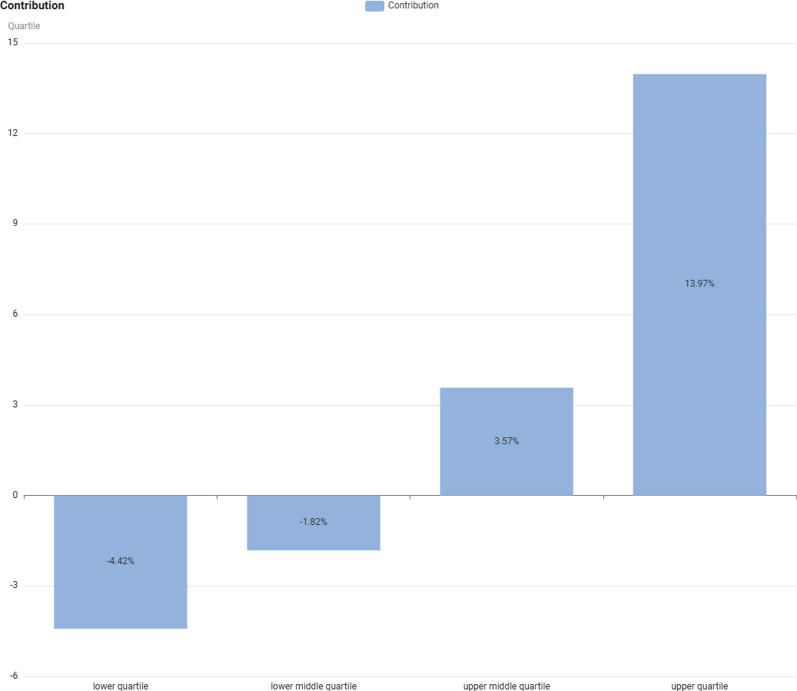The Contribution section shows how a given sub-category (i.e.

Quartile) contributes in percentage points towards your mean pay gap.



Workforce Representation by Quartiles

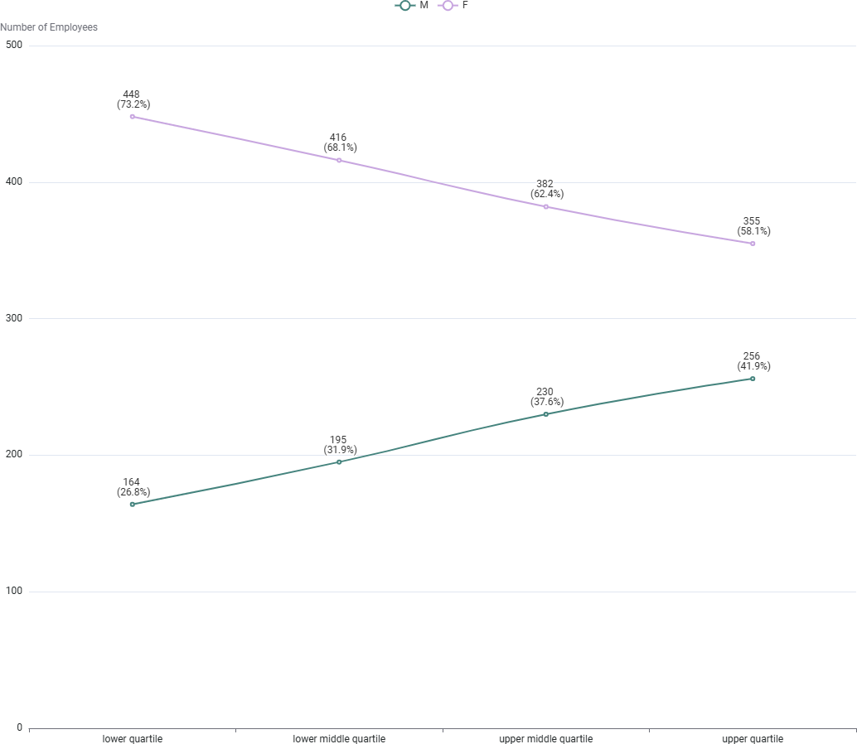This graph shows the data broken down into 4 equally sized groups ranging from the lowest to the highest paid employees.

This graph shows the difference

in the actual numbers of employees within the separate pay quartiles.



Pay Gaps by Quartiles

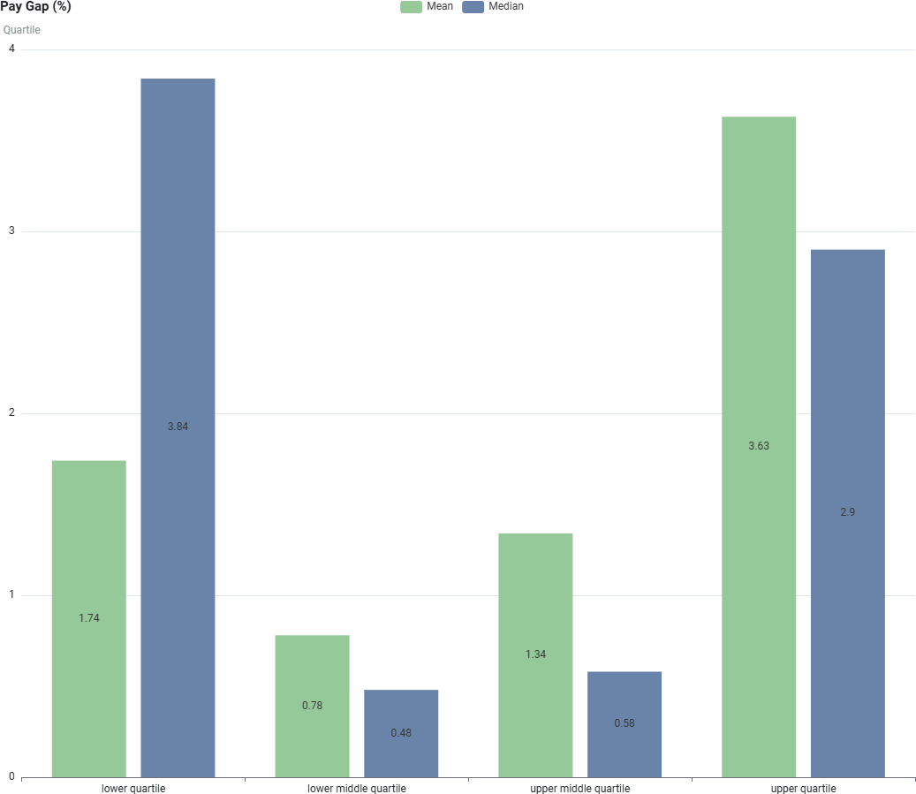Each Quartile has its own separate pay gap, comparing them shows what levels of pay present the key imbalances and breaks down your organisation’s overall pay gap.



Pay Ranges by Quartiles

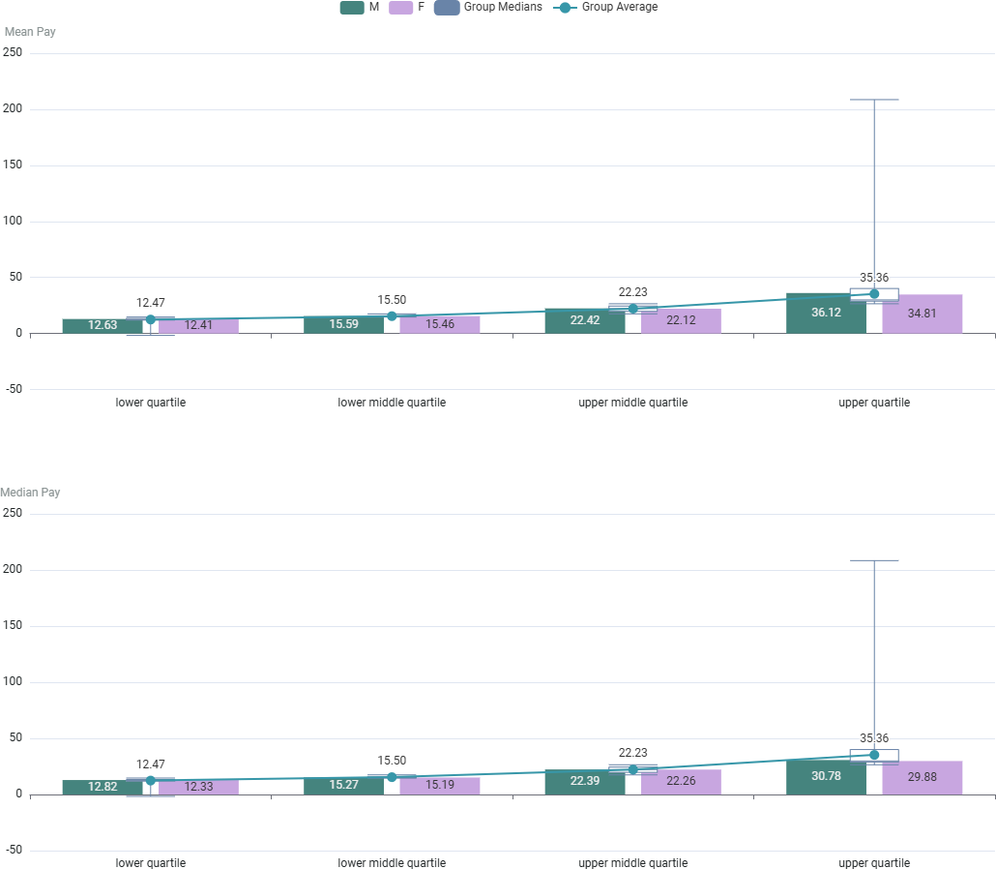This chart shows you the pay ranges that provide the averages of Mean and Median for comparison.



# Bonus



Bonus metrics

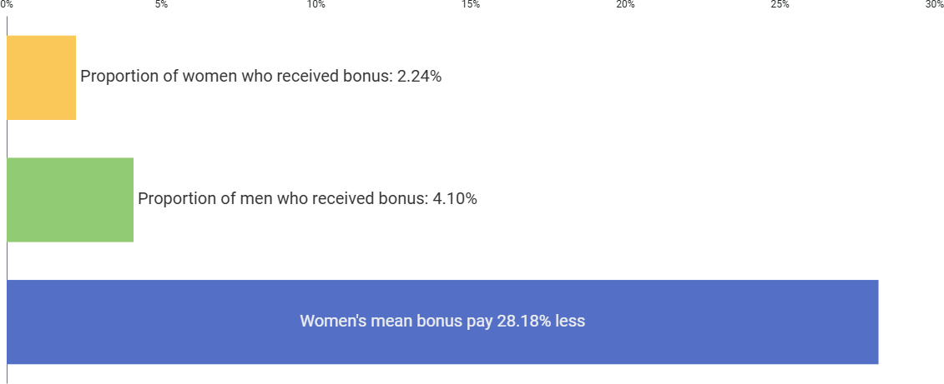



## Detailed Bonus Analysis By Quartiles

| Group | Mean Bonus Pay Ms | Mean Bonus Pay Fs | Bonus Pay Gap (mean) | Bonus Pay Gap (median) | Percentage of Ms | Percentage of Fs | Contribution to Bonus Pay Gap |
| --- | --- | --- | --- | --- | --- | --- | --- |
| Lower quartile | 1410.00 | 1080.00 | 23.4% | 0% | 40.00% | 60.00% | -0.39% |
| Lower middle quartile | 1500.00 | 1500.00 | 0% | 0% | 50.00% | 50.00% | 1.36% |
| Upper middle quartile | 2045.45 | 2076.92 | -1.54% | 0% | 45.83% | 54.17% | -1.43% |
| Upper quartile | 5769.23 | 3818.18 | 33.82% | 0% | 54.17% | 45.83% | 28.64% |



Contribution of Each Quartile to the Bonus Gap

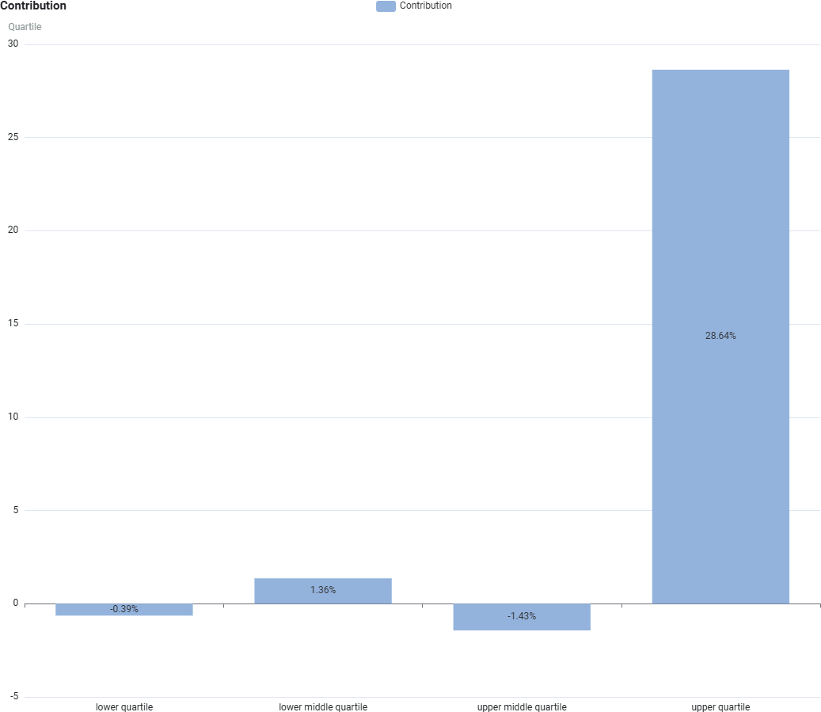The Contribution section shows how a given sub-category (i.e.

Quartile) contributes in percentage points towards your mean bonus pay gap.



Bonus Workforce Representation by Quartiles

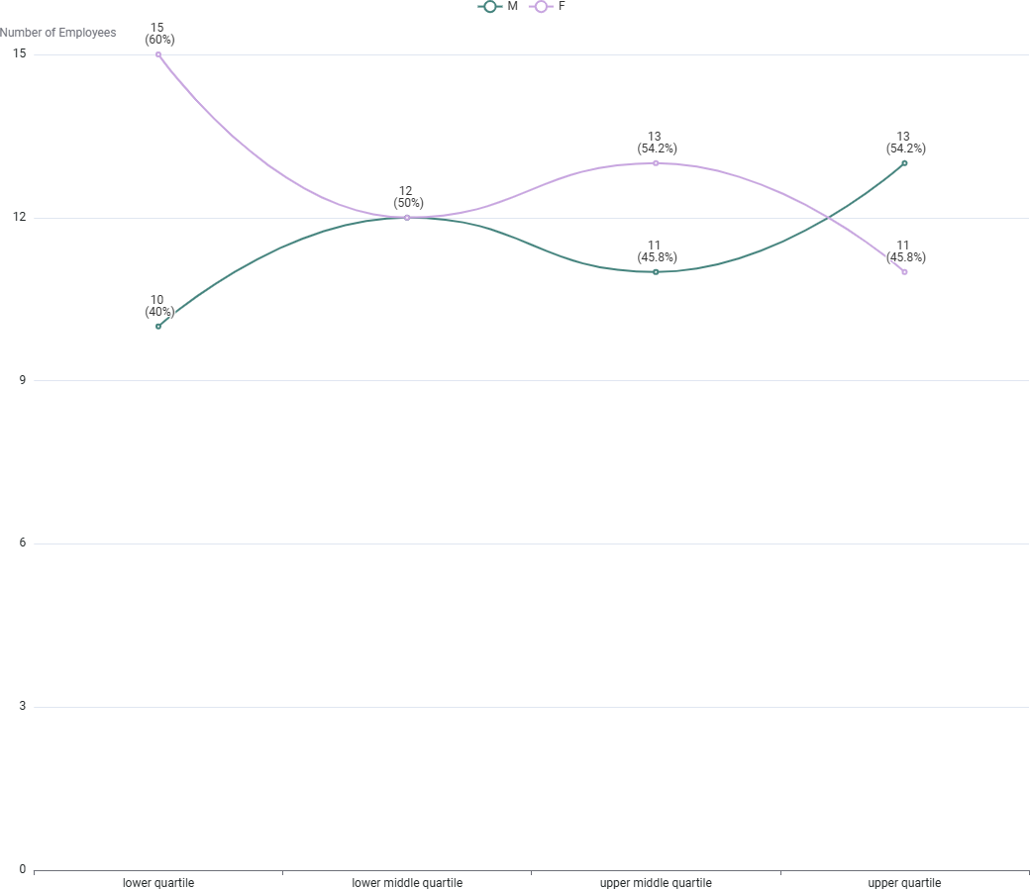This graph shows the data broken down into 4 equally sized groups ranging from the lowest to the highest paid employees.

This graph shows the difference

in the actual numbers of employees within the separate bonus pay quartiles.



Bonus Gaps by Quartiles

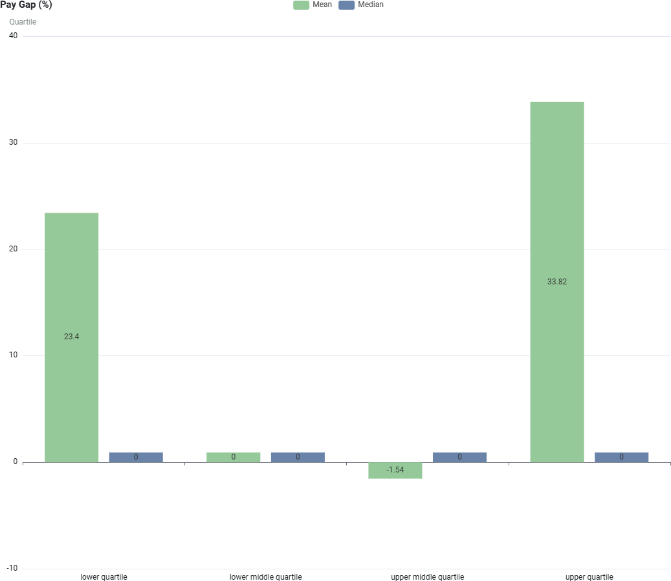Each Quartile has its own separate bonus pay gap, comparing them shows what levels of bonus pay present the key imbalances and breaks down your organisation’s overall bonus pay gap.



Bonus Ranges by Quartiles

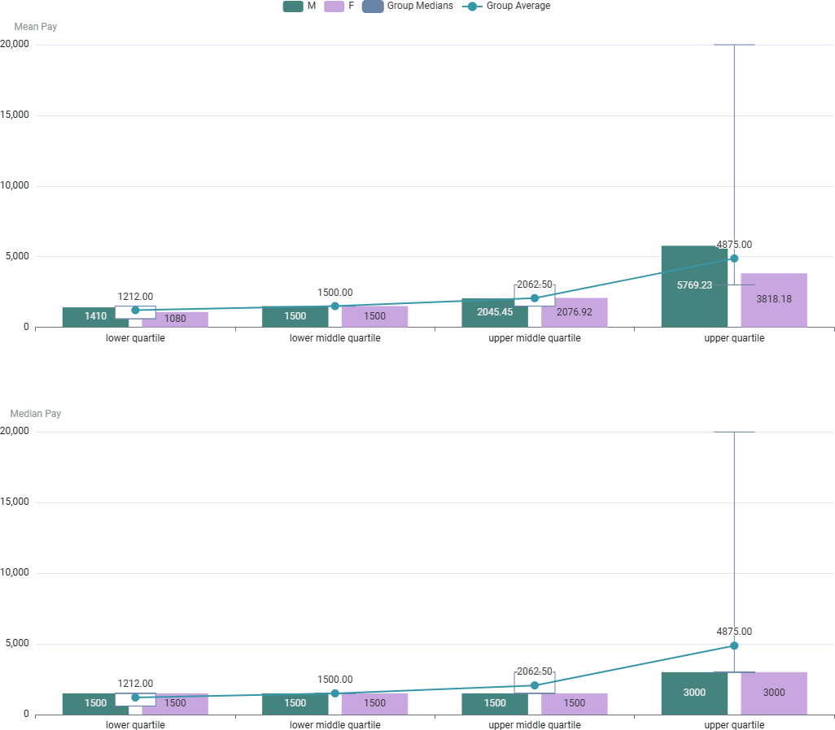This chart shows you the bonus pay ranges that provide the averages of Mean and Median for comparison.



### Gender Pay Gap Analysis – Edge Hill University (March 2024)

###### Summary of Findings

The Gender Pay Gap (GPG) data for Edge Hill University reveals a mean gender pay gap of 11.29% and a median gender pay gap of 20.37%. This is broadly in line with trends across the higher education sector, where pay gaps persist due to structural issues linked to occupational segregation, career progression pathways, and historical patterns of workforce distribution.

###### Key Issues Identified

1. **Workforce Segmentation and Gender Distribution in Pay Quartiles**
   1. Lower Quartiles: There is a significant concentration of women in lower-paid roles, many of which are within professional services and operational areas.
   2. Upper Quartile Representation: Although women are present, they are under-represented in the highest-paid roles, particularly at senior leadership and senior technical levels, where men are more prevalent.

###### Bonus Disparity

* 1. Women’s mean bonus pay is 28.18% lower than men’s, indicating that when bonuses are paid, they are typically higher for men.
  2. Fewer women (2.24%) received bonuses compared to men (4.10%), which suggests that bonus allocation processes and criteria may inadvertently favour male-dominated roles or levels.

###### Professional Services Career Progression

* 1. Similar to the wider sector**,** professional services career pathways are less structured compared to academic pathways, limiting progression opportunities for women concentrated in these roles.
  2. Academic promotions (where clearer criteria exist) tend to support greater pay progression, but this is less evident for professional services staff.

###### Part-Time Working and Flexible Arrangements

* 1. Although not explicitly stated in the dataset, sector-wide data indicates women are more likely to work part-time, particularly in lower grades, which affects their average hourly rate and progression opportunities.



### How Do We Compare to the Sector?

* + - Edge Hill’s **mean GPG of 11.29%** is within the sector average range (typically 10-15% for HE institutions).
    - The **median GPG of 20.37%** is slightly higher than average, which reflects the particular impact of occupational clustering and limited female representation at senior levels.
    - These figures mirror patterns seen across many Post-92 institutions, where women occupy the bulk of administrative, student-facing, and lower-graded roles, with fewer women progressing into the highest-paid roles in estates, IT, and leadership.

### A logo with orange dots and linesNext Steps

###### Accelerate Professional Services Career Pathways

We will fast-track the design and implementation of clear, competency-based career pathways for Professional Services colleagues, ensuring transparent progression criteria and fair access to development and promotion opportunities for women. This will form a core strand of the Employee Experience Project, with work commencing in earnest during 2025, informed by best practice from across the sector and tailored to Edge Hill’s strategic needs.

###### Targeted Leadership Development for Women

We will actively promote and embed opportunities for women to participate in leadership development initiatives such as Aurora, alongside our internal Leadership Programmes. We will also expand the reach and visibility of our Coaching and Mentoring schemes, ensuring they are fully accessible to women at all stages of their careers, with particular focus on supporting aspiring leaders. We will proactively build our internal leadership and succession pipelines, ensuring gender balance is factored into succession planning discussions at all levels.

###### Review and Embed Fair Bonus Allocation Processes

To ensure equity, transparency, and consistency, we will review the current bonus allocation processes and embed Equity Impact Assessments (EIAs) as standard practice before any bonuses are awarded. This will provide an objective check and balance, ensuring bonus awards are free from unintended bias and reflect a fair distribution across all eligible staff.

###### Monitor, Intervene, and Evolve at Key Career Stages

We will track and analyse promotion rates by gender to identify any patterns, barriers, or pinch points where women may be disadvantaged. This data will inform targeted career interventions, including tailored career coaching and mentoring for female staff, particularly those at transition points between grades or roles. Alongside this, we will further embed person-centred Organisational Development (OD) and align strategic Learning and Development activity to foster career resilience and empower women to pursue senior roles with confidence.

###### Strengthen Our Commitment to External Charters

We will continue to actively engage with external equality charters, including Athena Swan, not only to benchmark our progress but to embed meaningful change within our culture. This includes actively creating opportunities for male colleagues to act as visible advocates and allies, driving a more inclusive and balanced culture across the institution.

###### Create a supportive environment that promotes family well-being and prioritises women’s health

We are committed to strengthening our family-friendly policies and advancing our women's health strategy to foster a more inclusive and supportive workplace. By addressing the unique health and well-being needs of women — including physical, mental, and reproductive health — we aim to remove barriers to career progression, enhance work-life balance, and create an environment where all employees can thrive.



## Glossary of terms

##### Group:

The name of the groups is taken from your data, using the same terms you have mapped in the Pay Equity Analytics app.

##### Mean Pay Gap:

The raw difference between men's average pay and women's average pay, usually expressed as a percentage. This can be affected by outliers.

##### Median Pay Gap:

The difference in pay between the middle-paid man and middle-paid woman in your organisation, usually expressed as a percentage. This is less affected by outliers.

##### Quartile:

A division of your entire organisation into four groups of equal numbers, starting from the lowest-paid group (lower quartile) to your highest-paid group (upper quartile).

##### Contribution to Pay Gap:

The number of percentage points a group contributes to your overall mean pay gap, whereby summing all your contributions per group will give you the mean pay gap. Using this, you will see which group contributes most to your organisation's pay gap.



Thank you