


Maths GCSE

Equivalency Exam

Practice Questions

Calculator

Version: 8 September 2021 / Series B



(answers page 87)

1. A cake is made from fat, flour and sugar

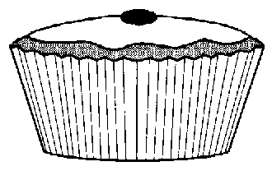
The cake weighs 110g
The weight of the sugar is 42g

(a)(i) What percentage of the weight is sugar?
Give your answer correct to one decimal place.
…………………………………………………………………………………………………………………………………
…………………………………………………………………………………………………………………………………
………………………………………………………………………………………………………………………………… [2]
(ii) The ratio of the weight of flour to the weight of sugar is 3 : 2.
What is the weight of the flour?
…………………………………………………………………………………………………………………………………
…………………………………………………………………………………………………………………………………
………………………………………………………………………………………………………………………………… [2]

Two packets of cereal are priced as shown.
Which packet represents the best value? You must show your working clearly.

260g

98p

500g

£1.88

…………………………………………………………………………………………………………………………………
…………………………………………………………………………………………………………………………………
………………………………………………………………………………………………………………………………… [2]
One Saturday a newsagent sells the following:

National daily newspapers 510
Echo 360
Magazines and comics 210

Draw a clearly labelled pie chart to represent these sales.

.

…………………………………………………………………………………………………………………………………
…………………………………………………………………………………………………………………………………
…………………………………………………………………………………………………………………………………
…………………………………………………………………………………………………………………………………
………………………………………………………………………………………………………………………………… [3]

4. The diagram illustrates a garden.
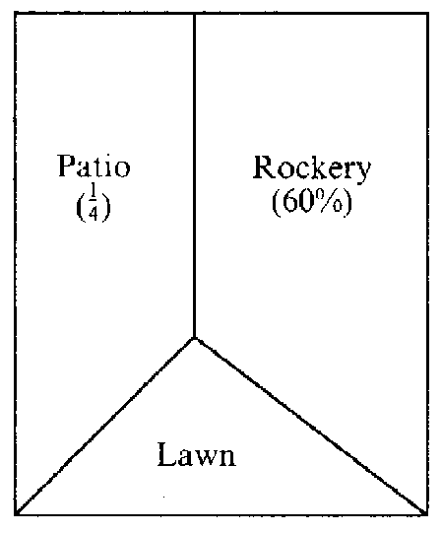
60% of the garden is a rockery.
¼ of the garden is a patio.
What percentage of the garden is lawn?

………………………………………………………………………………………………………………………………..………………………………………………………
……………………………………………………………………………………………
………………………………………………………………………………………………………………………………… [3]

5. (a) Light travels at 186,000 miles per second, to the nearest thousand miles.
Write this number in standard form.
………………………………………………………………………………………………………………………………… [2]

The planet Jupiter is 486.6 million miles from the sun.
Calculate how long the light takes to travel from the sun to Jupiter.
Give your answer to the nearest minute.
…………………………………………………………………………………………………………………………………
…………………………………………………………………………………………………………………………………
…………………………………………………………………………………………………………………………………
………………………………………………………………………………………………………………………………… [3]

6. Mrs Jones earns £21,000 per annum. Her annual pay rise this year
is 3%. What will her new salary be?
…………………………………………………………………………………………………………………………………
…………………………………………………………………………………………………………………………………
………………………………………………………………………………………………………………………………… [2]

7. Darren drives 38km at an average speed of 63km per hour
Calculate how long his journey takes. Give your answer in minutes.
…………………………………………………………………………………………………………………………………
…………………………………………………………………………………………………………………………………
………………………………………………………………………………………………………………………………… [2]

8. A ladder, 2.75m long leans against a wall.
The bottom of the ladder is 1.80m from the wall, on level ground.

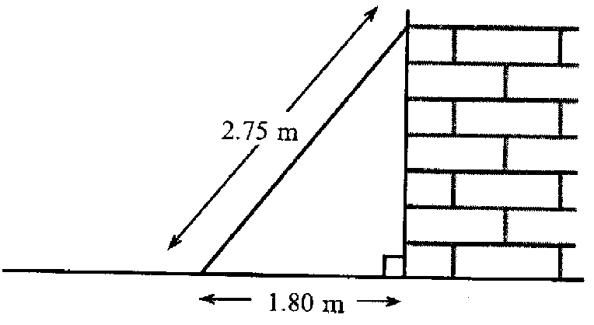

Calculate how far the ladder reaches up the wall.
Give your answer to an appropriate degree of accuracy.
…………………………………………………………………………………………………………………………………
…………………………………………………………………………………………………………………………………
…………………………………………………………………………………………………………………………………
…………………………………………………………………………………………………………………………………
…………………………………………………………………………………………………………………………………
………………………………………………………………………………………………………………………………… [3]

9. The scatter diagram shows the heights of sixteen Year 9 boys and their
fathers.
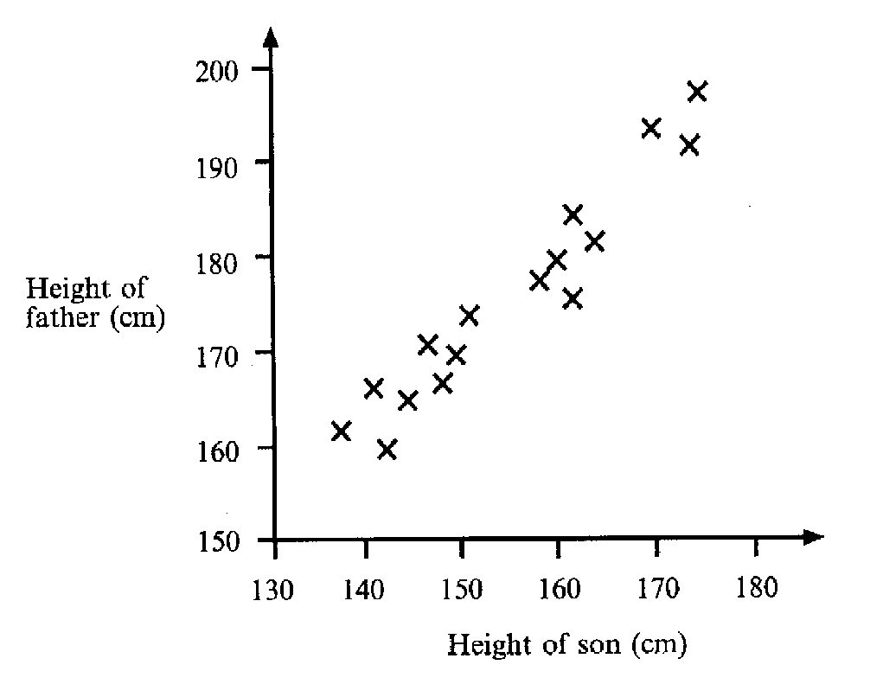
(a) What does the scatter diagram tell you about the relationship between the heights of these boys and their fathers?
…………………………………………………………………………………………………………………………………
…………………………………………………………………………………………………………………………………
………………………………………………………………………………………………………………………………… [1]
(b) Draw a line of best fit on the diagram. [1]

(c) Bill, another Year 9 boy, is 155cm tall.
Use the diagram to estimate the height of Bill’s father.
Show clearly how you obtained your answer.

…………………………………………………………………………………………………………………………………
…………………………………………………………………………………………………………………………………
………………………………………………………………………………………………………………………………… [2]

10. Given that y = x² + 1
(a) Complete the table below,
x | 0 | 1 | 2 | 3 | 4 | 5 | 6
y |  |  |  | 10 |  |  | 37
[2]
Plot these points on the grid below and hence draw the graph of y = x² + 1
[2]
Use your graph to find the value of x when y = 30
………………………………………………………………………………………………………………………………… [1]
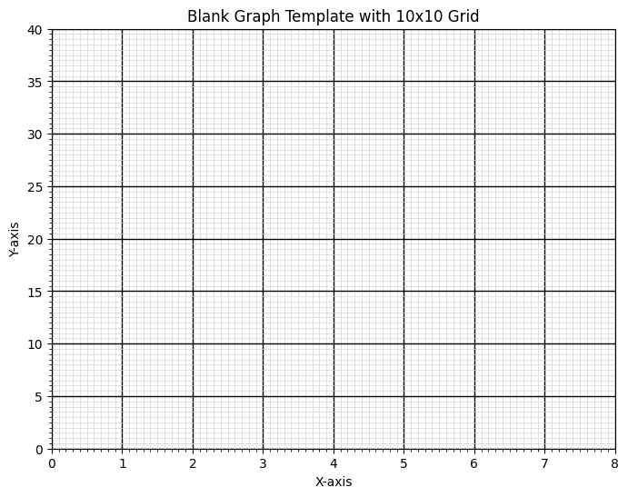

11. Use trial and improvement to solve the equation x³ + x² = 500
One trial has been completed for you.
Show all your trials.
Give your answer correct to 1 decimal place.

x | x³ + x²
7 | 7³ + 7² = 392 | Too small

………………………………………………………………………………………………………………………………… [4]
12. The diagram shows a map of a group of islands.
The map has been drawn to a scale of 1cm to 5km.
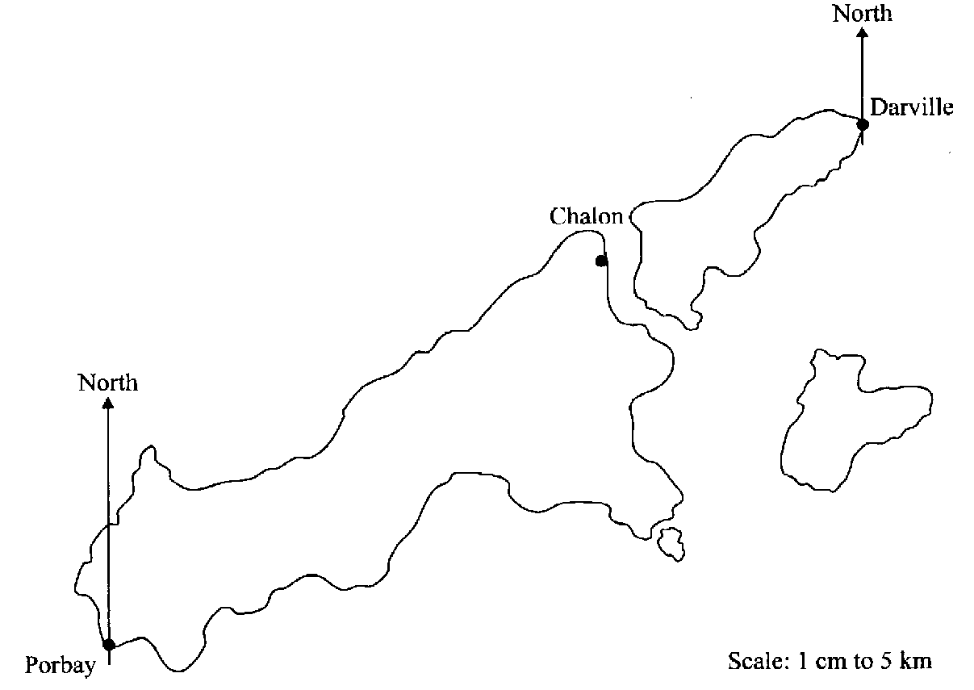

(a) A straight road joins Porbay to Chalon.

Use the map to find the length of this road in kilometres.
…………………………………………………………………………………………………………………………………
…………………………………………………………………………………………………………………………………
………………………………………………………………………………………………………………………………… [2]
(ii) Brian cycles to Porbay along this road.
He sets off at 0930 and cycles at an average speed of 18km per hour.
At what time does he arrive in Chalon?
…………………………………………………………………………………………………………………………………
…………………………………………………………………………………………………………………………………
…………………………………………………………………………………………………………………………………
………………………………………………………………………………………………………………………………… [2]

A lighthouse is on a bearing of 080º from Porbay and 200º from Darville.
Mark, with a cross, the position of the light house on the map.
[3]
13. A wire 18cm long runs from the top of a pole to the ground as shown in the diagram.
The wire makes an angle of 35º with the ground.

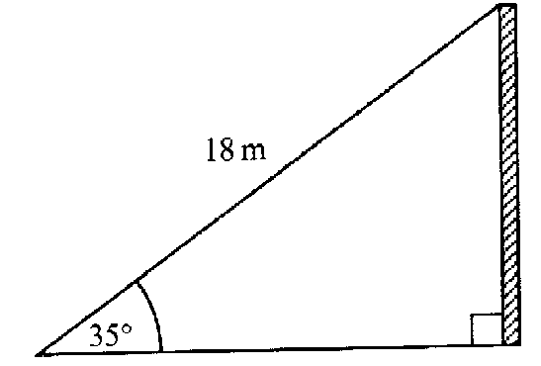

Calculate the height of the pole.
Give your answer to a suitable degree of accuracy.
…………………………………………………………………………………………………………………………………
…………………………………………………………………………………………………………………………………
…………………………………………………………………………………………………………………………………
………………………………………………………………………………………………………………………………… [4]

14. An Athletics stadium has 35,000 seats.
4% of the seats are fitted with headphones to help people hear the announcements.
How many headphones are there in the stadium?
…………………………………………………………………………………………………………………………………
…………………………………………………………………………………………………………………………………
………………………………………………………………………………………………………………………………… [2]

15. Use a calculator to find the value of

(a) 3.86 + 17.59
5 …………………………………………………………………………………………………… [1]

(b) 9.76 + 1.87
18.3 – 15.8 …………………………………………………………………………………………………… [1]

Question continues over page >
(c) 330
1.2 x 5.5 …………………………………………………………………………………………………… [1]

(d) 1
√(0.16) …………………………………………………………………………………………………… [1]

16. Louise does a sponsored bicycle ride.
Each wheel of her bicycle is of radius 25 cm.

(a) Calculate the circumference of one of the wheels
…………………………………………………………………………………………………………………………………
…………………………………………………………………………………………………………………………………
………………………………………………………………………………………………………………………………… [2]
She cycles 50km. How many revolutions does a wheel make during the sponsored ride? Give your answer to 3 significant figures.

…………………………………………………………………………………………………………………………………
…………………………………………………………………………………………………………………………………
…………………………………………………………………………………………………………………………………
………………………………………………………………………………………………………………………………… [3]

17. In a sale a dress costs £28.90.
The original price has been reduced by 15%
What was the original price?
…………………………………………………………………………………………………………………………………
…………………………………………………………………………………………………………………………………
………………………………………………………………………………………………………………………………… [2]

18. Katy is using trial and improvement to find an answer to the equation
x³ – x = 35
The table shows her first two tries.

x | x³ - x | Comment
3 | 24 | Too low
4 | 60 | Too high

Continue the table to find a solution to the equation.
Give your answer correct to 1 decimal place.
…………………………………………………………………………………………………………………………………
………………………………………………………………………………………………………………………………… [4]

19. On a computer keyboard there are 104 keys
(a) 26 of the keys have letters on them
What fraction of the keys have letters on them? Give your answer in its simplest form.
………………………………………………………………………………………………………………………………… [2]

13 of the keys have arrows on them.
What percentage of the keys on the keyboard have arrows on them?
…………………………………………………………………………………………………………………………………
………………………………………………………………………………………………………………………………… [2]
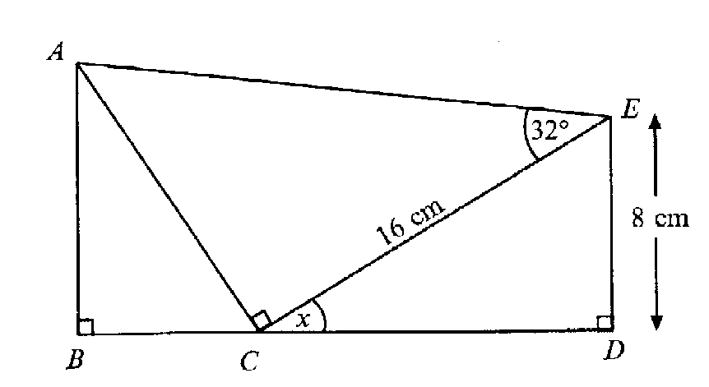

20.

the diagram is not drawn to scale

BCD is a straight line. CE = 16 cm

(a) Calculate the size of the angle marked x
…………………………………………………………………………………………………………………………………
…………………………………………………………………………………………………………………………………
………………………………………………………………………………………………………………………………… [3]

Calculate the length of AC
…………………………………………………………………………………………………………………………………
…………………………………………………………………………………………………………………………………
………………………………………………………………………………………………………………………………… [2]
Use your answers to parts (a) and (b) to calculate the length of BC
…………………………………………………………………………………………………………………………………
…………………………………………………………………………………………………………………………………
………………………………………………………………………………………………………………………………… [3]

21. On a motorway there are three lanes, an inside lane, a middle lane and an outside
lane.

On day, at midday, the speed of the traffic on these lanes was in the ration 3:4:5.

The speed on the outside lane was 70 miles per hour.
Calculate the speed on the inside lane.
…………………………………………………………………………………………………………………………………
………………………………………………………………………………………………………………………………… [2]

22. When a model is fired in a kiln, the probability that it shrinks is 0.95.
When taken out to cool, the probability that it cracks is 0.04
(a) What is the probability that when a model is fired it does not shrink?
…………………………………………………………………………………………………………………………………
…………………………………………………………………………………………………………………………………
[2]

A model is fired in a kiln and then taken out to cool.
Complete the tree diagram
Write all the missing probabilities on the appropriate branches
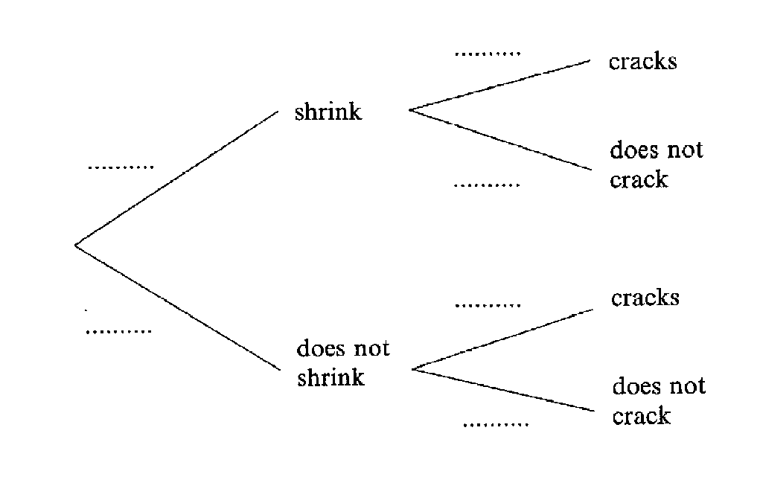

[2]
Calculate the probability that the model shrinks and also cracks.
…………………………………………………………………………………………………………………………………
…………………………………………………………………………………………………………………………………
…………………………………………………………………………………………………………………………………
………………………………………………………………………………………………………………………………… [2]

23. Graham and Wendy go ten pin bowling.
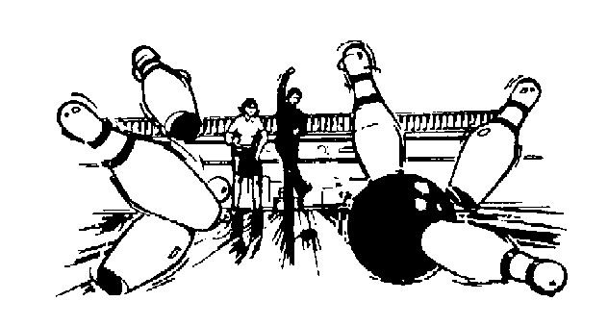

(a) Graham’s first eight scores are:
5, 8, 8, 5, 5, 6, 6, 5
What is his mean score?

…………………………………………………………………………………………………………………………………
…………………………………………………………………………………………………………………………………
………………………………………………………………………………………………………………………………… [2]
Wendy’s first eight scores are:
5, 8, 2, 2, 9, 3, 2, 9
(i) What is her modal score?
…………………………………………………………………………………………………………………………………
………………………………………………………………………………………………………………………………… [1]
(ii) What is the range for Wendy’s scores?
…………………………………………………………………………………………………………………………………
………………………………………………………………………………………………………………………………… [1]
Who is the better bowler?
Give a reason for your answer.
…………………………………………………………………………………………………………………………………
…………………………………………………………………………………………………………………………………
…………………………………………………………………………………………………………………………………
………………………………………………………………………………………………………………………………… [2]

24. Jane conducted a survey about what her neighbours did on bonfire night. Her results are summarised in the table below.

Stayed at home | 37
Went to the park | 83
Went to a friend’s house | 42
Went to the cinema | 3
Didn’t reply | 15
Total | 180

Jane was asked to draw a pie chart to illustrate these results.
What angle should she use for ‘Went to the park’?
…………………………………………………………………………………………………………………………………………
…………………………………………………………………………………………………………………………………………
…………………………………………………………………………………………………………………………………………
[3]

25. In a general election, a candidate loses her/his deposit if s/he does not get at
least 5% of the total votes cast.
Mary Ashworth, John Barnard and Bill Crowther are the only three candidates in the General Election in Bradworth.

5235 people voted for John Barnard
425 people voted for Bill Crowther

Bill Crowther kept his deposit because he got 5% of all the total votes cast.
How many people voted for Mary Ashworth?

…………………………………………………………………………………………………………………………………………
…………………………………………………………………………………………………………………………………………
…………………………………………………………………………………………………………………………………………
…………………………………………………………………………………………………………………………………………
…………………………………………………………………………………………………………………………………………
…………………………………………………………………………………………………………………………………………
[3]

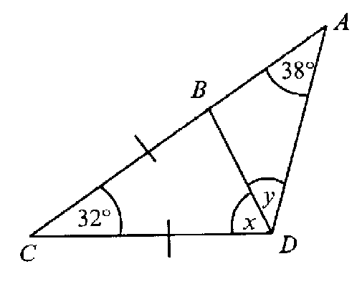
26.

In the diagram CB = CD
Calculate the size of the angle marked x
…………………………………………………………………………………………………………………………………………
…………………………………………………………………………………………………………………………………………
…………………………………………………………………………………………………………………………………………
[2]
Calculate the size of the angle marked y
…………………………………………………………………………………………………………………………………………
…………………………………………………………………………………………………………………………………………
…………………………………………………………………………………………………………………………………………
[2]
Does AB = BD?
Give as reason for your answer
…………………………………………………………………………………………………………………………………………
…………………………………………………………………………………………………………………………………………
…………………………………………………………………………………………………………………………………………
[1]

27. The sketch shows triangle ABC.
AB = 40cm, AC = 41cm and CB = 9cm
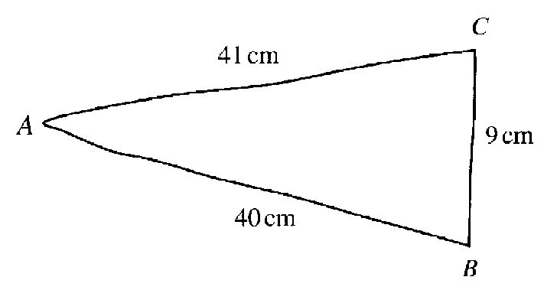
Not drawn accurately

By calculation, show that triangle ABC is a right angled triangle.
…………………………………………………………………………………………………………………………………………
…………………………………………………………………………………………………………………………………………
…………………………………………………………………………………………………………………………………………
…………………………………………………………………………………………………………………………………………
…………………………………………………………………………………………………………………………………………
[2]

28.(a) The distance from the earth to the moon is approximately 384,000 km.
Write this distance in standard form.
…………………………………………………………………………………………………………………………………………
…………………………………………………………………………………………………………………………………………
[2]
(b) Write these numbers in order, starting with the smallest:
8.17 x 10³ 5.55 x 10⁻⁵ 2.88 x 10² 7.22 x 10⁻⁵ 5.27 x 10⁵

…………………………………………………………………………………………………………………………………………
………………………………………………………………………………………………………………………………………[2]

29. Use trial and improvement to solve the equation x³ – 2x = 30
Two trials have been completed for you.
Show all your trials.
Give your answer correct to 1 decimal place.

X | x³ – 2x
3 | 3³ – 6 = 21 | Too small
4 | 4³ – 8 = 56 | Too big

[4]
30. A formula is given as v = u + at
(a) Calculate v when a = 3, t = 1.5 and u = 2
…………………………………………………………………………………………………………………………………………
…………………………………………………………………………………………………………………………………………
…………………………………………………………………………………………………………………………………………
[1]

(b) Re-arrange the formula to make a the subject
…………………………………………………………………………………………………………………………………………
…………………………………………………………………………………………………………………………………………
…………………………………………………………………………………………………………………………………………
[2]

Calculate a when v = 10, u = 3 and t = 5
…………………………………………………………………………………………………………………………………………
…………………………………………………………………………………………………………………………………………
…………………………………………………………………………………………………………………………………………
[2]

31(a) Write down a decimal that lies between and .
1
6
1
5

………………………………………………………………………………………………………………………………………
[1]
(b) Which of these two fractions is the bigger?
2
7
3
5
or

Show your working

………………………………………………………………………………………………………………………………………
………………………………………………………………………………………………………………………………………
………………………………………………………………………………………………………………………………………
[

32. A child’s hula hoop has a diameter of 80cm.

(a) What is the circumference of the hula hoop?

…………………………………………………………………………………………………………………………………………
…………………………………………………………………………………………………………………………………………
…………………………………………………………………………………………………………………………………………
[2]

(b) Jenny pushed the hula hoop along a 20 m path. How many complete turns did the hula hoop make?
…………………………………………………………………………………………………………………………………………
…………………………………………………………………………………………………………………………………………
…………………………………………………………………………………………………………………………………………
…………………………………………………………………………………………………………………………………………
[2]

This is an architect’s plan for a new church kitchen.

Scale 1:50
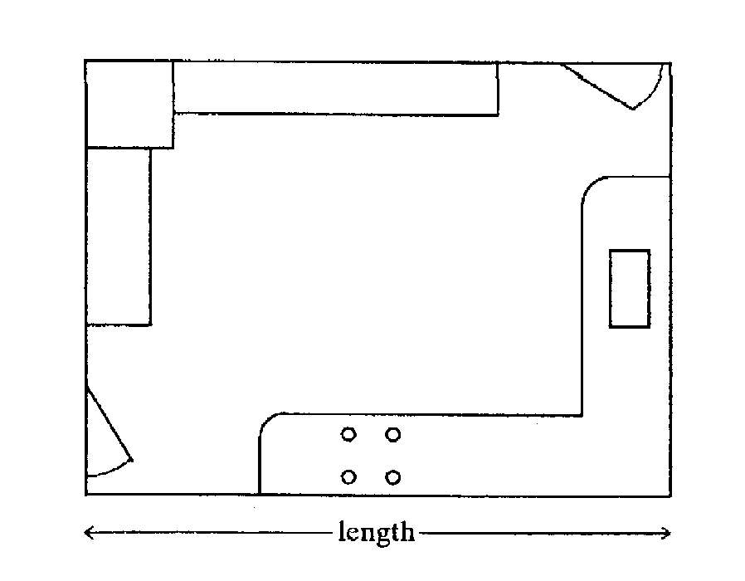

What is the actual length of the kitchen? Give your answer in metres.
…………………………………………………………………………………………………………………………………………
…………………………………………………………………………………………………………………………………………
………………………………………………………………………………………………………………………………………… [2]

Question continues over page >

(b) The doorways are 90cm wide. To improve disabled access, it has been decided that the doorways should be increased by 30%. How wide will they be after the work has been completed?

…………………………………………………………………………………………………………………………………………
…………………………………………………………………………………………………………………………………………
…………………………………………………………………………………………………………………………………………
[2]

34. Solve the equation
3x – 9 = 5x - 5
…………………………………………………………………………………………………………………………………………
…………………………………………………………………………………………………………………………………………
…………………………………………………………………………………………………………………………………………
[2]

35. Snooker is played with 15 red balls, 6 other coloured balls and one white ball. All 22 balls are kept in a box.

A ball is taken out of the box at random.
What is the probability that it is a red ball?
…………………………………………………………………………………………………………………………………………
………………………………………………………………………………………………………………………………………[1]

(b) The ball is put back in the box and another ball is taken out at random.
Calculate the probability that both balls taken out are red.
…………………………………………………………………………………………………………………………………………
…………………………………………………………………………………………………………………………………………
………………………………………………………………………………………………………………………………………[2]

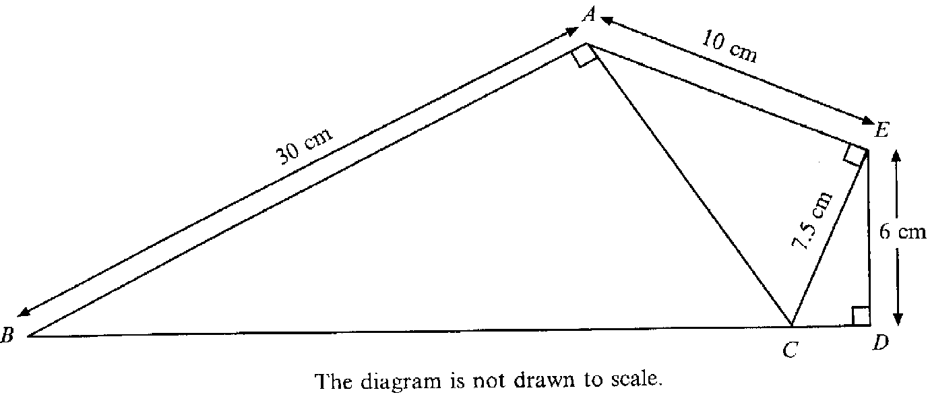
36.

Use Pythagoras’ Theorem to calculate
(a) The length of CD
…………………………………………………………………………………………………………………………………………
…………………………………………………………………………………………………………………………………………
…………………………………………………………………………………………………………………………………………
…………………………………………………………………………………………………………………………………………
……………………………………………………………………………………………………………………………………[2]

(b) The length of CB
…………………………………………………………………………………………………………………………………………
…………………………………………………………………………………………………………………………………………
…………………………………………………………………………………………………………………………………………
…………………………………………………………………………………………………………………………………………
…………………………………………………………………………………………………………………………………………
…………………………………………………………………………………………………………………………………………
…………………………………………………………………………………………………………………………………………
…………………………………………………………………………………………………………………………………………
………………………………………………………………………………………………………………………………………[3]

37. Find the value of ab² + $\frac{b}{a}$ when a = 5 and b = - 3
…………………………………………………………………………………………………………………………………………
…………………………………………………………………………………………………………………………………………
………………………………………………………………………………………………………………………………………[2]

38. The diagram shows a regular 12 sided polygon (called a dodecagon).
Each interior angle is 150º.
The lines BK and DI have been drawn.
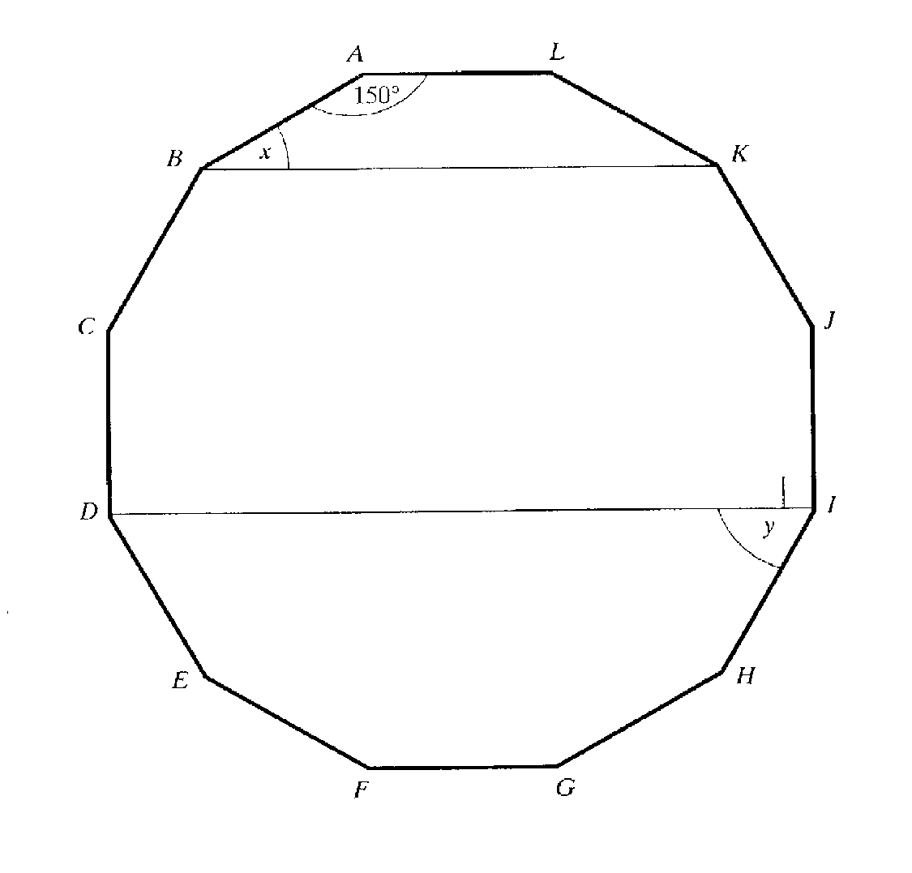

(a) What is the special name for the polygon ALKB?
…………………………………………………………………………………………………………………………………………
………………………………………………………………………………………………………………………………………[1]

(b) Calculate the size of the angle marked x.
…………………………………………………………………………………………………………………………………………
…………………………………………………………………………………………………………………………………………
………………………………………………………………………………………………………………………………………[2]
(c) Calculate the size of the angle marked y.
…………………………………………………………………………………………………………………………………………
…………………………………………………………………………………………………………………………………………
………………………………………………………………………………………………………………………………………[2]

39. The distance from the planet Earth to Kronos is 35 000 000 000 000 000 miles.
Write this number in standard form.
…………………………………………………………………………………………………………………………………………
………………………………………………………………………………………………………………………………………[2]

40. A ‘No Entry’ sign consists of a white rectangle on a red circle as shown:
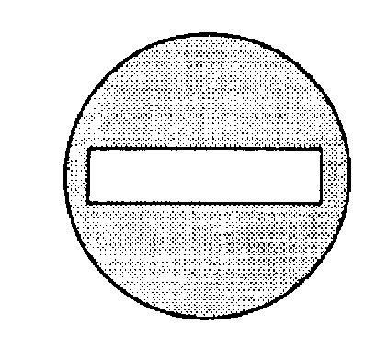

The sign has a radius of 35cm and the white rectangle is 60cm long and 10cm wide.

(a) What is the perimeter of the white rectangle?
…………………………………………………………………………………………………………………………………
……………………………………………………………………………………………………………………… [1]

(b) Find the area that is painted red.
…………………………………………………………………………………………………………………………………
…………………………………………………………………………………………………………………………………
…………………………………………………………………………………………………………………………………
………………………………………………………………………………………………………………………………… …………………………………………………………………………………………………………………………………
………………………………………………………………………………………………………………………………… …………………………………………………………………………………………………………………………[4]

41. A ‘Travel Saver Card’ entitles the holder to 40% off the normal price of a journey.

A particular journey normally costs £28.50.
How much would it cost with a Travel Saver Card?
……………………………………………………………………………………………………………………………………… ………………………………………………………………………………………………………………………………………
………………………………………………………………………………………………………………………………………
………………………………………………………………………………………………………………………………………[2]

42. The diagram shows a ladder leaning against a wall.
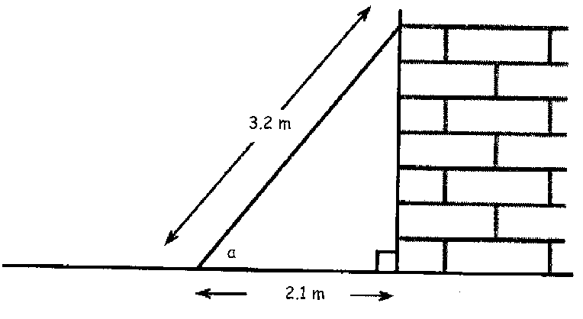

Calculate the size of angle a.
……………………………………………………………………………………………………………………………………… ………………………………………………………………………………………………………………………………………
……………………………………………………………………………………………………………………………………… ………………………………………………………………………………………………………………………………………[3]

43. There are two parts to a driving test, a theory test and a practical test.
You must pass the theory test before you are allowed to take the practical test.

Rob is taking his driving test.

The probability that he passes the theory test is 0.7
The probability that he passes the practical test is 0.9

(a) The tree diagram shows the possible outcomes. Fill in the missing probabilities.
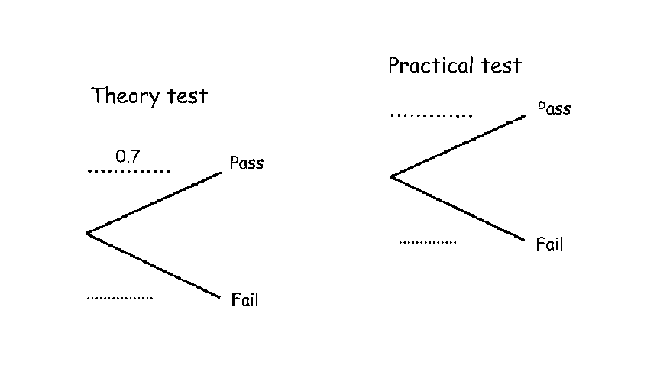

(b) Calculate the probability that Rob passes both parts of his driving test.
………………………………………………………………………………………………………………………………………
………………………………………………………………………………………………………………………………………
………………………………………………………………………………………………………………………………………[2]
(c) Calculate the probability that he passes the theory test but fails the practical test.
………………………………………………………………………………………………………………………………………
………………………………………………………………………………………………………………………………………
………………………………………………………………………………………………………………………………………
………………………………………………………………………………………………………………………………………[2]
(d) Calculate the probability that he fails the driving test.
………………………………………………………………………………………………………………………………………
………………………………………………………………………………………………………………………………………
………………………………………………………………………………………………………………………………………[2]

44. The cash price of a mountain bike is £1049
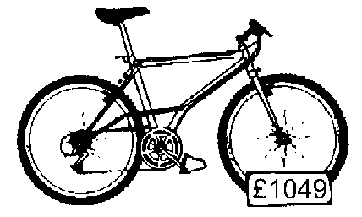

Fred buys the bike by paying a £200 deposit and 12 monthly instalments of £75.
How much more than the cash price does Fred pay?

………………………………………………………………………………………………………………………………………
…………………………………………………………………………………………………………………………………………
…………………………………………………………………………………………………………………………………………
………………………………………………………………………………………………………………………………………[2]

45. Solve the equation
3x + 8 = 23 – 3x
…………………………………………………………………………………………………………………………………………
…………………………………………………………………………………………………………………………………………
…………………………………………………………………………………………………………………………………………
…………………………………………………………………………………………………………………………………… [2]

46. Circular tops are stamped out of a sheet of metal like the one shown in the diagram below.
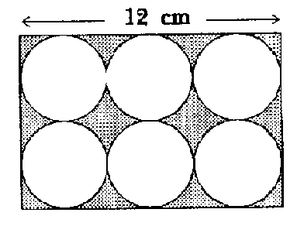

How much of the material is waste?
…………………………………………………………………………………………………………………………………………
…………………………………………………………………………………………………………………………………………
…………………………………………………………………………………………………………………………………………
…………………………………………………………………………………………………………………………………………
…………………………………………………………………………………………………………………………………………
……………………………………………………………………………………………………………………………………[5]

47. A girder is 5m long. Its cross section is L shaped as shown below.

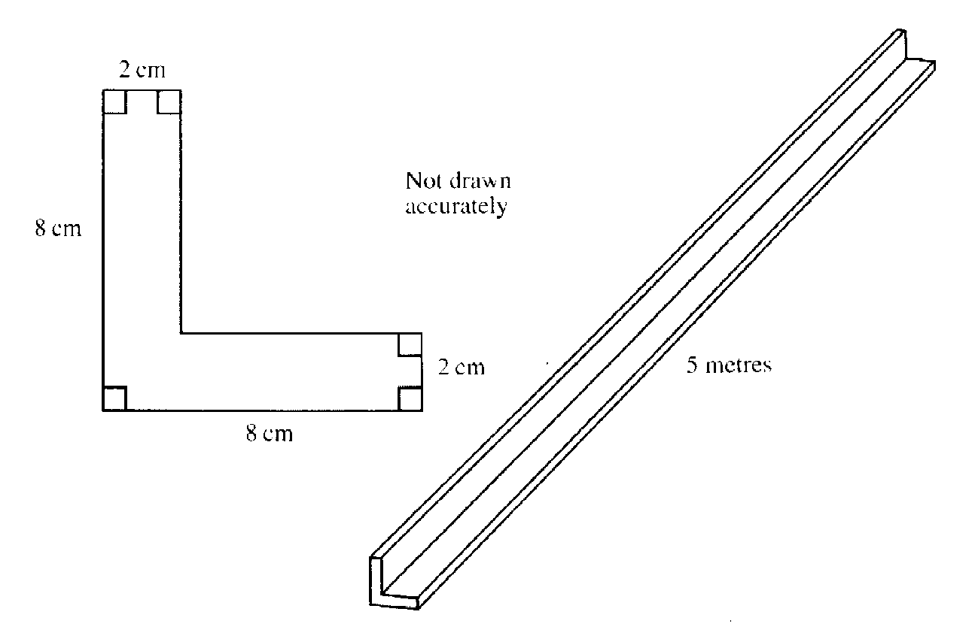

Find the volume of the girder. Remember to state the units in your answer.
…………………………………………………………………………………………………………………………………………
…………………………………………………………………………………………………………………………………………
…………………………………………………………………………………………………………………………………………
…………………………………………………………………………………………………………………………………………
…………………………………………………………………………………………………………………………………………
…………………………………………………………………………………………………………………………………………
…………………………………………………………………………………………………………………………………… [5]

48. The distance between Heysham and the Isle of Man is 80m.
A hovercraft travels at 50km per hour.
How long does the journey take? Give your answer in hours and minutes
…………………………………………………………………………………………………………………………………………
…………………………………………………………………………………………………………………………………………
…………………………………………………………………………………………………………………………………………
………………………………………………………………………………………………………………………………………[3]

49. The table below shows the number of candidates at each grade for two music examinations, Strings and Brass

 | Grades
 | Excellent | Very good | Good | Pass | Fail | Total number of candidates
Strings | 200 | 650 | 700 | 400 | 50 | 2000
Brass | 200 | 300 | 250 | 100 | 50 | 900

The pie chart for Strings has been drawn for you.
Complete the pie chart for brass.
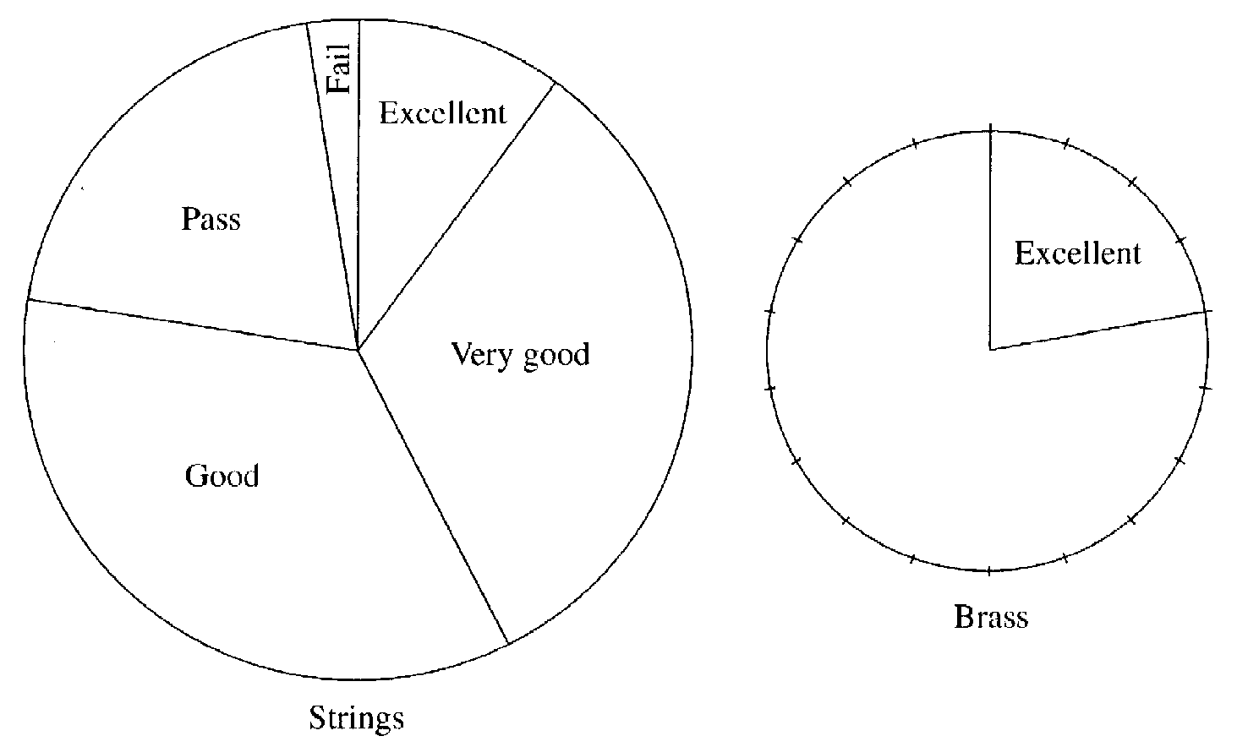

[3]
50. Use your calculator to evaluate the following questions. Give your answers to two places of decimals.

(a) $\frac{5.14 + 2.86}{1.38 + 3.57}$
………………………………………………………………………………………………………………………………………
………………………………………………………………………………………………………………………………………
………………………………………………………………………………………………………………………………………[1]
(b) $\frac{5.14 + 2.86}{1.38}$ + 3.57
………………………………………………………………………………………………………………………………………
………………………………………………………………………………………………………………………………………
………………………………………………………………………………………………………………………………………[1]
(c) 5.14 + $\frac{2.86}{1.38 + 3.57}$
………………………………………………………………………………………………………………………………………
………………………………………………………………………………………………………………………………………
………………………………………………………………………………………………………………………………………[1]

51(a) Four of the angles of an octagon are each 125º. The other angles are all equal. Find the size of one of the other angles.
………………………………………………………………………………………………………………………………………
………………………………………………………………………………………………………………………………………
………………………………………………………………………………………………………………………………………
………………………………………………………………………………………………………………………………………[3]

(b)(i) One of the interior angles of a regular polygon is 156º. Find the size of an exterior angle of this polygon.
………………………………………………………………………………………………………………………………………
………………………………………………………………………………………………………………………………………[1]
(ii) How many sides has this polygon got?
………………………………………………………………………………………………………………………………………[1]

52.

Thirty days hath September, April, June and November
All the rest have thirty one
Excepting February alone
Which has but twenty eight days clear
And twenty nine in a leap year

Twelve cards are labeled with the months of the year and put in a box.

April
March
February
January

May
June
July
August

December
November
October
September

Freda takes a card out of the box without looking at it.

(a) What is the probability that the month drawn has 31 days?
…………………………………………………………………………………………………………………………………
………………………………………………………………………………………………………………………………… [1]
(b) What is the probability that the month drawn has more than 27 days?
…………………………………………………………………………………………………………………………………
………………………………………………………………………………………………………………………………… [1]
53. A rectangle ABCD measures 6cm by 9cm.

A B

6cm Not drawn to scale

C 9cm D

(a) Find the area of the rectangle.
…………………………………………………………………………………………………………………………………
………………………………………………………………………………………………………………………………… [1]
(b) Calculate the perimeter of the rectangle
…………………………………………………………………………………………………………………………………
………………………………………………………………………………………………………………………………… [1]
Calculate the length of the diagonal AD. Show all your working. Give your answer correct to two places of decimals.
…………………………………………………………………………………………………………………………………
…………………………………………………………………………………………………………………………………
…………………………………………………………………………………………………………………………………
………………………………………………………………………………………………………………………………… [2]

(d) Nelma calculates the angle ADC to be 56.31º. Is she correct? Show all your working.
…………………………………………………………………………………………………………………………………
…………………………………………………………………………………………………………………………………
…………………………………………………………………………………………………………………………………
………………………………………………………………………………………………………………………………… [3]

54.
1 | 2 | 3 | 4 | 5 | 6 | 7 | 8 | 9 | 10
11 | 12 | 13 | 14 | 15 | 16 | 17 | 18 | 19 | 20
21 | 22 | 23 | 24 | 25 | 26 | 27 | 28 | 29 | 30
31 | 32 | 33 | 34 | 35 | 36 | 37 | 38 | 39 | 40
41 | 42 | 43 | 44 | 45 | 46 | 47 | 48 | 49 | 50
51 | 52 | 53 | 54 | 55 | 56 | 57 | 58 | 59 | 60
61 | 62 | 63 | 64 | 65 | 66 | 67 | 68 | 69 | 70
71 | 72 | 73 | 74 | 75 | 76 | 77 | 78 | 79 | 80
81 | 82 | 83 | 84 | 85 | 86 | 87 | 88 | 89 | 90
91 | 92 | 93 | 94 | 95 | 96 | 97 | 98 | 99 | 100

Bryan and Sue were playing a guessing game. Sue thought of a number between 1 and 100 which Bryan had to guess. Bryan was allowed to ask 5 questions, which are listed with Sue’s responses in the table below.

Bryan’s Questions | Sue’s Responses
Is it prime? | No
Is it odd? | No
Is it less than 50? | Yes
Is it a multiple of 3? | Yes
Is it a multiple of 7? | Yes

What is the number that Sue thought of?
………………………………………………………………………………………………………………………………… [3]

55. The population of Australia is 18 million, of which 3.5 million people live in Sydney and 1 million people live in Perth.
(a) What fraction of the population live in Perth?
……………………………………………………………………………………………………………………………………
…………………………………………………………………………………………………………………………………… [2]
(b) What fraction of the population live in Perth or Sydney?
……………………………………………………………………………………………………………………………………
……………………………………………………………………………………………………………………………………
…………………………………………………………………………………………………………………………………… [2]
56. The figure shows part of a regular 9 sided figure. Its centre is O.
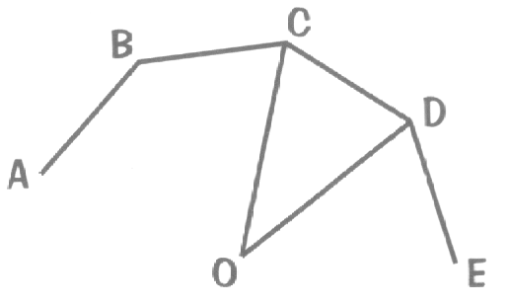

(a) Calculate the size of angle COD:
…………………………………………………………………………………………………………………………………
………………………………………………………………………………………………………………………………… [1]
(b) Calculate the size of angle OCD
…………………………………………………………………………………………………………………………………
………………………………………………………………………………………………………………………………… [2]
(c) Calculate the size of angle ABC
…………………………………………………………………………………………………………………………………
………………………………………………………………………………………………………………………………… [1]

57. 2700 people work in one department of the European Parliament.
The pie chart shows where the people come from.
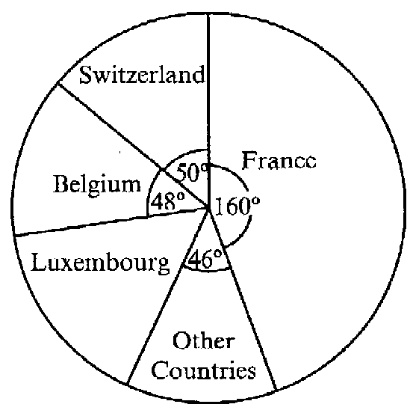

Calculate how many of the 2700 people came from Switzerland.
…………………………………………………………………………………………………………………………………
…………………………………………………………………………………………………………………………………
………………………………………………………………………………………………………………………………… [2]

58. ABCD is a trapezium where the AB = BC, angle ABC = 142º,
angle DAC = 90º and the line AB is parallel to the line DC
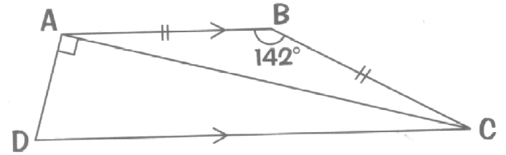

(a) Calculate the size of angle BAC
…………………………………………………………………………………………………………………………………
…………………………………………………………………………………………………………………………………
………………………………………………………………………………………………………………………………… [2]
(b) Calculate the size of angle ADC
…………………………………………………………………………………………………………………………………
…………………………………………………………………………………………………………………………………
………………………………………………………………………………………………………………………………… [2]

59. A square tablecloth has a diagonal measurement of 130cm. Calculate the length of one side

…………………………………………………………………………………………………………………………………
…………………………………………………………………………………………………………………………………
…………………………………………………………………………………………………………………………………
…………………………………………………………………………………………………………………………………
………………………………………………………………………………………………………………………………… [4]
60. Use trial and improvement to find the value of x in the equation
x³ – x² = 350
Give your answer correct to one place of decimals.
[3]
x | x³ – x² | Comment
6 | 180 | Too low
7 | 294 | Too low

61. The scale drawing shows the position of three towns.
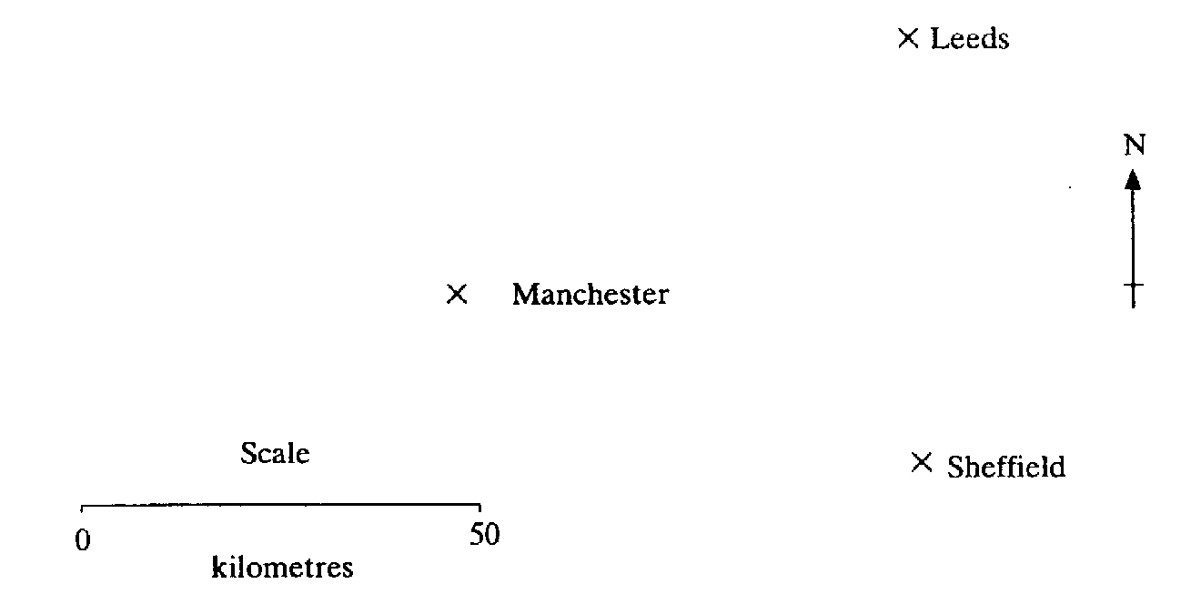

(a) What is the actual distance, in kilometres, between Manchester and Leeds?
…………………………………………………………………………………………………………………………………
………………………………………………………………………………………………………………………………… [2]

(b) What is the bearing of Sheffield from Manchester?
…………………………………………………………………………………………………………………………………
………………………………………………………………………………………………………………………………… [2]
(c) What is the bearing of Manchester from Leeds?
…………………………………………………………………………………………………………………………………
………………………………………………………………………………………………………………………………… [2]

62. Use your calculator to evaluate the following questions. Give your answers correct to two places of decimals.

(a) $\frac{3.24 + 7.16}{2.32 + 3.75}$
…………………………………………………………………………………………………………………………………
…………………………………………………………………………………………………………………………………
………………………………………………………………………………………………………………………………… [1]
(b) $\frac{3.24 + 7.16}{2.32}$ + 3.75
…………………………………………………………………………………………………………………………………
…………………………………………………………………………………………………………………………………
………………………………………………………………………………………………………………………………… [1]
(c) 3.24 + $\frac{7.16}{2.32 + 3.75}$
…………………………………………………………………………………………………………………………………
…………………………………………………………………………………………………………………………………
………………………………………………………………………………………………………………………………… [1]

63. A teacher has a small group of pupils in a special needs class. Their ages are:

12 years 4 months 11 years 6 months 11 years 11 months
11 years 8 months 12 years 3 months 12 years 1 month
12 years 1 month 11 years 6 months

(a) What is the median age of the children?
…………………………………………………………………………………………………………………………………
………………………………………………………………………………………………………………………………… [1]

(b) What is the mean age of the children?
…………………………………………………………………………………………………………………………………
…………………………………………………………………………………………………………………………………
………………………………………………………………………………………………………………………………… [2]

64. ABCDE is a shape with AB = AE and DE = BC. BE is parallel to CD.
E
B

D

C

A

›

›

/

\
=

=

(a) Show any lines of symmetry for the shape ABCDE on the diagram [1]
(b) What is the mathematical name given to the shape ABE?
…………………………………………………………………………………………………………………………………[1]
(c) What is the mathematical name give to the shape BCDE?
…………………………………………………………………………………………………………………………………[1]

(d) If angle BAE = 40º and angle BCD = 100º, then calculate the size of angle ABC.
…………………………………………………………………………………………………………………………………
…………………………………………………………………………………………………………………………………
…………………………………………………………………………………………………………………………………[3]

65. The council surround a circular flower bed with a concrete edge.
5m

The radius of the flower bed is 5 metres and the concrete extends for a further metre.

(a) Calculate the area of the flower bed.
…………………………………………………………………………………………………………………………………
…………………………………………………………………………………………………………………………………
………………………………………………………………………………………………………………………………… [2]

(b) Calculate the area of the flower bed and the concrete surround together.
…………………………………………………………………………………………………………………………………
………………………………………………………………………………………………………………………………… [1]

(c) Find the area of the concrete surround.
…………………………………………………………………………………………………………………………………
………………………………………………………………………………………………………………………………… [1]
(d) If the concrete surrounding the flower bed is 8cm thick, calculate the volume of concrete used for the job. Remember to state the units in your answer.
…………………………………………………………………………………………………………………………………
…………………………………………………………………………………………………………………………………
………………………………………………………………………………………………………………………………… [3]

66. The number of journeys made using public transport by a group of people in one month are shown in the graph.

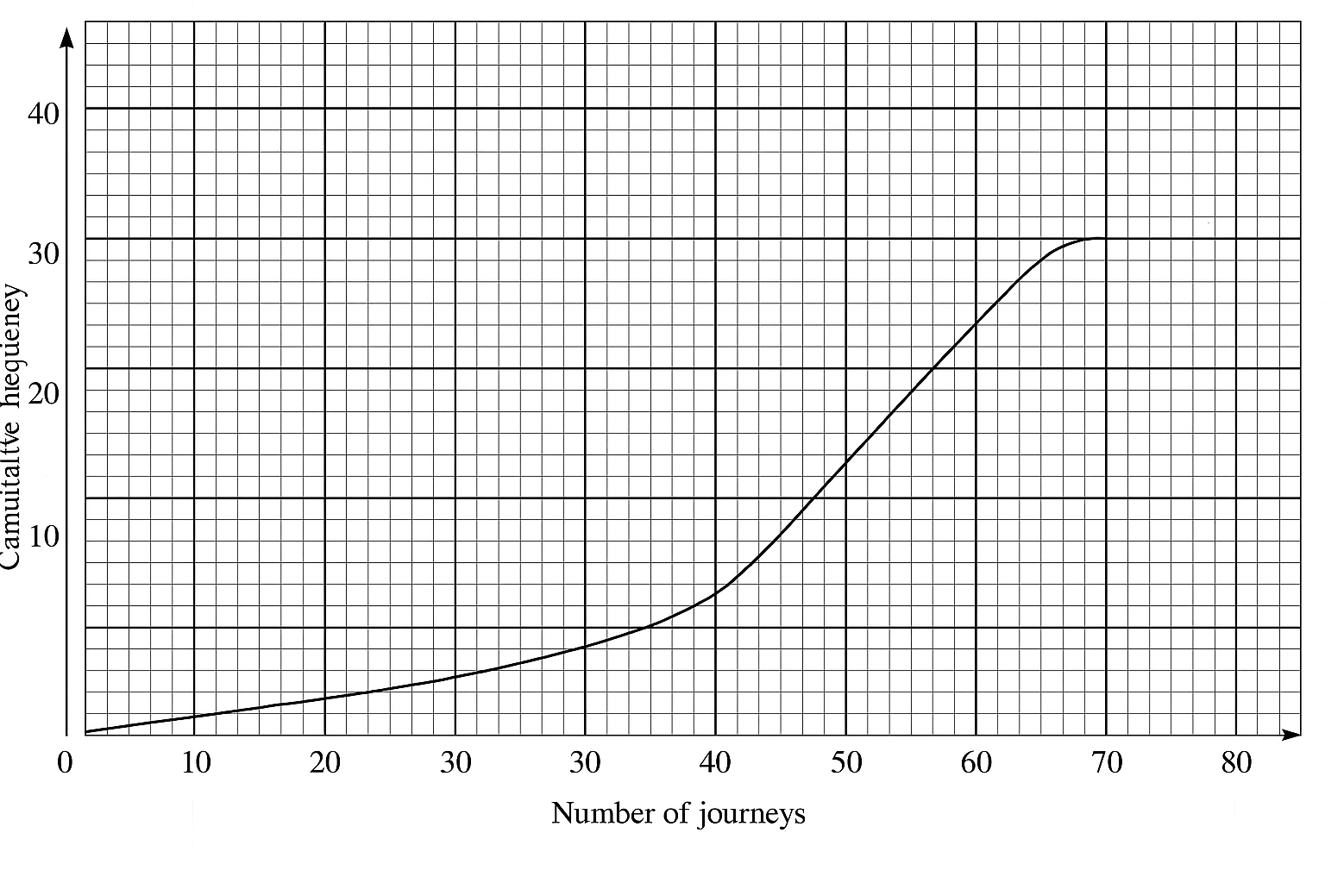

(a) Find the interquartile range
…………………………………………………………………………………………………………………………………
………………………………………………………………………………………………………………………………… [2]
(b) Use the graph to estimate how many people make more than 55 journeys a month on public transport.
…………………………………………………………………………………………………………………………………
………………………………………………………………………………………………………………………………… [2]

67.
A B

C D

ABCD is a rectangle with AB:BD = 8:5.

If the perimeter of the rectangle is 78 cm, find the length of AB.
…………………………………………………………………………………………………………………………………
…………………………………………………………………………………………………………………………………
………………………………………………………………………………………………………………………………… [3]

68. A shopkeeper buys a box of 24 chocolate bars for £6.30. She sells them at a profit of 45%, rounding the price to the nearest penny. How much does she sell each bar for?
…………………………………………………………………………………………………………………………………
…………………………………………………………………………………………………………………………………
…………………………………………………………………………………………………………………………………
………………………………………………………………………………………………………………………………… [3]
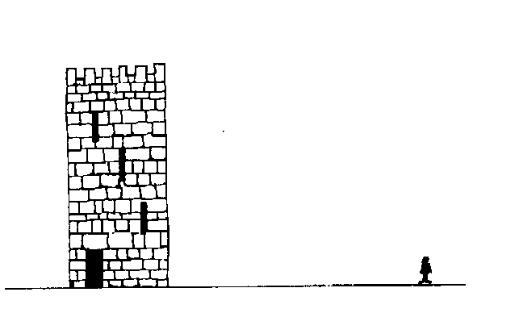
69.

A boy is 90 m due East from the foot of a tall tower and on level ground. He measures the angle of elevation of the top of the tower as 38º from the ground at his feet. Calculate the height of the tower.
…………………………………………………………………………………………………………………………………
…………………………………………………………………………………………………………………………………
………………………………………………………………………………………………………………………………… [3]

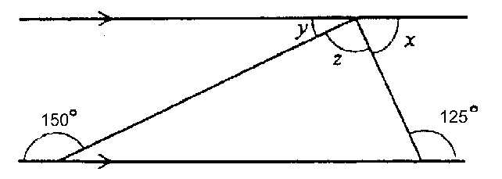
70.

- Find the value of x in the diagram.

…………………………………………………………………………………………………………………………………
………………………………………………………………………………………………………………………………… [1]

- Find the value of y in the diagram.

…………………………………………………………………………………………………………………………………
………………………………………………………………………………………………………………………………… [1]

- Find the value of z in the diagram.

…………………………………………………………………………………………………………………………………
………………………………………………………………………………………………………………………………… [1]

71. The probability that I am late for work on a Monday is 0.8 and the probability that I find a parking space within 5 minutes of arriving at work is 0.7.

- What is the probability that I don’t find a parking space within the first 5 minutes of arriving at work?

…………………………………………………………………………………………………………………………………
……………………………………………………………………………………………………………………………… [1]

(b) Complete the tree diagram to show the possible outcomes. [2]
0.8
Late
Not late
Parking
Parking
No Parking
No Parking
0.7

(c) Use the tree diagram to find the probability that I’m both on time and find a parking space within the first 5 minutes.
…………………………………………………………………………………………………………………………………
…………………………………………………………………………………………………………………………………
………………………………………………………………………………………………………………………………… [2]

72. Use trial and improvement to find the value of x in the equation
x² – 3x = 150
Give your answer correct to one place of decimals.
x | x² – 3x | Comment
12 | 108 | Too low
13 | 130 | Too low
[3]
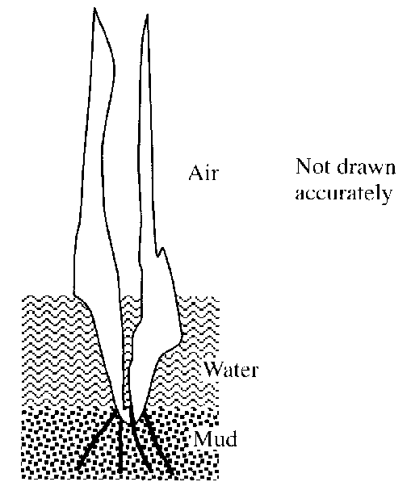
73. A water plant has $\frac{7}{12}$ of its length in the air. Nineteen centimetres of its length are in the water. $\frac{1}{6}$ of its length is in the mud. Calculate the total length of the plant.

…………………………………………………………………………………………………………………………………
…………………………………………………………………………………………………………………………………
…………………………………………………………………………………………………………………………………
………………………………………………………………………………………………………………………..……… [2]
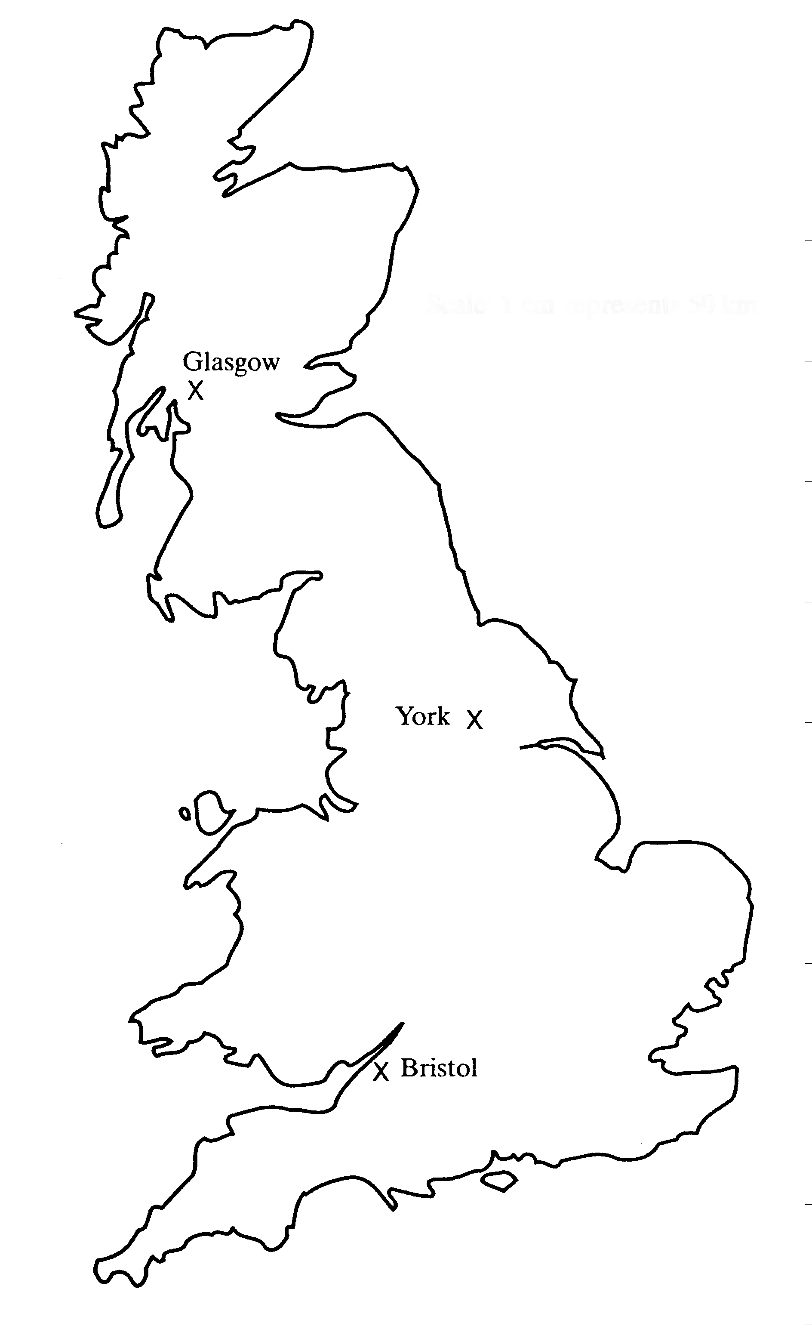
74.
North

(a) A plane flies from Bristol to Glasgow. Use the map to find the flight bearing.
…………………………………………………………………………………………………………………………………
………………………………………………………………………………………………………………………………… [1]
(b) A ship at sea is on a bearing of 110º from York and 070º from Bristol. Show its position on the map.[2]

75. List these numbers from smallest to largest. Remember to show all your working.
$\frac{5}{7}$, $\frac{7}{9}$, $\frac{3}{4}$,
…………………………………………………………………………………………………………………………………
…………………………………………………………………………………………………………………………………
…………………………………………………………………………………………………………………………………
………………………………………………………………………………………………………………………………… [3]

76. Nadia is paid a basic rate of £4.90 per hour for a 35 hour week.
Overtime is paid at 1½ times the basic rate.
In one week her total pay was £230.30.
Calculate how many hours of overtime she had worked
…………………………………………………………………………………………………………………………………
…………………………………………………………………………………………………………………………………
…………………………………………………………………………………………………………………………………
………………………………………………………………………………………………………………………………… [2]

77(a) ABCDE is a regular pentagon.
E
A
B

D
C

Calculate the size of angle A.
…………………………………………………………………………………………………………………………………
…………………………………………………………………………………………………………………………………
………………………………………………………………………………………………………………………………… [2]

(b) Jane sketches a pattern of tessellating tiles which are regular pentagons.

Is her assumption that regular pentagons will tessellate correct? Explain how you got your answer.
…………………………………………………………………………………………………………………………………
…………………………………………………………………………………………………………………………………
………………………………………………………………………………………………………………………………… [1]

78. Solve the following equations: Do not use a trial and improvement method.
(a) 4a – 7 = 13
…………………………………………………………………………………………………………………………………
…………………………………………………………………………………………………………………………………
………………………………………………………………………………………………………………………………… [2]
(b) 3f + 15 = 5f + 21
…………………………………………………………………………………………………………………………………
…………………………………………………………………………………………………………………………………
………………………………………………………………………………………………………………………………… [2]
(c) 2h + 4 = h – 5
9
…………………………………………………………………………………………………………………………………
…………………………………………………………………………………………………………………………………
…………………………………………………………………………………………………………………………………
…………………………………………………………………………………………………………………………………
…………………………………………………………………………………………………………………………… [3]

79. (a) A camera is in a sale with 12% off the recommended price. If the recommended price was £135, how much will the camera cost now?
…………………………………………………………………………………………………………………………………
…………………………………………………………………………………………………………………………………
………………………………………………………………………………………………………………………………… [2]
(b) A tripod is in the same sale for £13.20. what was its original price?
…………………………………………………………………………………………………………………………………
…………………………………………………………………………………………………………………………………
…………………………………………………………………………………………………………………………………
………………………………………………………………………………………………………………………………… [3]

80. Two porthole designs are being considered for use in a cabin panel of a ship
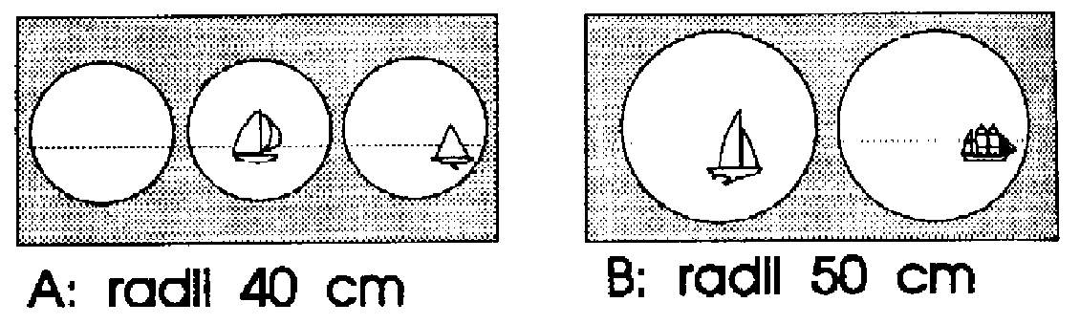

A: radii 35 cm B: radii 45 cm

Design A consists of three portholes, each of radius 35 cm.
Design B consists of two portholes each of radius 45 cm.

(a) Calculate the area of one of the windows in panel A
…………………………………………………………………………………………………………………………………
…………………………………………………………………………………………………………………………………
………………………………………………………………………………………………………………………………… [2]
(b) Calculate the total window area for panel A
…………………………………………………………………………………………………………………………………
………………………………………………………………………………………………………………………………… [1]

(c) Which of the two porthole designs would let in most light? Show all your working clearly.
…………………………………………………………………………………………………………………………………
…………………………………………………………………………………………………………………………………
…………………………………………………………………………………………………………………………………
………………………………………………………………………………………………………………………………… [3]

81. The mean weight of six parcels is 4.2 kg. When another parcel is added, the mean weight is increased to 5.1 kg. What is the weight of the seventh parcel?
…………………………………………………………………………………………………………………………………
…………………………………………………………………………………………………………………………………
…………………………………………………………………………………………………………………………………
………………………………………………………………………………………………………………………………… [3]
82. ABC is a triangle with A at (-3,2). B at (-1,3) and C at (-1, -2)

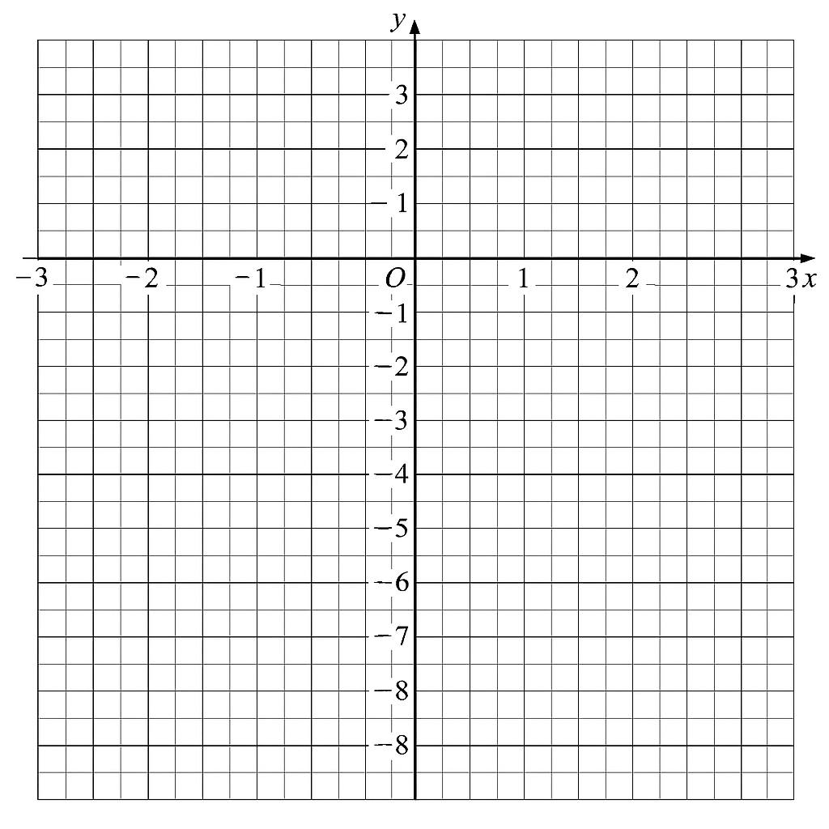
(a) Plot the points A,B and C and draw in the triangle ABC.
[2]
(b) Calculate the area of triangle ABC
…………………………………………………………………………………………………………………………………
…………………………………………………………………………………………………………………………………
…………………………………………………………………………………………………………………………………
[3]
(c) The triangle ABC is reflected in the line y = -3. Draw the image of the triangle after this transformation. Label it A’B’C’
[3]
(d) The image of ABC after an enlargement is at A’’ ( - $\frac{1}{2}$,$\frac{1}{2}$), B’’ ( $\frac{1}{2}$,1) and C’’ ( $\frac{1}{2}$, 1$\frac{1}{2}$). Draw this new triangle on the diagram and give the scale factor of the enlargement.
…………………………………………………………………………………………………………………………………
…………………………………………………………………………………………………………………………………
[2]
(e) Find the coordinates of the centre of enlargement.
…………………………………………………………………………………………………………………………………
…………………………………………………………………………………………………………………………………
[2]

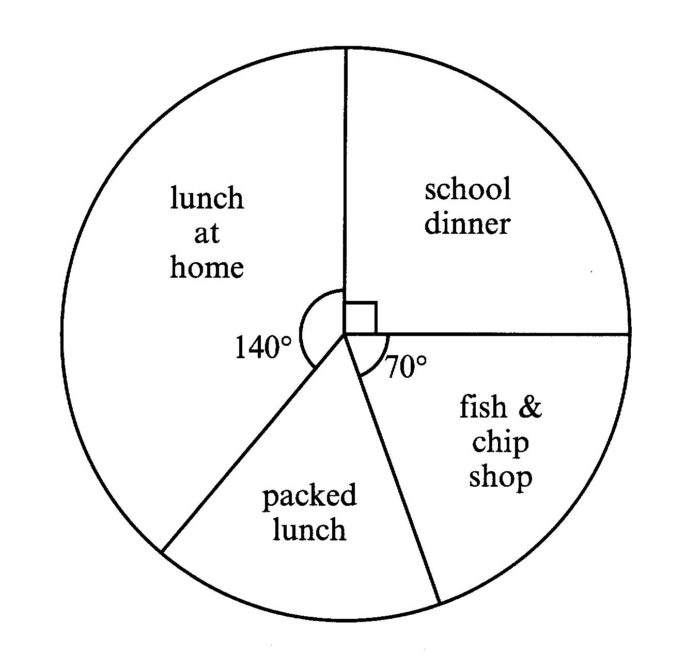
83. The teachers in a secondary school did a survey to find out what pupils in their school did for lunch one day. They asked a total of 900 pupils. The results are shown in the pie chart below.

(a) How many pupils had lunch at the fish and chip shop?
…………………………………………………………………………………………………………………………………
…………………………………………………………………………………………………………………………………
………………………………………………………………………………………………………………………………… [2]

(b) How many had a packed lunch?
…………………………………………………………………………………………………………………………………
………………………………………………………………………………………………………………………………… ………………………………………………………………………………………………………………………………… [2]
84. (a) Complete the table for the graph of y = x² – 2x - 7

x | -2 | -1 | 0 | 1 | 2 | 3
y | 1 | -4
[2]
(b) Draw the graph on the grid.
[3]
(c) Use your graph to solve the equation x² – 2x -7 = -5

…………………………………………………………………………………………………………………………………
…………………………………………………………………………………………………………………………………
[2]

85. David sketches a toy boat.
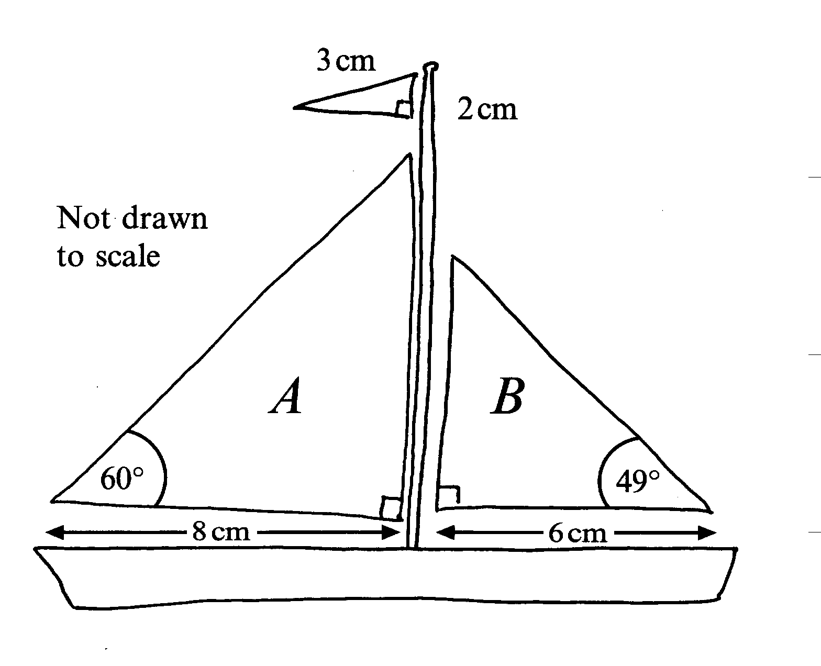

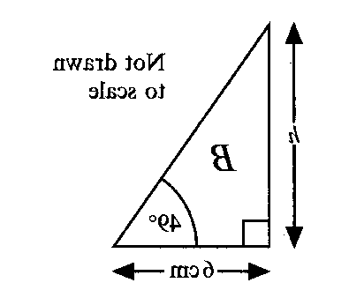

h cm
A

60º
8 cm

(a) Calculate the height h of sail A.

…………………………………………………………………………………………………………………………………
…………………………………………………………………………………………………………………………………
…………………………………………………………………………………………………………………………………
…………………………………………………………………………………………………………………………………
………………………………………………………………………………………………………………………………… [3]

(b) Sail B is 4.5 cm high. Calculate the perimeter of the sail.
…………………………………………………………………………………………………………………………………
…………………………………………………………………………………………………………………………………
…………………………………………………………………………………………………………………………………
…………………………………………………………………………………………………………………………………
………………………………………………………………………………………………………………………………… [4]

END OF EXAM
Answers to Calculator Practice Questions

Answers to questions involving diagrams of graphs may vary slightly

1. (a)(i) 38.2%
(ii) 63g

2. The 260g box gives 265.30612g per £ so it is better value.

3. Pie chart with angles 170˚, 120˚, 70˚

4. 15%

5. (a) 1.86 x 10⁵
(b) 44 mins

6. £21,630

7. 36 minutes

8. 2.10m to 2dps

9. There is a good positive correlation – the taller the father, the taller the son.

10. (a) 1, 2, 5, 17, 26
(b) On graph
(c) 5.4

11. 7.6

12. (a) (i) 45km, (ii) 1200
(b) On map.

13.10.32m

14. 1400

15. (a) 4.29
(b) 4.652
(c) 50
(d) 2.5

16. (a) 157.1cm
(b) 31800

17. £34

18. 3.4

19. (a) ¼
(b) 12.5%

20. (a) 300
(b) 9.997cm
(c) 4.95cm

21. 42mph

22. (a) 0.05
(b) 1st column 0.95, 0.05, 2nd column 0.04, 0.96, 0.04, 0.96.
(c) 0.038

23. (a) 6
(b) (i)2 (ii)7
(c) different answers
(d) Graham – he has a higher mean score OR, the smaller range means that he is more consistent.

24. 166˚

25. 2840

26. (a) 74˚
(b) 39˚
(c) No, the triangle isn’t isosceles
as y ≠38˚

27. 9² + 40² = 41² (Pythagoras)

28. (a) 3.84 x 10⁵
(b) 5.55 x 10⁻⁵, 7.22 x 10⁻⁵, 2.88 x
10², 8.17 x 10³, 5.27 x 10⁵

29. x = 3.3

30. (a) 6.5
(b) a = $\frac{v - u}{t}$
(c) 1.4
31. (a) Any number between 0.1666 and 0.2
(b) $\frac{3}{5}$
33. (a) 4m
(b) 117cm

34. x = -2

35. (a) $\frac{15}{22}$

(b) $\frac{225}{484}$

36. (a) 4.5cm
(b) 32.5cm

37. 44.4

38. (a) Trapezium
(b) 30˚
(c) 60˚

39. 3.5 x 10¹⁶

40. (a) 140cm
(b) Area of circle = 3848.45cm²
Area of rectangle = 600cm²
Red area = 3248.45cm²

41. £17.10

42. 49˚

43. (a) 0.3, 0.9, 0.1
(b) 0.63
(c) 0.07
(d) 0.37

44. £51

45. 205

46. 20.6cm²

47. 1.4m³

48. 1 hour 36 minutes

49. 6, 5, 2 and 1 sections respectively for VG, G, P and F

50. (a) 1.62
(b) 9.37
(c) 5.72

51. (a) 145˚
(b) i) 24˚
ii) 15

52. (a) 7/12
(b) 1

53. (a) 54cm²
(b) 30cm
(c) 62+92=36+81 = 117 √117 = 10.82
(d) tan ADC = 6/9, tan ADC = 2/3

54. 42

55. a) $\frac{1}{18}$
(b) $\frac{1}{4}$

56. (a) 40˚
(b) 70˚
(c) 140˚

57. 375

58. (a) 19˚
(b) 71˚

59. 91.92cm

60. 7.4

61. (a) 65km
(b) 110˚
(c) 240˚

62. (a) 1.71
(b) 8.23
(c) 4.42

63. (a) 12 years
(b) 11 years 11 months

64. (a) one vertical line
(b) isosceles triangle
(c) trapezium
(d) 150˚

65. (a) 78.54cm²
(b) 113.1cm²
(c) 34.56cm²
(d) 2.76m³

66. (a) 14
(b) 3

67. 24cm

68. 38p

69. 70m

70. (a) 55˚
(b) 30˚
(c) 95˚

71. (a) 0.3
(b) on time 0.2, spaces/ no
spaces 0.7, 0.3, 0.7, 0.3
(c) 0.14

72. x = 13.84

73. 78cm

74. (a) 345˚ ± 2˚
(b) on map

75. $\frac{5}{7}$, $\frac{3}{4}$ $\frac{7}{9}$

76. 8 hours

77. (a) 108˚
(b) No 360˚ is not a multiple of
108˚

78. (a) a = 5
(b) f = - 3
(c) h = 7
79. (a) £118.80
(b) £15

80. (a) 3848cm²
(b) 11545cm²
(c) B is the best with an area of
12723cm²

81. 10.5KG

82. (a) on graph
(b) 10 cm²
(c) A’(-3,-8), B’(-1,-9), C’(-1,-4)
(d) $\frac{1}{2}$
(e) (2, -1)
83. (a) 175
(b) 150

84. (a) -7, -8, -7, -4
(b) graph
(c) x = -0.75 or x = 2.75

85. (a) 13.86cm
(b) 18cm




Edge Hill GCSE Maths

Collection of
Non-Calculator
Practice Questions

(answers page 151)

1. (a) Factorise completely 3a² – 6a
………………………………………………………………………………………………………………………………… [2]
Multiply out and simplify ( 2x – 1 )( x – 3)
…………………………………………………………………………………………………………………………………
…………………………………………………………………………………………………………………………………
…………………………………………………………………………………………………………………………………
………………………………………………………………………………………………………………………………… [3]

2. Look at this number pattern.

7² = 49
67² = 4489
667² = 444889
6667² = 44448889

The pattern continues.

(a) Write down the next line of the pattern.
………………………………………………………………………………………………………………………………… [2]
Use the pattern to work out 6666667²
…………………………………………………………………………………………………………………………………
………………………………………………………………………………………………………………………………… [1]
What is the square root of 4444444488888889?
…………………………………………………………………………………………………………………………………
………………………………………………………………………………………………………………………………… [2]

3. (a) Find the next two terms in the sequence:
3, 8, 13, 18, 23, …, …, …
…………………………………………………………………………………………………………………………………
………………………………………………………………………………………………………………………………… [1]

(b) Write down the n^{th} term of the sequence:
…………………………………………………………………………………………………………………………………
…………………………………………………………………………………………………………………………………
…………………………………………………………………………………………………………………………………
………………………………………………………………………………………………………………………………… [2]
(c) What would be the 100th term in the sequence?
…………………………………………………………………………………………………………………………………
…………………………………………………………………………………………………………………………………
………………………………………………………………………………………………………………………………… [1]

4. In the diagram, AB is parallel to ED. Angle CED = 54º and angle BCD = 100º.

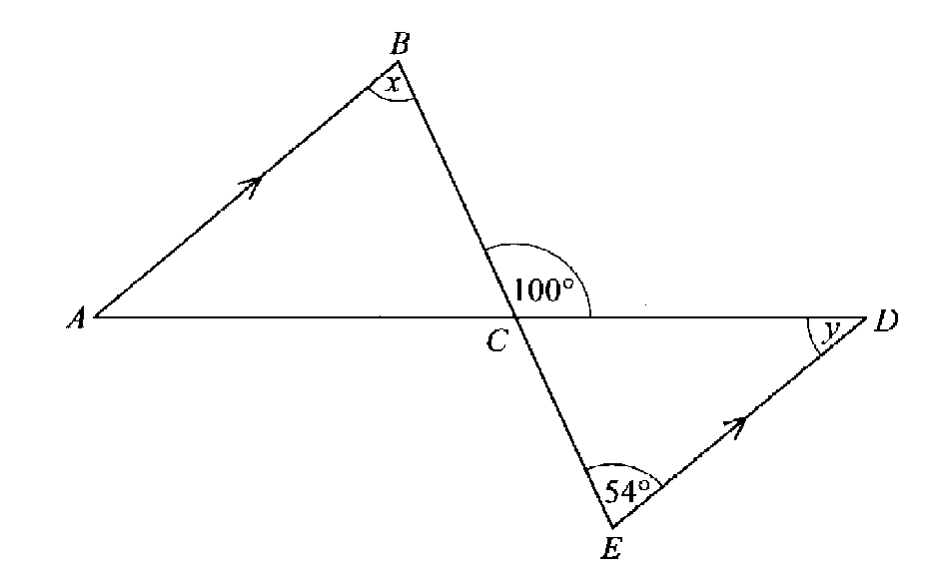not to scale
(a) (i) Write down the size of angle x
………………………………………………………………………………………………………………………………… [1]

Question continues over page >
(ii) Find the size of angle y
…………………………………………………………………………………………………………………………………
………………………………………………………………………………………………………………………………… [2]
Triangle ABC is similar to triangle DEC.
AC:CD is 3:2
AB = 5.4 cm

Calculate the length of DE.
…………………………………………………………………………………………………………………………………
…………………………………………………………………………………………………………………………………
…………………………………………………………………………………………………………………………………
…………………………………………………………………………………………………………………………………
………………………………………………………………………………………………………………………………… [3]

5. The diagram represents a regular pentagon with two of its lines of symmetry shown.
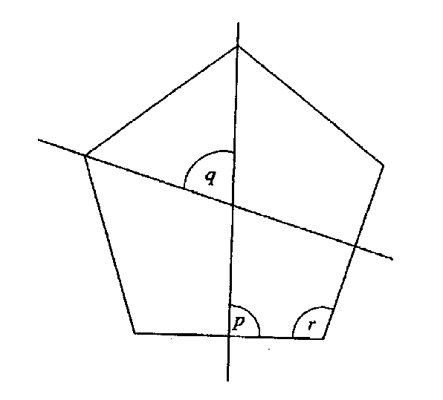
(a) Write down the size of angle p.
………………………………………………………………………………………………………………………………… [1]
(b) Calculate the size of angle q
…………………………………………………………………………………………………………………………………
…………………………………………………………………………………………………………………………………
………………………………………………………………………………………………………………………………… [2]
Question continues over page >

Calculate the size of angle r
…………………………………………………………………………………………………………………………………
…………………………………………………………………………………………………………………………………
………………………………………………………………………………………………………………………………… [2]

6. (a) Solve the equation
3x – 2 = x + 7
…………………………………………………………………………………………………………………………………
…………………………………………………………………………………………………………………………………
………………………………………………………………………………………………………………………………… [2]
Solve the simultaneous equations
x + y = 4
15x + 25y = 76
…………………………………………………………………………………………………………………………………
…………………………………………………………………………………………………………………………………
…………………………………………………………………………………………………………………………………
…………………………………………………………………………………………………………………………………
…………………………………………………………………………………………………………………………………
………………………………………………………………………………………………………………………………… [3]

(c) Solve the inequality
2 ( 3x – 2 ) < 11
…………………………………………………………………………………………………………………………………
…………………………………………………………………………………………………………………………………
…………………………………………………………………………………………………………………………………
………………………………………………………………………………………………………………………………… [2]

7. Boxes P and Q each contain five numbered balls.
The balls in each box are numbered as shown.

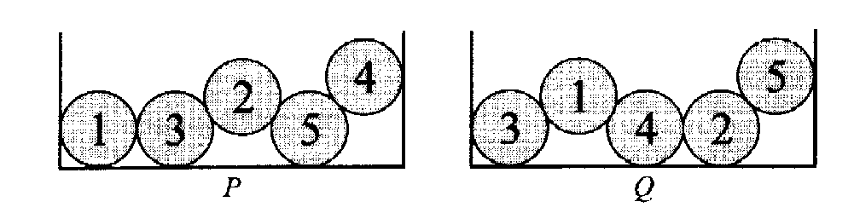

A ball is taken from each box at random.

(a) What is the probability that both balls are numbered 2?
…………………………………………………………………………………………………………………………………
…………………………………………………………………………………………………………………………………
………………………………………………………………………………………………………………………………… [2]
(b) What is the probability that both balls have the same number?
…………………………………………………………………………………………………………………………………
…………………………………………………………………………………………………………………………………
………………………………………………………………………………………………………………………………… [2]

8. (a) Write down a decimal that lies between and .
1
2
1
3
………………………………………………………………………………………………………………………………… [1]
Which of these two fractions is the bigger?
2
3
3
4
or

Show your working

…………………………………………………………………………………………………………………………………
…………………………………………………………………………………………………………………………………
………………………………………………………………………………………………………………………………… [2]

9. An examiner marked 320 examination papers.
He noted the time it took to mark each one.
The table gives a summary of these times.

Time, t minutes | Frequency | Cumulative frequency
0 < t ≤ 2 | 15
2 < t ≤ 4 | 85
4 < t ≤ 6 | 170
6 < t ≤ 8 | 40
8 < t ≤ 10 | 10

(a) (i) Complete the table by filling in the cumulative frequencies.
[2]
(ii) On the grid opposite, draw a cumulative frequency diagram to show this information
[2]
Making your method clear, use your diagram to find

the median time taken to mark each paper
…………………………………………………………………………………………………………………………………
………………………………………………………………………………………………………………………………… [2]
(ii) the inter-quartile range of the times taken
…………………………………………………………………………………………………………………………………
………………………………………………………………………………………………………………………………… [2]
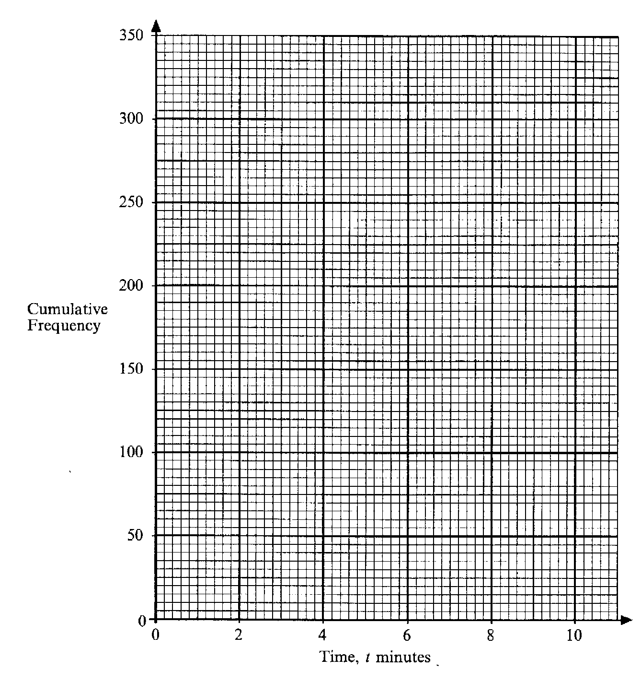

10. The distance between Southampton and London is 120km.

A coach leaves Southampton at 0800 to travel to London.

The coach travels 60 km at an average speed of 80 km per hour and then stops for 30 minutes. It then continues its journey arriving in London at 1100.

At 1115 the coach leaves London and returns to Southampton without stopping. It arrives in Southampton at 1230.

(a) Draw a travel graph for the journey of the coach.

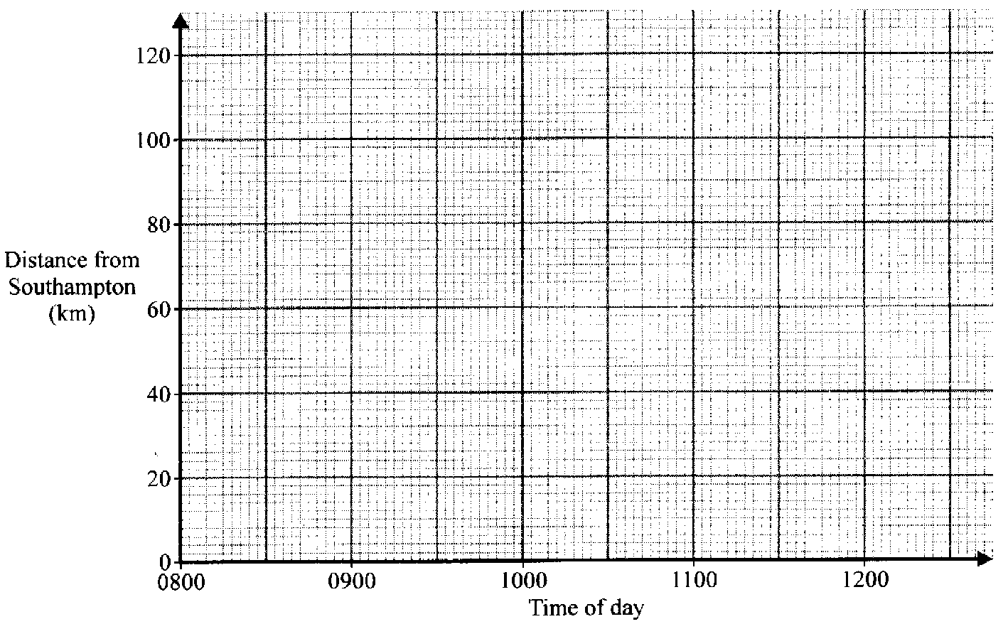

[3]
What was the average speed of the coach on the return journey?
…………………………………………………………………………………………………………………………………
…………………………………………………………………………………………………………………………………
…………………………………………………………………………………………………………………………………
………………………………………………………………………………………………………………………………… [2]
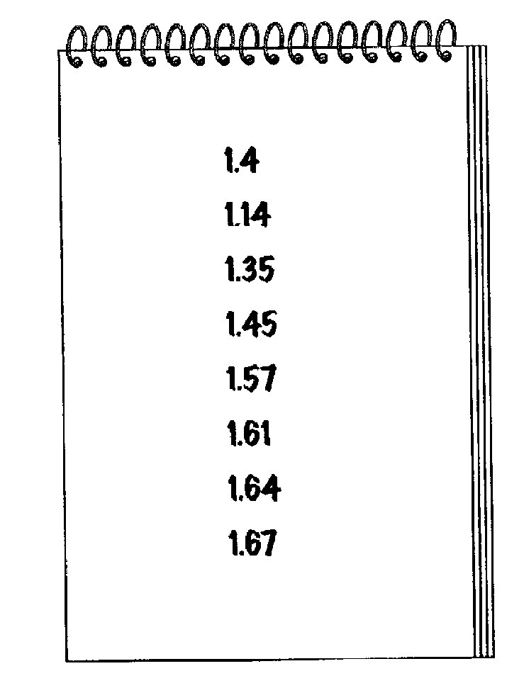
11.

A pupil measures the height in metres of the girls in her class.

She writes these heights in order of size as shown above. One of the heights is in the wrong place.

(a) Put a ring round the height that is in the wrong place.
[1]
Calculate the mean height of the girls.

…………………………………………………………………………………………………………………………………
…………………………………………………………………………………………………………………………………
…………………………………………………………………………………………………………………………………
………………………………………………………………………………………………………………………………… [2]

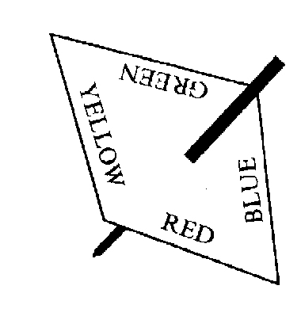
12. The spinner shown is biased.

The probabilities of getting a particular colour are shown
in the table below.
Colour | RED | YELLOW | BLUE | GREEN
Probability | 0.4 | 0.1 | 0.3

(a) Complete the table to show the probability of getting GREEN
[1]
(b) The spinner is spun once.
What is the probability of getting either RED or BLUE?
…………………………………………………………………………………………………………………………………
…………………………………………………………………………………………………………………………………
…………………………………………………………………………………………………………………………………
………………………………………………………………………………………………………………………………… [2]
(c) The spinner is spun 50 times.
Approximately how many times would you expect to get RED?
…………………………………………………………………………………………………………………………………
…………………………………………………………………………………………………………………………………
………………………………………………………………………………………………………………………………… [2]
13. Solve the simultaneous equations
2a + 4c = 13
a + 3c = 8
…………………………………………………………………………………………………………………………………
…………………………………………………………………………………………………………………………………
…………………………………………………………………………………………………………………………………
…………………………………………………………………………………………………………………………………
…………………………………………………………………………………………………………………………………
…………………………………………………………………………………………………………………………………
…………………………………………………………………………………………………………………………………
………………………………………………………………………………………………………………………………… [4]
14. Jenny cycles to school each day.
The graph shows her journey from home to school. On the way she stops to talk to her friends.
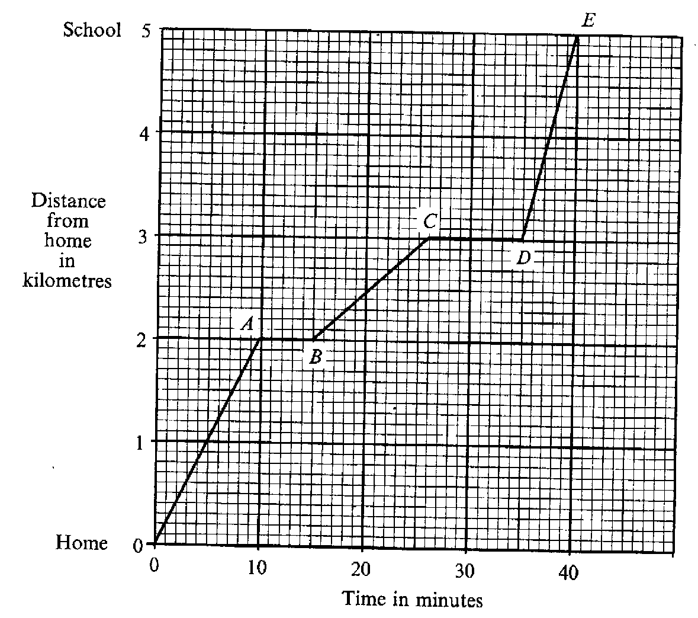

(a) How many times does she stop to talk to her friends?
………………………………………………………………………………………………………………………………… [1]
(b)(i) How far does she travel in the first stage from home to A?
………………………………………………………………………………………………………………………………… [1]
(ii) What is her average speed for the first 10 minutes?
Give your answer in kilometres per hour.
…………………………………………………………………………………………………………………………………
…………………………………………………………………………………………………………………………………
…………………………………………………………………………………………………………………………………
………………………………………………………………………………………………………………………………… [2]
On which stage of her journey is her average speed fastest?
…………………………………………………………………………………………………………………………………
………………………………………………………………………………………………………………………………… [1]

15. Write down the nth term for each of the following sequences.
(a) 3, 6, 9, 12
…………………………………………………………………………………………………………………………………
………………………………………………………………………………………………………………………………… [1]
1, 4, 7, 10
…………………………………………………………………………………………………………………………………
………………………………………………………………………………………………………………………………… [1]
1, 4, 9, 16
…………………………………………………………………………………………………………………………………
………………………………………………………………………………………………………………………………… [2]

16. The map shows part of Shropshire.
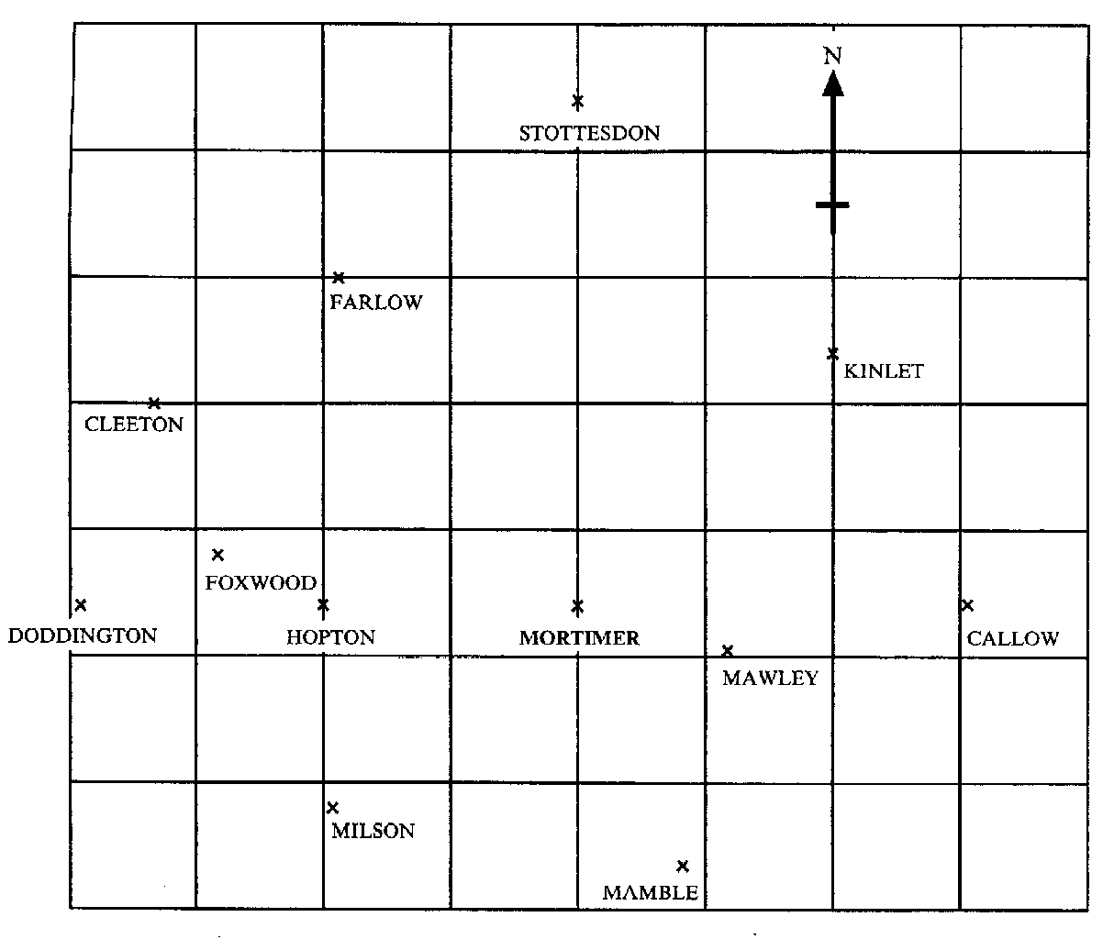
(a) What is the bearing of Cleeton from Mortimer?
…………………………………………………………………………………………………………………………………
………………………………………………………………………………………………………………………………… [2]
Which town is on a bearing of 011º from Mamble?
…………………………………………………………………………………………………………………………………
………………………………………………………………………………………………………………………………… [2]

17. The table shows the mathematics test results for 90 students.
The test was marked out of 60.

Mark (x) | Frequency | Cumulative Frequency
0 ≤ x ≤ 10 | 12 | 12
10 < x ≤ 20 | 15
20 < x ≤ 30 | 29
30 < x ≤ 40 | 16
40 < x ≤ 50 | 11
50 < x ≤ 60 | 7

(a) Complete the cumulative frequency column
[1]
Draw a cumulative frequency diagram on the grid opposite
[3]
Use your diagram to estimate

the median
…………………………………………………………………………………………………………………………………
………………………………………………………………………………………………………………………………… [2]

the interquartile range
…………………………………………………………………………………………………………………………………
…………………………………………………………………………………………………………………………………
………………………………………………………………………………………………………………………………… [2]

The pass mark for the test is 25 marks.
Use your graph to estimate how many pupils pass the test.

…………………………………………………………………………………………………………………………………
…………………………………………………………………………………………………………………………………
………………………………………………………………………………………………………………………………… [2]
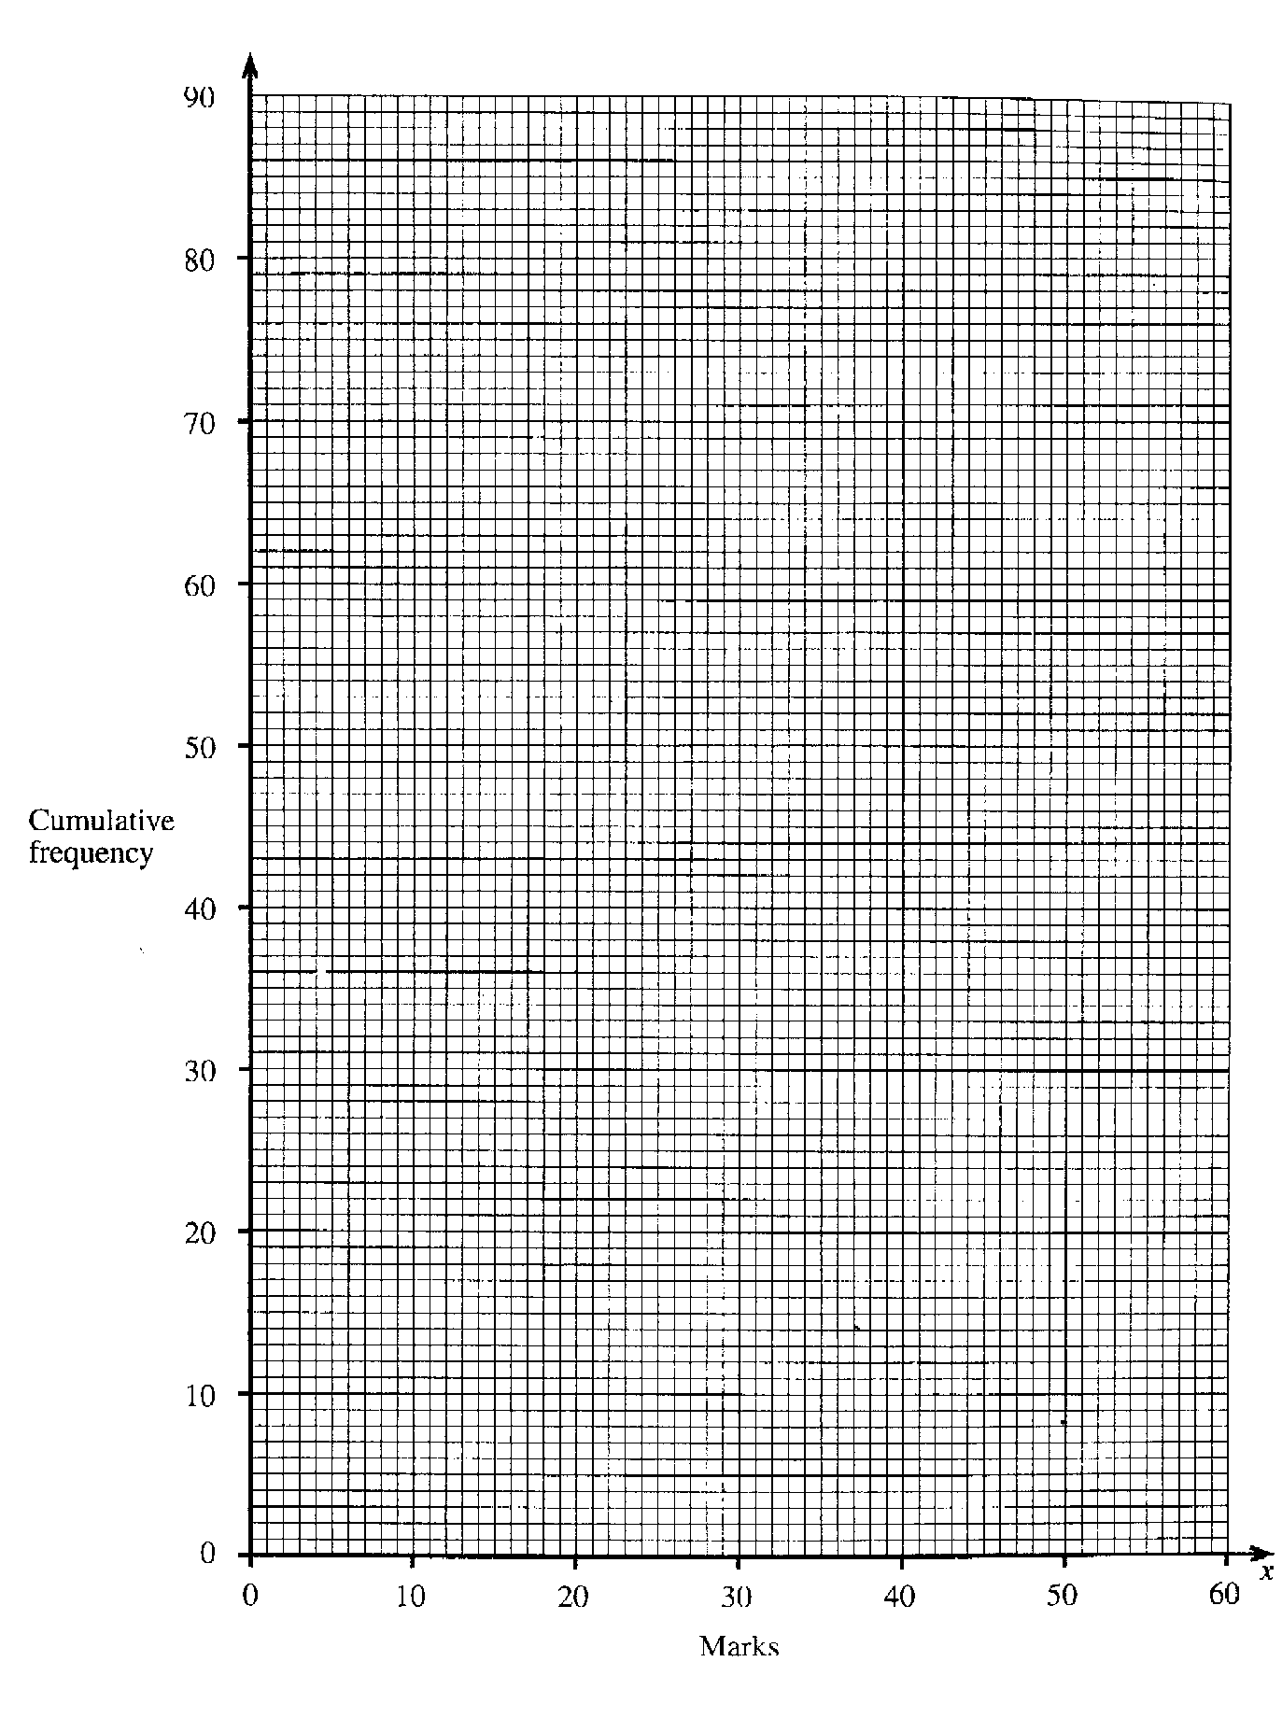
3, 9, 20, 25, 29, 75, 92, 100
18.

Which of the numbers in the box are

(a) square numbers?
………………………………………………………………………………………………………………………………… [2]
factors of 100?
………………………………………………………………………………………………………………………………… [2]
(c) prime numbers?
………………………………………………………………………………………………………………………………… [2]

19. (a) Factorise completely
3x² – 6x
…………………………………………………………………………………………………………………………………
………………………………………………………………………………………………………………………………… [2]
Make t the subject of the formula.
W = 5t + 3
4
…………………………………………………………………………………………………………………………………
…………………………………………………………………………………………………………………………………
…………………………………………………………………………………………………………………………………
………………………………………………………………………………………………………………………………… [2]

20.
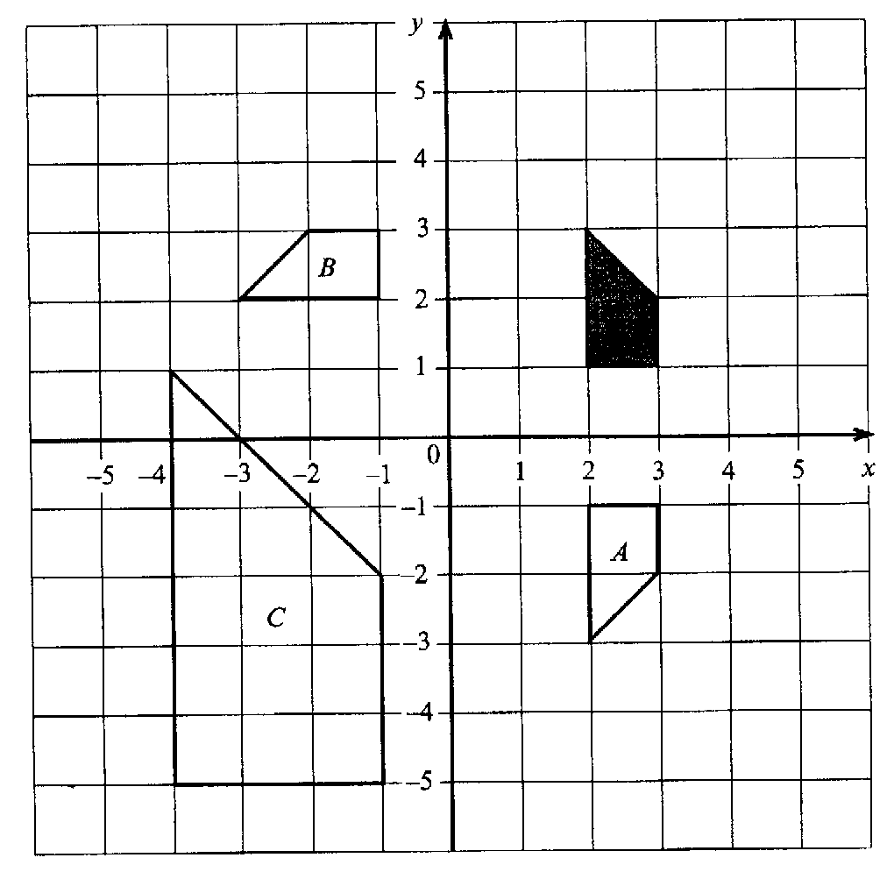

Describe fully a single transformation that would map the shaded shape onto
(a) shape A
…………………………………………………………………………………………………………………………………
…………………………………………………………………………………………………………………………………
………………………………………………………………………………………………………………………………… [2]
shape B
…………………………………………………………………………………………………………………………………
…………………………………………………………………………………………………………………………………
………………………………………………………………………………………………………………………………… [3]
shape C
…………………………………………………………………………………………………………………………………
…………………………………………………………………………………………………………………………………
………………………………………………………………………………………………………………………………… [2]

21. Solve the equations
(a) 2x + 10 = 29
…………………………………………………………………………………………………………………………………
…………………………………………………………………………………………………………………………………
…………………………………………………………………………………………………………………………………
………………………………………………………………………………………………………………………………… [2]
5x – 4 = 8 – x
…………………………………………………………………………………………………………………………………
…………………………………………………………………………………………………………………………………
…………………………………………………………………………………………………………………………………
………………………………………………………………………………………………………………………………… [2]
22.
1, 4, 5, 23, 25, 36, 41, 43, 45

Look at the numbers in the box above.

(a) Which of these numbers are multiples of 3?
………………………………………………………………………………………………………………………………………… [1]
(b) Which of these numbers are square numbers?
………………………………………………………………………………………………………………………………………… [1]
(c) Which of these numbers are prime numbers?
………………………………………………………………………………………………………………………………………… [1]

23. The probability that I am late for work on a Monday is 0.4
The probability that I am late for work on a Tuesday is 0.2
What is the probability that in one particular week.
(a) I am late for work on both Monday and Tuesday
…………………………………………………………………………………………………………………………………………
………………………………………………………………………………………………………………………………………… [2]
(b) I am late for work on Monday but on time on Tuesday
…………………………………………………………………………………………………………………………………………
…………………………………………………………………………………………………………………………………………
………………………………………………………………………………………………………………………………………… [2]
(c) I am on time both on Monday and on Tuesday
…………………………………………………………………………………………………………………………………………
…………………………………………………………………………………………………………………………………………
………………………………………………………………………………………………………………………………………… [2]
(d) I am late for work on Monday or Tuesday but not both days
…………………………………………………………………………………………………………………………………………
…………………………………………………………………………………………………………………………………………
………………………………………………………………………………………………………………………………………… [2]

24. The three angles of a triangle are given as xº, 3xº and 5xº.
Calculate the value of x.
…………………………………………………………………………………………………………………………………………
…………………………………………………………………………………………………………………………………………
…………………………………………………………………………………………………………………………………………
………………………………………………………………………………………………………………………………………… [3]

25. Factorise fully 5x² – 10x
………………………………………………………………………………………………………………………………………… …………………………………………………………………………………………………………………………………………
………………………………………………………………………………………………………………………………………… [2]

26. List the values of x, where x is a whole number, such that
-2 ≤ x < 3
…………………………………………………………………………………………………………………………………………
…………………………………………………………………………………………………………………………………………
………………………………………………………………………………………………………………………………………… [2]

27. These are the prices charged for different journeys by taxi.

Length of journey (km) | 1 | 2 | 3 | 5 | 8 | 13 | 14 | 18
Cost (£) | 1.80 | 2.30 | 2.50 | 2.80 | 5.40 | 7.50 | 8.40 | 10.30

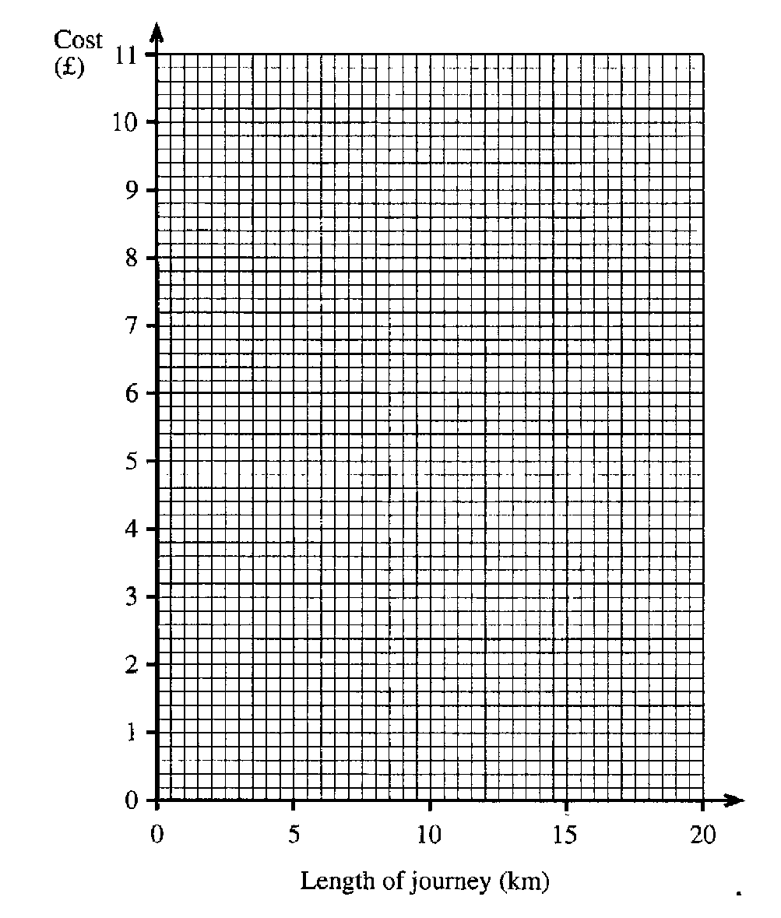
(a) On the grid below, draw a scatter diagram to show this information.

[3]
(b) What does this diagram tell you about the relationship between the length of a journey and its cost?
…………………………………………………………………………………………………………………………………………
………………………………………………………………………………………………………………………………………… [1]
(c) Draw a line of best fit [1]
(d) Estimate the cost of a taxi journey of 16 km.
…………………………………………………………………………………………………………………………………………
………………………………………………………………………………………………………………………………………… [1]

(e) I was charged £6.20 for a taxi journey.
Estimate the length of the journey.
…………………………………………………………………………………………………………………………………………
………………………………………………………………………………………………………………………………………… [1]
28. Paul and Kay take part in a quiz.
The rules are:
For each correct answer +5 points
For each wrong answer -2 points

(a) In the first round, Paul gets three questions correct and one question wrong.
What is his total number of points?
…………………………………………………………………………………………………………………………………………
…………………………………………………………………………………………………………………………………………
………………………………………………………………………………………………………………………………………… [1]
(b) Kay has +6 points after her first four questions.
Write down one way she may have done this.
…………………………………………………………………………………………………………………………………………
…………………………………………………………………………………………………………………………………………
………………………………………………………………………………………………………………………………………… [1]

29. Solve the equation
3 (4x – 1) = 27
…………………………………………………………………………………………………………………………………………
…………………………………………………………………………………………………………………………………………
…………………………………………………………………………………………………………………………………………
………………………………………………………………………………………………………………………………………… [3]

30. Solve the simultaneous equations
6x + 3y = 12
2x – y = -2
…………………………………………………………………………………………………………………………………………
…………………………………………………………………………………………………………………………………………
…………………………………………………………………………………………………………………………………………
…………………………………………………………………………………………………………………………………………
…………………………………………………………………………………………………………………………………………
………………………………………………………………………………………………………………………………………… …………………………………………………………………………………………………………………………………………
…………………………………………………………………………………………………………………………………………
…………………………………………………………………………………………………………………………………………
………………………………………………………………………………………………………………………………………… [4]

31. Solve the equations:
(a) 3x + 9 = 30
…………………………………………………………………………………………………………………………………………
…………………………………………………………………………………………………………………………………………
………………………………………………………………………………………………………………………………………… [2]
5x – 2 = 2x + 7
…………………………………………………………………………………………………………………………………………
…………………………………………………………………………………………………………………………………………
…………………………………………………………………………………………………………………………………………
………………………………………………………………………………………………………………………………………… [2]

32. Max shares £420 with a friend in the ratio 5:3
How much does each receive?
…………………………………………………………………………………………………………………………………………
…………………………………………………………………………………………………………………………………………
…………………………………………………………………………………………………………………………………………
………………………………………………………………………………………………………………………………………… [2]

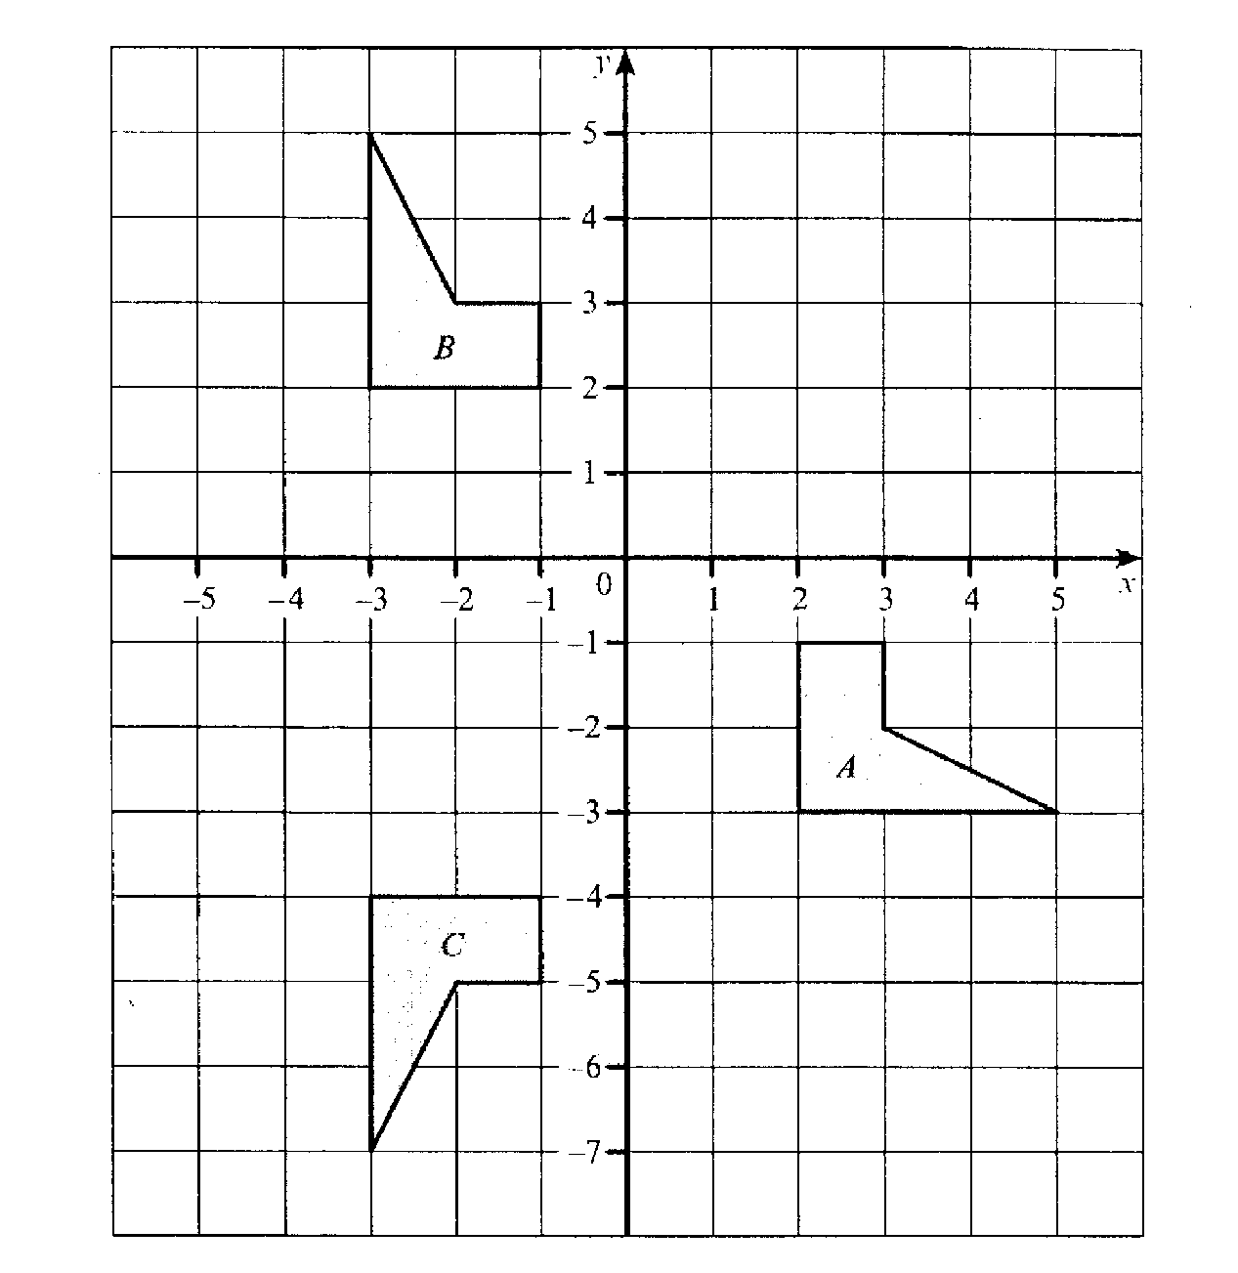
33.

(a) Describe the single transformation that will transform shape C to shape B
…………………………………………………………………………………………………………………………………………
…………………………………………………………………………………………………………………………………………
………………………………………………………………………………………………………………………………………… [2]

(b) Describe the single transformation that will transform shape A to shape C.

…………………………………………………………………………………………………………………………………………
…………………………………………………………………………………………………………………………………………
…………………………………………………………………………………………………………………………………………
…………………………………………………………………………………………………………………………………………
…………………………………………………………………………………………………………………………………………… [3]

34. A carton is 50cm long, a40 cm wide and 30 com high. How many boxes measuring 10 cm x 8 cm x 3cm would fit into one of these cartons?

…………………………………………………………………………………………………………………………………………
…………………………………………………………………………………………………………………………………………
…………………………………………………………………………………………………………………………………………
…………………………………………………………………………………………………………………………………………
………………………………………………………………………………………………………………………………………… [2]

35. The heights of a small group of boys were measured. The results were:
151 cm, 148 cm, 147 cm, 152cm, 154cm, 160 cm, 148 cm, 149 cm

(a) What was their median height?
…………………………………………………………………………………………………………………………………………
…………………………………………………………………………………………………………………………………………
………………………………………………………………………………………………………………………………………… [1]
(b) What was their modal height?
…………………………………………………………………………………………………………………………………………
………………………………………………………………………………………………………………………………………… [1]
(c) What was the range of their heights?
…………………………………………………………………………………………………………………………………………
………………………………………………………………………………………………………………………………………… [1]

36. (a) List the prime numbers that lie between 20 and 30.
…………………………………………………………………………………………………………………………………………
………………………………………………………………………………………………………………………………………… [2]
(b) List the square numbers that lie between 20 and 50.
…………………………………………………………………………………………………………………………………………
…………………………………………………………………………………………………………………………………………
………………………………………………………………………………………………………………………………………… [2]

37. 2700 people work in one department of the European Parliament.
The pie chart shows where the people come from.

Calculate the size of the angle for Luxembourg.
…………………………………………………………………………………………………………………………………………
………………………………………………………………………………………………………………………………………… [1]

(b) From the information given, calculate how many of the 2700 people came from France.
…………………………………………………………………………………………………………………………………………
…………………………………………………………………………………………………………………………………………
…………………………………………………………………………………………………………………………………………
………………………………………………………………………………………………………………………………………… [2]

38. (a) Complete the following number pattern.

1³ = 1 x 1 x 1 = 1
2³ = 2 x 2 x 2 = 8
3³ = ………………. = 27
4³ = ………………. = …….. [1]

(b) Use your answers to part (a) to complete this number pattern.
1³ = 1 = 1²
1³ + 2³ = 9 = 3²
1³ + 2³ + 3³ = 36 = 6²
1³ + 2³ + 3³ + 4³ = …… = …… [2]

(c) A line of pattern (b) is shown below.
Fill in the missing parts of this line.
………………………………………………… = 441 = ……………… [2]

39. Solve the simultaneous equations
3a + 2b = 29
2a – 3b = 2
…………………………………………………………………………………………………………………………………………
…………………………………………………………………………………………………………………………………………
…………………………………………………………………………………………………………………………………………
…………………………………………………………………………………………………………………………………………
…………………………………………………………………………………………………………………………………………
…………………………………………………………………………………………………………………………………………
…………………………………………………………………………………………………………………………………………
………………………………………………………………………………………………………………………………………… [4]
40. The map shows the position of three towns.
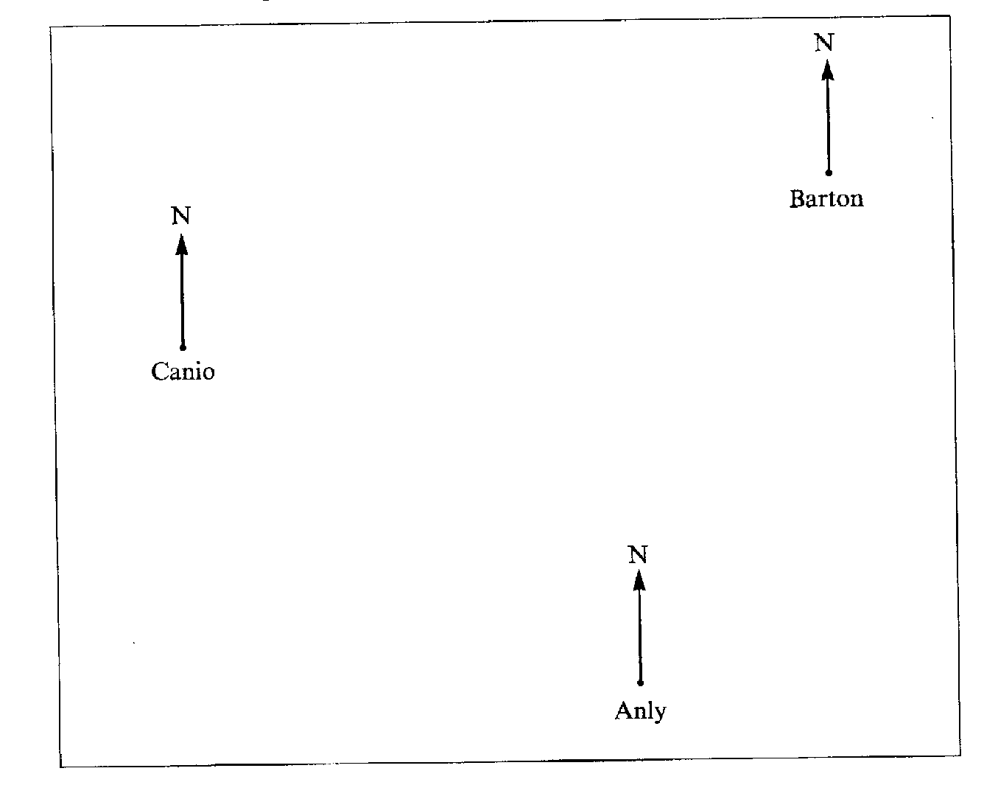
PTO for questions

What is the bearing of Barton from Anly?
…………………………………………………………………………………………………………………………………………
…………………………………………………………………………………………………………………………………………
………………………………………………………………………………………………………………………………………… [2]

What is the bearing of Canio from Barton?
…………………………………………………………………………………………………………………………………………
…………………………………………………………………………………………………………………………………………
………………………………………………………………………………………………………………………………………… [2]

41. ABCD is a rectangle
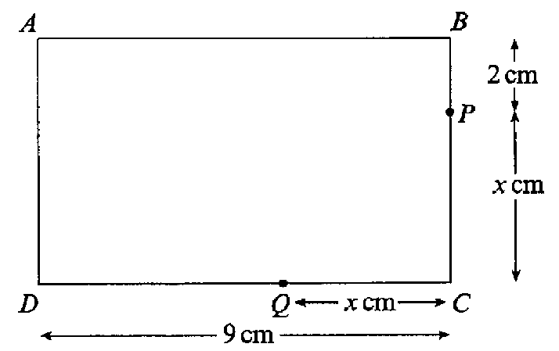

(a) Write down the expression, in terms of x, for
The length of BC,
………………………………………………………………………………………………………………………………
……………………………………………………………………………………………………………………………… [1]
The length of DQ
………………………………………………………………………………………………………………………………
……………………………………………………………………………………………………………………………… [1]
(b) (i) Given that BC =DQ, use your answers to (a) to write down an equation in
terms of x.
………………………………………………………………………………………………………………………………
……………………………………………………………………………………………………………………………… [1]
PTO for part (ii)
(ii) Solve your equation to find the value of x
………………………………………………………………………………………………………………………………
………………………………………………………………………………………………………………………………
……………………………………………………………………………………………………………………………… [2]

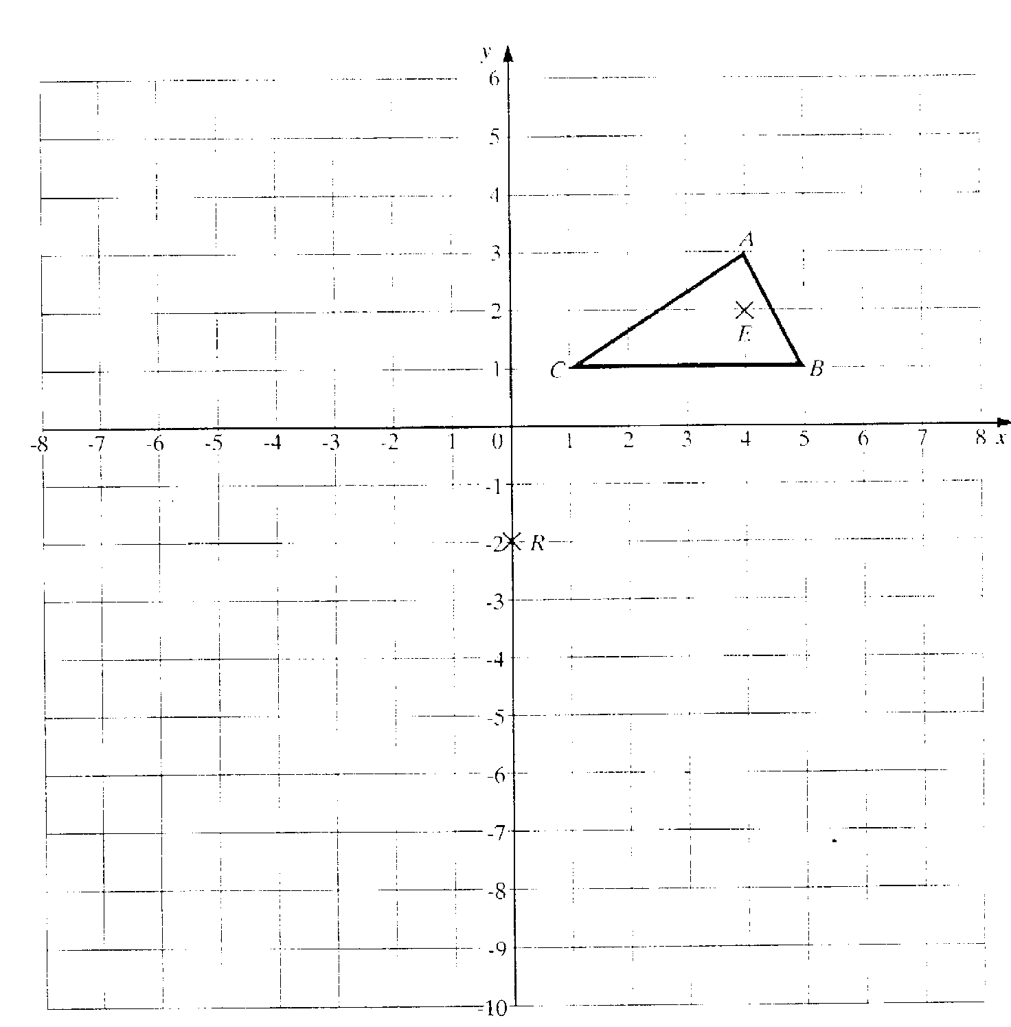
42. A triangle ABC has vertices A(4,3), B(5,1), C(1,1).

(a) Draw an enlargement of triangle ABC by scale factor of 3 from the
centre of enlargement E(4,1). Label the enlarged triangle A’B’C’. [2]

(b) Draw the image of the triangle A’B’C’ after it has been rotated
through 180º about the point R(0,-2). Label the new triangle A’’B’’C’’. [2]

43. A magic square is shown below.
Every row, column and diagonal adds up to the same total of 15.

8 | 3 | 4
1 | 5 | 9
6 | 7 | 2

For the magic square below, every row, column and diagonal should add up to 3. Fill in the missing numbers.

2 | -3 | 4
3 | 1
-2 |  | 0

[2]

44. (a) Draw the lines of symmetry on this rectangle.
[1]

(b) What is the order of rotational symmetry of this rectangle?

………………………………………………………………………………………………………………………………………
……………………………………………………………………………………………………………………………………… [1]

45. The pupils in a class are asked how many goals they each scored in a netball lesson. The results are shown in the table.

Number of goals | Number of pupils
0 | 1
1 | 8
2 | 11
3 | 5
4 | 4
5 | 1

Calculate the mean number of goals per pupil.

………………………………………………………………………………………………………………………………………
………………………………………………………………………………………………………………………………………
………………………………………………………………………………………………………………………………………
………………………………………………………………………………………………………………………………………
………………………………………………………………………………………………………………………………………
………………………………………………………………………………………………………………………………………
……………………………………………………………………………………………………………………………………… [3]

46. A quadrilateral with 4 equal sides and 4 right angles is called a square.
What mathematical name is given to :

(a) A quadrilateral with 4 equal sides but no right angles?
…………………………………………………………………………………………………………………………………
………………………………………………………………………………………………………………………………… [1]
(b) A quadrilateral with 2 pairs of opposite sides equal but diagonals of different lengths?
…………………………………………………………………………………………………………………………………
………………………………………………………………………………………………………………………………… [2]

47. AD, BC and EF are parallel. Angle BAC = 79º. Angle ACB = 61º
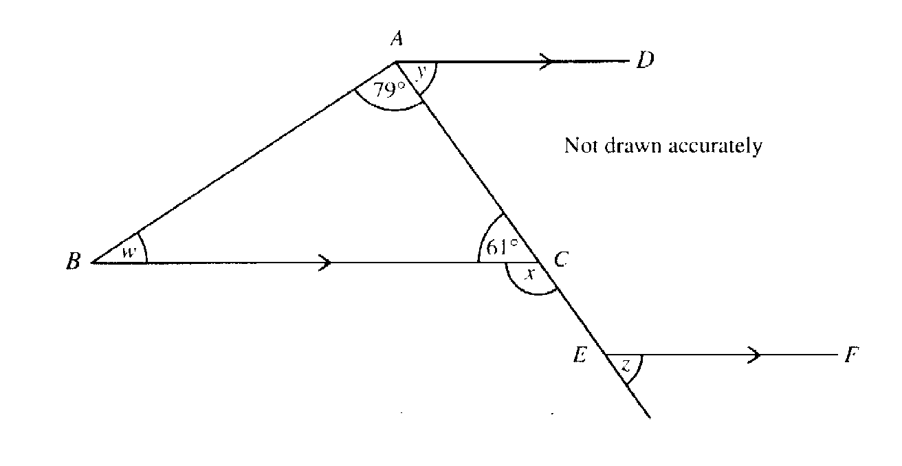

Work out the size of the angles marked w, x, y and z
Angle w
…………………………………………………………………………………………………………………………………
………………………………………………………………………………………………………………………………… [1]
Angle x
…………………………………………………………………………………………………………………………………
………………………………………………………………………………………………………………………………… [1]
Angle y
…………………………………………………………………………………………………………………………………
………………………………………………………………………………………………………………………………… [1]
Angle z
…………………………………………………………………………………………………………………………………
………………………………………………………………………………………………………………………………… [1]

48. Amy is x years old

(a) Her brother Brian is 4 years older than Amy.
Write down an expression, in terms of x, for Brian’s age.
…………………………………………………………………………………………………………………………………
………………………………………………………………………………………………………………………………… [1]
(b) Their mother is three times as old as Amy.
Write down an expression in terms of x, for their mother’s age.
…………………………………………………………………………………………………………………………………
………………………………………………………………………………………………………………………………… [1]
(c) The total of their three ages is 64 years.
Write down an equation in x
…………………………………………………………………………………………………………………………………
…………………………………………………………………………………………………………………………………
………………………………………………………………………………………………………………………………… [2]
(d) Solve your equation for x and find Brian’s age
…………………………………………………………………………………………………………………………………
…………………………………………………………………………………………………………………………………
…………………………………………………………………………………………………………………………………
…………………………………………………………………………………………………………………………………
………………………………………………………………………………………………………………………………… [3]

49. Three radio stations at A, B and C receive a distress call from a boat

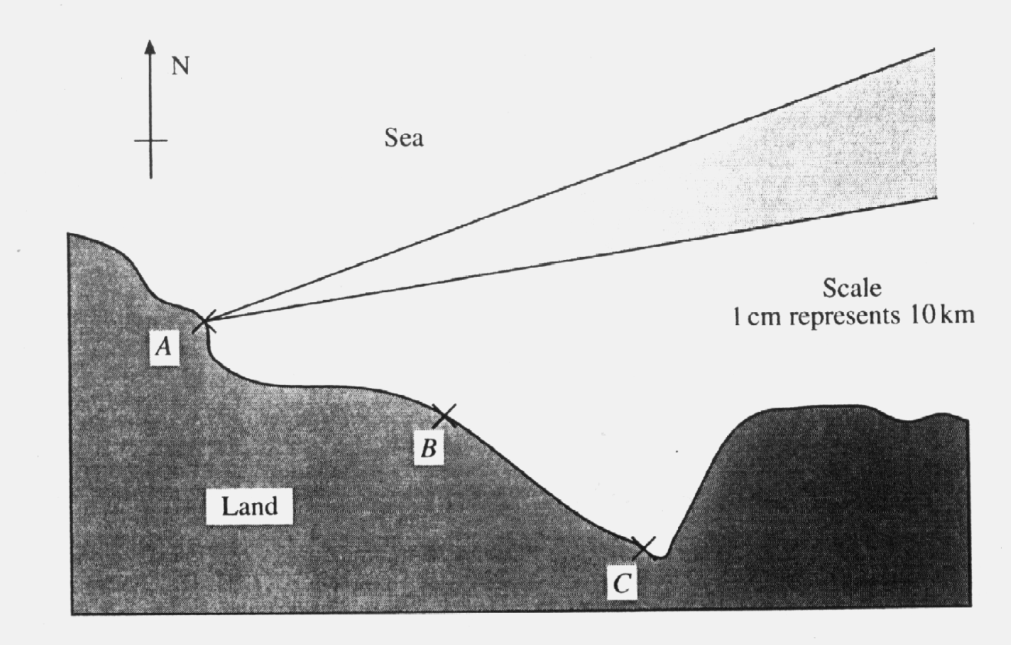
Station A can tell that the boat is on a bearing of between 070º and 080º from A. (This area is shown on the diagram)

Station B can tell that the boat is between 30 km and 40 km from B.

Station C can tell that the boat is between a bearing of 340º and 355º from C.

Show clearly on the diagram where the boat could be. [4]

50. Solve the simultaneous equations

3c + 5d = 23
4c – 3d = -37
………………………………………………………………………………………………………………………………………
………………………………………………………………………………………………………………………………………
………………………………………………………………………………………………………………………………………
………………………………………………………………………………………………………………………………………
………………………………………………………………………………………………………………………………………
………………………………………………………………………………………………………………………………………
………………………………………………………………………………………………………………………………………
………………………………………………………………………………………………………………………………………
………………………………………………………………………………………………………………………………………
……………………………………………………………………………………………………………………………………… [4]

51. A box contains counters which are numbered 1, 2, 3, 4 or 5.
A counter is taken from the box at random.

(a) Complete the table to show the probability of each number being chosen.

Number on counter | Probability
1 | 0.20
2 | 0.30
3 | 0.15
4
5 | 0.10
[1]
(b) Is the number on the counter chosen more likely to be odd or even? You must show your working
………………………………………………………………………………………………………………………………………
………………………………………………………………………………………………………………………………………
………………………………………………………………………………………………………………………………………
……………………………………………………………………………………………………………………………………… [2]

52. (a) Factorise the expression
12y – 18z
…………………………………………………………………………………………………………………………………
………………………………………………………………………………………………………………………………… [1]

(b) (i) Factorise the expression
x² – 3x – 10
…………………………………………………………………………………………………………………………………
…………………………………………………………………………………………………………………………………
………………………………………………………………………………………………………………………………… [2]

(ii) Using your answer from part (i), solve the equation
x² – 3x – 10 = 0
…………………………………………………………………………………………………………………………………
…………………………………………………………………………………………………………………………………
………………………………………………………………………………………………………………………………… [2]

53. The table shows the mathematics test results for 90 students.
The test was marked out of 60.
Mark (x) | Frequency | Cumulative Frequency
0 ≤ x ≤ 10 | 10 | 10
10 < x ≤ 20 | 17
20 < x ≤ 30 | 27
30 < x ≤ 40 | 18
40 < x ≤ 50 | 10
50 < x ≤ 60 | 8

(a) Complete the cumulative frequency column
[1]
(b) Draw a cumulative frequency diagram on the grid opposite
[3]
(c) Use your diagram to estimate

the median
…………………………………………………………………………………………………………………………………
………………………………………………………………………………………………………………………………… [2]

the interquartile range
…………………………………………………………………………………………………………………………………
…………………………………………………………………………………………………………………………………
………………………………………………………………………………………………………………………………… [1]

(d) The pass mark for the test is 25 marks.
Use your graph to estimate how many pupils pass the test.

…………………………………………………………………………………………………………………………………
…………………………………………………………………………………………………………………………………
………………………………………………………………………………………………………………………………… [2]
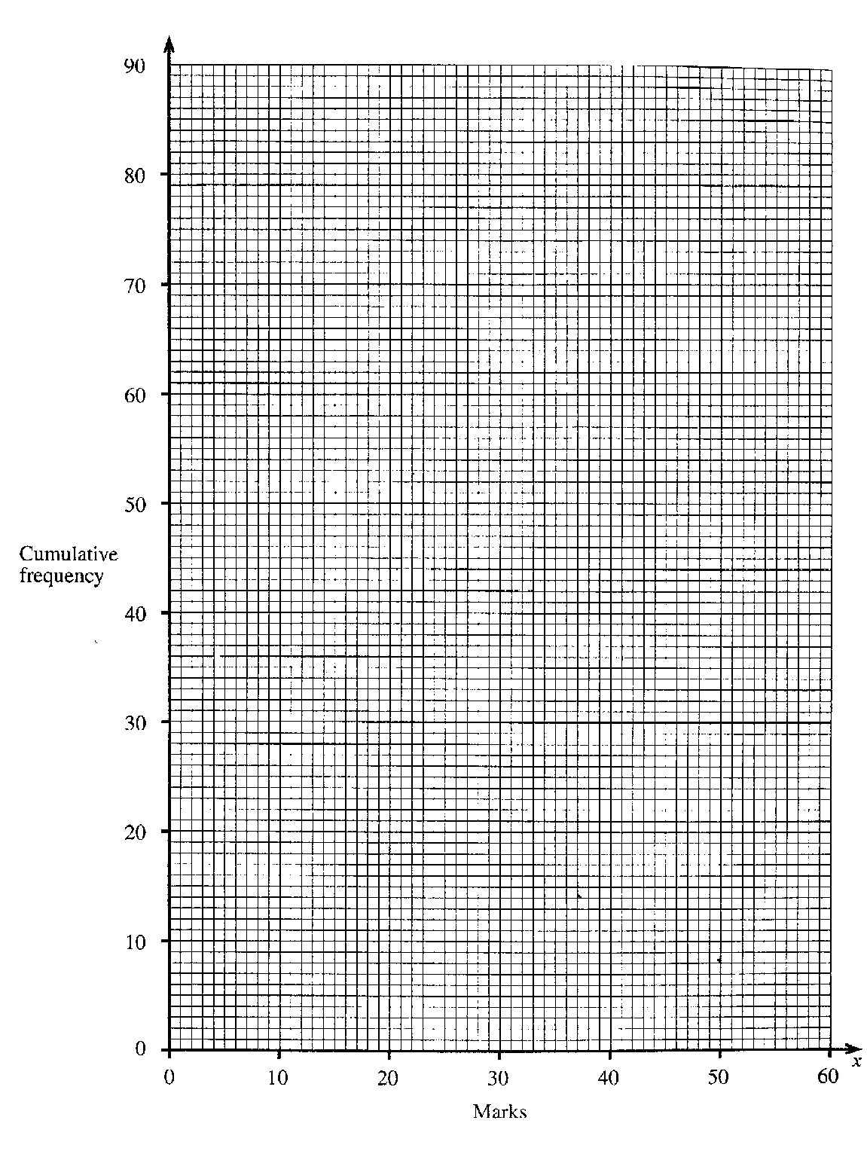

54.
3 | 5 | 7 | 9 | 11
8 | 10 | 12 | 14 | 16
13 | 15 | 17 | 19 | 21
18 | 20 | 22 | 24 | 26

Which of the numbers in the table are multiples of 7
…………………………………………………………………………………………………………………………………
…………………………………………………………………………………………………………………………………
………………………………………………………………………………………………………………………………… [2]
Which numbers in the table are prime numbers?
…………………………………………………………………………………………………………………………………
…………………………………………………………………………………………………………………………………
………………………………………………………………………………………………………………………………… [2]
Which numbers in the table are square numbers?
…………………………………………………………………………………………………………………………………
…………………………………………………………………………………………………………………………………
………………………………………………………………………………………………………………………………… [2]

55. Solve the following equations

(a) 3x - 8 = 13
…………………………………………………………………………………………………………………………………
…………………………………………………………………………………………………………………………………
………………………………………………………………………………………………………………………………… [1]
(b) 5(x – 1) + 3(x – 4) = 7
…………………………………………………………………………………………………………………………………
…………………………………………………………………………………………………………………………………
………………………………………………………………………………………………………………………………… [2]

56. Solve the simultaneous equations
3a - 7b = -1
2a + 3b = 30
…………………………………………………………………………………………………………………………………
…………………………………………………………………………………………………………………………………
…………………………………………………………………………………………………………………………………
…………………………………………………………………………………………………………………………………
…………………………………………………………………………………………………………………………………
…………………………………………………………………………………………………………………………………
…………………………………………………………………………………………………………………………………
…………………………………………………………………………………………………………………………………
…………………………………………………………………………………………………………………………………
…………………………………………………………………………………………………………………………………
………………………………………………………………………………………………………………………………… [4]

57. The table gives the diameter and distance from the sun of some planets.

Planet | Distance from Sun in km | Diameter in km
Earth | 1.5 x 10⁸ | 1.3 x 10⁴
Venus | 1.085 x 10⁸ | 1.2 x 10⁴
Mars | 2.28 x 10⁸ | 6.8 x 10³
Mercury | 5.81 x 10⁷ | 4.9 x 10³
Jupiter | 7.8 x 10⁸ | 1.4 x 10⁵
Neptune | 4.52 x 10⁹ | 4.9 x 10⁴
Saturn | 1.43 x 10⁹ | 1.2 x 10⁵

(a) Which planet listed in the table is furthest from the Sun?
…………………………………………………………………………………………………………………………………
…………………………………………………………………………………………………………………………………
………………………………………………………………………………………………………………………………… [2]
(b) Using the information in the table, list the planets in order of size, from smallest to largest.
…………………………………………………………………………………………………………………………………
…………………………………………………………………………………………………………………………………
………………………………………………………………………………………………………………………………… [2]

58. A darts player scored 190 with 6 darts, the individual scores being as follows:

Dart 1 – treble 19
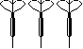
Dart 2 – treble 3
Dart 3 – treble 18
Dart 4 – single 20
Dart 5 – single 18
Dart 6 – double 16

What is the mean score per dart? Give your answer to the nearest whole number.

Question continues over page >

…………………………………………………………………………………………………………………………………
…………………………………………………………………………………………………………………………………
………………………………………………………………………………………………………………………………… [3]

59. The notepad below shows orders for 4 different sorts of rice at a local takeaway.
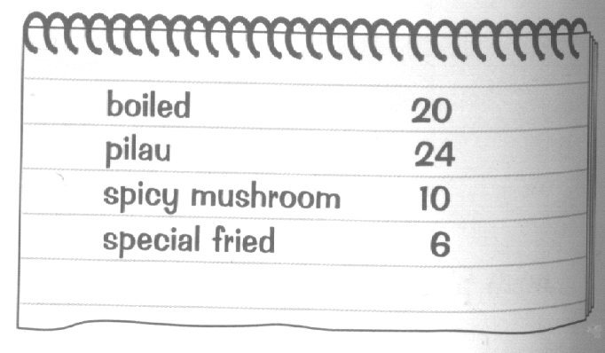

Based on this data, what is the probability that the next order of rice is:
(a) for pilau rice?
…………………………………………………………………………………………………………………………………
…………………………………………………………………………………………………………………………………
………………………………………………………………………………………………………………………………… [2]
(b) for spicy mushroom or special fried rice?
…………………………………………………………………………………………………………………………………
…………………………………………………………………………………………………………………………………
………………………………………………………………………………………………………………………………… [1]
(c) not for boiled rice?
…………………………………………………………………………………………………………………………………
…………………………………………………………………………………………………………………………………
………………………………………………………………………………………………………………………………… [1]

60. Factorise the following expressions completely:
(a) 4a + 2b - 6c
…………………………………………………………………………………………………………………………………
………………………………………………………………………………………………………………………………… [1]
(b) 3g – 12gh
…………………………………………………………………………………………………………………………………
………………………………………………………………………………………………………………………………… [2]
(c) x² – 7x + 12
…………………………………………………………………………………………………………………………………
………………………………………………………………………………………………………………………………… [2]
(d) Use your answer to part (c) to solve the equation
x² – 7x + 12 = 0
…………………………………………………………………………………………………………………………………
…………………………………………………………………………………………………………………………………
………………………………………………………………………………………………………………………………… [2]
61. Given that y = x² + 2x
(a) Complete the table below,
x | 0 | 1 | 2 | 3 | 4 | 5
y |  |  | 8 | 15
[2]
(b) Plot these points on the grid below and hence draw the graph of
y = x² + 2x [2]

(c) Use your graph to find the value of x when y = 30
……………………………………………………………………………………………………………………………….. [1]

Use graph over the page.

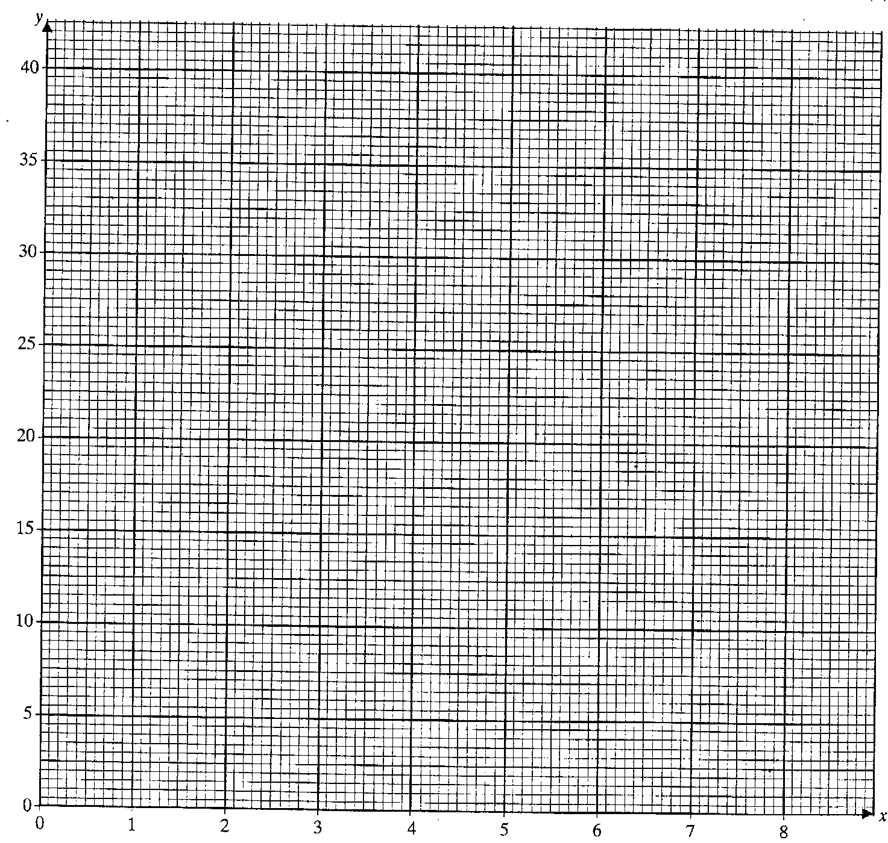
62. Expand the brackets and simplify:

(a) 2a(af + 3g)
…………………………………………………………………………………………………………………………………
………………………………………………………………………………………………………………………………… [2]
(b) (3x + 4)(2x – 3)
…………………………………………………………………………………………………………………………………
…………………………………………………………………………………………………………………………………
………………………………………………………………………………………………………………………………… [2]

63. Ten people entered a craft competition.
Their displays of work were marked by two different judges.
The table shows the marks that they gave to each of the competitors.

Competitor | A | B | C | D | E | F | G | H | I | J
First judge | 90 | 35 | 60 | 15 | 95 | 25 | 5 | 100 | 70 | 45
Second judge | 75 | 30 | 55 | 20 | 75 | 30 | 10 | 85 | 65 | 40
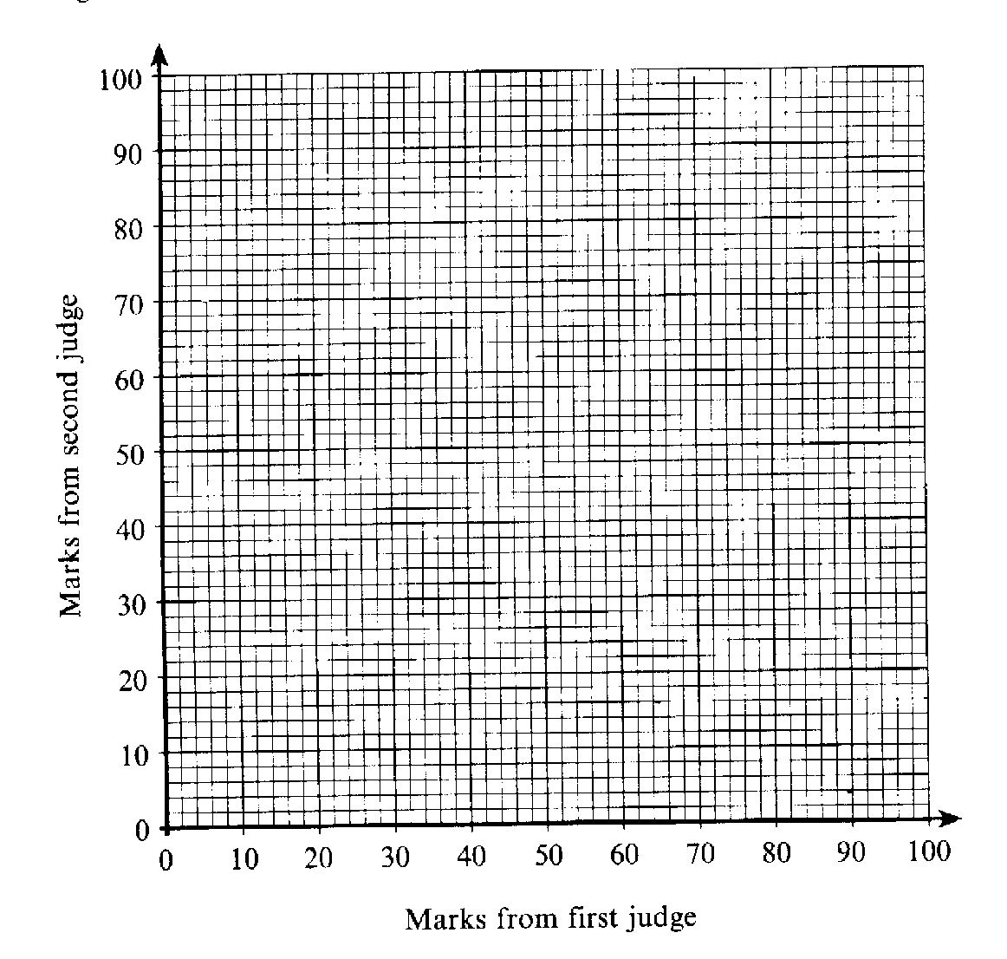
On the grid below, draw a scatter diagram to show this information. [3]

Draw a line of best fit [1]

(c) A late entry was given 75 marks by the first judge.
Use your scatter diagram to estimate the mark that might have been given by the second judge. Show how you found your answer.
…………………………………………………………………………………………………………………………………
…………………………………………………………………………………………………………………………………
………………………………………………………………………………………………………………………………… [1]

64. Complete the multiplication table below:
X | -3 | 2 |  | -9
-1 |  | -2 | 4
 | 9 |  | 12 | 27
5 |  | 10 | -20 | -45
7 | -21 | 14
[4]

65. Mr Jones monitored the distance that employees in his company had to drive on business in one week:

Employee A 152 miles
Employee B 608 miles
Employee C 332 miles
Employee D 348 miles

If he represents this information on a pie chart, calculate the size of the angle needed to represent employee B.
…………………………………………………………………………………………………………………………………
…………………………………………………………………………………………………………………………………
………………………………………………………………………………………………………………………………… [2]

66. Solve the following equations

(a) 5x - 7 = 33
…………………………………………………………………………………………………………………………………
………………………………………………………………………………………………………………………………… [1]
(b) 5(x – 1) + 2(x – 5) = 13
…………………………………………………………………………………………………………………………………
…………………………………………………………………………………………………………………………………
…………………………………………………………………………………………………………………………………
………………………………………………………………………………………………………………………………… [2]
67. Write these numbers in order, smallest first. Remember to show all your working.
0.5, $\frac{4}{9}$, 46%
…………………………………………………………………………………………………………………………………
…………………………………………………………………………………………………………………………………
………………………………………………………………………………………………………………………………… [2]

68. Solve the simultaneous equations

3x + 5y = -1
2x – 4y = 14
…………………………………………………………………………………………………………………………………
…………………………………………………………………………………………………………………………………
…………………………………………………………………………………………………………………………………
…………………………………………………………………………………………………………………………………
…………………………………………………………………………………………………………………………………
…………………………………………………………………………………………………………………………………
…………………………………………………………………………………………………………………………………
…………………………………………………………………………………………………………………………………
………………………………………………………………………………………………………………………………… [4]

69. Factorise the following expressions:
(a) 3a + 9b -6c
…………………………………………………………………………………………………………………………………
………………………………………………………………………………………………………………………………… [1]
(b) 5g² – 15gh
…………………………………………………………………………………………………………………………………
………………………………………………………………………………………………………………………………… [2]
(c) x² – 2x - 15
…………………………………………………………………………………………………………………………………
………………………………………………………………………………………………………………………………… [2]
(d) Use your answer to part (c) to solve the equation
x² – 2x - 15 = 0
…………………………………………………………………………………………………………………………………
…………………………………………………………………………………………………………………………………
………………………………………………………………………………………………………………………………… [2]

70. Here are the first five terms in a series
3 7 11 15 19
Find the nth term in the series
…………………………………………………………………………………………………………………………………
………………………………………………………………………………………………………………………………… [2]

71. 5 8 15 18 23 48 51
From the numbers in the box, write down
(a) Two prime numbers
………………………………………………………………………………………………………………………………… [2]

(b) A cube number
………………………………………………………………………………………………………………………………… [1]

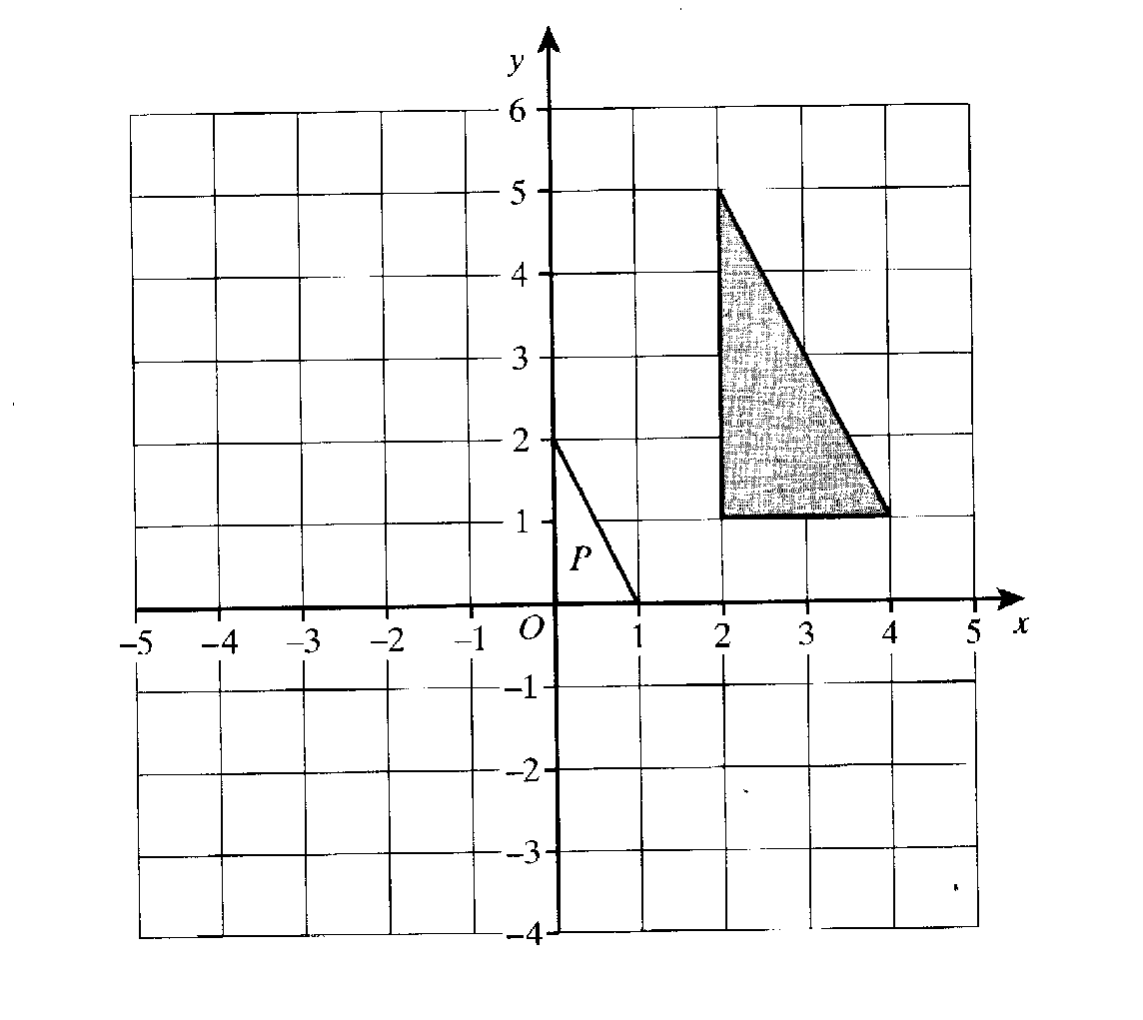
72.

Triangle P is an enlargement of the shaded triangle.

(a) What is the scale factor of the enlargement?
…………………………………………………………………………………………………………………………………
………………………………………………………………………………………………………………………………… [1]
(b) Find the coordinates of the centre of enlargement.
…………………………………………………………………………………………………………………………………
………………………………………………………………………………………………………………………………… [1]

73.
1 | 2 | 3 | 4 | 5 | 6 | 7 | 8 | 9 | 10
11 | 12 | 13 | 14 | 15 | 16 | 17 | 18 | 19 | 20
21 | 22 | 23 | 24 | 25 | 26 | 27 | 28 | 29 | 30
31 | 32 | 33 | 34 | 35 | 36 | 37 | 38 | 39 | 40
41 | 42 | 43 | 44 | 45 | 46 | 47 | 48 | 49 | 50
51 | 52 | 53 | 54 | 55 | 56 | 57 | 58 | 59 | 60
61 | 62 | 63 | 64 | 65 | 66 | 67 | 68 | 69 | 70
71 | 72 | 73 | 74 | 75 | 76 | 77 | 78 | 79 | 80
81 | 82 | 83 | 84 | 85 | 86 | 87 | 88 | 89 | 90
91 | 92 | 93 | 94 | 95 | 96 | 97 | 98 | 99 | 100

John and Kate were playing a guessing game. Kate thought of a number between 1 and 100 which John had to guess. John was allowed to ask 5 questions, which are listed with Kate’s responses in the table below.

John’s Questions | Kate’s Responses
Is it prime? | No
Is it odd? | Yes
Is it less than 50? | No
Is it a multiple of 3? | Yes
Is it a multiple of 7? | Yes

What is the number that Kate thought of?
…………………………………………………………………………………………………………………………………
………………………………………………………………………………………………………………………………… [3]

74. Join up all the pairs of equivalent expressions.

2a(a + 4b) 2a² + 4b

2(a² + 2b) 12ab + 27a²

12ab + 9a 2a² + 8ab

3a(4b + 9a) 3a(4b + 3)

[3]

75.

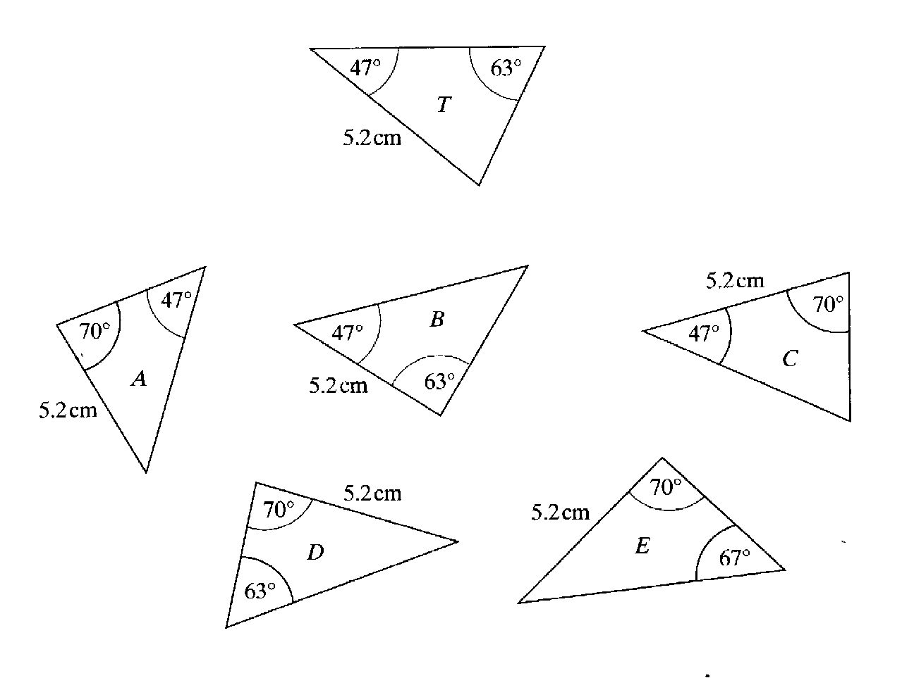

Which of the triangles A, B,C, D and E are congruent to triangle T?
…………………………………………………………………………………………………………………………………
………………………………………………………………………………………………………………………………… [2]

76. Solve the following simultaneous equations. Do not use a trial and improvement method.

4a + 5b = 22
3a + 2b = 6
…………………………………………………………………………………………………………………………………
…………………………………………………………………………………………………………………………………
…………………………………………………………………………………………………………………………………
…………………………………………………………………………………………………………………………………
………………………………………………………………………………………………………………………………… [4]

77. In the box are six numbers written in standard form.
7.5 x 10⁴ 8.1 x 10⁵ 9.3 x 10⁻³
6.25 x 10⁻¹ 8.16 x 10³ 5.37 x 10⁻²

(a) Write down the largest number. ………………………………………………………………………………………………………………………………… [1]
(b) Write down the smallest number.
………………………………………………………………………………………………………………………………… [1]
(c) Write your answer to (b) as an ordinary number.
………………………………………………………………………………………………………………………………… [1]

78. A bag contains a total of 20 beads. There are 6 red beads, 9 blue beads and
5 white beads.
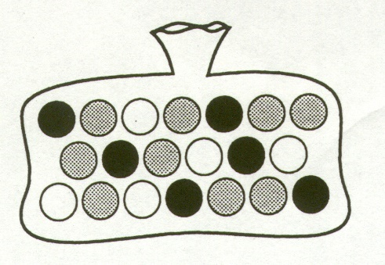

(a) A bead is taken at random from the bag. What is the probability that it is a blue bead?
…………………………………………………………………………………………………………………………………
………………………………………………………………………………………………………………………………… [1]
(b) A bead is taken at random from the bag. What is the probability that it is not a white bead?
…………………………………………………………………………………………………………………………………
………………………………………………………………………………………………………………………………… [1]

(c) A bead is taken at random from the bag and not replaced. A second bead is then taken from the bag. Complete the tree diagram to show the possible outcomes.

First ball Second ball

$\frac{3}{10}$
red

[3]

(d) Use the tree diagram to determine the probability that both of the balls are white.
………………………………………………………………………………………………………………………………
………………………………………………………………………………………………………………………………
……………………………………………………………………………………………………………………………… [2]
(e) Use the tree diagram to determine the probability that at least one of the balls is white.
………………………………………………………………………………………………………………………………
………………………………………………………………………………………………………………………………
………………………………………………………………………………………………………………………………
……………………………………………………………………………………………………………………………… [3]

79. ABCDEFGH is a regular octagon.

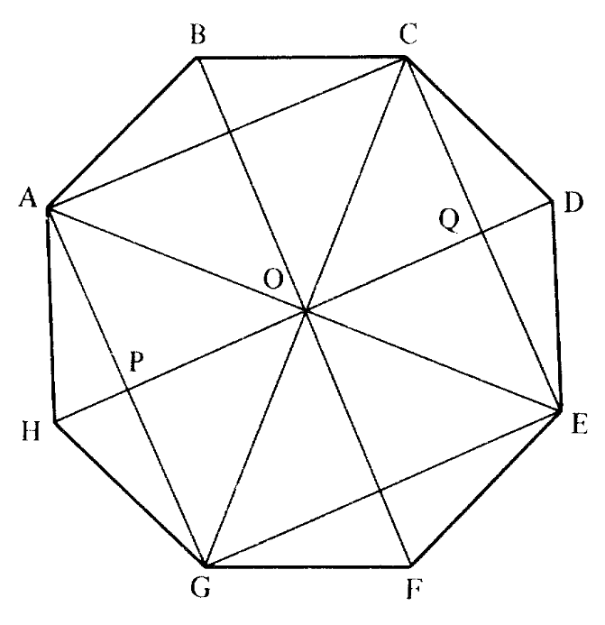

(a) Describe the figure AOGH.
………………………………………………………………………………………………………………………………… [1]
(b) Describe the figure OPGE
………………………………………………………………………………………………………………………………… [1]
(c) Calculate the size of angle COD
………………………………………………………………………………………………………………………………… [1]

80. Make p the subject of the formula
$\frac{2(p - 5)}{6}$= r
…………………………………………………………………………………………………………………………………
…………………………………………………………………………………………………………………………………
…………………………………………………………………………………………………………………………………
………………………………………………………………………………………………………………………………… [2]

81. Solve the following inequalities:
(a) 2p – 5 > -11
………………………………………………………………………………………………………………………………… ………………………………………………………………………………………………………………………………… [1]
(b) 6 - 3x < -6
…………………………………………………………………………………………………………………………………
…………………………………………………………………………………………………………………………………
………………………………………………………………………………………………………………………………… [2]

82. North
X Lighthouse

X
Ship Not drawn to scale

A captain of a ship at sea spots a lighthouse on a bearing of 085º from the ship. What is the bearing of the ship from the lighthouse?

……………………………………………………………………………………………………………………………………….
……………………………………………………………………………………………………………………………………….
……………………………………………………………………………………………………………………………………… [2]

83. (a) Factorise the expression
x² + 3x - 10
……………………………………………………………………………………………………………………………………
……………………………………………………………………………………………………………………………………
…………………………………………………………………………………………………………………………………… [2]

(b) Using your answer from part (a), solve the equation
x² + 3x - 10= 0
…………………………………………………………………………………………………………………………………
…………………………………………………………………………………………………………………………………
………………………………………………………………………………………………………………………………… [2]

84. For each of the following number series, find the next two terms and then find the nth term.

(a) 1, 4, 7, 10, …, …,
Next two terms
………………………………………………………………………………………………………………………………… [1]
nth term
………………………………………………………………………………………………………………………………… [2]
(b) 3, 6, 11, 18, …, …,
Next two terms
………………………………………………………………………………………………………………………………… [1]
nth term
………………………………………………………………………………………………………………………………… [2]
(c) 2, 4, 8, 16, …, …,
Next two terms
………………………………………………………………………………………………………………………………… [1]
nth term
………………………………………………………………………………………………………………………………… [2]

85. Jason weighs 9 stone 8 pounds. He converts his weight to kilograms using the following calculation.

$\frac{(9 x 14) + 8}{2.2}$

(a) What is his weight in Kg?
……………………………………………………………………………………………………………………………………… [1]
(b) Show how he could simplify the calculation to get a good mental estimate.
………………………………………………………………………………………………………………………………………
………………………………………………………………………………………………………………………………………
………………………………………………………………………………………………………………………………………
……………………………………………………………………………………………………………………………………… [2]

86. A survey was conducted in a street of 50 houses, asking how many people lived in each house. These are the results:

Size of household | 1 | 2 | 3 | 4 | 5 | 6
Number of households | 11 | 16 | 12 | 7 | 4 | 2

(a) Calculate the modal number of people per household.
………………………………………………………………………………………………………………………………………
………………………………………………………………………………………………………………………………………
……………………………………………………………………………………………………………………………………… [2]
(b) Calculate the median number of people per household.
………………………………………………………………………………………………………………………………………
………………………………………………………………………………………………………………………………………
……………………………………………………………………………………………………………………………………… [2]
(c) Calculate the mean number of people per household.
………………………………………………………………………………………………………………………………………
………………………………………………………………………………………………………………………………………
………………………………………………………………………………………………………………………………………
……………………………………………………………………………………………………………………………………… [3]

87. A wood with 600 trees is planted. The wood is planted with 200 pine trees, 80 oak trees, some birch trees and some ash trees.

(a) Five twelfths of the 600 trees are birch. How many birch trees are there?
……………………………………………………………………………………………………………………………………
……………………………………………………………………………………………………………………………………
…………………………………………………………………………………………………………………………………… [1]
(b) What is the ratio of pine trees to oak trees? Give your answer in its simplest form.
……………………………………………………………………………………………………………………………………
……………………………………………………………………………………………………………………………………
…………………………………………………………………………………………………………………………………… [2]

END OF EXAM

Answers to Non-Calculator Practice Questions

Answers to questions involving diagrams of graphs may vary slightly

1. (a) 3a(a-2)
(b) 2x2 – 7x + 4

2. (a) 666672 = 4444488889
(b) 44444448888889
(c) 66666667

3. (a) 28, 33
(b) 5n-2
(c) 498

4. (a)(i) 54˚ (ii) 46˚
(b)3.6cm

5. (a) 90˚
(b) 72˚
(c) 108˚

6. (a) x = 4.5
(b) x = 2.4, y = 1.6
(c) x < 2.5

7. (a) $\frac{1}{25}$
(b) $\frac{1}{5}$
8. (a) any decimal between 0.33333 and 0.5
(b) ¾ is bigger

9. (a) (i) 15, 100, 270, 310, 320 (ii) on diagram
(b) (i) 4.6 minutes (ii) 1.8 minutes

10. (a) On graph
(b) 96 km per hour

11. (a) 1.4
(b) 1.48m

12. (a) 0.2
(b) 0.7
(c) 20

13. a = 3½ , c = 1½

14. (a) twice
(b)(i) 2km, (ii) 12km per hour,
(c) D to E

15. (a) 3n, (b) 3n-2, (c) n²

16. (a) 295˚
(b) Mawley

17. (a) 27, 56, 72, 83, 90
(b) on diagram
(c)(i)27 (ii) 20
(d) 53

18. (a) 9, 25, 100
(b) 20, 25, 100
(c) 3, 29

19. (a) 3x(x-2)
(b) t = 4W –3
5

20. (a) Reflection in the line y = 0 (i.e. x axis)
(b) Rotation through 90˚ in an anticlockwise direction. The centre of the rotation is (0,0)
(c) Enlargement, scale factor 3, centre of enlargement at (5,4)
21. (a) x = 9.5
(b) x = 2

22. (a) 36, 45
(b) 1, 2, 25 ,36
(c) 5, 23, 41, 43

23. (a) 0.08
(b) 0.32
(c) 0.48
(d) 0.44

24. 20˚

25. 5x (x-2)

26. -2,-1,0,1,2

27. (a) On graph
(b) The longer the journey, the higher the higher the cost. Good positive correlation.
(c) On graph
(d) £9.50,
(e) 9.5 to 10km

28. (a) 13
(b) 5+5-2-2

29. x = 2.5

30. x = $\frac{1}{2}$, y = 3
31. (a) x = 7
(b) x = 3

32. Max £262.50, friend £157.50

33. 250

34. (a) 0,2,6,20,30
(c) 4.6
35. (a) 150cm
(b)148cm
(c) 13cm

36. (a) 23, 29
(b) 25, 36, 49

37. (a) 56˚
(b) 1200 people

38. (a) 3 x 3 x 3, 4 x 4 x 4 = 64
(b) 100 = 10²
(c) 1³ + 2³ + 3³ + 4³ + 5³ + 6³ = 441 = 21²

39. a = 7, b = 4

40. (a) 020˚
(b) 255˚

41. (a) (i) 2 + x, (ii) 9 – x
(b) (i) 2 + x = - x, (ii) 3.5

42. (a) A’ (4,5), B’(7,1), C’(-5,-1)
(b) A’’(-4,-9), B’’(-7,-3), C’’(5,-3)

43. -1, 5

44. (a) on image.
(b) 2

45. 2.2

46. (a) Rhombus
(b) Parallelogram

47. 40˚, 119˚, 61˚, 61˚

48. (a) x+4
(b)3x
(c)3x+x+x+4=64
(d) x=12, Brian=16

49. Diagram

50. c = -4, d = 7

51. (a) 0.5
(b) odd total 0.45, even total 0.55. Even more likely

52. (a) 12y-18z = 6(2y-3z)
(b) (i) x²-3x-10=0 = (x-5)(x+2)=0 (ii) x=5 or x=-2

53. On graph.

54. (a) 7, 14, 21
(b) 3, 5, 7, 11, 13, 17, 19
(c) 9 and 16

55. (a) x = 7
(b) x = 3

56. a = 9, b=4

57. (a) Neptune
(b) Mercury, Mars, Venue, Earth, Neptune, Saturn, Jupiter

58. 32

59. (a) $\frac{2}{5}$
(b) $\frac{4}{15}$
(c) $\frac{2}{3}$
60. (a) 2(2a + b – 3c)
(b) 3g(1 – 4h)
(c) (x – 3)(x – 4)
(d) either x = 3 or x = 4

61. (a) 1.71
(b) 8.23
(c) 4.42

62. (a) 2a²f + 6ag
(b) 6x² – x - 12

63. (a) graph
(b) Line passes through (0,6) and (100,85) or thereabouts
(c) approximately 65

64. -4, 3, 9, -3, -6, -15, -28, -63

65. 152˚

66. (a) x = 8
(b) x = 4

67. 0.444, 0.46, 0.5

68. x=3, y=-2

69. (a) 3(a + 3b -2c)
(b) 5g(g – 3h)
(c) (x – 5)(x + 3)
(d) x = 5 or x = -3

70. 4n-1

71. (a) 5 and 23
(b) 8

72. (a) Enlargement scale factor 2
(b) (-2, -1)

73. 63

74. 2a(a+4b) = 2a²+8b
2(a²+2b) = 2a²+4b
12ab+9a = 3a(4b+3)
3a(4b+9a) = 12ab + 27a²
75. C and D

76. a=-2 b=6

77. (a) 8.1 x 10⁵
(b) 9.3 x 10⁻³
(c) 0.0093
78. (a) $\frac{9}{20}$
(b) $\frac{3}{4}$
(c) 1st ball - Bl $\frac{9}{20}$, Wh $\frac{1}{4}$,
2nd ball – R $\frac{5}{19}$, Bl $\frac{9}{19}$, Wh $\frac{5}{19}$, R $\frac{6}{19}$, Bl $\frac{8}{19}$, Wh $\frac{5}{19}$, R $\frac{6}{19}$, Bl $\frac{9}{19}$, Wh $\frac{4}{19}$
(d) $\frac{1}{19}$
(e) $\frac{17}{38}$

79. (a) kite
(b) trapezium
(c) 45˚

80. 2p = 6r + 10

81. (a) p>-3
(b) x>4

82. 265˚

83. (a) (x + 5)(x – 2)
(b) x = -5 or x = 2

84. (a) 3, 16, 3n – 2
(b) 27,38, n² + 2
(c) 32, 64, 2^{n}

85. (a) 60.91 kg
(b) $\frac{(10 x 14) + 10}{2}$= 75

86. (a) 2
(b) 2
(c) 2.78

87. (a) 250
(b) 5.2

PRACTICE PAPER

Edge Hill GCSE Maths
Equivalency Test

Calculator Paper

Name …………………………………………………………………………

ATTEMPT ALL QUESTIONS

Show all your working in the space provided and make sure your answer is clear.

It is assumed that you have a scientific calculator, ruler and protractor.

If your calculator does not have a π button, take the value of π to be 3.142

Diagrams are not necessarily drawn to scale.

The marks for each question are given in brackets by the side of the question.

Marks may be given for method even if your answer is wrong.

The total marks available are 120

1.
Work out the cube of 4

Answer………………………………………………………… (1 mark)

Work out 6 ÷ 0.7²

Write down the full calculator display.

Answer…………………………………………………………… (1 mark)
Give your answer to the nearest whole number.

Answer…………………………………………………………… (1 mark)

Calculate 29.4
20.1 - 3.6

Give your answer to an appropriate degree of accuracy.

Answer………………………………………………………… (1 mark)

2.
Here is a sequence of numbers:

2 5 11 23

The rule for continuing this sequence is Multiply by 2 and add 1

The same rule is used for a sequence that starts with the number -4.
What are the next two numbers in the sequence?

Answer……………………………………………………… (2 marks)
3.
Circle the correct statement
⅓ ≤ 30% ⅓ = 30%
⅓ < 30% ⅓ ≠ 30%

Answer……………………………………………………… (1 mark)

Andy is saving for a bike that costs £75. He has saved £31.50.
What percentage is £31.50 of £75?

Answer……………………………………………………… (2 marks)

k is an even number.
Jo says that ½ k + 3 is always even.

Give an example to show that Jo is wrong.

Answer……………………………………………………… (1 mark)

In one hour, a machine can make 600 nuts or 720 bolts.
At 9 am the machine starts working.
It makes 900 nuts and then changes to making bolts.
How many bolts will the machine make by 2 pm?
………………………………………………………………………………………………………
………………………………………………………………………………………………………
………………………………………………………………………………………………………
………………………………………………………………………………………………………
Answer………………………………………………………………(3 marks)

There are men and women at a drama group.
There are 35 women.
30% of the people in the group are men.
Calculate the total number of people in the drama group.
………………………………………………………………………………………………………
………………………………………………………………………………………………………
………………………………………………………………………………………………………
………………………………………………………………………………………………………
Answer……………………………………………………………………(3 marks)

The diagram shows the two points A and B.
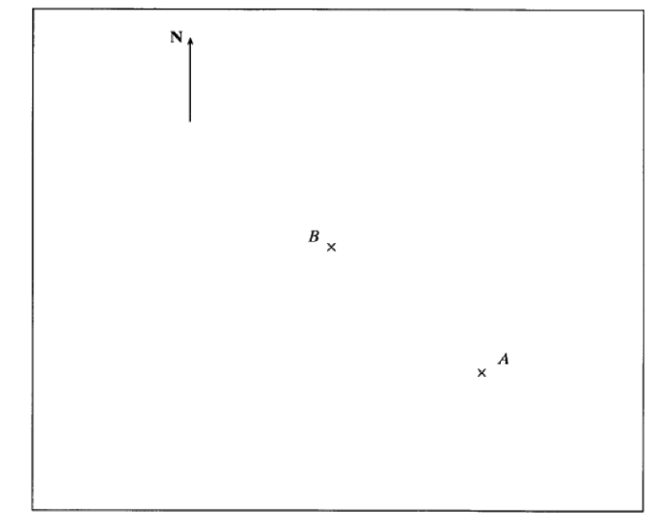
a) Measure the bearing of A from B

Answer…………………………………………………………… (2 marks)

b) Point C is South-West of B and West of A. Mark the position of C on the diagram.
(2 marks)
A circular dish has a diameter of 8cm.
Calculate the circumference of the dish.
State the units in your answer.

Answer ………………………………… (2 marks)

The equation $x^{3}-2x=97$ has a solution between 4 and 5.
Using trial and improvement solve $x^{3}-2x=97$ correct to 1 decimal place.
$$x$$ | $$x^{3}-2x=97$$ | Too big/  too small
Too small
Too big

Answer……………………… (1dp) (4 marks)

On the grid, reflect the shaded shape in the mirror line.
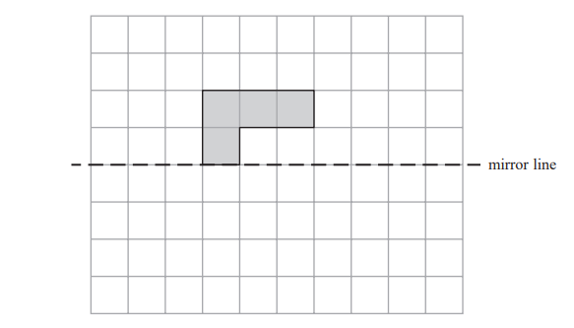
mark)

a) An ordinary six-sided dice is biased.
The probabilities of the dice landing on each of the numbers are:
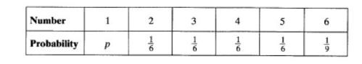

Work out the value of p.

Answer p = …………………………………………………………………… (2 marks)
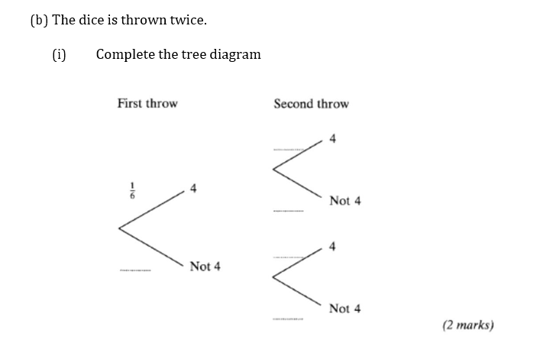
(ii) Calculate the probability that a 4 is thrown both times.

Answer……………………………………………………………………(3 marks)

Make $x$ the subject of the formula
$2x+3y=8y- 3$

Answer……………………………………………………………………(3 marks)

(i) Multiply out and simplify 4(x - 1) + 3(x + 1)

Answer………………………………………………………… (2 marks)

(ii) Multiply out and simplify (n + 5)²

Answer………………………………………………………… (2 marks)

Factorise completely the following expressions:
3a² + a

Answer………………………………………………………… (1 mark)

10x³y² – 5xy³

Answer………………………………………………………… (1 mark)

A shape has dimensions as shown:
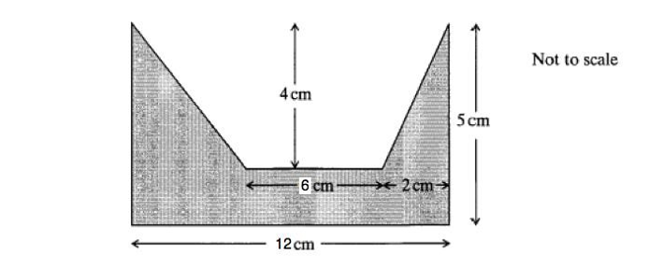
Calculate the shaded area.

Answer…………………………………………………cm² (3 marks)

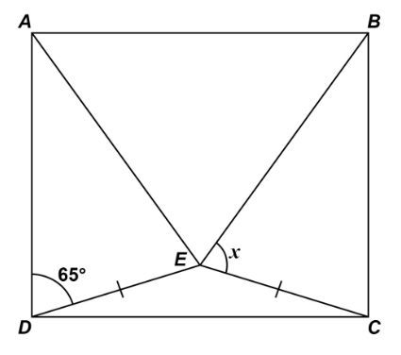
In the rectangle ABCD, triangle ABE is equilateral, triangle CDE is isosceles where CD = DE.
The diagram is not drawn accurately.
Work out the size of angle $x.$

…………………………………………….
…………………………………………….
…………………………………………….
……………………………………………
…………………………………………….
…………………………………………………………………………………………………………………………………………

Answer………………………………… (4 marks)

200 people live in a village.
23 people do not have a garden.
10 males do not have a garden.
95 people are male.

Use this information to complete the frequency tree.
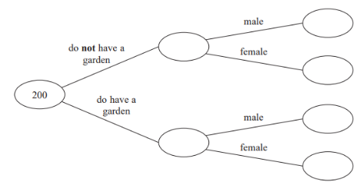

(2 marks)

Calculate the percentage of people in the village who are men and do not
have a garden.

Answer………………………………… (1 mark)

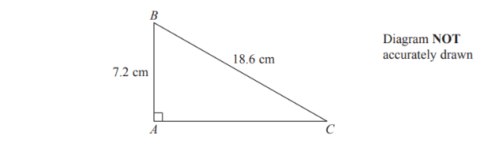

Calculate the length of AC.
Give your answer correct to 3 significant figures.

Answer……………………………………………………………………(3 marks)

ABC is a right-angled triangle.
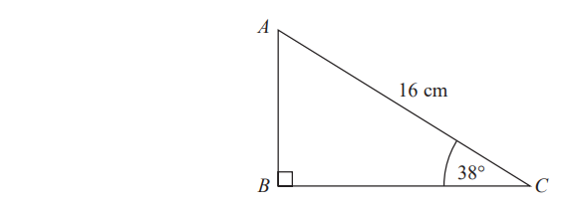
Calculate the length of AB.
Give your answer correct to 2 decimal places.

Answer……………………………………………………………………(3 marks)

END OF CALCULATOR PAPER

Edge Hill GCSE Maths
Equivalency Test

Non-Calculator Paper

Name …………………………………………………………………………

ATTEMPT ALL QUESTIONS

Show all your working in the space provided and make sure your answer is clear.

It is assumed that you have a scientific calculator, ruler and protractor.

If your calculator does not have a π button, take the value of π to be 3.142

Diagrams are not necessarily drawn to scale.

The marks for each question are given in brackets by the side of the question.

Marks may be given for method even if your answer is wrong.

The total marks available are 120

1.
Mr Smith is collecting money for a school trip.
All pupils pay the same amount.
He keeps a record of what he collects in this table.

Day | Number of pupils | Amount collected
Monday | 8 | £24
Tuesday |  | £18
Wednesday | 10

Complete Mr Smith’s table.

(2 marks)

2.

Which is the larger amount?
You must show your working.

Answer………………………………………… (3 marks)

(a) Simplify 4𝑥 + 3𝑦 − 2𝑥 + 4𝑦

Answer………………………………………… (1 mark)
(b) Find the value of 5𝑝 + 2𝑞 when p= 4 and q = - 7

Answer………………………………………… (1 mark)
Find the value of u² + v² when u = 5 and v =3

Answer………………………………………… (1 mark)

4. Solve these equations:

4𝑥 − 9 = 3

Answer x = ………………………………………………………………… (2 marks)

2(𝑦 + 5) = 26

Answer y= ………………………………………………………………… (3 marks)

7𝑧 + 2 = 9 − 𝑧

Answer z = ………………………………………………………………… (3 marks)

5.
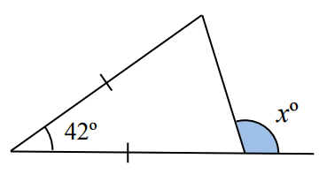
Calculate the value of $angle x$.
Clearly show each stage of calculation.

……………………………………………………
……………………………………………………
……………………………………………………
……………………………………………………

Answer $angle x=$………………………………………………………… degrees
(2 marks)

Mrs Millington gives her class two mock GCSE examination papers.
The scatter graph shows the results.

Write down the highest mark scored on Paper 1.

Answer ……………………………………………………marks (1 mark)

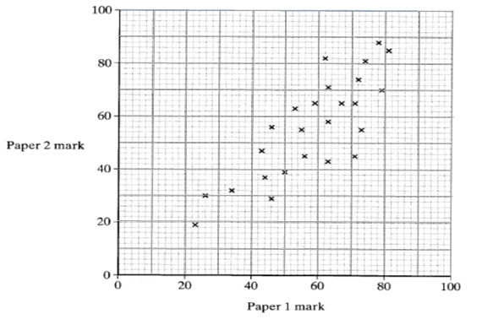

Describe the relationship shown on the scatter graph.

…………………………………………………………………………………………………
(1 mark)

Draw a line of best fit on the scatter graph.
(1 mark)

Kay was absent for Paper 2 but scored a mark of 62 on paper 1. Use your line of best fit to estimate Kay’s mark on Paper 2

………………………………………………………………………………………………………

Answer……………………………………………………marks (1 mark)

7.
Simplify:

𝑤⁵ × 𝑤²

Answer…………………………………………………………………………(1 mark)

𝑥² ÷ 𝑥⁵

Answer…………………………………………………………………………(1 mark)

(𝑦²)³

Answer…………………………………………………………………………(1 mark)

8.
Complete the table of values for 𝑦 = 2𝑥² − 4𝑥 − 1

𝒙 | -2 | -1 | 0 | 1 | 2 | 3
𝒚 | 15 |  | -1 |  | -1 | 5
(2 marks)

(b) On the grid, draw the graph of 𝑦 = 2𝑥²-4𝑥-1 for values of 𝑥 from -2 to +3
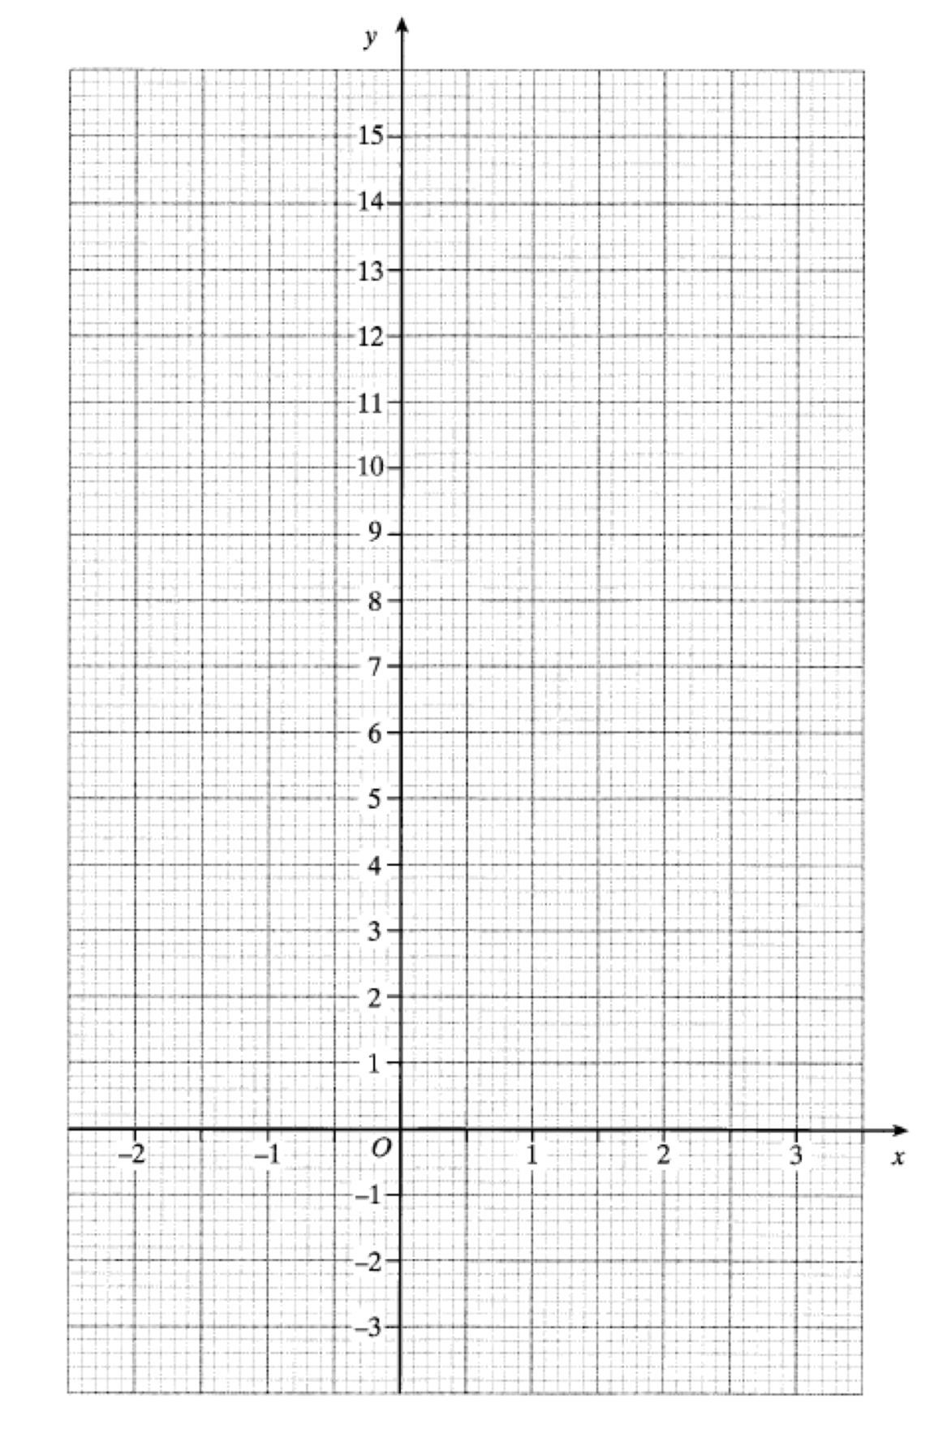
(2 marks)

9. Two bags, A and B, each contain five numbered discs that are all the same size.

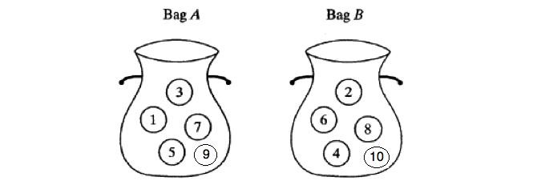

A disc is drawn at random from bag A and a disc is drawn at random from
bag B.
A score is obtained by adding the numbers on the two discs.
Complete the table to show all the possible scores.

Bag A
 | 1 | 3 | 5 | 7 | 9
2 | 3 | 5
4
6
8
10

+

Bag B

(2 Marks)

Find the probability of scoring less than 9

Answer………………………………………………………………………..... (2 marks)

10. a) On the isometric grid complete the drawing of a cuboid 5cm by 3cm by 2cm.

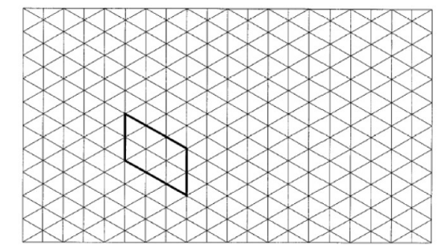

(2 marks)

(b) Calculate the volume of the cuboid. State the units in your answer.

Answer ………………………………………………… (2 marks)

11. The vertices of triangle T are (1,1), (1,4) and (2,1).
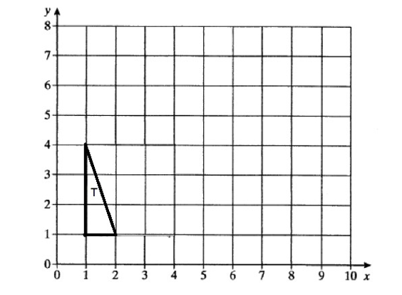
Enlarge triangle T by scale factor 2, with (0,0) as the centre of enlargement.
(2 marks)

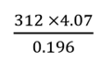
12.
Use approximations to estimate the value of
You must show your working.

Answer ………………………………………………… (3 marks)

13.
Factorise $x^{2}-10x+24$

Answer ………………………………………………… (2 marks)

14.
The manager of a clothes shop recorded the size of each dress sold one morning.

10 10 12 12 14 14 14 14 14 14 16 16 16 16 18 18 18 20 20 20

The sizes of dresses are always even numbers.
The mean size of the dresses sold that morning is 15.3
The manager says,
“The mean size of the dresses is not a very useful average.”

Explain why the manager is right.
................................................................................................................................................................................................................................................................................................................................................................................................................................................................................................................................................................................................................................ (1 mark)
Which is the more useful average for the manager to know, the median or the mode?
You must give a reason for your answer. ........................................................................................................................................................................................................................................................................................................................................................................................................................................................................
mark)

15. Megan tested her ability to memorise a sequence of playing cards.
She had nine attempts and recorded the number of cards she correctly remembered each time.
Here are her results.

4 6 4 7 8 $x$ 6 7 7

The mean of Megan’s nine scores is 6.
Work out the missing score $x$.

………………………………………………………………………………………………………
………………………………………………………………………………………………………
………………………………………………………………………………………………………
………………………………………………………………………………………………………
………………………………………………………………………………………………………
Answer ………………………………………… (3 marks)

A triangle has lengths as shown in the diagram.
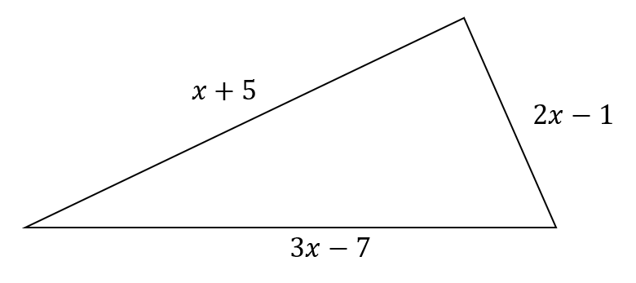
The perimeter of the triangle is 24 cm.
Work out the value of $x.$

Answer $x=$…………………………… cm (3 marks)

Solve the simultaneous equations
$$4x+3y=28$$
$$2x+y=10$$
You must show your working and don’t use trial and improvement.
………………………………………………………………………………………………………………………………………………………
………………………………………………………………………………………………………………………………………………………
………………………………………………………………………………………………………………………………………………………
………………………………………………………………………………………………………………………………………………………
…………………………………………………………………………………………………………………………………………………………
………………………………………………………………………………………………………………………………………………………
………………………………………………………………………………………………………………………………………………………
Answer $x=$…………………………… $y=$…………………………… (3 marks)
The perimeter of a triangle is 90 cm.
The lengths of the sides of the triangle are in the ratios
3 : 5 : 7
Work out the length of the longest side of the triangle.

Answer ……………………………… cm
(2 marks)

A fruit drink contains only lemon, lime and grapefruit.
The ratios of lemon to lime to grapefruit are
1 : 2 : 5
The volume of grapefruit in a carton of Tropico is 200 cm³.
Find the total volume of Tropico in a carton.

Answer ……………………………… cm
(3 marks)

END OF NON-CALCULATOR PAPER
Answers to Calculator Practice Paper Questions

Answers to questions involving diagrams of graphs may vary slightly

1. (a) 64
(b)(i) 12.24489796
(ii) 12
(c) 1.8

2. -7 and -13
1
3
3. ≠ 30%

4. 42

5. Any correct example.
Let k = 4
½ x 4 + 3 = 2+3 = 5

6. 2520 bolts

7. 50 people

8.
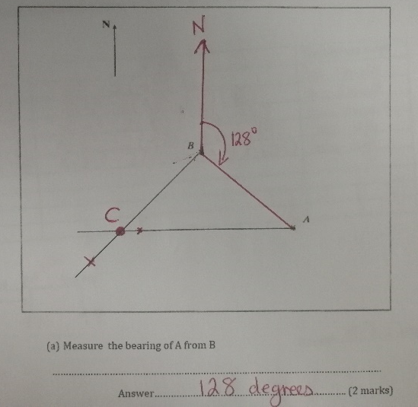

9. 25.13 cm

10. 4.7 (1dp)

11.
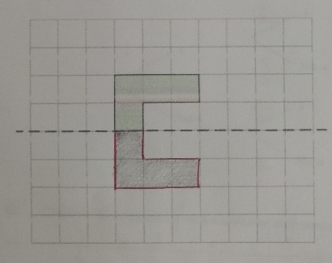

(a) 2/9
(b)(i)
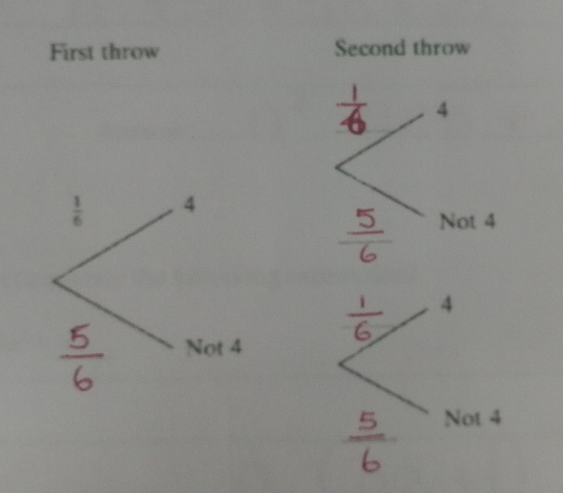
(ii) 1/36

x = 5y - 3
2

14.a)i) 7x - 1
ii) n² + 10n + 25

b)i) a (3a + 1)
ii) 5xy² (2x² – y)

15.
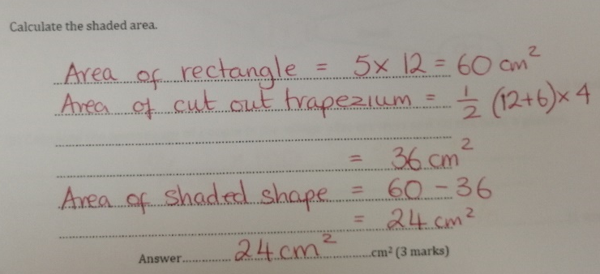

16.
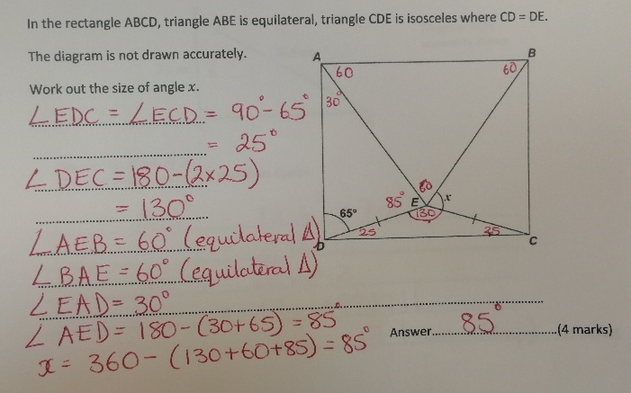

17.a)
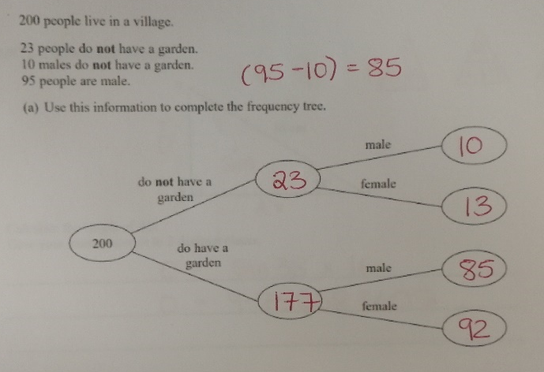
5%

18. 17.1cm (3sf)

19. AB = 9.85cm (2dp)

Answers to Non-Calculator Practice Paper Questions

Answers to questions involving diagrams of graphs may vary slightly

1. 6 and £30

60% of £80

a) 2x + 7y
6
34

a) x = 3
b) y = 8
z = 7/8

5. 111

a) 81
b) Positive correlation
c)
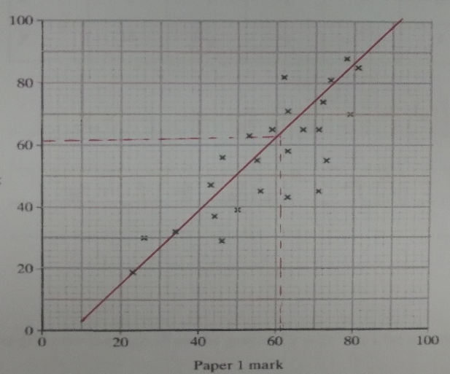
d) Take reading from their L of best
fit = 62

a) w⁷
b) x⁻³
y⁶

a) 5 and -3

b)
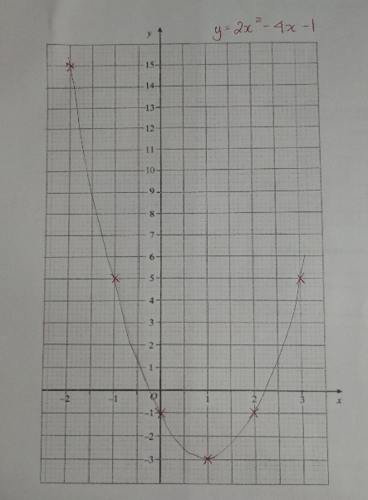

a)
 | 1 | 3 | 5 | 7 | 9
2 | 3 | 5 | 7 | 9 | 11
4 | 5 | 7 | 9 | 11 | 13
6 | 7 | 9 | 11 | 13 | 15
8 | 9 | 11 | 13 | 15 | 17
10 | 11 | 13 | 15 | 17 | 19
b) 6/25

10. a)
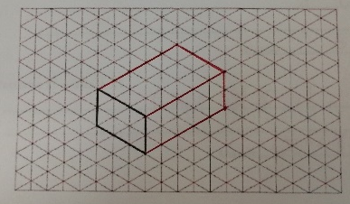

b) 30 cm³

11.
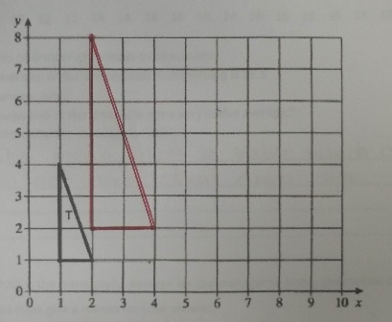
6000

(x-4)(x-6)

14. a) The mean gives a value which is a decimal so not an actual dress size.

b) The mode would be more useful as it gives the manager a better idea as to the most popular dress size sold.

15.
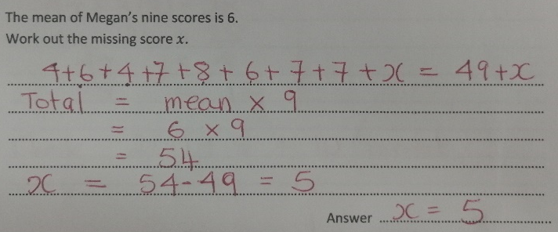

16.
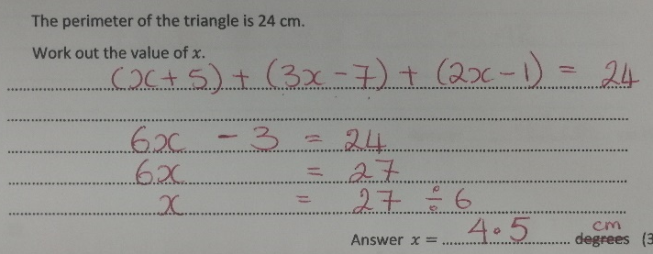

17.
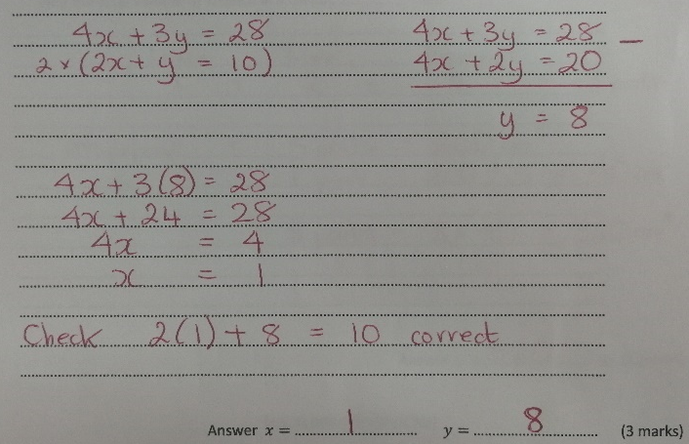

18. 42cm

- 320cm

