


Standalone Test
Handbook

GCSE Maths
Equivalency Exam

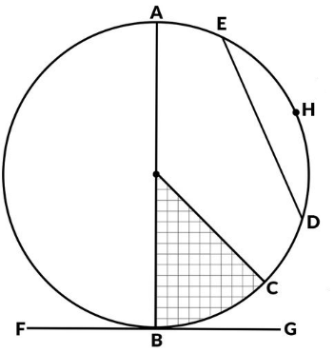
‘

For tests from September 2019 onwards
Version 2.0
1 September 2025

Contents
Purpose of study 3
Exam Specification at a Glance 4
Scheme of Assessment 7
Assessment Objectives 8
Subject content 9
Number and Algebra 9
Shape and Space 11
Handling Data 12
Mathematical Formulae 13
Your GCSE Maths Equivalency Exam 15
Revision Guidance 15
Exam Details 16

Purpose of study

The GCSE Maths equivalency test will allow students to be awarded an equivalent qualification for entry onto most Edge Hill University degree programmes (excluding Social Work and Medicine), where GCSE Maths is included in the entry requirements.

Studying GCSE Maths provides essential skills that form the foundation for many aspects of education, employment, and everyday life. It develops logical thinking, problem-solving abilities, and numerical fluency, which are crucial not only in academic settings but also in practical situations such as budgeting, interpreting data, and making informed decisions. A solid understanding of maths empowers learners to approach challenges with confidence and precision, laying the groundwork for further study and career progression.
For those aiming to progress into higher education for courses such as Teaching, IT or Sciences, achieving a GCSE Maths qualification is often a key requirement. It demonstrates a level of competence and commitment that universities and employers value highly. Whether you're preparing for a specific course, like teaching or nursing, or simply strengthening your academic profile, studying GCSE Maths is a strategic step toward unlocking future opportunities and achieving long-term goals.

Exam Specification at a Glance

Candidates study at Intermediate Level and could potentially achieve a Grade 5 as a maximum level of attainment. You must achieve at least 45% to pass the GCSE Maths equivalency test with a Grade 4 equivalent.

The GCSE Maths equivalency exam is 2 hours and 30 minutes in duration. Candidates will sit a calculator paper first, 1 hour and 15 minutes in duration, immediately followed by a non-calculator paper, which is also 1 hour and 15 minutes in duration.

The topics covered in the GCSE Maths equivalency exam are as follows:

- Number and Algebra
- Shape and Space
- Handling Data

Calculator Paper | Non-Calculator Paper
Assessment Format  - Written exam, 1 hours and 15 minutes in duration.  - 60 marks available.  - Content from any part of the specification may be assessed.  - A calculator should be used. | Assessment Format  - Written exam, 1 hours and 15 minutes in duration.  - 60 marks available.  - Content from any part of the specification may be assessed.  - A calculator cannot be used.
- A mix of question styles, from short, single-mark questions to multi-step problems. The mathematical demand increases as a student progresses through the paper.
- Candidates must achieve at least 45% overall to pass the exam.
- 45% = Grade 4 equivalent (previously Grade C, standard pass).
- 65% = Grade 5 equivalent (previously Grade B).

How the numbered grades compare with the old lettered grades:

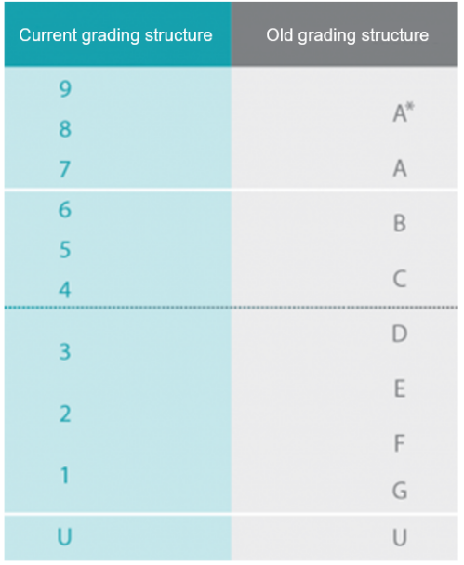

Scheme of Assessment

Aims

Mathematics is a creative and highly inter-connected discipline that is essential to everyday life, critical to science, technology and engineering, and necessary for financial literacy and most forms of employment.

This specification in mathematics enables students to:

- develop fluent knowledge, skills and understanding of mathematical methods and concepts.

- acquire, select and apply mathematical techniques to solve problems.

- reason mathematically, make deductions and inferences and draw conclusions.

- comprehend, interpret and communicate mathematical information in a variety of forms appropriate to the information and context.

Assessment Objectives
We follow the assessment objectives set by The Office of Qualifications and Examinations Regulation (Ofqual) which are applied to all GCSE Maths specifications and all exam boards. Therefore, the exam will measure how candidates have achieved the following assessment objectives:

Objective | Description
AO1 | Use and apply standard techniques.  Students should be able to:  - accurately recall facts, terminology and definitions  - use and interpret notation correctly  - accurately carry out routine procedures or set tasks requiring multi-step solutions.
AO2 | Reason, interpret and communicate mathematically.  Students should be able to:  - make deductions, inferences and draw conclusions from mathematical information  - construct chains of reasoning to achieve a given result  - interpret and communicate information accurately  - present arguments and proofs  - assess the validity of an argument and critically evaluate a given way of presenting information.
AO3 | Solve problems within mathematics and in other contexts.  Students should be able to:  - translate problems in mathematical or non-mathematical contexts into a process or a series of mathematical processes  - make and use connections between different parts of mathematics  - interpret results in the context of the given problem  - evaluate methods used and results obtained  - evaluate solutions to identify how they may have been affected by assumptions made.

Subject content

In addition to this subject content, students should be able to recall, select and apply mathematical formulae.

Number and Algebra
Topic | Notes
Understand place value | Read and write whole numbers expressed in figures and words.  Order whole numbers to the nearest 10, 100, 1000 etc.  Round decimals to the nearest whole number or a given number of decimal places.  Round numbers to a given number of significant figures.
Understand and use decimals, fractions and percentages | Show equivalence between the three forms.  Use and apply the four rules of numbers to decimals and fractions.  Calculate percentages of a quantity and express a given number as a percentage of another.
Negative numbers | Using and applying the four rules of number to negative numbers.
Ratio
Index notation, including standard form | - Express and use number in standard form with positive and negative powers of 10.
Understand and use common number properties | - Show familiarity with multiples, factors, primes, HCF & LCM, powers and roots.
Manipulate algebraic expressions | - Collect like terms; find common factors; multiply two simple brackets; factorise expressions in the form ax² + bx + c
Manipulate algebraic expressions - continued | - Apply the rules of indices to simplify algebraic expressions.
Manipulate algebraic expressions - continued | - Change the subject of a formula.
Solve equations | - Linear equations.
Solve equations | - Simultaneous equations in two unknowns.
Solve equations | - Quadratic equations using factorization.
Solve equations | - Use Trial and Improvement to solve equations.
Solve inequalities

Number sequences | - Explore number patterns and find a general expression to describe the nth term of a sequence where the rule is linear or quadratic.

Shape and Space
Topic | Notes
Graphs | - Plotting Cartesian Coordinates.
Graphs | - Conversion graphs, distance time graphs.
Graphs | - Draw and interpret graphs of linear functions and quadratic functions.  - y = mx + c
Graphs | - Use graphs to solve simultaneous equations.
Transformations in a plane | - Translation, reflection, rotation and enlargement.
Name and understand the properties of simple 2D and 3D shapes | - Angle properties of polygons including interior and exterior angles.
 | - Angle properties of parallel lines and transversals (corresponding, alternate and interior or allied angles).
Name and understand the properties of simple 2D and 3D shapes – continued. | - Area and perimeter of triangles, rectangles.  - Area of parallelograms, trapeziums.  - Circumference and area of a circle.
 | - Volumes of cuboids, cylinders and regular prisms.
Pythagoras Theorem | - Solve problems in two dimensions.
Trigonometry | - Solve problems in right angled triangles using sin, cos and tan.
Bearings | - 3 figure bearings and scale diagrams.
Locus | - Points equidistant from:  - a point  - a line

Handling Data
Topic | Notes
Data collection and representation | - Tally charts.  - Grouped frequency tables.  - Cumulative frequency tables.  - Bar charts.  - Pie charts.  - Cumulative frequency curves.  - Scatter graphs.
Interpreting data | - Find the range of a set of data.  - Find averages using mean, median and mode.  - Using cumulative frequency curves to find the median, upper and lower quartiles and interquartile range of a set of data.  - Box and Whisker diagrams.
Probability | - Outcomes of a combination of 2 experiments.  - Using tree diagrams and sample space diagrams.

Mathematical Formulae
Students are expected to know the following formulae included in the subject content; they will not be given in the exam.

Name | Formula
Circumference and area of a circle | Where r is the radius and d is the diameter:  Circumference of a circle = 2 π r = πd  Area of a circle = π r²
Pythagoras’ theorem | In any right-angled triangle where a, b and c are lengths of the sides and c is the hypotenuse:  a² + b² = c²
Trigonometry formulae | In any right-angled triangle ABC where a, b and c are lengths of the sides and c is the hypotenuse:
Compound interest | Where P is the principal amount, r is the interest rate over a given period and n is number of times that the interest is compounded:
Kinematics formulae | Where a is constant acceleration, u is initial velocity, v is final velocity, s is displacement from the position when t = 0 and t is time taken:  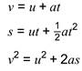

Students are not expected to memorise the following formulae; they will be given in the exam in the relevant question.
Name | Formula
Perimeter, area, surface area and volume formulae | Where r is the radius of the sphere or cone, l is the slant height of a cone and h is the perpendicular height of a cone:  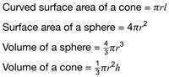
Trigonometry formulae | In any triangle ABC where a, b and c are lengths of the sides:  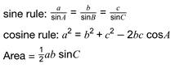
Perimeter, area, surface area and volume formulae | Where a and b are the lengths of the parallel sides and h is their perpendicular separation:  Volume of a prism = area of cross section x length

Your GCSE Maths Equivalency Exam



Revision Guidance

This handbook contains a list of the topics which you will need to revise for your exam, it should be used in conjunction with the other listed preparation information and practise papers. The information is designed to support your revision in preparation for your equivalency exam, but it is not designed to emulate the exams in any way.
You will also need to use additional revision materials.

Recommendations
Text books:

Any Intermediate Level GCSE Mathematics book on the market will cover all the main points in the syllabus.

Online:

The BBC GCSE Bitesize website is also a useful resource for many of the topics: https://www.bbc.com/bitesize/subjects/z38pycw

You should follow the advice given in the AQA or Edexcel specifications.

AQA: https://www.bbc.com/bitesize/examspecs/z8sg6fr



Exam Details

Please take time before each exam to read the instructions on the front of the exam paper.

GCSE Maths equivalency standalone test:

- 2.5 hours in duration.
- 75 minute calculator paper, immediately followed by a 75 minute non-calculator paper.
- You much achieve at least 45% to pass the test.
- 45% = Grade 4 equivalent
- (previously Grade C, standard pass).
- 65% and above = Grade 5 equivalent (previously Grade B).

For more information on your exam day, what to bring with you and our terms and conditions please visit our dedicated webpage.

