



**Standalone Test**

**Revision Support**

**GCSE English**

**Equivalency Exam**

**Letter Writing**

A screenshot of a computer



For tests from September 2019 onwards

Version 2

1 September 2025

# LETTER WRITING

You will be asked to write a letter in response to the

comprehension passage used in the previous question.

## Introduction

There are two forms of letter that you might need to write:

1. Formal letters you write to people on business matters or to find out information.
2. Informal letters you write to friends and relatives.

The language and style you use, which can be called the ‘register’, will depend upon your reason for writing the letter. Formal letters will be precise, factual language with formal grammar and punctuation while informal letters may be written in the everyday sort of language you may use when speaking to friends. Whatever type of letter you are writing ask yourself the following questions:

Is it a business letter or a letter to a friend?

Do I know the person I’m writing to?

Why a letter to a friend?

Do I know the person I’m writing to?

Why am I writing to them?

What register will I need to use?

If you are writing to complain about something you will need to be polite but firm.

### Golden Rules

1. Make sure you use the correct format for the occasion: the formal business letter or the informal, personal letter.

2. Letters must be understood by the receiver; make sure you include all the information necessary. For example, if you are arranging to meet someone you must state the day/date, the place and the time.

3. Avoid using a post script (PS) particularly in a formal letter. This tends to indicate that you forgot to plan your letter and left out some information.

4. There are accepted guidelines for the layout of letters, especially formal ones.

Use them to help you write a good, well-planned letter.

5. Letters, like all forms of communication, must be well presented and free from spelling errors.

6. Use notepaper that is unlined for writing your letters and make sure that both paper and envelope are clean and neat-looking.

7. Allow for a margin on the left hand side of the page. If your letter is going to be short, try to position it nicely on the page - don’t end up with a few lines squeezed at the top and a lot of space at the bottom.

8. Address the envelope clearly and accurately, naming the addressee by name or title. Always include the postcode, which enables your letters to arrive safely and quickly at their destination.

If you know the name of the person to whom you are writing use it.

Dear Mr.…, Dear Mrs.…, Dear Miss…, etc.

If you do not know the name of a person, write to whoever you think will be the most appropriate person using ‘Dear Sir’ or ‘Dear Madam’.

Put their position in the company on the first line of their address on your letter to them as well as on the envelope. Using a name rather than a position means that your letter goes directly to the person who will deal with it quickly. It will not be passed from one department to another which will take time.

If you are replying to a business letter check whether there is a reference

number on the letter you received. It should appear at the top of the letter

– ‘Our ref: …’. If there is one, quote it as the first line of your reply, like a

title, and underline it. This will enable a firm to trace their correspondence

with you quickly when they receive your letter.

## FORMAL LETTER TEMPLATE

### Beginning the Letter

Letters should have the address of the sender in the top right-hand corner.

The address of the person to whom the letter is going should appear on the left-hand side as in the diagram. Write the date on the right just below the second address.

The name or title of the person/department you are writing to, plus the address.

Your full postal address

The greeting normally Dear Sir, Dear Mr... or Dear Mrs...

The date

Heading/referencenumber

number

Text of letter

Your signature. Print your name clearly underneath it.

The ending:

Yours faithfully or Yours sincerely.

**NOTE: Do not use different styles that are digitally fashionable, i.e. email format. Adhere To the traditional letter-writing format.**

### Example:

Edge Hill University

St Helens Road

Ormskirk

L39 4QP

John Smith

123 The Moon

Earth’s Orbit

Space

SP4 4CE

Thursday 30th March 2083

Dear Mr. Smith,

RE: EXAM LOCATION ENQUIRY

Thank you for your letter enquiring about the possibility of sitting your exam on the Moon. We do allow exams to take place on satellites, providing you have found an educational establishment or test centre where the invigilator is an employee.

You should arrange a date and time with the venue when your exam will take place. The invigilator should then email edgehilltests@edgehill.ac.uk from their professional email account confirming that they are happy to invigilate your exam at their venue. We will the liaise with the invigilator directly and arrange to have your exam paper sent to the Moon.

If you have any further questions, please do not hesitate to contact me.

Yours sincerely,

Joanne Bloggs

Equivalency Tests Team

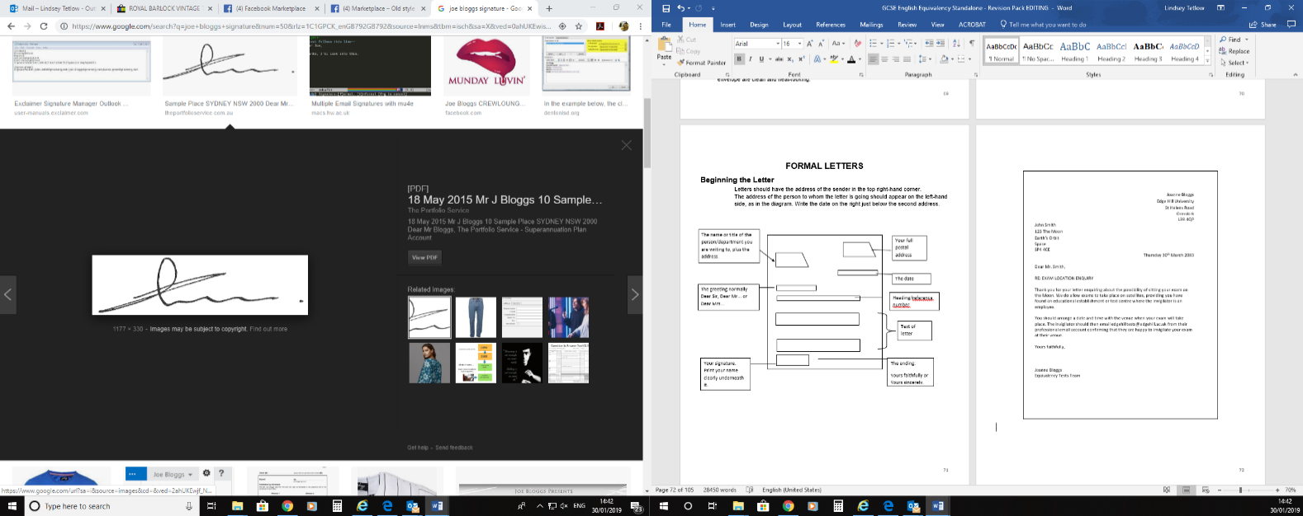

## Assignment

Imagine that you are writing a letter to the following:

The Features Editor, Dress Sense Magazine, Clayton Road, Bilthwell, Herts B13 2HE.

Placing your own address in the appropriate place, set this information out as you would a business letter. Remember to include the date.

### Planning your letter

Planning is important and you need to think carefully about the type of information you wish to include in your letter. People are usually prompted to write formal letters for a reason and you will want to make sure that all vital information has been included. Think also about the order you will put it in; make notes to help you.

The length of the letter may vary a good deal depending upon your reason for writing. The acceptance of an invitation will generally be shorter than a letter asking for a lot of information.

You should divide the text of your letter into three parts.

1 A beginning (Explain your reason for writing).

2. A middle (This will contain the main information which should be divided into paragraphs. Make notes before you write to help make your paragraphs as clear as possible).

3. A conclusion (Possibly explaining what the next step should be, if you expect a reply, or summarising the main purpose of the letter).

4. Ending (Finish your letter courteously and add something like ‘I look forward to hearing from you’ or ‘I hope to hear from you soon’. Do not forget to add ‘**Yours faithfully’** if you are writing Dear Sir / Dear Madam or ‘**Yours sincerely’** if you are writing to the person by name. Sign your name and print your name clearly below your signature.

## Assignment

You are Mr. Smith. Write a letter taking account of the following.

Mr. Smith bought a vacuum cleaner at a shop called Highfield Stores on

6th December. It cost £110 and was guaranteed for six months. At the end of two months it broke down. The shop he bought it from has closed down, so he has to write to the manufacturers to ask them to mend it. He writes to them at this address: Mr. W Payne; Vac-cleen Inc., Clevedon Industrial Estate, Bartley EC3 6AN.