


Standalone Test
Revision Support

GCSE English
Equivalency Exam
Grammar

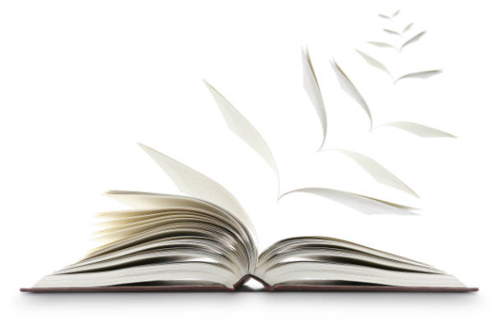

For tests from September 2019 onwards
Version 2
1 September 2025

GRAMMAR

In order to meet the assessment criteria for the English and Literacy examinations, you must demonstrate a satisfactory level of English language proficiency through the use of appropriate grammar in your answers.
We would advise that you use the following BBC Bitesize Revision pages for support:

Spelling:
https://www.bbc.com/bitesize/guides/zs47xsg/revision/1

Punctuation:
https://www.bbc.com/bitesize/guides/zc2sv4j/revision/1

Grammar:
https://www.bbc.com/bitesize/guides/z2y9dmn/revision/1

