Employability Strategy

2025-2030

Employability Strategy
Contents
Glossary of Terms 3
Strategy 4
1. Consultation 4
2. Introduction 4
3. Background and Context 4
4. Employability 2025-2030 6
4.1. Definition of Employability 6
5. Employability Strategy 2025-2030 Primary Objectives 6
6. Careers Support 7
6.1. Student Focused Approach 8
6.2. Career Development Programme 8
7. Key Performance Metrics and KPIs 10
8. Employability Committee Reporting Schedule 10
8.1. Autumn meeting 10
8.2. Winter meeting 10
8.3. Spring meeting 11
9. Staff Development and Recognition 11
Annexes 12
Appendix 1: Hierarchy of Work Experience Activities 13
Appendix 2: Faculty Employability Action Plan Template 14
Endmatter 15

Glossary of Terms
Employability: “a set of achievements – skills, understandings and personal attributes – that makes graduates more likely to gain employment and be successful in their chosen occupations, which benefits themselves, the workforce, the community and the economy.” [Yorke (2006)]
Career readiness: the annual process of understanding a students’ stage of career readiness, undertaken at enrolment each year.
Graduate attributes: the agreed set of common attributes that all students will develop during their time studying at Edge Hill.

Strategy

Consultation
The strategy has been developed and shared with the following groups, committees, and partners:
- Employability Committee
- Faculty leads for Employability or Student Experience
- Employers and other external stakeholders via an open consultation meeting on 23rd April 2024.
- Students Union

Introduction

The aim of our employability strategy is to enhance the life chances for all students following the completion of their studies at Edge Hill University. This will be achieved by enabling them to access and succeed in graduate positions, further study or other positive life choices. To achieve this, there will be a coherent offer of employability development and exploration embedded into all courses, integrating work experience with academic studies. Our employability strategy will bring together the work of both professional support services, specifically Careers, and that of Faculties, Departments and programmes.

Background and Context
Since the introduction of graduate outcomes, the sector has been regulated through OfS conditions of registration, specifically B3:
The provider must deliver successful outcomes for all of its students, which are recognised and valued by employers, and/or enable further study. [OfS 2022]
and the Teaching Excellent Framework. We are also judged on our performance through league tables and other external requirements e.g. OfSTED but more importantly we have a moral imperative to ensure all our students move into a successful outcome – however they define this - once they have completed their studies with us.
In November 2024, the Secretary of State for Education provided the sector with a letter outlining the rationale for an increase in the tuition fee. Also contained within this letter were five priorities for the reform of the higher education system. Three of these will be directly evidenced through our employability strategy:
- Play a stronger role in expanding access and improving outcomes for disadvantaged students.
- Play a greater civic role in communities.
The introduction to our Widening Access and Student Success strategy makes clear our commitment to all students and out role in communities. Our Employability Strategy is written as a sister strategy to this and other relevant internal strategies.
At Edge Hill University, widening access and participation is in our DNA. When we first opened our doors in 1885, as a women-only college, we became the first place in the country where women were able to train to teach without having an affiliation to the church. Now, 140 years later, supporting students from all backgrounds remains core to what we do. Each year we attract and support a diverse student body, with over 70% of our undergraduate students being from backgrounds typically under-represented within higher education.
- Make a stronger contribution to economic growth.
Edge Hill’s strategic plan for 2020-2025 identified for employability a specific aim “to further strengthen our links to employers and the region and enhance student employability and self-employment”. The key performance indicator for graduate employability for the previous employability strategy was to secure employability above the sector norm.
Our performance in the most recent graduate outcomes survey (2021-22) demonstrates we have met this KPI:
Nationally, graduates in employment or unpaid work accounted for 83% of survey respondents (82% the previous year), including 10% who were engaged in both employment and further study (10% last year). At EHU our figures are 3.9% above the national data at 86.9%, including 10.4% in both employment and further study.
Excluding specialist providers, Edge Hill is top in the North West for the percentage of graduates in employment/further study.
If we exclude those who were unavailable for work from the population, the figure goes from 91.7% to 96.7% and we remain top, meaning EHU has the lowest unemployment rate in the North West. (Graduate Outcomes Survey results 2021-22)
We have outgrown our previous strategy having achieved these KPIs. Our new strategy places the focus on continual improvement and localised focus to ensure we make a sustained and strengthened contribution to economic growth.
During the last five years we have:
- Introduced changes in expectations for programmes, e.g. graduate attributes mapping.
- Embedded an annual process of career readiness for all students which includes understanding their career goal and future plans.
- Restructured the careers support available by growing the careers team and providing a dedicated, professionally qualified careers expert for all departments and schools.
- Approved a compulsory requirement for all programmes to include at least one work-based module.

Employability 2025-2030
The focus for our new employability strategy 2025-2030 is to continue our success with supporting students and recent graduates (up to three years post-graduation) to secure a positive outcome that will be reflected not only in national metrics but also in the lived experiences of our students.
To build on the work that has already been done, it is recognised that there needs to be greater consistency in expectations across the university whilst allowing for bespoke approaches and targeted interventions.

Definition of Employability
The following internationally recognised definition of employability is adopted to reflect the ambition and context of the University:
Employability is taken as:
“a set of achievements – skills, understandings and personal attributes – that makes graduates more likely to gain employment and be successful in their chosen occupations, which benefits themselves, the workforce, the community and the economy.” [Yorke (2006)]

Employability Strategy 2025-2030 Primary Objectives
- All programmes achieve minimum B3 expectations (latest set of data).
- All programmes achieve minimum B3 expectations (rolling 4-year trend data).
- All programmes are benchmarked against local and nation data sets (TEF expectation).
- Achieve more than B3 threshold for PRSB programmes.
- Ensure equitable outcomes for all as identified by the APP.
- Develop a framework for delivery of appropriate work experience that meets the needs of our regional landscape.
We will achieve this through a consistent approach to development, monitoring and accountability of programmes, departments and faculties and where the expertise of careers is integrated into the planning, delivery and curriculum development of programmes. Intrinsic to this approach is the expectation that good practice is shared and adopted.
Central to this is approach is:
- The development of a university framework for employability which outlines the relationship between key colleagues and processes.
  - Bespoke adaptations of this framework will be produced by each faculty.
- A common approach to action planning, where a cross-faculty agreed list of actions to be taken is applied. These actions are based on the primary objectives outlined above and are designed to address them.
- Evidence of integration of the Careers Development Programme and engagement with the Careers team by all students at all levels of study.

Careers Support
Careers support will adapt according to the needs of our students and the evaluation of strategies adopted. The approach of the Careers team is to ensure that all students are engaged in:
- Discovering their career options and graduate attributes.
- Developing their graduate attributes and engaging in meaningful and authentic work experience as part of their course.
- Preparing to compete for a positive graduate outcome.
Our approach to career readiness embeds the needs of employers, and specifically our regional partners, by ensuring our programmes can respond to regional LMI needs and that our alumni are able to adapt to an ever-changing employability landscape and context.
We achieve this through working collaboratively with Faculties and external stakeholders to:
- Understand individual stages of career readiness, future plans and career goals from our career readiness approach.
- Implement the Edge Hill Model of Career Development:
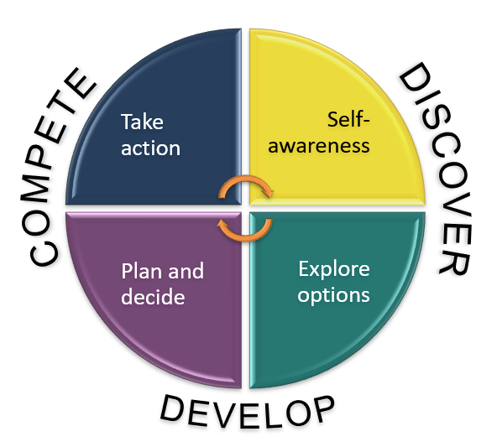
- Embed the Career Development Programme into all courses at all levels of study.​
- Involve employers and other partners in the development, delivery and assessment of our portfolio, understanding their needs and aligning to gaps in the labour market. Their feedback and expertise to be clearly visible in validation processes and documentation.
- Implement a consistent approach to the strategic oversight of graduate outcomes across the University.
- Devolve responsibility for identifying areas of focus to departments/Schools, enabling our approach to be agile and responsive to changes in policy and local requirements.
- Utilise authentic learning, teaching and assessment strategies within all courses.
Every programme is already required to include at least one compulsory module which provides students with opportunities for work experience. The hierarchy of work experience included at Appendix 1 provides an overview of suitable authentic work-based learning opportunities.

Student Focused Approach
Our approach will be student focused at all times:

Personal tutors are key to linking between curriculum content and referring to support services
Personal tutors are key to linking between curriculum content and referring to support services
External engagement activities meet the needs of our students and courses through active collaboration with appropriate stakeholders
Supporting access 24/7/365; providing a stimulating programme of extra curricular activity
External engagement activities meet the needs of our students and courses through active collaboration with appropriate stakeholders
Implementing early engagement in careers activities.
Student feedback and co-design
Embedding employability within the curriculum; engaging students, staff and externals.

Career Development Programme
We recognise that our students arrive with different expectations about their future careers and with different experiences of pre-HE careers advice and guidance.
To ensure all students are provided with appropriate information, advice and guidance during their studies, a set of Edge Hill specific learning outcomes have been developed to provide enhancement to the sector recognised standards from the OfS.
The Edge Hill model of Career Development embodies sector recognised standards and our career readiness process.
As approved by Academic Board, the following six learning outcomes have been embedded into all courses from 2024-25. This content is delivered by staff in the Careers team and constitutes a minimum of two taught sessions per academic year.
Level 4 students will have the qualities and transferable skills necessary for employment requiring the exercise of some personal responsibility:
- LO1 - I know how to find careers info and get career support
- LO2 - I know how to research career ideas related to my degree and beyond
- LO3 - I know my CR stage and how I can prepare for my future
- LO4 - I am aware of my strengths and skills I need to develop
- LO5 - I can evaluate how my own interests match with potential career paths
- LO6 - I have some career ideas / areas of interest and have identified at least one way to help me move forward
Level 5 students will have the qualities and transferable skills necessary for employment requiring the exercise of personal responsibility and decision-making:
- LO1 - I know of ways to develop my experience or skills
- LO2 – I can describe how I am developing these skills, or have a plan in place to do this
- LO3 - I can identify the skills and knowledge I have gained from a variety of experiences.
- LO4 – I can effectively describe my skills and experience within recruitment and application processes, relating these to set criteria.
- LO5 - I know the timescales to apply for graduate jobs, graduate schemes and postgraduate study and the tools and support available to help me prepare for recruitment processes
- LO6 - I can create a personal career plan, including realistic short-term and long-term career goals
Level 6 students will have the qualities and transferable skills necessary for employment requiring the exercise of initiative and personal responsibility; decision-making in complex and unpredictable contexts and the learning ability needed to undertake appropriate further training of a professional or equivalent nature.
- LO1 - I know where to find and apply for work/further study
- LO2 - I understand the options available and how to consider which is best for me
- LO3 - I have experience of applications and/or recruitment processes and know what to expect
- LO4 - I can identify any gaps and how to mitigate these
- LO5 - I understand the factors influencing decision making e.g. pressures, expectations, research
- LO6 - I know how to prepare for life after my degree and understand what may be expected of me in work/further study

Key Performance Metrics and KPIs
Clear evidence of our impact on student outcomes must be apparent. B3 and TEF metrics, as evidenced by our Graduate Outcomes, are the key metric that will demonstrate the success of our refreshed employability strategy. These will form the basis of the KPIs on which the university’s, and the employability strategy’s success, will be measured on. These metrics include ensuring equitable outcomes are achieved as identified in our primary objectives.
Each department will be responsible for setting their own key performance metrics and KPIs, determined by their performance in the graduate outcomes survey. These will be reviewed by Employability Sub-Committee annually as outlined below. Faculties should ensure that plans have been scrutinised by relevant departmental/school and/or faculty meetings as appropriate.
Plans will address the national context of the subject area and identify relevant performance metrics on an annual basis.

Employability Committee Reporting Schedule
The outline schedule presented below is intended to fit the needs of our largest cohort that becomes cohort D for graduate outcomes. An amended schedule can be produced for courses that fall into cohorts A, B or C or where these timescales are not appropriate.

Autumn meeting
- Results of the most recent graduate outcomes survey are analysed and presented to the meeting.
- Outcomes RAG rated with a clear action plan produced addressing how performance will be enhanced, maintained or improved.
- Data will be set within the national context identifying areas at risk on both an internal and national basis.
- Career readiness data available for interrogation.

Winter meeting
- Graduate outcomes Cohort D (our biggest cohort) spring/summer activity for finalists is shared.
- Survey week plans for cohort D to be presented to the committee. These plans to be jointly organised and delivered by Faculties and the Careers team.
- This activity to be replicated in October and April for Cohorts A-C as appropriate.

Spring meeting
- Plans for the forthcoming academic year are presented to the committee, including reflections and evaluations on activity delivered during the current academic year.
- Indicative graduate outcomes results are addressed if the data is available, ditto data from Ofsted and other PRSB bodies.

Staff Development and Recognition
Employability leads are to be encouraged to engage in research and scholarship. This is to be their own research on institutional or departmental initiatives, or scholarship i.e. the application of research. This activity needs to be reflected in activities that could ultimately lead to an academic L&T or KE career path.
A consistent approach to strategic leads for employability underpins this strategy, ensuring all departments/School have someone accountable at a strategic level for employability. This role will be responsible for providing the reports outlined above to the Faculty lead for employability.

Annexes

Appendix 1: Hierarchy of Work Experience Activities
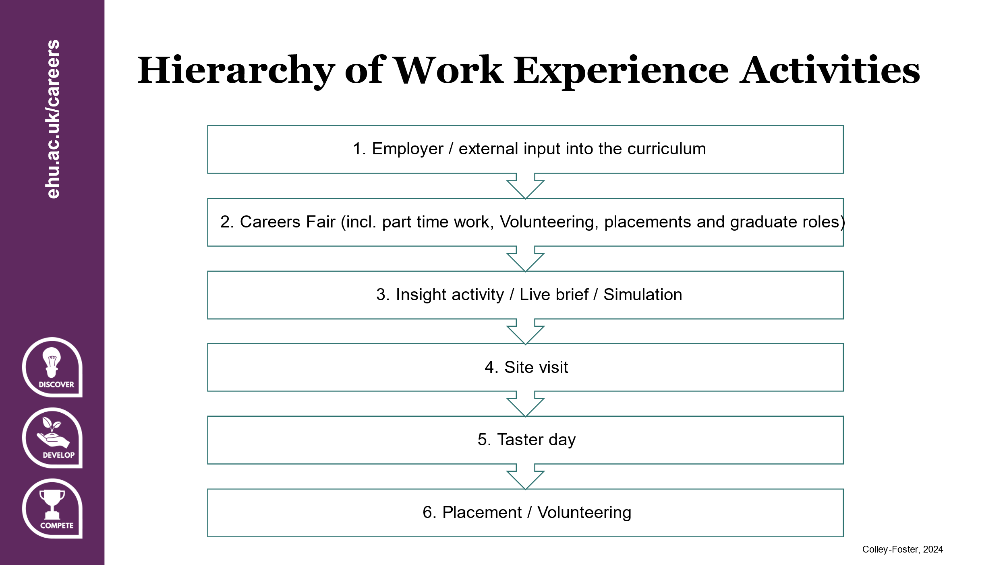

Appendix 2: Faculty Employability Action Plan Template
- Name of Faculty, Department/School
- Academic year
- Data from Tableau: Undergraduate and Postgraduate graduate outcomes.
- Destination data broken down by course and set into the context of CAH groupings for national scrutiny.
- Data from national league tables e.g. career prospects from Guardian league table.
- RAG rating for all courses based on likelihood of achieving score of 60 or above in graduate outcomes.
- Career readiness and career goal data analysed to help identify emerging trends or issues.
- Mapping of graduate attributes to programmes, to ensure all graduate attributes are covered with appropriately varied authentic learning, teaching and assessment activities.
- Overview of intra- and extra-curricular activity planned, delivered, and evaluated focusing on graduate outcomes and graduate attributes. Produced in conjunction with the Careers Adviser (Faculty Consultant).
- Graduate outcomes communications plan to be developed and overseen by Faculty lead.
- For all areas at risk of not meeting threshold an action plan of activity to be delivered to:
  - Finalists from February onwards.
  - Recent graduates from January to June.
  - Survey week activities to count as positive graduate outcome.
Timings for the above will vary depending on graduate outcomes cohort, the example above is for Cohort D.
Ongoing staff development and support is available from the Careers team.
Support from Careers Advisers (Faculty Consultants) to devise and implement relevant intra- and extra-curricular activities.
Exemplar from FoE: Early Years.

Endmatter
Title | Employability Strategy 2025-2030
Policy Owner | Head of Careers and Graduate Employability
Policy Manager | Head of Careers and Graduate Employability
Approved by | Academic Board
Date of Approval | December 2024
Date for Review | September 2029

