Edge Hill Training College for Teachers

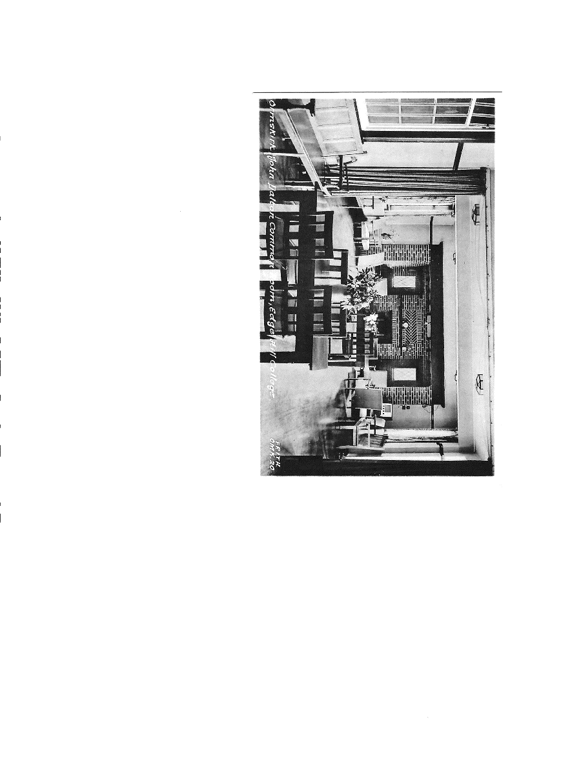
The Letter 1958 – 2024

It was September 1956 when
Margaret Buckle from Sheffield (Saunders)
Jennifer Croston from Kidderminster (Jones)
Kathleen Green from Wigan (Woods)
Margaret Hands from St Helens (Bevington)
Dorothy Howarth from Southport (Leatherbarrow)
Enid Martin from Tipton (Simpkin)

first met in the Common Room of John Dalton Hall (pictured) Edge Hill Training College for Teachers, Ormskirk.

During the summer months we had all received a letter of welcome from one of the 2nd year students, known as our “college mother” thus creating what was known as “a family.” These letters helped to introduce college life in a friendly, informal way and to make settling in easier for 18-year-olds embarking on a completely different way of life, having just left school and saying goodbye to parents and friends.
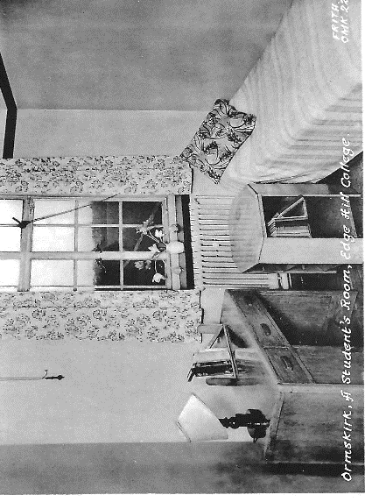
This “family” group was therefore 12 in total, mostly meeting up in the evening and taking it in turns to make supper for our “family” being hostess each in our own room (pictured). Suitable snack food was provided and left in each Hall’s kitchen every evening and Saturday teatimes. We met up at approximately 9.30pm – we had to ‘Tick In’ the Hall book by 9.50pm (10.30pm on Saturdays) and ‘Own Room’ time (a bell rang) was 10.30pm, thus giving us an hour to socialise with firm, long- lasting friendships being formed.

In September 1957, when we were the old hands, we were joined by Joan Jackson from Oswaldtwistle ((Clark).
She was actually one year late in coming to college (I don’t remember why) but consequently she always related more to our year. Our second year passed all too quickly, and it was soon time for us to leave Edge Hill and say goodbye.

How could we say “Goodbye - the answer was we couldn’t – hence The Letter was born. A rotation system was drawn up, a letter was written then posted to the next on the list then, when yours came back to you, you took your letter out and wrote a new one- It worked like magic.

Sadly, both Kath and Enid dropped out quite early on, but Joan joined in the circulation order. Over the years sometimes you may wait almost 12 months before it came back, with teaching, moving house, weddings, babies etc etc but it always appeared in the end. Photographs were included helping to make them even more fascinating. I only wish I had kept all the letters I had written – wouldn’t they make interesting reading now.

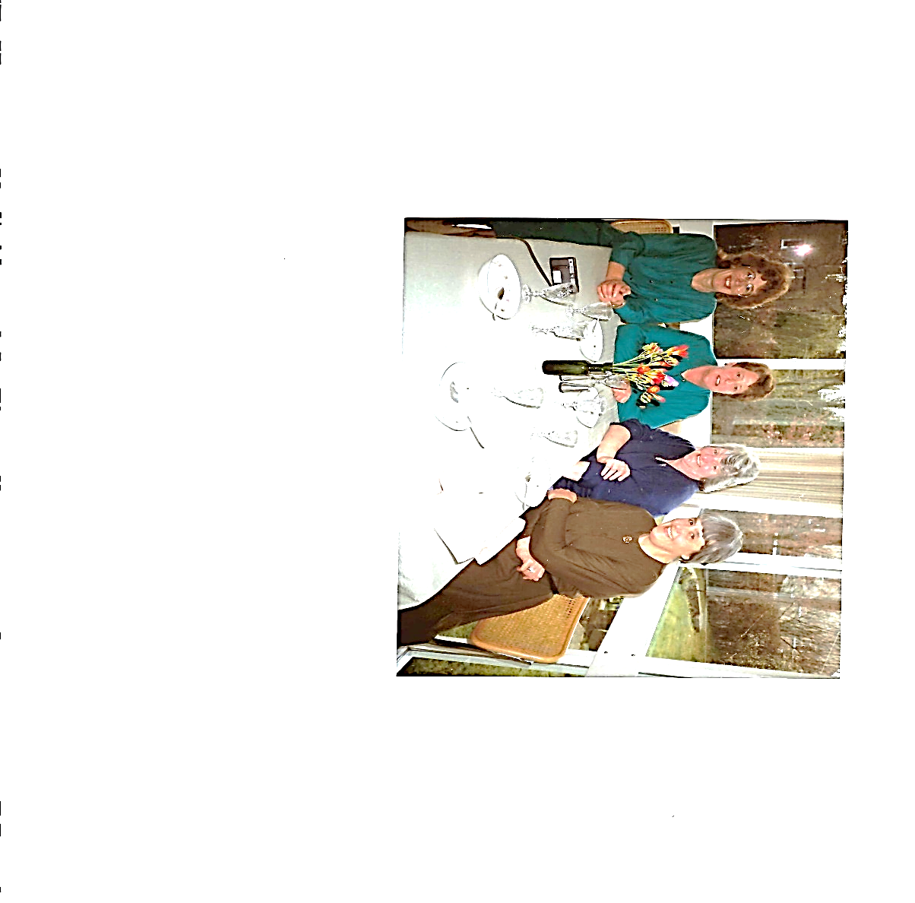
After babies and with children of school age we all returned to teaching with Dorothy and I ending up in the same school in dockland Liverpool – Lander Road Infant and Junior School with a Nursery Unit where I was Teacher in charge. We were still there together when my husband Gerry was moved to Sheffield in 1983 and my teaching career ended (but that’s another story.)

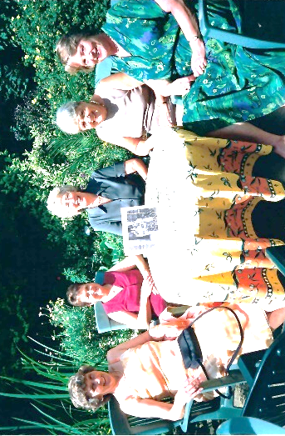
On the plus side of this I was able to remake direct contact with Margaret (Saunders). We went over to Maghull to visit Dorothy with Joan. A little later we met at Margaret’s home with Brenda Giles (pictured.) She was in the same year as Joan but had been in touch with Margaret while she was also living in Sheffield. Sadly, not so long after this, we heard that she had died with cancer.

Margaret and Jim Bevington’s grandson came to Sheffield University, so we began reunions complete with husbands. We had lunches at ‘Baldwin’s Restaurant’ in Sheffield on more than one occasion where I remember us all drinking pink champagne at the behest of Terry Saunders!
(at Baldwin’s Sheffield 2006)

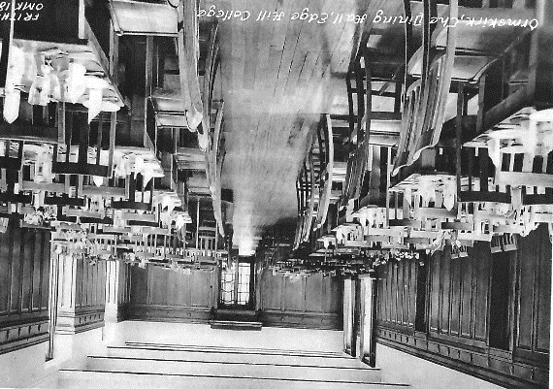
But The Letter never stopped.

However, our most memorable reunion was in September 2008 when we went back to Edge Hill to mark our 50 years. It was much changed, as by then, it had University status. We were taken round the parts we knew before being served lunch in The Dining Room (pictured) we had known. We were thrilled that Enid came, with husband Brian, but Kath was unable to make it because, if I remember correctly, it was around the time that her husband, Frank, had recently died.
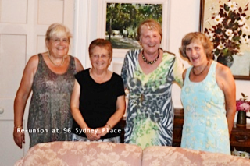
The Letter continued then in August 2013 we met one more time – in Bath. Gerry and I had finally left Sheffield in 2011 to make our home in Bath and as it is so high on the Tourist trail it made an obvious venue - pictured in our Living room
Jenny – Joan -Margaret S – Margaret B

Shortly after this Margaret S became ill with Alzheimers so keeping track of the Letter became increasingly difficult even though we still managed to stay in touch. Then Covid struck and sadly, in October 2021, Margaret Saunders died.

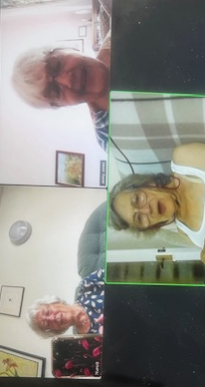
By then Zoom calls had become the new way to communicate so we moved into 21st century by chatting once a month. To begin with Joan tried to take part but we soon realised that she too was suffering from some form of dementia leaving three survivors of the famous Letter.
Dorothy, Margaret and Jennifer

Zoom Call Tuesday 30th July 2024

Compiled by Jenny Jones 2024

