Degree Outcomes Statement – Edge Hill University

At Edge Hill University we strive to ensure that the standard of our degrees is appropriately set and maintained, and that our qualifications hold their value at the point of award and over time. This Degree Outcomes Statement provides evidence to our Academic Board and Board of Governors, students, employers and professional and regulatory bodies that the University’s academic governance arrangements are robust and ensure that our qualifications meet Sector Recognised Standards.
The University’s overall rating in the Teaching Excellence Framework (TEF) is Silver, meaning, typically, the experience students have at Edge Hill University and the outcomes it leads to are very high quality. The University’s TEF rating for student experience is Gold, which means the student academic experience is typically outstanding.

Institutional degree classification profile

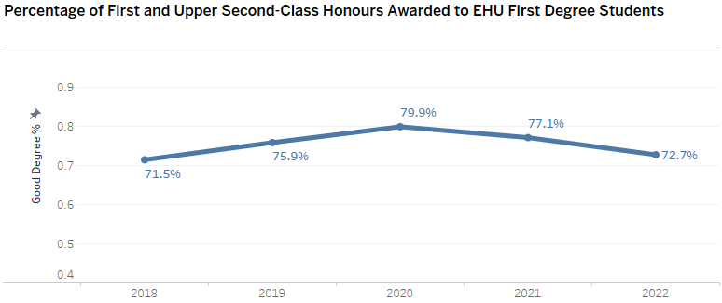

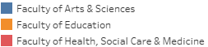
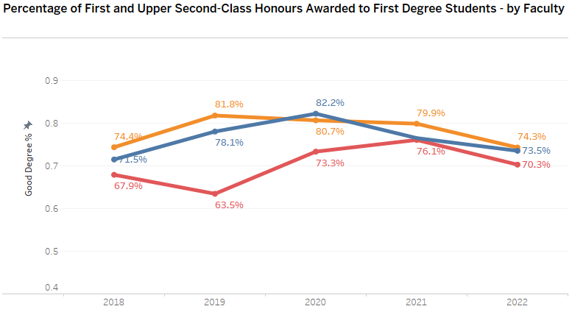
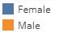
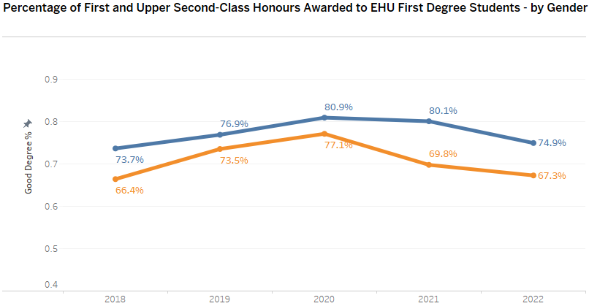

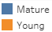
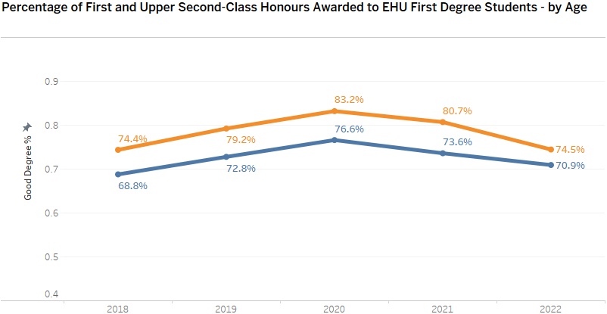

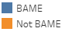
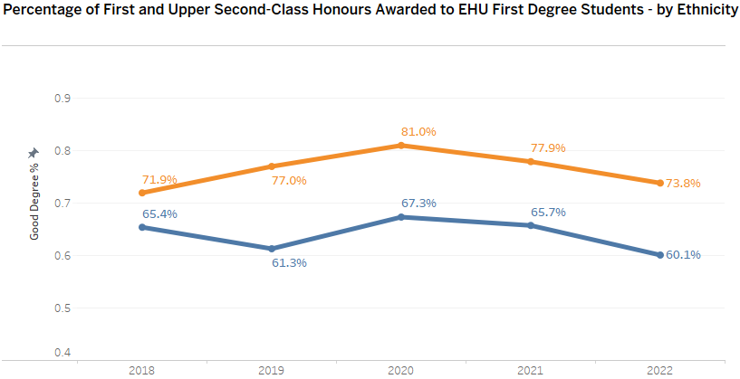

Assessment and Marking Practices

The University’s quality management strategy, and individual strategies for teaching, learning and assessment underpin programme design, monitoring and evaluation. All of our degrees undergo detailed academic scrutiny at the point of approval (‘validation’) which ensures that programme content, Intended Learning Outcomes, teaching and assessment are aligned with the Sector Recognised Standards for providers of Higher Education in England and discipline-specific Subject Benchmark Statements. Degrees conferring professional recognition or Licence to Practise, for example in law, medicine and teacher education, are also aligned with the standards of relevant Professional Statutory and Regulatory Bodies. Internal validation panels include external academic subject experts of other degree providers who support them in making judgements on programme standards and quality. Due regard is also given to regulatory expectations and advice laid out in the UK Quality Code for Higher Education.
Academic staff undergo detailed preparation and training for assessment which includes a postgraduate teaching certificate and professional development programme which is accredited by Advance HE and led by staff of the Centre for Learning and Teaching. Specific support is provided for academic partner organisations and employers who contribute to students’ assessment. Coursework briefs and examinations are set in accordance with validated Intended Learning Outcomes, and assessment criteria measure and grade student attainment beyond threshold (Pass) standard. All assessment criteria contain overt reference to English language proficiency which is incorporated in learning outcomes. A process of internal verification (‘moderation’) supports the quality and consistency of marking and feedback within programmes and subjects. Students are able to notify the University of any special circumstances impacting on their ability to perform to the best of their potential, through the Personal Circumstances scheme, and Appeals Procedures where necessary.

All degrees, including those delivered by partners, are subject to annual monitoring which includes input from suitably-qualified external examiners who confirm that the standards set at validation are being adhered to, that students are meeting those standards, and that assessment is of high quality. We are scrupulous in our appointment and use of external examiners, protecting their independence to make academic judgements on our degrees. External examiners’ reports for the most recent completed academic year confirmed that standards remained current and aligned with national reference points across all programmes, that grading and classification were comparable with other degree providers, and that students were achieving the standards set for them through valid and fair assessment. External examiners receive a detailed briefing and induction and attend Module and Progression & Award Boards to verify they are conducted fairly and consistently in accordance with our own Academic Regulations.

Academic Governance

Reporting to the University’s governing body, the Academic Board has ultimate responsibility for the setting and maintenance of degree standards. Processes for, and outcomes from, programme validation, monitoring (including external examiners) and review are overseen by the Academic Quality Enhancement Committee (AQEC) on behalf of the Academic Board. No degree may be delivered without AQEC approval, and a full list of approved awards accompanies our regulations.

Academic Board and its committees receive reports on final degree classifications, academic appeals and academic malpractice cases which supports the continuous monitoring of standards. Assessment strategies, policies and regulations, including those governing academic malpractice and appeals, are kept under continuous review, and proactive monitoring and intervention help safeguard standards. Annual monitoring detects grade improvement and decline at individual programme level and explores, where appropriate, how intake standards attained from different types of entry qualification, enhanced teaching and assessment practices and academic support have contributed to student achievement.

The Regulations Review Sub-Committee oversees the continued appropriateness and fairness of our Academic Regulations and advises the Learning and Teaching Committee on any changes for the approval of Academic Board. The External Examiners Sub-Committee has oversight of external examiners, their appointment and reports, and assures AQEC and the Academic Board that they are discharging their responsibilities appropriately and that any matters raised by them have received proper consideration. An annual Academic Assurance Report helps satisfy the Board of Governors that we continue to meet national expectations and regulatory requirements for degree standards.

Classification Algorithm

Students are required to successfully complete all modules registered against their programme in order to qualify for a classified award. This incorporates the University’s provision for condonement. Where a student is unsuccessful at the first attempt they may be offered a maximum of two reassessment opportunities, which will be capped at the pass mark. This is in line with the total number of re-sits/ re-takes permitted across the sector, as outlined in the Universities UK publication 'Understanding Degree Algorithms'.

The University last reviewed its permanent approach to classifying honours degrees in 2016. This was in response to then-emerging concerns expressed by government about the classification systems applied by higher education providers across the United Kingdom. The impact of the review was that the University moved to a single system for classification, which came into effect in July 2019 and is described below.

The University applies the standard classification bands used across the sector. Classifications are determined by a percentage mark which is calculated using the average mark from Level 5 and Level 6 study, weighted at 40% and 60% respectively. The lowest mark, to the value of 20 credits, is discarded. The only deviation from this approach is where an honours degree has an atypical credit total, for example Conversion Degrees or programmes that incorporate a credit-bearing placement year. In these cases, the standard algorithm is adapted as appropriate for the different credit totals and values.

Placing greater weight on marks from the final year ensures that classifications appropriately reflect the standard of performance a student has achieved on obtaining their qualification, acknowledging the accumulation of knowledge, expertise and skills in the preceding years. Discarding the lowest mark supports students to undertake some study outside of their specialism, for example, diversifying their learning (in up to 20 credits) to undertake a language module without fear that this may impact on their final classification.

Where a student is within 2% of a higher classification band, the University will consider whether a higher classification is appropriate and justified. In these cases, either the average mark for the final year must be at the higher classification standard, or at least half the module marks across Levels 5 and 6 must be in the higher classification band for that classification to be awarded. The application of this discretion is governed by guidance specified in Appendix 12 to the Academic Regulations.

Edge Hill’s classification algorithm is published on the University’s Academic Regulations web pages. We also publish a guide for students to explain how classifications are determined, and ensure students have access to this information through central communications and local briefings.

Coronavirus (COVID-19) Pandemic 2019/20 and 2020/21

In May 2020 the University approved a Framework for the Assessment, Progression and Award of Qualifications to Students undertaking taught programmes (incorporating Temporary Regulations). This Framework was developed to mitigate the impacts of the Covid-19 Pandemic, and to allow for the assessment, progression and confirmation of credit and qualifications for students within an agreed set of academic standards in these extraordinary circumstances. At all stages in the development of this Framework, the University followed regulatory guidance from the Office for Students and advice from the Quality Assurance Agency. The provisions within the Framework were wide ranging, recognising the University’s pivot to online teaching and learning in March 2020, and the corresponding adjustments to teaching, learning and assessment strategies for the period. The main feature of the Temporary Regulations that had the potential to impact on classifications in 2020 was the introduction of a ‘no-detriment’ approach. That is, providing the threshold (Pass) standard was met, marks achieved during the Pandemic were not counted if they fell below the student’s regular standard prior to the pandemic (‘the benchmark’). In view of the ongoing circumstances, Temporary Regulations were also applied in 2021, with a ‘safety net’ algorithm designed to ensure that marks impacted by the pandemic were weighted accordingly. Individual Academic Transcripts provide a full account of marks achieved and how these correspond with the final classification. The University reverted to standard practice for awards made in July 2022.

Teaching Practices and Learning Resources

University-led improvements to teaching, assessment and student support have had a cumulative positive impact on degree outcomes over the last five years. A Taught Degrees Framework supports curriculum design and delivery by requiring that course teams systematically plan and describe the ‘student journey’ from induction, through in-programme transitions to graduation and employment or further study. Specific sections of the Framework provide advice and guidance on developing students’ academic and employability skills and integrating work-related and placement learning within the curriculum. Separate guidance governs the use of learning technologies, including our virtual learning environment, which supports independent study and preparation for assessment, and the operation of personal academic tutoring and student peer mentoring. Learning resources and support have been enhanced and expanded over time, including the £26 million development of our Catalyst centre in 2018 to house library and learning services, student support and careers advisors, including support for students with specific learning difficulties or disabilities. Generous IT provision is available to all students, and specialist labs, studios and simulation facilities support the delivery of individual subjects. Student satisfaction with learning resources exceeded the benchmark set in the 2023 NSS, at 89.7% compared to the benchmark of 86.5%.

Identifying Good Practice and Actions

Many of our innovations have resulted from high-level, cross-faculty projects and developmental enquiries, all aligned with the University’s over-arching strategy and designed to address areas for improvement as well as exposing and sharing good practice, thus benefiting students across our whole portfolio of degrees. Programme design prioritises equal opportunity and inclusive learning in line with University strategy for widening access and participation. Policies and procedures for reasonable adjustments and personal circumstances help ensure that individuals, including those with specific learning difficulties or disabilities, are not disadvantaged. The Taught Degrees Framework sets specific expectations of high-quality assessment to which have been added a series of ‘baseline’ assessment practices which all programmes must follow. A ‘What You Need To Know About Assessment’ Guide, written in plain English and accessible by all students, focuses on developing their understanding of assessment, the nature of feedback and how to use it effectively. Training and mentoring are provided for all internal assessors.

Risks and Challenges

Despite having confidence in our assessment processes and practices we are never complacent. Degree outcomes are monitored continuously by senior managers and evaluated and acted on by Faculties, the Academic Board and its committees. External examiners’ reports are responded to promptly and fully. As our portfolio of degrees increases and our student intake grows more diverse we will continue to address the learning needs of students with a wide range of previous educational backgrounds, qualifications and protected characteristics; supporting the development of excellence in learning and teaching to underpin maximum student success in, and progress from, higher education.

The year dated denotes the start of the relevant academic session, eg ‘2022’ relates to the 2022/23 period.

