The Academic
Regulations
Appendix 24: The
Revocation of Awards
2025-2026
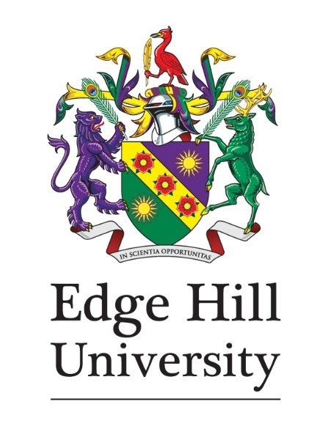
The Academic Regulations
Appendix 24: The Revocation of Awards

Contents
Summary 3
Glossary of Terms 3
Purpose 3
Regulations 4
Key to Relevant Documents 5
Annexes 5
End matter 6

Summary
The University may, for good reason, deprive any person of a University award (or, in the case of a joint or dual award, may do so jointly with the other institution[s]) or may recommend revocation to an appropriate awarding body. Good reason shall include academic fraud. Appendix 24 details the process to be followed for the consideration of revocation of awards.

Glossary of Terms
Term | Meaning
Assessment Board | The name given to the meeting that confirms student’s results and overall progression.

Purpose
Appendix 24 details the process to be followed for the consideration of revocation of awards.

Regulations
- Awards made by Edge Hill University are conferred in good faith. Allegations of misconduct relating to an award, which are made subsequent to conferment, will be investigated and, if proven, may lead to the revocation or re-classification of the award. Evidence of falsification of material factors concerned with student registration or improper use of any award conferred will be similarly investigated. The standard procedures for misconduct will apply in determining whether a case is substantiated.
- Recommendations for revocation or reclassification of an award will be referred to the appropriate Assessment Board for confirmation.
- Where a recommendation for revocation of an award is confirmed by an
Assessment Board, an application for revocation will be made to the Edge Hill Academic Board. Procedures for confirming revocation will be determined by the University as appropriate with respect to each case as it occurs but provision will be made for the award-holder to present any mitigating circumstances and to be represented.
- Appeal against revocation will be to the Vice-Chancellor, or nominee. This appeal will be final.
- Any cases relating to awards conferred by Lancaster University under previously extant accreditation arrangements will be investigated and reported to Lancaster University for appropriate action.
- The revocation of any award which also carries professional registration/recognition will be reported to the appropriate professional body.

Key to Relevant Documents
This policy refers to the following documents, which you may find useful.
- The Academic Regulations Appendix 8: Procedures Relating to Academic Misconduct
- The Academic Regulations Appendix 20: Certification of Awards

Annexes
There are no annexes to this policy.

End matter
Title | Appendix 24: The Revocation of Awards
Policy Owner | Head of Academic Registry
Policy Manager | Senior Registrar: Records, Assessment and Awards
Approved by | Regulations Review Sub-Committee
Date of Approval | February 2008
Date for Review | June 2026 (last reviewed June 2025)

