The Academic Regulations Appendix 19:
Information
Provided to
Students Upon
Completion of Their
Studies
2025-2026

The Academic Regulations
Appendix 19 – Information Provided to Students
Upon Completion of Their Studies
Contents
Summary 3
Glossary of Terms 3
Purpose 3
Regulations 4
1. Information provided to students on completion of their studies 4
2. Academic Transcripts 4
3. Student Name Changes 5
Key to Relevant Documents 7
Annexes 8
A.1: Data Set for an Edge Hill Programme Transcript & Diploma Supplement 8
A.2 Sample Transcript 10
Endmatter 11

Summary

All Edge Hill students, and students studying toward an Edge Hill Award, will receive an official Academic Transcript detailing their achievement on an annual basis and at the end of the registered programme of study. Appendix 19 details the information included as part of this process.

Glossary of Terms

Term | Meaning
Transcript | A document detailing a student’s performance on their programme of study.
Bologna Guidelines | The Bologna guidelines, or Bologna process seeks to bring more coherence to higher education across Europe.

Purpose

Edge Hill recognises that transcripts are produced for two different purposes;

- The first purpose is to provide learners with a record of their learning while they are studying. This information is intended to help them monitor and reflect on their progress and plan their further academic development. It is an aid to learning and an essential element of their personal development records.

- The second purpose is to provide a student who has completed or exited their programme with a formal, verifiable and comprehensive record of learning for whoever needs such information. As such, it will have to satisfy a variety of interests and needs including employers, HE admissions tutors, professional bodies and statutory regulatory authorities in the UK and overseas.

Regulations

1. Information provided to students on completion of their studies

All Edge Hill students, and students studying toward an Edge Hill Award, will receive online results detailing their achievement on an annual basis and a final Academic Transcript at the end of the registered programme of study. Students that exit their programme prior to the point of completion will be eligible for an Academic Transcript to record their confirmed achievement at that stage.

A Diploma Supplement and Certificate, which comply with Bologna guidelines on recording achievement, will be issued to those that successfully complete a Target Award and candidates that qualify for an Exit Award.

The University has an agreed policy on the retention of academic records and an approved procedure for alumni to acquire duplicates of their certification. Detailed information on the retention and retrieval process can be accessed at the links below:

- Retention

- Retrieval

2. Academic Transcripts

2.1 The policy objectives for the HE Transcript are:

- to improve the quality and consistency of information on the learning and achievement of individual students in higher education for the benefit of everyone who has an interest in such information;
- to promote awareness of the national qualification frameworks and national and international transparency and recognition of higher education awards;
- to contribute to an individual's lifelong record of learning and achievement;
- to support the process of personal development planning;
- to promote good practice in the provision of information on the outcomes of UK higher education.

2.2 Edge Hill recognises that transcripts are produced for two different purposes;

- The first purpose is to provide learners with a record of their learning while they are studying. This information is intended to help them monitor and reflect on their progress and plan their further academic development. It is an aid to learning and an essential element of their personal development records.
- The second purpose is to provide a student who has completed or exited their programme with a formal, verifiable and comprehensive record of learning for whoever needs such information. As such, it will have to satisfy a variety of interests and needs including employers, HE admissions tutors, professional bodies and statutory regulatory authorities in the UK and overseas.
2.3 Edge Hill transcripts reflect the complete record of academic learning and achievement and include information on what was studied, what was successfully completed and what was not successfully completed.
2.4. Edge Hill operates a standard data set for all University transcripts. Details, and an example, are provided under Appendix A.
2.5 Transcripts are legal documents. Academic Registry will produce all
transcripts in the full legal name (including middle names) as presented to the Award Board which confirms the final award. This will be the name that students are formally registered with at the University on the date of the award board.

3. Student Name Changes
3.1 Should a student’s name change during their studies it is the student’s responsibility to inform Academic Registry and to provide the relevant documentation to confirm the change.
3.2 Name changes should be reported to the University as soon as is reasonably possible and by no later than the end of teaching for the final term.
3.3 Once students have completed their course and final results have been confirmed by an Award Board, the University will not permit retrospective changes to the name on a transcript aside from where one, or more, of the conditions set out in 3.4 is met.
3.4 The University may make an exception to 3.3 and retrospectively amend the name that an award is confirmed under where one or more of the following circumstances is evidenced:
- Where a name change has been made in accordance with the Gender Recognition Act.
- Where a change of name is associated with vital personal security such as victim or witness protection, where a former student changes their identity and the police or security services recommend that the change should include the individual's qualifications.
- Other highly exceptional circumstances where the individual's human rights or vital interests justify the reissue of a transcript in a new name. The Head of Academic Registry will consider such applications on a case-by-case basis, depending on reasons and evidence provided.

Guidance on how a student can retrospectively change their name with the University are outlined on the Academic Registry webpages.

Key to Relevant Documents

This policy refers to the following documents, which you may find useful.

- Bologna Process

- The Academic Regulations Appendix 20: Certification of Awards

Annexes

A.1: Data Set for an Edge Hill Programme Transcript & Diploma Supplement

Student
- Name
- Date of birth
- Institutional registration number
- HESA reference number

Qualification
- Name of qualification
- Level of qualification in National Qualifications Framework (NQF)
- Name of awarding institution
- Name of teaching institution
- Location of study
- Language(s) of instruction (to meet European Communities requirement)
- Language(s) of assessment (to meet European Communities requirement)
- Professional Body accreditation
- Statutory Regulatory Body recognition/approval
- Mode of study
- Field of study

Record of Learning and Achievement

- Name of programme
- Module or unit study code (this should also indicate the level in the NQF that the module/unit is studied)
- Module or unit study title
- Number of credits awarded for each module/unit completed
- Date (year) in which credit studied
- Mark or grade for each module or unit studied

Other Types of Learning within the context of a programme

- Study Abroad (include ECTS credits if applicable)
- Work placement
- Work experience
- Accredited prior transcript and experiential learning
- Accredited Key Skills

Award
- Overall credits achieved
- Overall classification or performance indicator (e.g. merit/distinction)
- Professional/Statutory Body recognition (if applicable, an indication that in gaining the award a candidate has satisfied the academic requirements for registration or membership etc)
- Information on dual award institutions (if applicable)
- Date of award

Authentication

- Date Generated
- Signature/seal

Explanatory information (provided in the accompanying results letter and Diploma Supplement)

- Guidance on how to interpret the transcript
- Contact details for validating the transcript
- Information on the grading scheme
- Overview of the National Qualification Awards Framework
- Overview of the UK HE system

A.2 Sample Transcript
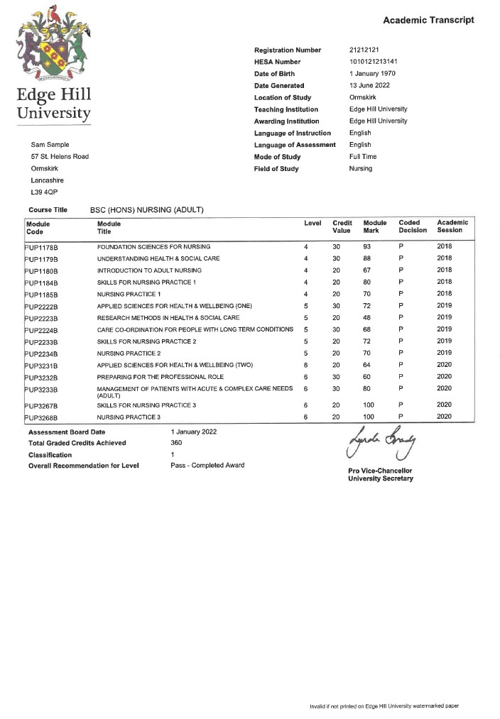

Endmatter
Title | Appendix 19: Information Provided to Students Upon Completion of their Studies
Policy Owner | Head of Academic Registry
Policy Manager | Senior Registrar: Records, Assessment and Awards
Approved by | Regulations Review Sub-Committee
Date of Approval | September 2017
Date for Review | June 2026 (last reviewed June 2025)

