Edge Hill University Milestones and Memories

Alumni Newsletter – September 2025

Welcome Back
We’ve had a little break while updating our records system, and we’re delighted to bring you a fresh round of alumni newsletters with this bumper edition to recap the past few months.
A big thank you for your patience during this time and thanks to everyone who took the time to update their details with us. It means we can keep you connected with all the latest news, events, and opportunities from Edge Hill and our global alumni community.

Graduations 2025
This July, campus was alive with celebration as we came together to mark one of the biggest moments in the Edge Hill calendar – graduation week. Over the course of a week, more than 4,000 students crossed the stage in 16 ceremonies, each one filled with pride, joy and a few happy tears.
We were excited to welcome six new honorary doctors, each sharing words of wisdom and inspiration that will stay with our graduates for years to come. Read more about our new honorary doctors, Amy Truesdale MBE, Claire McColgan CBE, Rebecca Ferguson MBE, Chelcee Grimes, David Sweeney CBE and Dr John Cater. Also, head over to our news page to read about some of our fabulous graduates, including the story of a mother and daughter graduating from the same course.
It was a historic year, as we celebrated our first-ever cohort of doctors, a milestone moment for the University, the graduates received a special visit and some inspirational words from Dr Zoe Williams, who received an honorary doctorate from Edge Hill in 2022.
📸 Explore the Graduation Photo Library on the alumni webpage to see if you can spot yourself and your friends.
🎥 Catch the inspirational stories of our honorary doctors on our YouTube channel, with interviews led by one of our 2024 Honorary Doctors, Chris Kirkland.
To all our new graduates – welcome to the alumni community. Your journey is just beginning, and we can’t wait to see where it takes you.

Nominate an Honorary Doctor

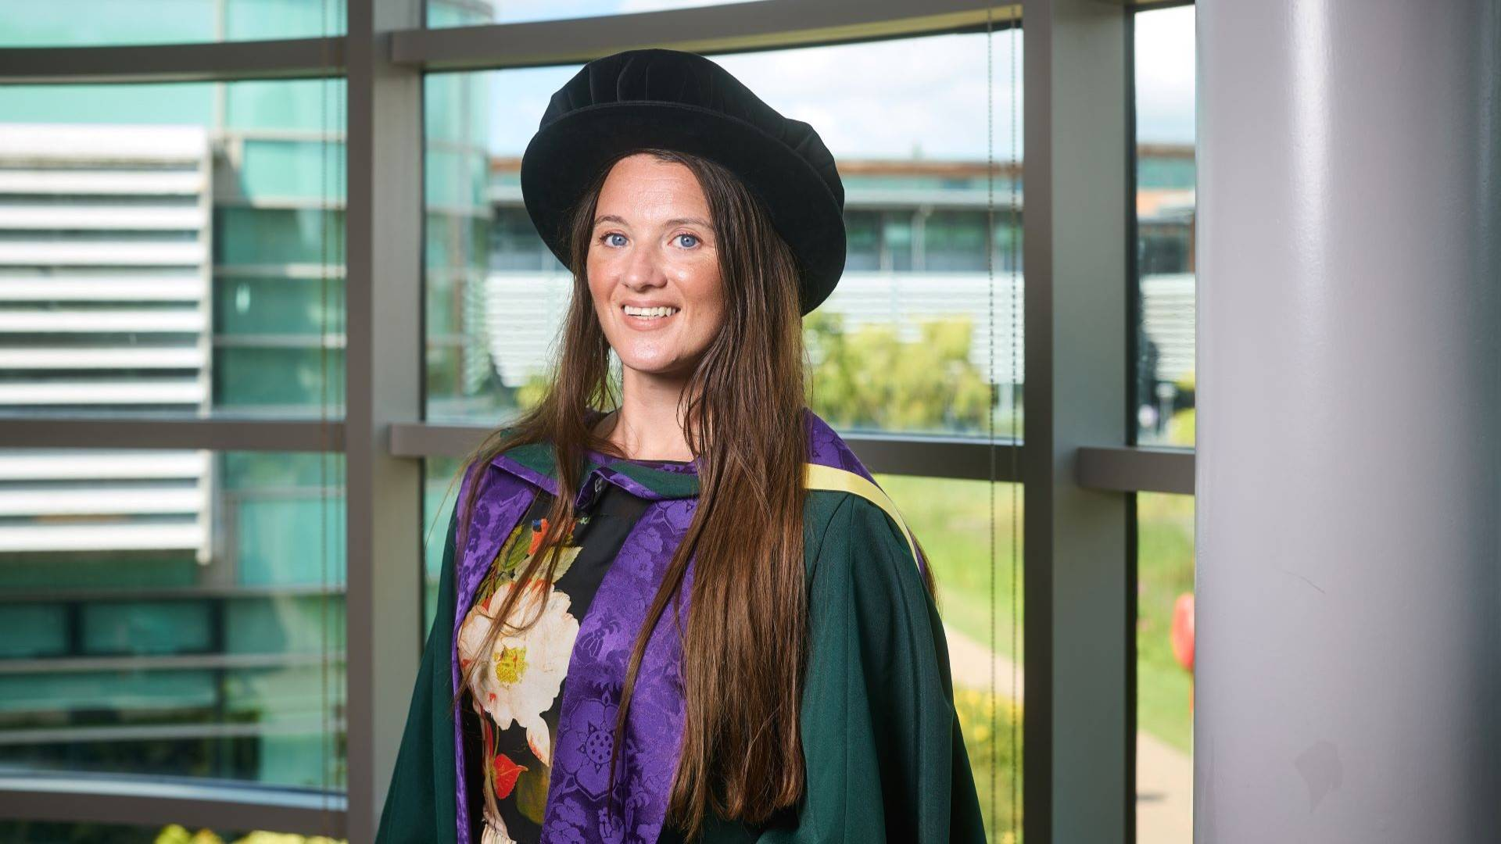

Did you know alumni are eligible to nominate honorary doctors?

Edge Hill’s honorary awards celebrate individuals who have roots in, or connections to, the region and have achieved at least one of the following:
- Made an exceptional and outstanding contribution to the development of the University over a prolonged period.
- Gained recognition for national or international excellence in an academic area relevant to the University.
- Made a significant contribution to the national, cultural, academic, educational, professional or economic arena.

Find out more about our honorary awards and if you would like to submit a nomination, contact us via email alumni@edgehill.ac.uk.

Tenderfoot Theatre celebrates award win

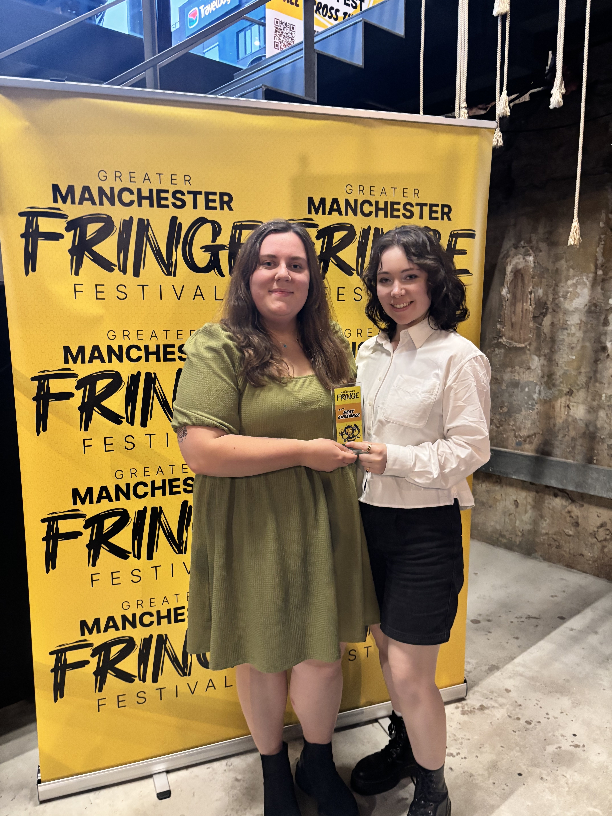

Congratulations to Tenderfoot Theatre, a company created by our talented dance, drama and musical theatre graduates, who have won Best Ensemble at the Greater Manchester Fringe Festival 2025.

We love celebrating the success of our graduates and we’re proud to see our alumni making their mark in the theatre world and inspiring future performers with their creativity and collaboration.

At the festival, Tenderfoot also received nominations for Best Comedy and Write for the Stage – well done!

Alumni Spotlight
Tobias Hammond: From early years graduate to educational leader and community advocate
Since graduating from Edge Hill University with a BA (Hons) Early Years Education with QTS, Tobias Hammond has carved out an impressive and varied career, combining his passions for education, youth leadership and community service.
After starting his career as a primary school teacher, Tobias quickly expanded his professional horizons. He now works as a Primary Early Years Subject Expert with Best Practice Network, supporting teacher trainees online and as an Initial Teacher Trainer at Bradford Birth to 19 School-Centred Initial Teacher Training (SCITT). Alongside this, Tobias holds several influential voluntary roles, including his latest appointment as County Lead Volunteer (County Commissioner) for West Yorkshire Scouts, where he supports more than 10,000 young people and volunteers weekly, and as a member of both the National Youth Agency’s Education & Standards Sub-Committee and Bradford’s UK City of Culture 2025 Cultural Learning Steering Group.
Reflecting on his journey, Tobias credits his degree at Edge Hill as a strong foundation for everything he’s achieved since, he said: “My degree fuelled my passion for giving every child the chance to thrive. The practical experience and the professional network I built at Edge Hill were invaluable in shaping my career.”
During his time at Edge Hill, Tobias embraced every opportunity to grow, serving as a Course Rep, Department Rep and President of the Early Years Education Society, experiences that helped him develop leadership and communication skills that continue to serve him well today. His placements during the course also opened doors, leading to his first teaching role.
As he prepares to take on a new role as an Ofsted Inspector in September 2025, Tobias continues to pursue opportunities that combine his love for education and community leadership. He says: “The more you put in, the more you get out of your experience. Edge Hill provided the platform for me to explore my interests and develop the skills that have led me to where I am now.”
Tobias gave his advice to prospective education students, he said: “Go for it. If teaching or working with young people is your passion, Edge Hill will support you every step of the way.”

Alumni return to campus

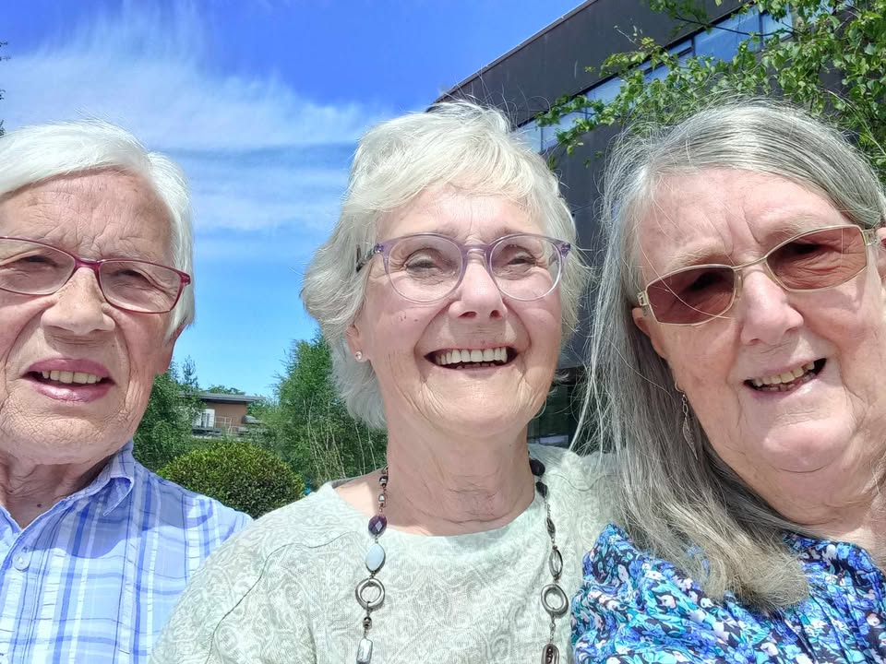

Celebrating 60 years of friendship at Edge Hill
In June, we were delighted to welcome back three alumni who studied here at Edge Hill when it was still a teacher training college.
Maureen Frankland (née Foster), Heather Rowlinson (née Mapes), and Dilys Peacock (née Maude) first met on campus in 1965 as trainee teachers and have remained close friends ever since. Their visit marked an incredible 60 years of friendship.

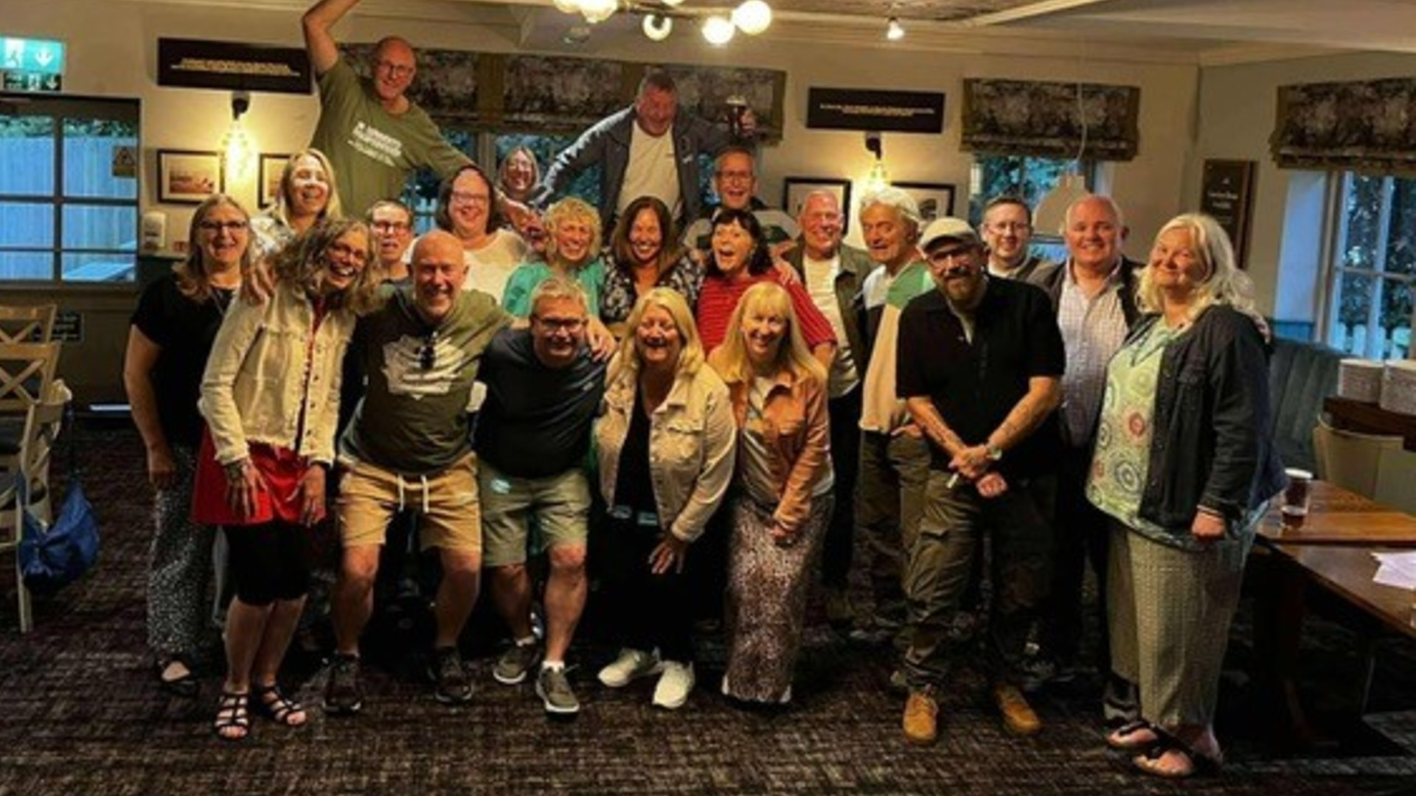

A 40-year reunion to remember
In July, a group of alumni – all part of the 1985 intake at Edge Hill College – reunited to celebrate four decades of friendship, laughter and unforgettable memories.
Those present included:
John Dalton Halls: Julie Wilson, Trisha Joyce, Wendy Trenwith, Jayne Ling, Alison Jones, Mel Williams, Gaynor Sims and Paula Farrington.
Eleanor Rathbone Halls: Rachel Pelver and Patti Susan Pattison.
Lady Openshaw Halls: Sarah Rowbottom.
Milton House: Jon Myers, Damien Ratchford, Ian Roberts, Gary Smith, Andy Stevenson, Ian Squire, Mark Stanley and Dave Swift.
From the 1988 intake (also of Milton House): Steve Hill and Steve McLoughlin.
If you're thinking about meeting up at Edge Hill for a reunion, we’d love to hear from you, email alumni@edgehill.ac.uk.

Edge Hill Health and Social Work graduates in Wigan – We want to hear from you

As a valued member of our alumni community, we are excited to reconnect and hear about your journey since graduation.

We want to hear your success stories. Whether it’s career milestones, personal achievements, or any other significant experiences, we would love to celebrate your accomplishments and inspire our current students.

Please take a moment to reflect on your journey and send us your story. Your insights and experiences are invaluable to us and can make a meaningful impact on our community.
Thank you for being an integral part of the Edge Hill alumni network. We look forward to hearing from you, email alumni@edgehill.ac.uk.

WWL Governor Elections

Are you passionate about local healthcare? Do you want to make a real difference by representing patients, staff, and our community in shaping the future of the NHS?

If you think a governor role could be for you, attend an upcoming insight session to learn more about what the role involves and how you can get involved.

Your voice matters – this is your chance to help influence positive change in our healthcare system.

📅 Follow the QR code below to find out more and book your place.
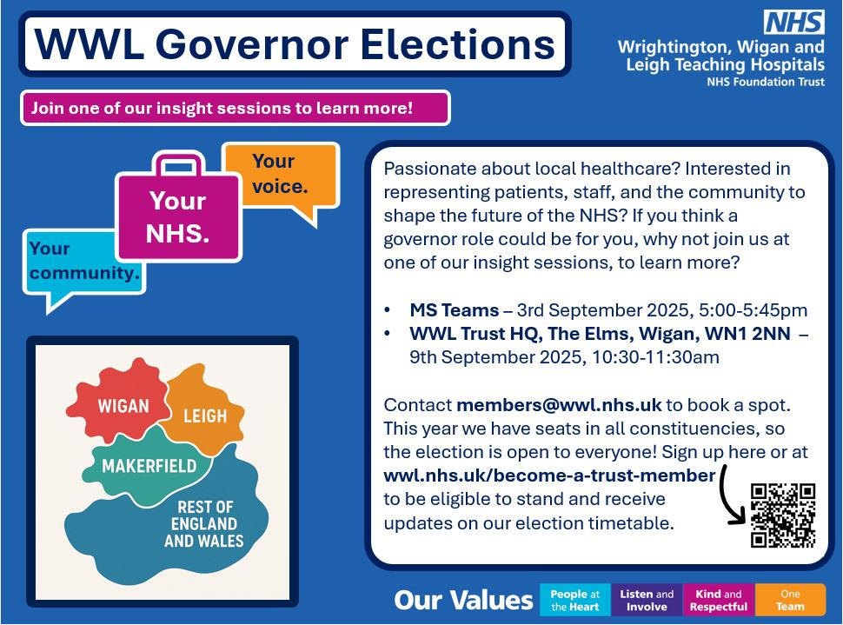

What’s on at Edge Hill

Enhance Your Skills with Our Flexible CPD Courses

A beginner’s guide to taking great photographs | 7 October | 6 weeks
An introduction to Spanish | 9 October | 10 weeks
An introduction to Italian | 9 October | 10 weeks
Jane Austen: reading, romance and revolution | 30 October

Find out more and book your place Continuing professional development - Edge Hill University

Graduate Outcomes Survey

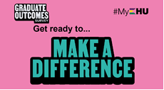

The Graduate Outcomes Survey is an annual national survey for all graduates who completed a higher education course in the UK. It looks to understand whether you’re in employment, further study or have decided to set up your own business/freelance. Or perhaps, you are still finding a path that is right for you. Whatever you're up to, we'd love for you to share your journey through the graduate outcomes survey. Graduate Outcomes captures the activities and perspectives 15 months after graduates finish their course.

If you are still finding a path that is right for you, don't forget to check out all the resources available through our Careers webpage.
With best wishes,
The Alumni Team
Edge Hill University

