Edge Hill University: Life Sciences hub launch

Alumni Newsletter – October 2025

# Welcome

Welcome to the Alumni newsletter for October. Campus life is thriving once again as we celebrate the arrival of new students, the official opening of our state-of-the-art Life Sciences hub, and the achievements of our inspiring alumni community. From sporting success stories and national media appearances to golden anniversaries and groundbreaking cultural exhibitions, this issue showcases the many ways Edge Hill continues to make an impact locally, nationally and globally.

# Official opening of the Life Sciences hub

We’re delighted to share a major milestone for Edge Hill University. On Thursday 25 September, the Rt Hon Baroness Jacqui Smith, Minister for Skills, officially opened our brand-new Life Sciences hub, a £17.4 million facility. The hub houses cutting-edge laboratories for histology, cell culture and molecular biology, as well as flexible teaching and collaboration spaces. It will support pioneering work in areas such as biomedical science, microbiology, and plant and environmental sciences.

The launch highlights Edge Hill’s commitment to driving innovation and regional growth, creating opportunities for students, researchers and industry partners to work together on projects with real-world impact. As alumni, you can be proud that your university continues to invest in world-class facilities, that prepare future generations of scientists while enhancing our reputation in health and environmental research.

Read more link [Minister for Skills officially opens Edge Hill’s new Life Sciences hub - Edge Hill University](https://www.edgehill.ac.uk/news/2025/09/minister-for-skills-officially-opens-edge-hills-new-life-sciences-hub/)

# Alumni Guest Speaker - Barry Lewtas

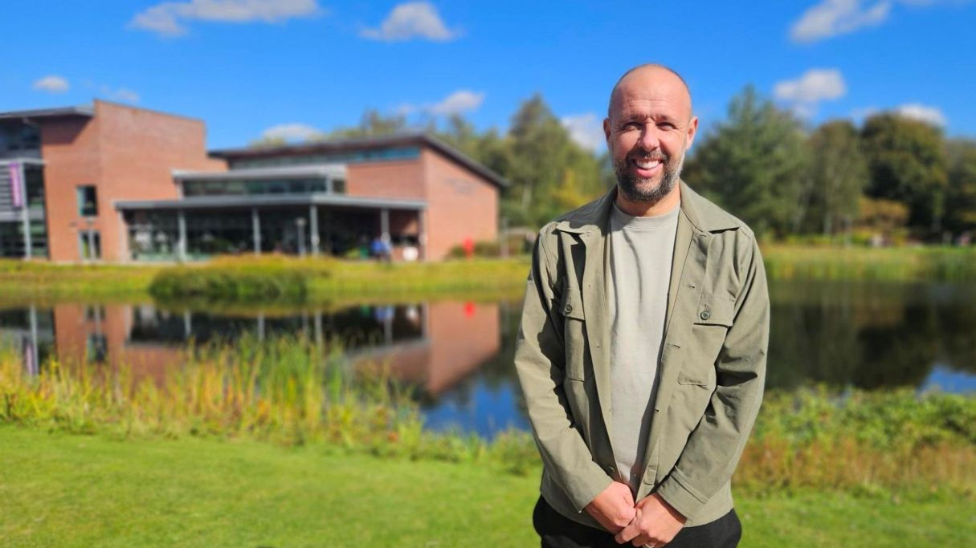

We were delighted to welcome Barry Lewtas, an Edge Hill University alumnus, back for the fourth time to inspire our PGCE Secondary PE students.

Barry first graduated from Edge Hill with a BSc in Sports Science (1999) and returned in 2003 to complete his PGCE in Secondary PE. He began his career as a PE teacher at Formby High School, where he eventually became Head of Department. Alongside his teaching role, he coached four evenings a week. While Barry enjoyed the work, personal circumstances, with his wife becoming pregnant and the arrival of their son, meant the balance wasn’t sustainable. So, when the opportunity came to leave his “day job” and coach full-time, he jumped at the chance.

Barry went on to build an impressive career in football coaching, working with Wigan and Bolton, before spending 12 years at Liverpool FC, where he rose to become U21 Head Coach. In August 2025, he began an exciting new chapter as England U16 Head Coach with the FA.

Reflecting on his PGCE, Barry emphasised how it opened endless possibilities beyond teaching in schools. He shared: “I wanted to be the best PE teacher. I thought I knew everything when I left university, but going into the world of teaching made me realise I still had a lot to learn. I thought I had everything to equip me but soon realised I was unaware of my lack of knowledge or skill in particular areas. I didn’t know what I didn’t know. With every new role I’ve taken, I’ve gained more knowledge.”

PGCE Lecturer Simon Dougherty thanked Barry for once again sharing his journey, he said: “I want to extend sincere thanks to Barry for sharing his experiences and invaluable advice with the next generation of PE teachers. It’s a fantastic story and one that left a real impact on our PGCE students. A genuine privilege to have him with us.”

Read more link [Barry Lewtas - Edge Hill University](https://www.edgehill.ac.uk/person/barry-lewtas/alumni/)

# Alumni return to campus

# Alumni Reunite at Edge Hill – 50 Years On

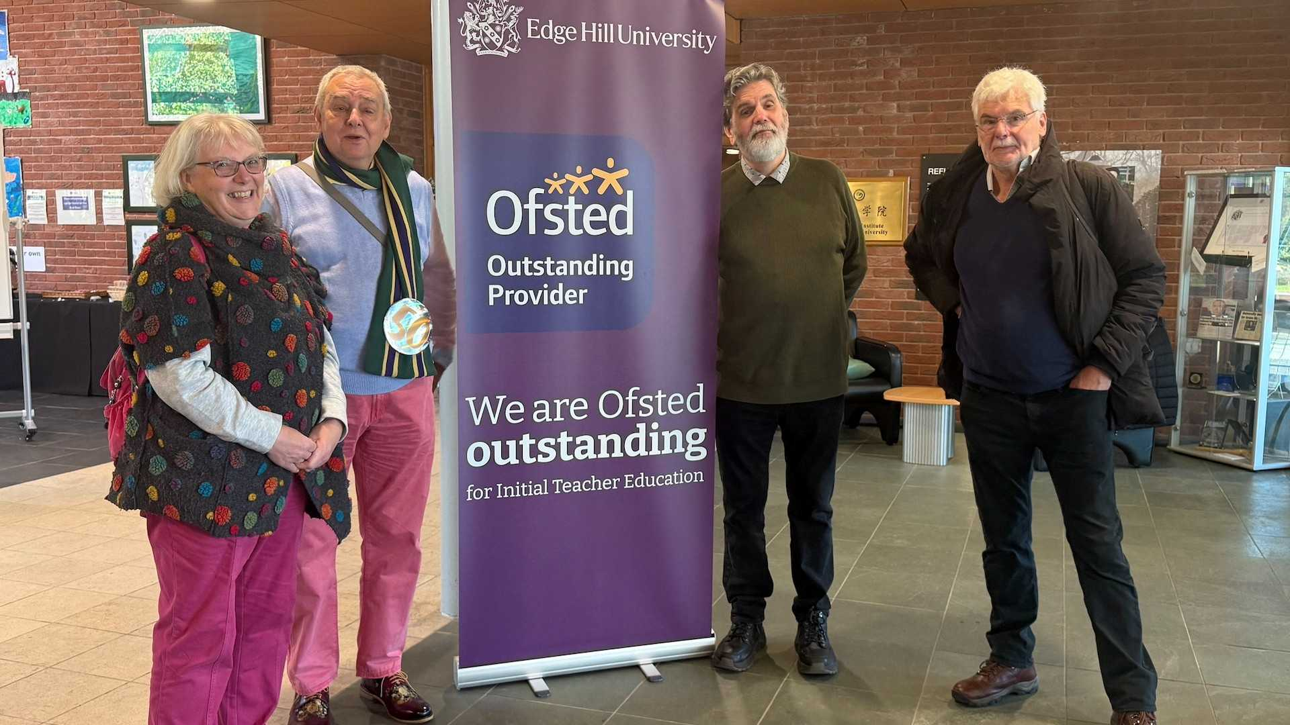

A group of alumni from the 1970s returned to Edge Hill University on Thursday 25 September 2025 to celebrate the 50th anniversary of their enrolment – to the day!

The reunion was organised by Phil Logan, who first arrived on campus in 1975, when the University was still known as Edge Hill College of Higher Education. He was joined by fellow alumni Chris Maybury and Paul Restall, along with his wife Linda.

Reminiscing together, Phil, Chris, and Paul recalled gigs in the refectory during their student days, including Mungo Jerry in Freshers’ Week, as well as bands Eddie and the Hot Rods, The Stranglers, The Regulators, and Lindisfarne.

Phil reflected: “It was wonderful to see how the campus has changed over the years.

“When three of us started at Edge Hill, back in 1975, we knew that we were coming to a college with an excellent reputation and that the education we were about to receive would be high in quality. It was the same for my wife who joined as a mature student in 1989, and it was reassuring to see that this is still the case for today’s Edgehillians."

Some in the group had not seen one another in many years, making the occasion a memorable celebration of lifelong friendships and the enduring Edge Hill spirit.

If you're thinking about meeting up at Edge Hill for a reunion we’d love to hear from you, email [Alumni@edgehill.ac.uk](mailto:Alumni@edgehill.ac.uk).

Read more link [Alumni 50 years since arriving as freshers in 1975 | Edge Hill University](https://www.edgehill.ac.uk/news/2025/09/edge-hill-university-alumni-reunion-50-years-on/)

# Alumni Spotlight

# Edge Hill graduate Greg Anderton wins second RHS gold and features on Gardeners’ World



Edge Hill University graduate Greg Anderton is celebrating a double success this year after winning his second Royal Horticultural Society (RHS) gold medal and appearing on the BBC’s Gardeners’ World.

Greg, who graduated in 2016 with a BSc (Hons) Business Management, is Managing Director of Leafy Lytham Ltd, a thriving garden centre and design business he founded while still a student.

Greg chose Edge Hill for its location and setting, allowing him to combine his studies with running his business. Greg said: “The community and friendly atmosphere, together with the overall ambition of the University to be the very best, really stood out to me.”

His achievements were showcased to a national audience when Gardeners’ World followed him preparing for the RHS Wentworth Flower Show. Greg said: “It was a surreal moment seeing myself on TV, over two million people watch the programme each week, to be part of that was a huge privilege.”

The television appearance came shortly after Greg secured gold medals at both RHS Hampton Court Flower Show and RHS Wentworth Woodhouse, recognition he describes as “a dream come true” for his team.

Looking ahead, Greg hopes to exhibit at the Chelsea Flower Show, write a gardening book, open a second garden centre and expand the range of plants grown in-house at Leafy Lytham’s nursery.

He added: “Take every opportunity that comes your way, put your all into it, and it will pay off. If you need help, ask, there will always be someone willing to support you.”

Read more link [Greg Anderton - Edge Hill University](https://www.edgehill.ac.uk/person/greg-anderton/alumni/)

# Podcast - Edge Ahead: What's in your head?

Introducing Edge Ahead: our brand-new podcast series that aims to put important conversations in the spotlight.

Our first series, ‘What’s in your Head?’, is all about mental health and wellbeing, hosted by former Liverpool goalkeeper and honorary doctorate Chris Kirkland, alongside regional podcast host, Gareth Roberts.

In episode one out now, Chris speaks openly about his battle with depression, addiction and anxiety, joined by his wife Leona who shares what it’s like supporting a loved one through crisis.

Throughout this series, expect to hear conversations with leading figures from the world of sport, media, the University, and beyond.

We’d love for you to listen, share it with friends and family, and join us in breaking the stigma around mental health.

Watch on [YouTube](https://www.youtube.com/watch?v=zhrBqXU2BRg) or listen on [Spotify](https://open.spotify.com/episode/5yHobTob7v8sMZFJFXFmGM?si=oNF6moxyQeCcbIV07KMIEg&nd=1&dlsi=519d2d027d894dfd) today.

# EHU curates landmark Terence Davies exhibition at BFI Southbank

The University became proud caretakers of Terence Davies’ personal archive when the Liverpool-born screenwriter and director gifted it to Edge Hill three days before he died in 2023.

The Archives Team have curated a collection of artefacts, many have never been seen before, including the recently discovered short film Boogie. These will be showcased at a free exhibition during the BFI’s upcoming season Love, Sex, Religion, Death: The Complete Films of Terence Davies.

Edge Hill archivist Dan Copley said: “Edge Hill University is honoured to safeguard Terence Davies’ archive and to bring this extraordinary collection to a wider audience.”

Join us as Edge Hill helps share previously unseen insights into Davies’s life, his creative process, and his influence on British cinema.

Read more link [Archives team curate national Terence Davies exhibition | Edge Hill University](https://www.edgehill.ac.uk/news/2025/09/edge-hill-university-curates-landmark-terence-davies-exhibition-at-bfi-southbank/)

# What's on at Edge Hill

# Dead on the Vine Screening + Alumni Q&A

Join us on Thursday 16 October, 7.30pm in the Studio Theatre for a special FREE screening of Dead on the Vine, followed by a Q&A with its writer/director Mark A C Brown, an Edge Hill alumnus.

Mark will share his journey from Edge Hill to award-winning filmmaker, with Dead on the Vine already celebrated on the festival circuit. This is a great chance to reconnect with campus, enjoy a gripping film, and hear first-hand from one of our own.

Book now link [Dead On The Vine Film Screening | Edge Hill University](https://www.edgehill.ac.uk/event/dead-on-the-vine-film-screening-qa/)

# Open Days

Do you know someone interested in studying at Edge Hill or are you considering returning for postgraduate study?

Don't miss your chance to attend our last few Open Days of 2025:

Ormskirk - Saturday 18 October and Saturday 15 November

Manchester - Saturday 29 November

Book your place, we'd love to see you!

Open Days webpage [Open Days | Book Today | Edge Hill University](https://www.edgehill.ac.uk/study/visit-us/open-days/)

# Graduate Outcomes Survey

The Graduate Outcomes Survey is an annual national survey for all graduates who completed a higher education course in the UK. It looks to understand whether you’re in employment, further study or have decided to set up your own business/freelance. Or perhaps, you are still finding a path that is right for you. Whatever you're up to, we'd love for you to share your journey through the graduate outcomes survey. Graduate Outcomes captures the activities and perspectives 15 months after graduates finish their course.

If you are still finding a path that is right for you, don't forget to check out all the resources available through our careers service.

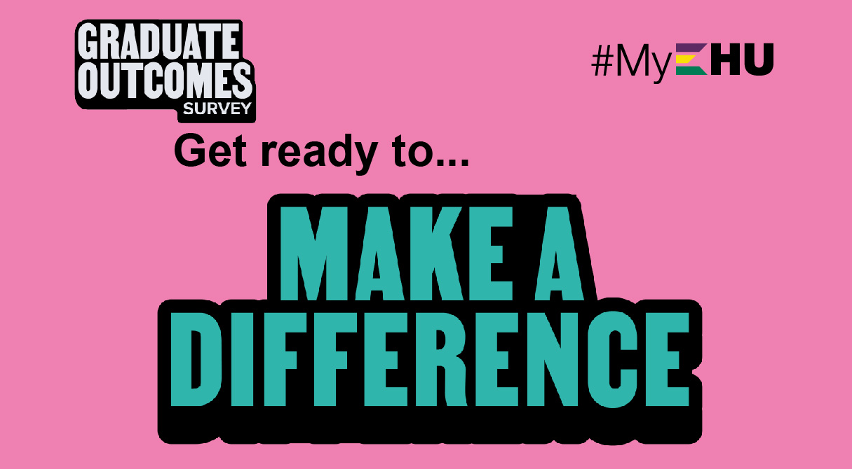

Careers webpage link [Careers | Edge Hill University](https://www.edgehill.ac.uk/departments/support/careers/)

Alumni webpage link [Alumni | Access alumni benefits | Edge Hill University](https://www.edgehill.ac.uk/alumni/)