Edge Hill Alumni News | March edition


Welcome to your March edition of the Edge Hill Alumni Newsletter. This month, as we step into spring, we’re proud to share a bold new chapter in our story shaped by your feedback, your achievements and your continued connection to our community. From the launch of our refreshed brand identity to alumni making an impact across the globe, this edition celebrates the progress and ambition that defines Edge Hill today.

Whether you’re looking to reconnect, revisit campus, continue your learning or simply catch up on the latest news, there’s something for you in this month’s newsletter.

A bold new chapter for Edge Hill
As a valued member of our alumni community, you’ve helped shape the story of Edge Hill – and now we’re entering an exciting new chapter.
Over the past two years, we’ve been shaping this next chapter behind the scenes, guided by the feedback you shared with us during our 2024 brand perception research.
We’re proud to introduce our refreshed brand identity, reflecting how far we’ve come together and the ambition that defines us today. It’s bold and forward-looking, while remaining true to the heritage you were part of during your time here.
Our historic crest has evolved into a cleaner, more confident symbol. The suns remain, representing enlightenment and the transformative power of education. The refined shield features a diagonal sash inspired by our suffragette story – a nod to the activism, courage and progress that have long shaped our community.
Importantly, our original crest isn’t going anywhere. It will continue to appear at our most special ceremonial moments – including graduation – honouring the traditions you share with generations of Edge Hill graduates.
As alumni, you remain an important part of that story. You’ll start to see our new look across campus and in our communications, and we hope it makes you feel proud of the University you’re connected to.
Read more – link to brand story

ALUMNI FOCUS

Alumni Spotlight: Kate James

Kate James, a BSc Sports Coaching alumni has taken her passion for sport and community engagement to a global stage since leaving Edge Hill University, she's now a Volunteer and Sport Programme Manager in Ghana with United Through Sport.
During her time at Edge Hill Kate developed her leadership skills by captaining the Women’s Basketball First Team on campus and represented Liverpool Basketball Club, embracing opportunities for personal and professional growth. It was these practical coaching experiences and community sport modules during her degree that equipped her with the skills she uses every day in her role training volunteer coaches and expanding access to sport for young people.
Kate's journey began long before graduation, with a transformative volunteer placement in South Africa the summer before she started at Edge Hill. Since then, Kate has progressed through roles supporting volunteers and communities in Africa and continues to live out her dedication to sport and development in Ghana.
Kate’s advice to students and graduates: “Embrace travel and volunteer experiences, these will enhance personal growth alongside professional development.”
Read Kate’s alumni profile Kate James - Edge Hill University

Alumni Profile: Lauren Hicks

From achieving a First after a challenging start to building a career in Commercial and Intellectual Property Law at Brabners, Lauren Hicks’ journey is a powerful story of resilience, networking, and making the most of every opportunity.
While at Edge Hill, Lauren immersed herself in negotiation and mooting competitions, sports law events, and networking opportunities, experiences that helped shape her career in the sports and technology sectors today. She credits the University’s supportive staff, smaller class sizes, and access to the Student Opportunity Fund with giving her the confidence and connections to succeed.
Reflecting on her time as a student, Lauren said: “Getting involved in extracurricular activities, whether that’s negotiation and mooting competitions, networking events or summer schools, is what really helps you stand out.”
Now a solicitor in Manchester and passionate about supporting aspiring lawyers, Lauren shares the setbacks, successes, and lessons that defined her path.
Read more Lauren Hicks - Edge Hill University
ALUMNI RETURN TO CAMPUS
Sport and Physical Activity Careers Fair
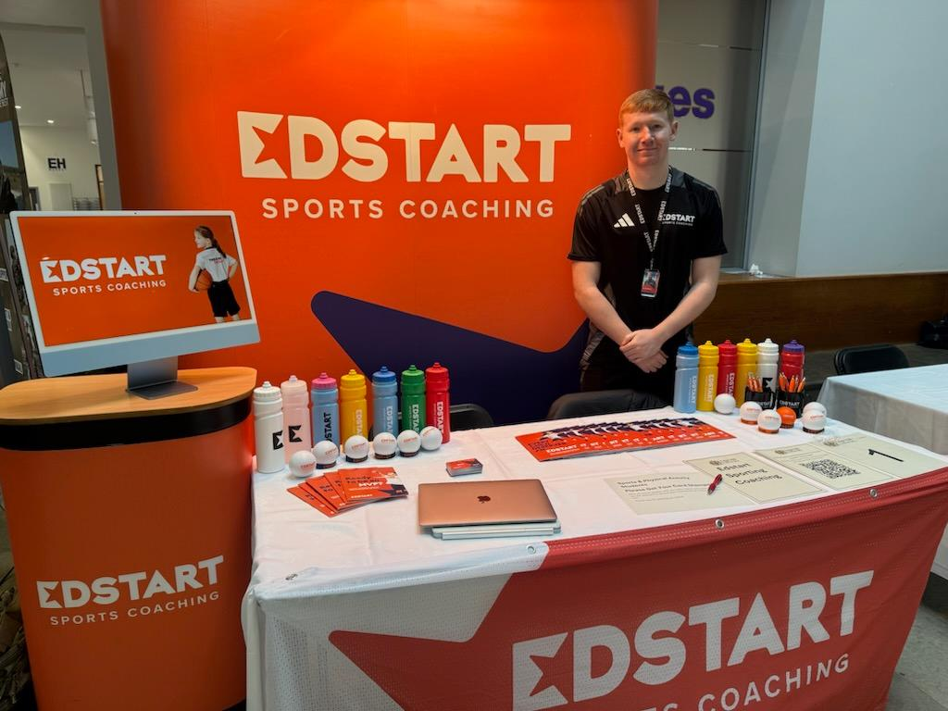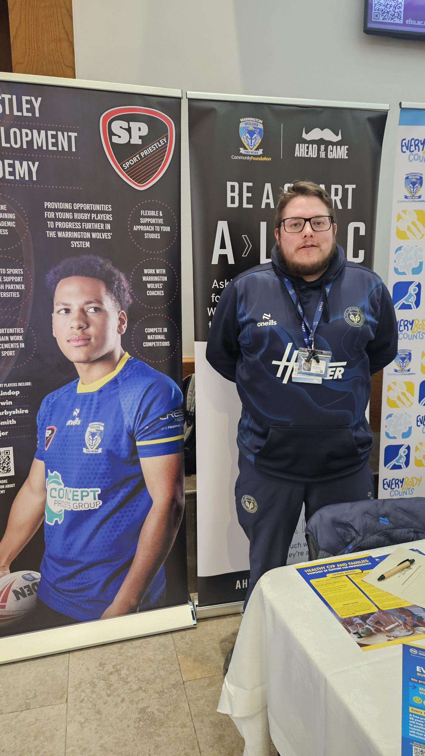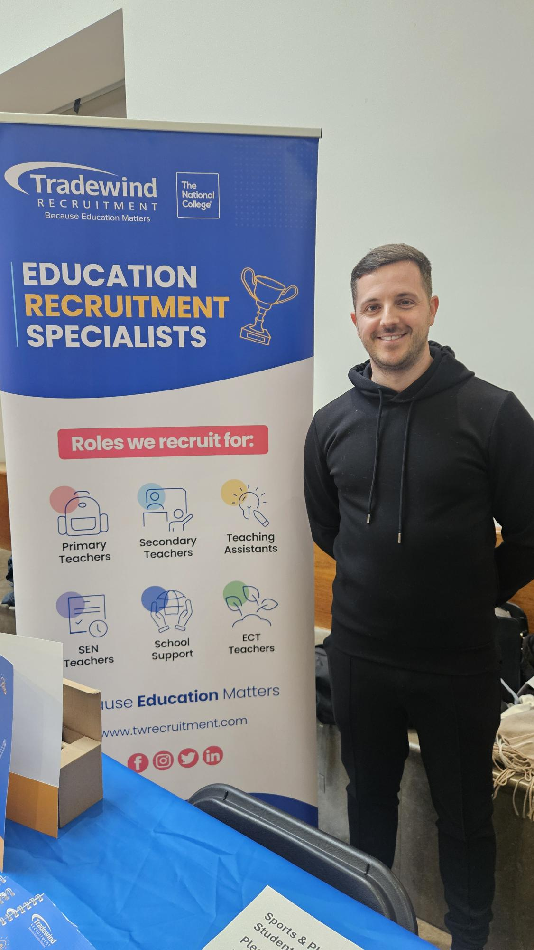
In February, we welcomed local employers to campus for the Sport and Physical Activity Careers Fair, giving current students the chance to explore volunteering and employment opportunities and it was fantastic to see alumni representing their workplaces.
We caught up with three graduates sharing their journeys:
Alex Speakman – Area Manager (Liverpool), Edstart
Starting as a volunteer at just 16, Alex continued gaining experience while studying, shadowing coaches and taking on casual work before securing a full-time role. Now, aged 23, he’s an Area Manager and part-owner of the Liverpool franchise, a brilliant example of where early experience can lead.
Ryan Cartlidge – Community Activator, Warrington Wolves
Ryan returned to campus to promote volunteering and casual roles, now working as a Pathways Coordinator for Health and Wellbeing supporting community engagement through sport.
Liam Hickson – Senior Manager, Tradewind Recruitment
After qualifying as a primary school teacher and teaching for over a decade, Liam changed direction into recruitment. Today he helps schools find staff across the region, using his classroom experience to support education from a different perspective.
Thank you to all our alumni who came back to campus to inspire the next generation and share your Edge Hill journeys, we love seeing where your careers take you!
Do you want to volunteer your time? Email Alumni@edgehill.ac.uk.

Edge Hill to Dubai: Lewis Hammill returns to recruit future teachers
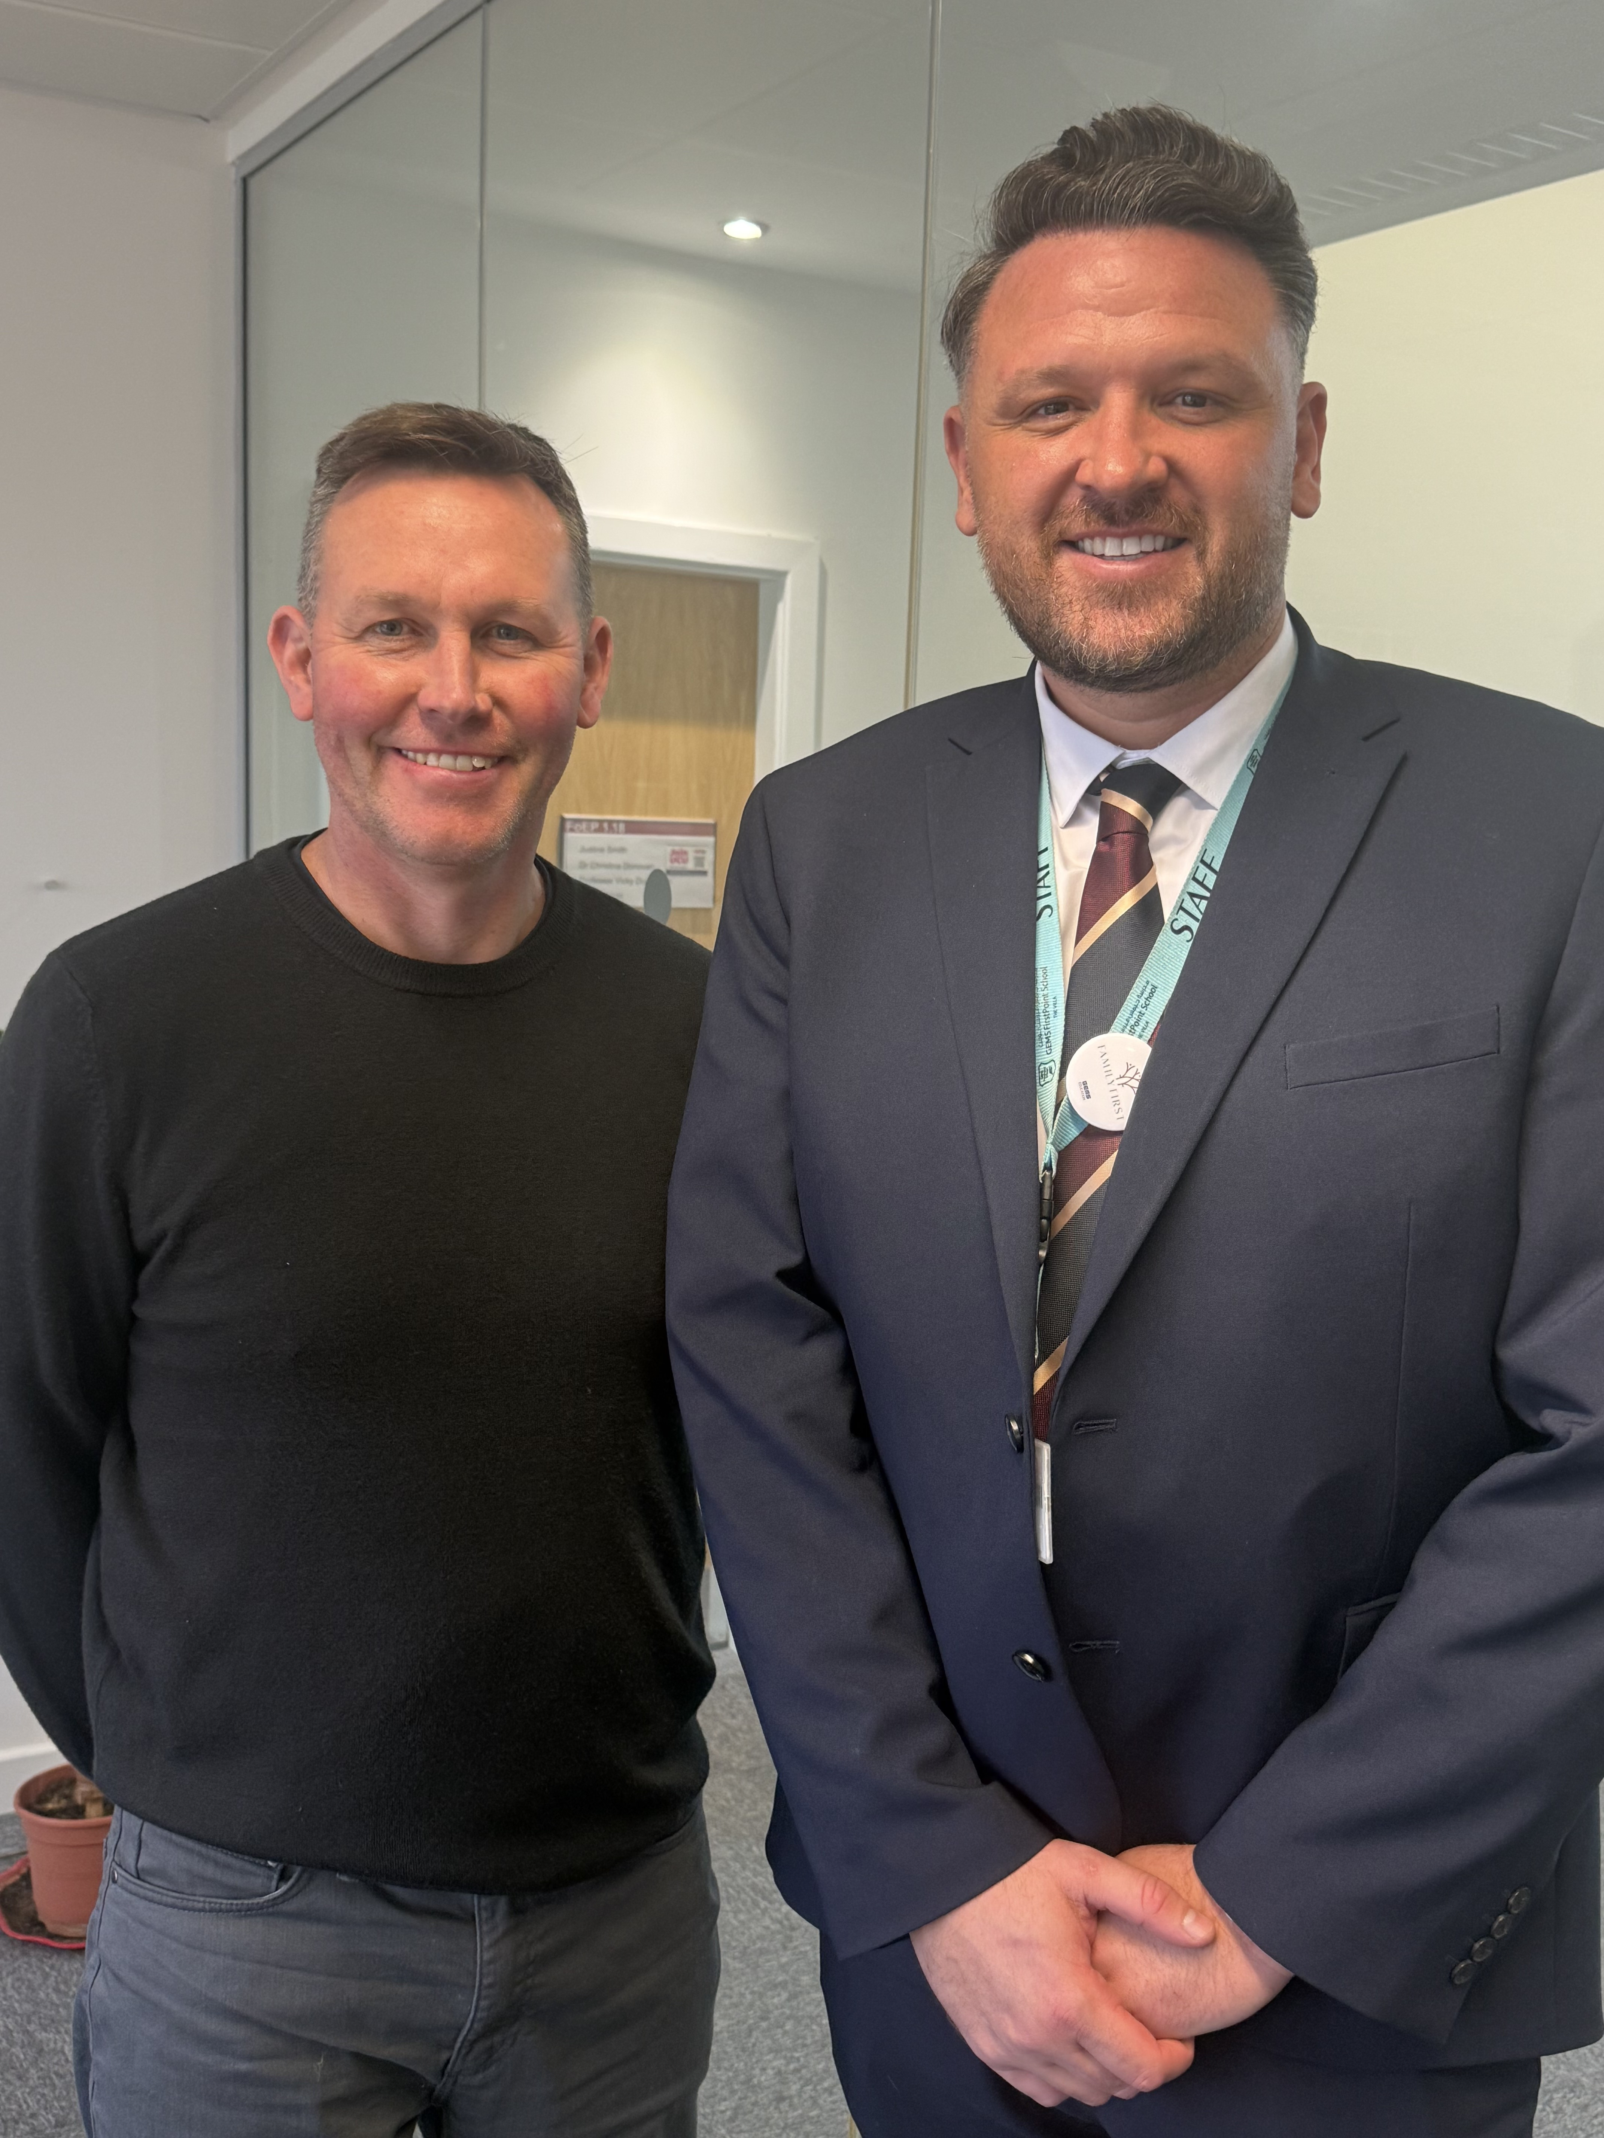
We were delighted to welcome alumnus Lewis Hammill back to campus last week.Now Deputy Head of Secondary at GEMS FirstPoint School, Lewis returned to Edge Hill University to interview our PGCE students for teaching opportunities in Dubai.
Having completed his PGCE in PE at Edge Hill, it’s fantastic to see one of our graduates now supporting the next generation of teachers as they begin their careers and explore international pathways.
Lewis said: “Brilliant to be back where my journey in education began, and incredible to see the growth and development of the campus since 2012.
A privilege to interview such high-quality PGCE candidates and to provide both opportunities and valuable interview experience at the very start of their careers.
Made possible through strong relationships with past mentors – a reminder of the power of education and networks.”
Visits like this highlight the strength of our alumni community and the global opportunities available to our trainees.
Are you an Edge Hill graduate working internationally? We’d love to hear where your journey has taken you, email alumni@edgehill.ac.uk.

Alumni return for Law & Criminology and Business Careers Fairs
It was great to welcome our alumni back to campus for the Law & Criminology and Business Careers Fairs. Representing their employers were:
Lara Webber (Class of 2023) – Unit Chambers
Sam Hilton (2018) and Connor Eager (2024) – Grant Thornton UK LLP
Katie Bolger (2022) – Avove
Rebecca Kliszat (2023) – Civil Service
They shared invaluable advice with our current students about their roles, routes into employment (including graduate schemes), what to expect from the application process and how to stand out.
It’s always inspiring to see our alumni giving back, supporting the next generation and representing Edge Hill in their industries.
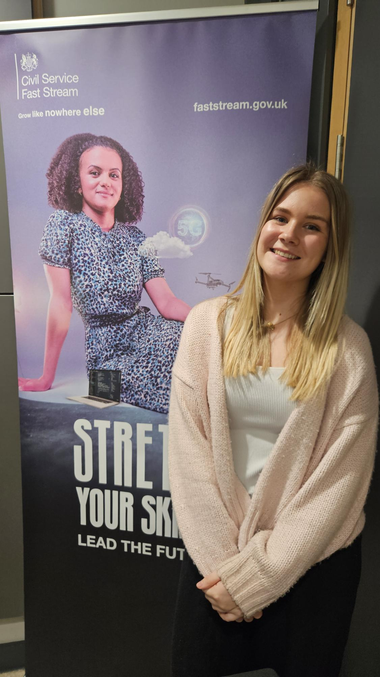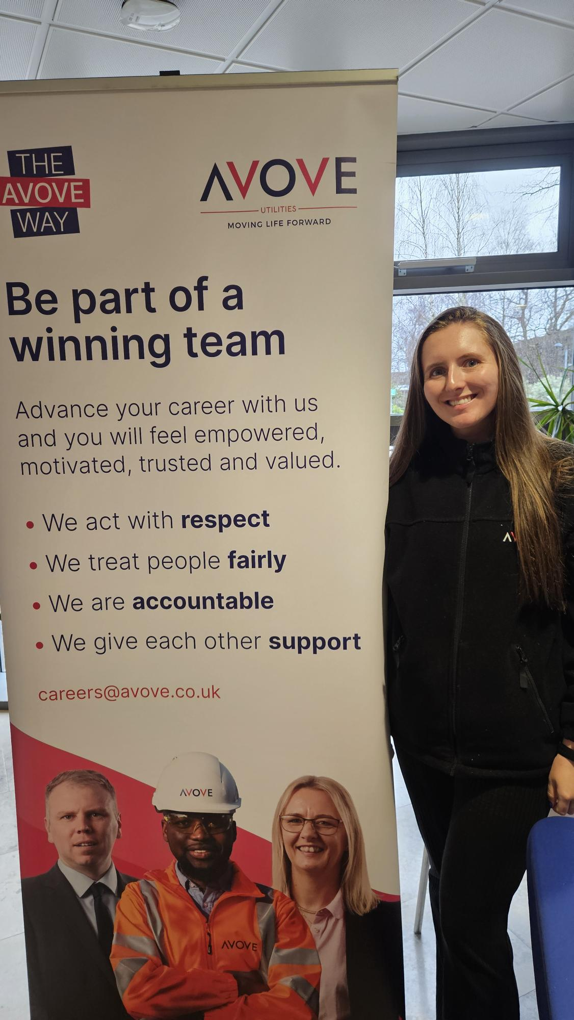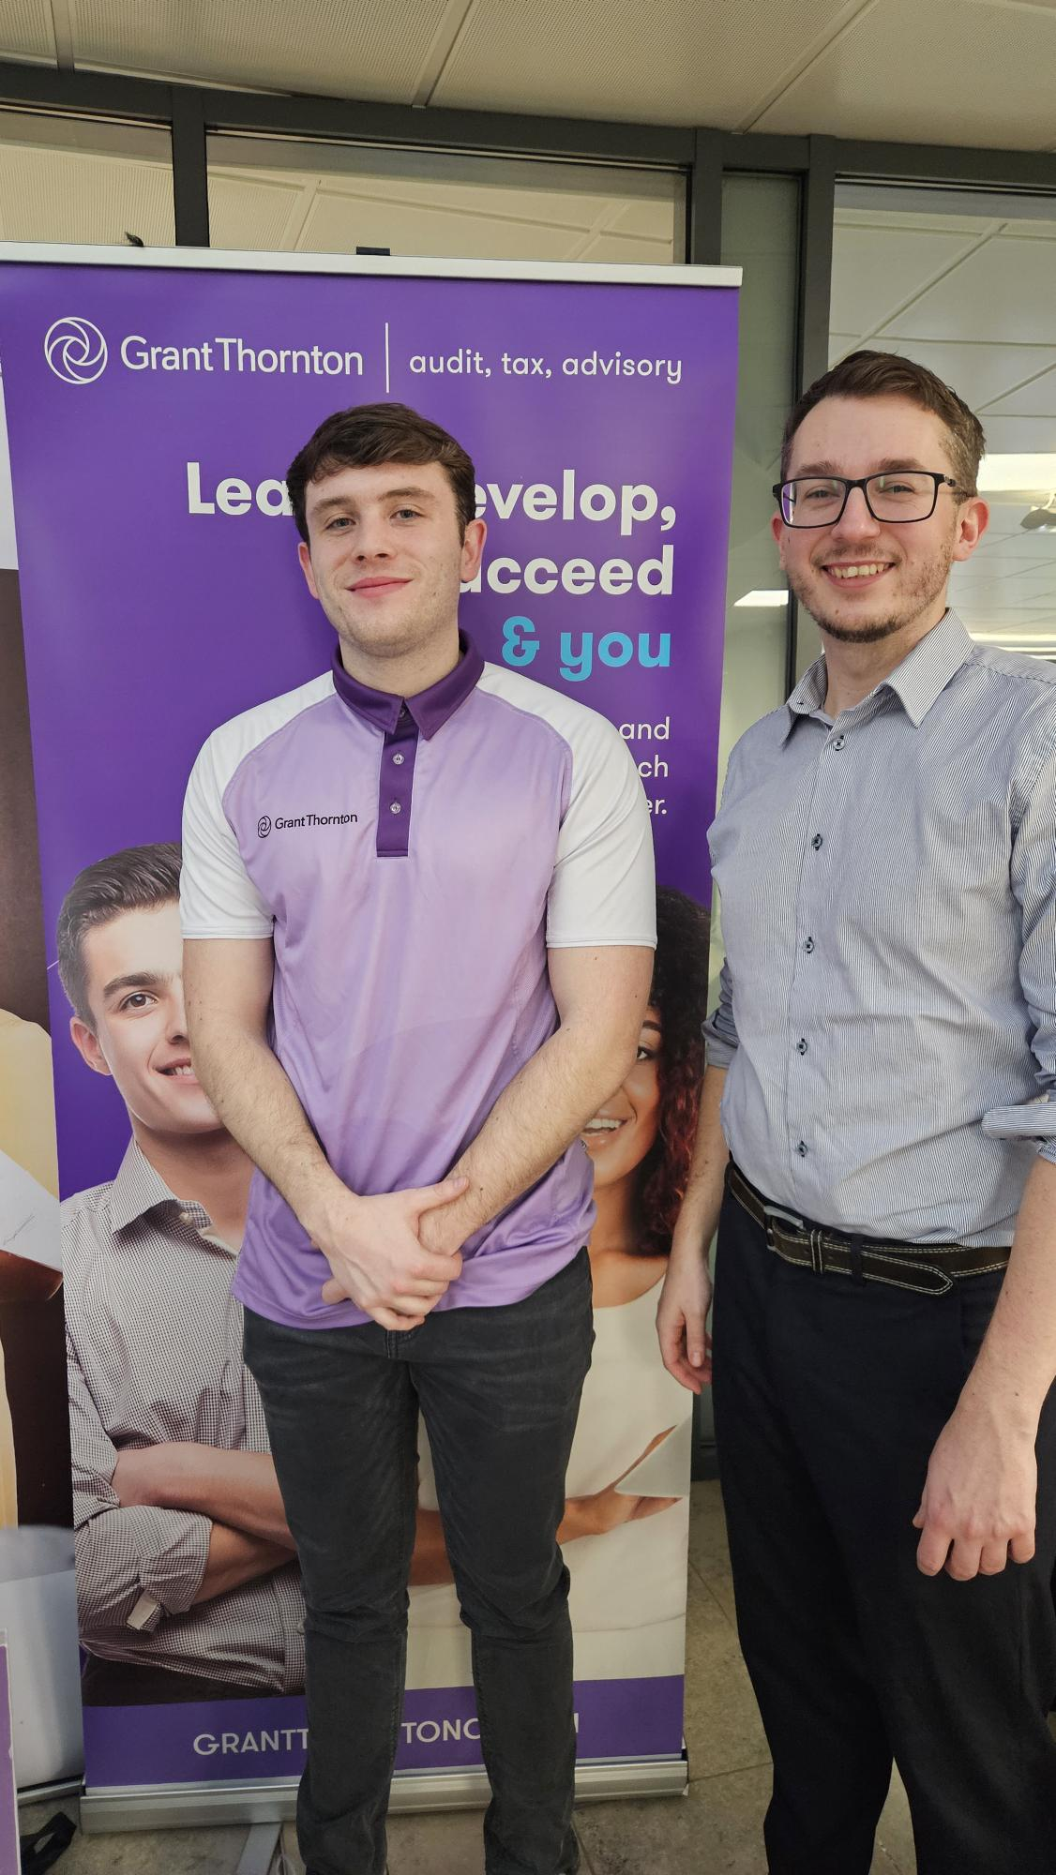

GET INVOLVED AND RECONNECT

Edge Ahead: What's in your head?
Catch up on the latest episodes of the Edge Ahead podcast, hosted by Chris Kirkland and Gareth Roberts, as they explore powerful conversations around mental health, wellbeing and hope.
Nature, Connection and the Power of Social Prescribing
Professor Michelle Howarth shares why better mental health may start in our parks and communities, shifting the question from “what’s the matter with you?” to “what matters to you?”
The Importance of Reaching Out
Danny Bowman highlights how starting conversations early can make a life-changing difference.
From Crisis to Hope with Jake Mills
Released on Blue Monday, Jake Mills, founder of Chasing the Stigma and Hub of Hope, discusses breaking stigma and improving access to support.
Suicide Prevention is Hope Promotion
For Helpline Awareness Day, Edge Hill researcher Nina Smith and Mike Palmer of Three Dads Walking reflect on turning personal tragedy into national action and how teacher training at Edge Hill is helping equip educators with the skills to save lives.
Stream all episodes on YouTube and Spotify.

International Women’s Day – Women in Law Panel event
We proudly invite you to our annual student-led International Women’s Day Panel and Networking Event, hosted by the School of Law and Criminal Justice.
The panel event, organised by our law students, will bring together inspirational women from the legal and criminal justice sectors to discuss and celebrate their career journeys.
This event is free to attend on Tuesday 10 March starting at 5.30pm with the opportunity to network afterwards.

IWD Women in Law | Edge Hill University

Psychology Department Careers Fair
Join us on Wednesday 11 March 2026 (11am–2pm) for the Psychology Department Careers Fair at the Law & Psychology Building, Edge Hill University.
Open to current students and alumni, this free event is a great opportunity to connect with employers, explore part-time and graduate roles, gain application advice, and discover postgraduate and entrepreneurship pathways.
A quieter early access session will run from 10:30–11:00am for those who would benefit from it.
Take the next step in your psychology career — we look forward to seeing you there.
Psychology Department Careers Fair | Edge Hill University

Postgraduate Open Evening
If you’re considering postgraduate study, join us on campus to explore our range of courses and find out where studying with Edge Hill University could take you.
Thurs 19 March 3-6pm.
Postgraduate Open Evening - Edge Hill University

CPD Courses

The Beatles: Liverpool and beyond | Online
Reconnect with learning and rediscover an iconic cultural story with The Beatles: Liverpool and beyond, an engaging online course from Edge Hill University. This course explores how The Beatles emerged from Liverpool to become a global phenomenon, shaping music, identity and popular culture along the way.
Delivered fully online, it’s a great opportunity for alumni to continue their lifelong learning journey, revisit the spirit of the region, and gain fresh insight into the band’s enduring legacy, all from wherever you are in the world.
The Beatles: Liverpool and beyond - Edge Hill University
Best wishes,
Edge Hill University Alumni

