Edge Hill Alumni News | February edition
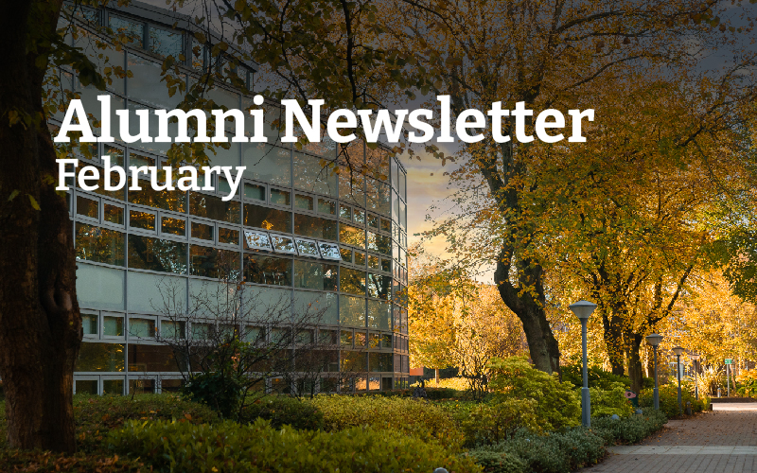
Welcome to your February edition of the Edge Hill Alumni Newsletter. This month, we’re celebrating the creativity, dedication and impact of our alumni community. From award-nominated actors and documentary filmmakers to inspiring educators and industry leaders, our graduates continue to shape communities, challenge perceptions and make a difference in their fields.

We’re also delighted to share opportunities to reconnect with campus, support current students and get involved in upcoming events. Wherever your journey has taken you since Edge Hill, we’re proud to keep you connected and to spotlight the achievements that make our alumni network so special.

ALUMNI FOCUS

Alumni Spotlight: Philip Sean McGuinness
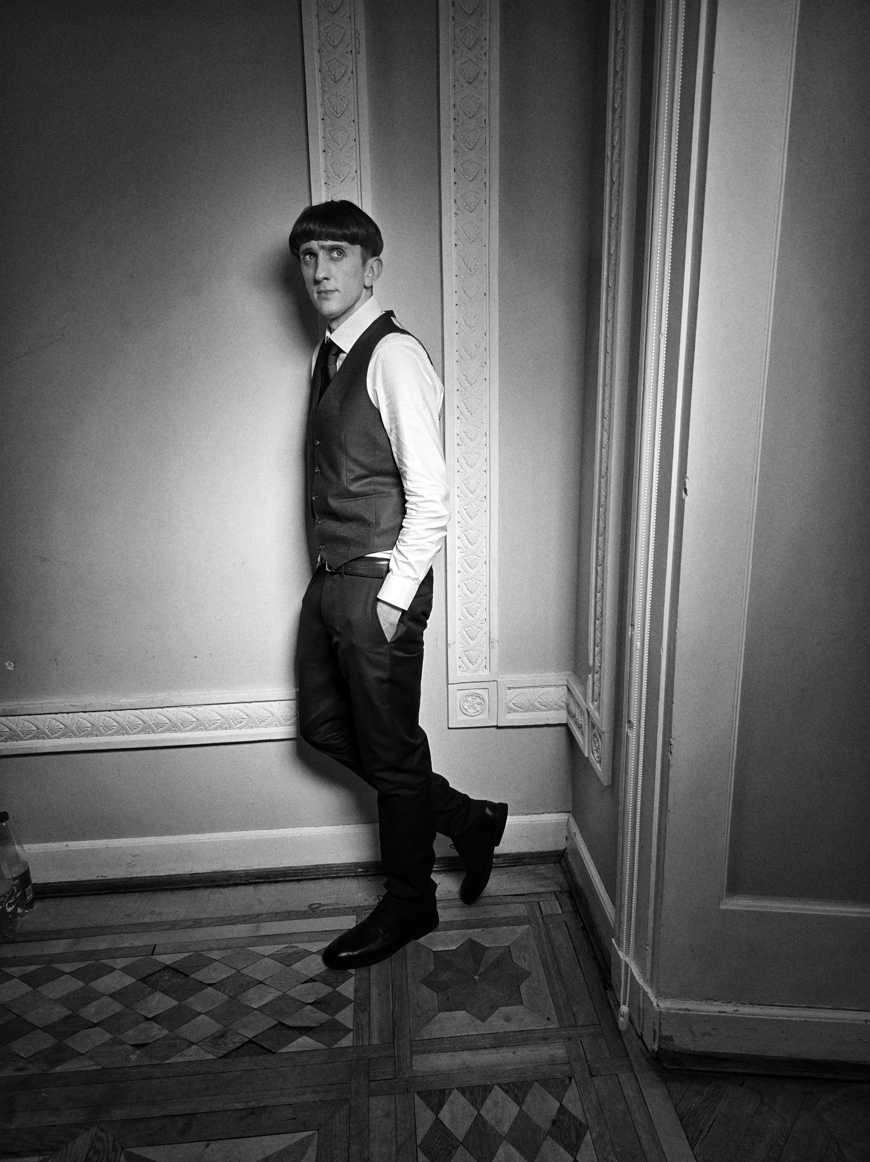
Meet Edge Hill alumnus Philip Shaun McGuinness, actor, theatre-maker and proud Kirkby native, as he reflects on his journey from campus to screen.
Philip is celebrating continued success after starring in the BAFTA-nominated TV series G’wed, a show praised for its authentic portrayal of young people and life in Merseyside.
From changing course to follow the path he was meant to take, to creating his own theatre company as a student and going on to appear in international productions such as The Alienist, Philip’s story is one of perseverance, community and hard work.
“Seeing young people being represented so positively has been incredibly rewarding.”
Read Philip’s alumni story: https://www.edgehill.ac.uk/news/2026/01/edge-hill-alumnus-stars-in-bafta-nominated-tv-series-gwed/

Alumni Spotlight: Thomas Griffiths
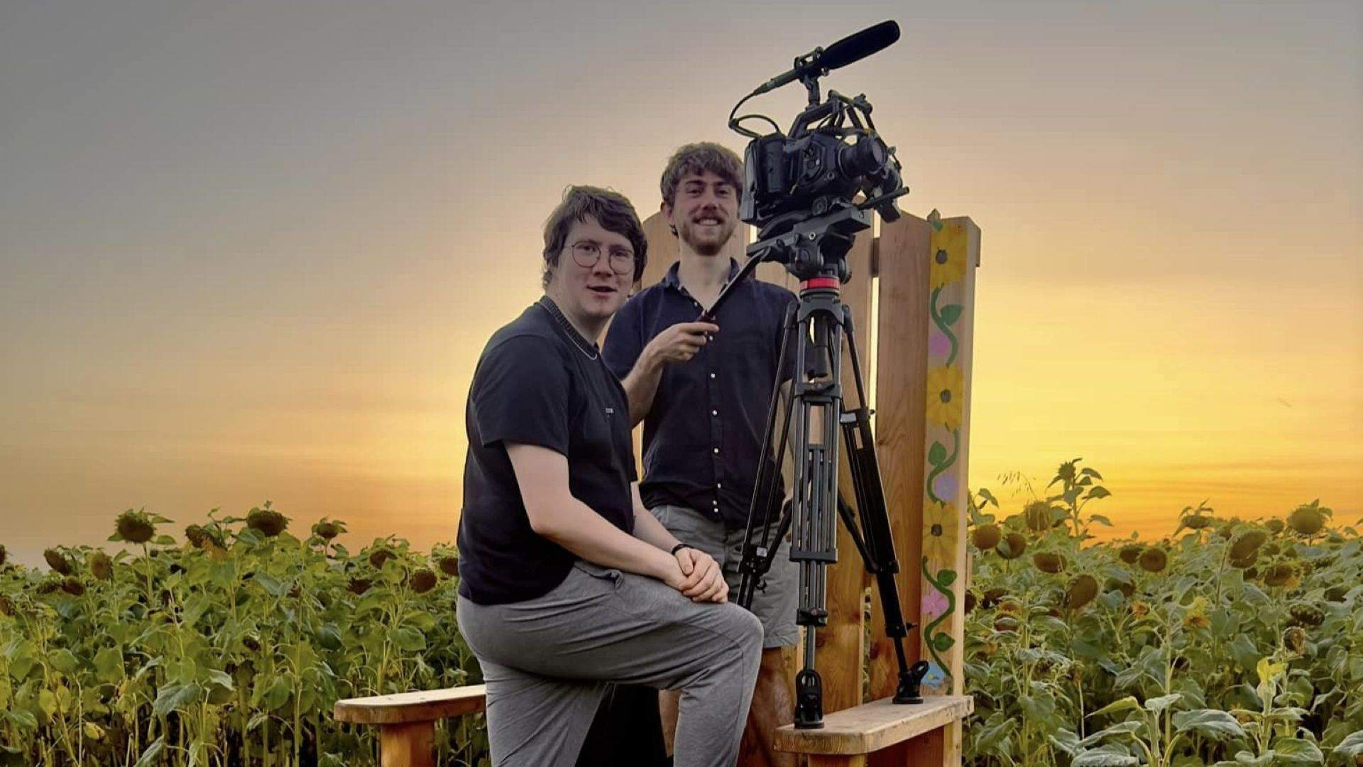
We’re proud to celebrate Edge Hill University alumnus Thomas Elliott Griffiths, BA (Hons) Film Studies with Film Production, whose powerful documentary The Little Things is now streaming worldwide on Amazon Prime Video and Tubi.
Produced through his company Old Swan Films, the documentary shares the moving stories of children, families and staff at Derian House Children’s Hospice, helping to challenge perceptions and open up important conversations around children’s hospice care.
Thomas said: “If it helps start conversations about the importance of children’s hospice care, then all the hard work has been worth it.”
Congratulations Thomas and everyone involved on this outstanding achievement.
Read more: Edge Hill alumnus’s documentary streams worldwide on Amazon Prime

From Student to Lecturer: Ellen’s Edge Hill Journey

Ellen Hayes first came to Edge Hill as an undergraduate, drawn by the course content and beautiful campus. What made her stay was the support she received as a neurodivergent student — feeling recognised as a person, not just a number. Today, Ellen has come full circle and is now a Lecturer in Child and Adolescent Mental Health at Edge Hill.
Living with ADHD, Ellen describes her neurodivergence not as a barrier, but as a strength — bringing creativity, empathy and energy to both her teaching and research. With encouragement from staff and tailored support, she thrived as a student and now works to make learning accessible and meaningful for others.
“Edge Hill gave me the confidence to step forward into my career,” Ellen says. “Now I want to help others do the same.”
Ellen now teaches on the BSc (Hons) Child & Adolescent Mental Health & Wellbeing and PGDip Education Mental Health Practitioner, inspiring the next generation of professionals supporting young people’s mental health.
Read more: https://www.edgehill.ac.uk/news/2026/01/from-student-to-lecturer-ellens-neurodivergent-journey-in-higher-education/

Alumni Profile: Callum O’Neill
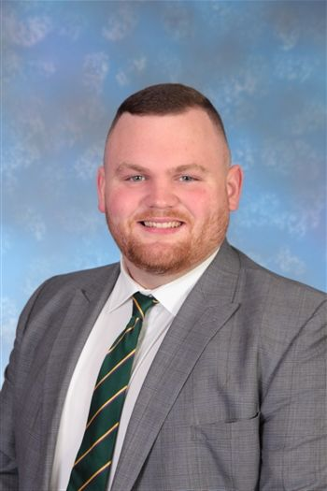
Alumnus Callum O’Neill BSc (Hons) Computing says his time at Edge Hill University laid a strong foundation for both his professional and personal growth. Today, Callum is Second in Personal Development with RSE and KS3 Computer Science Curriculum Lead at Blessed Thomas Holford Catholic College, where he combines his passion for technology and education in inspiring young minds.
Through his journey from computing student to educational leader, Callum demonstrates how the skills and confidence he gained at Edge Hill continue to shape his career and influence others.
Reflecting on his time on campus, Callum says: “Edge Hill played a truly special part in my life, helping me develop confidence, independence, and skills that have been invaluable both professionally and personally.” His experience shows how a supportive learning environment and practical opportunities can make a lasting impact well beyond graduation.
Read Callum’s alumni profile: https://www.edgehill.ac.uk/person/callum-oneill/alumni/
ALUMNI RETURN TO CAMPUS

Alumni return for an inspiring event with current students
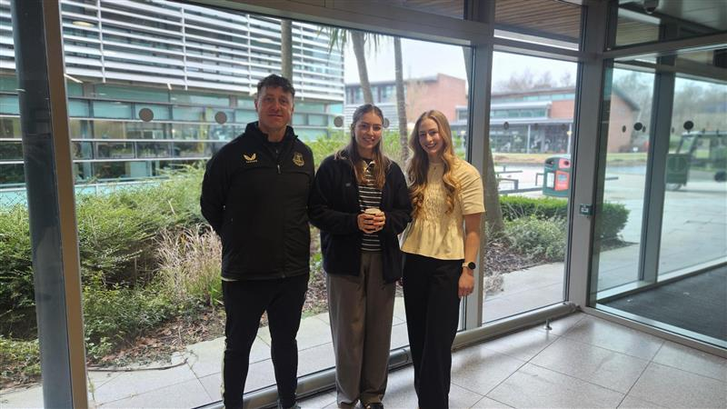
Last month, we were delighted to welcome Edge Hill alumni back to campus for the Nutrition Careers and Alumni Event, where they shared their career journeys and practical advice with current students.
Our alumni offered valuable insights into navigating the world of work, alongside guidance on postgraduate study options available at Edge Hill. Students also had the opportunity to ask questions, make connections and gain first-hand perspectives on careers across the nutrition and health sector.
A huge thank you to our alumni presenters for giving their time and expertise: Nicola Fenna, Nutrition and Training Specialist at Revive; Eleanor Yerkess, Allied Health Professional Assistant at Midlands Partnership Foundation Trust; and John Bilsborrow, Place Programme Lead – Physical Activity and Sport at Everton in the Community.
Nicola encouraged students to be proactive online, sharing that “LinkedIn is so important – I set up a profile when I was at university, and that’s where I found a number of my roles.” Eleanor highlighted the value of confidence and curiosity, advising students to “reach out, make connections, say yes to opportunities and keep a CPD folder to track your experiences and achievements.” John emphasised the importance of strong foundations, reminding students that “working your way up helps you truly understand the role.”
Thank you to everyone who joined us and helped make the event such a success.
Do you want to volunteer your time, email Alumni@edgehill.ac.uk.

Alumni Reunion – Katherine Fletcher Girls 1984-88
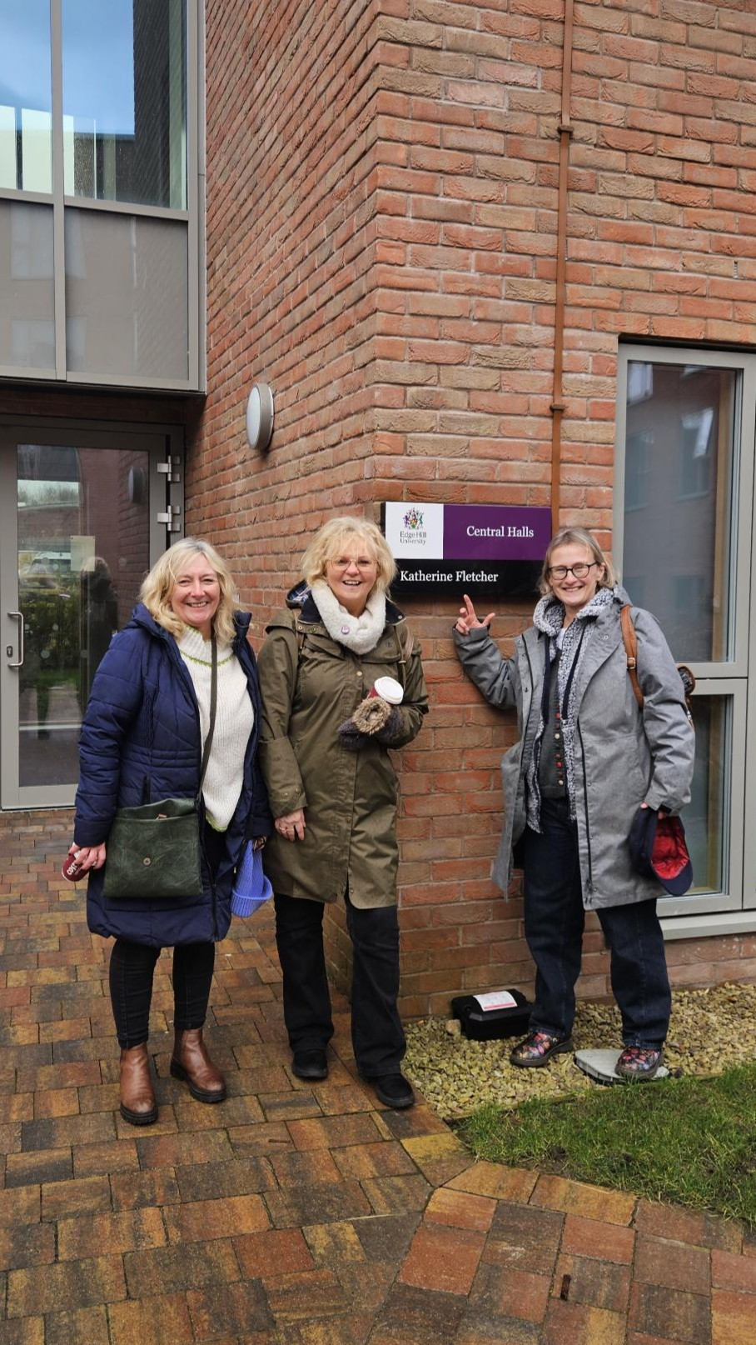
While taking photos of Central Halls for our History of Buildings series on Facebook, we were delighted to bump into a group of alumni visiting campus for the first time in almost 40 years.
Formerly known as the Back Halls, these residences were opened in 1963 to accommodate growing student numbers and named after influential figures in Edge Hill’s history. Although the original Back Halls were demolished in 2023, their legacy lives on through Central Halls, which carries forward the names of four of the original residences.
By chance, we met Kath Eastwood, Sue Bird (Connor) and Lis Cooper — KF girls from 1984–88 — who were revisiting campus and reminiscing about their time living in Katherine Fletcher Hall. It was a pleasure to capture this moment and hear their memories of student life.

GET INVOLVED AND RECONNECT
Future Focus: Sociology Alumni Panel and Careers Event
We are delighted to invite Edge Hill University Sociology alumni to take part in this year’s Future Focus: Sociology Alumni Panel and Careers Event, taking place on Thursday 12 March, 9-10am on campus.

Following the success of last year’s Future Focus event, we are once again bringing together alumni to share their experiences with our current Sociology students in a relaxed, informal panel setting. The session is designed to give students an inspiring insight into life after graduation.

As a panel member, you would be invited to talk about:
- What you’ve been up to since graduating from Edge Hill
- Your career journey so far – whether conventional or unconventional
- Where you are now, and what you’ve learned along the way

It’s a conversation-based session, with plenty of opportunity for students to ask questions and hear about the realities of work, career decision-making and progression to showcase how a Sociology degree can lead to meaningful and varied careers.
Interested in getting involved? Please email an expression of interest by Friday 20 February to alumni@edgehill.ac.uk, outlining your current role and career path, to be considered for the panel.

We would love to welcome you back to Edge Hill and give you the opportunity to inspire the next generation of Sociology graduates.

Did you start your university journey through Fastrack?
We’d love to hear where you are now. Help us shine a spotlight on the incredible successes of the Fastrack community.
As part of our upcoming Fastrack celebration campaign, we’re collecting inspiring stories from alumni who completed Fastrack and have since graduated and moved on in their careers. Your journey could help motivate future students and may be featured in our promotional materials or press.
If you’d like to share your story, please complete our short questionnaire:
👉 https://app.onlinesurveys.jisc.ac.uk/s/edgehill/face-of-fastrack-pen-portraits-25-26

Graduate Voices
We’re looking for graduates to share why they took part in the Graduate Outcomes survey to demonstrate why it matters for others to do the same. These authentic stories help make the survey tangible and relatable for future graduates. You can view current graduate voices on Graduate Outcomes survey website.
To take part, provide a high-quality photo and a short quote explaining why you’ve completed the survey and why it’s important. Send to alumni@edgehill.ac.uk.
This is a great opportunity for you to showcase your success and shape the conversation about graduate outcomes, while staying connected with your alumni network.
Psychology alumni wanted
The Psychology team would love to share more stories from our Psychology students and graduates in future newsletters and across their social media channels.
If you have news, achievements or experiences you’d like to share, we’d be delighted to hear from you.
Email alumni@edgehill.ac.uk.

WHAT’S ON AT EDGE HILL?

Free reading for pleasure CPD - OU/UKLA Teachers Reading Group
Looking to refresh your classroom practice and rediscover the joy of reading? Join the OU/UKLA Teachers’ Reading Group — a welcoming, informal space for educators who want to explore reading for pleasure, share ideas and connect with like-minded colleagues.
These friendly and supportive sessions are open to all, whether you’re new to the approach or already championing reading in your setting. Expect practical tips, inspiring discussion and plenty of book talk.
Upcoming sessions:
Tuesday 3 March 4.15pm – 5.45pm
Tuesday 5 May 4.15pm – 5.45pm
Come along, bring your enthusiasm for reading, and leave with fresh inspiration for your learners. Register your interest here.

Extend Your Impact in Maths with Every Child Counts and the Faculty of Education
The Every Child Counts (ECC) team in Edge Hill’s Faculty of Education is growing its accredited trainer network.
Since 2008, ECC has supported 175,000+ children through evidence-based maths interventions — and we’re now inviting experienced Edge Hill graduates to explore becoming ECC trainers.
This opportunity may suit you if you’re:
- an experienced teacher or education professional
- working in a MAT or Local Authority
- interested in extending your impact beyond your own school
ECC trainers combine professional growth, flexibility and meaningful impact, while staying closely connected to classroom practice.
Interested in attending?
📧 Contact: ecc@edgehill.ac.uk🔗 Learn more: https://www.ehu.ac.uk/ecc
👉 Book a conversation: https://outlook.office.com/book/EveryChildCountsECCFoEEdgeHillUniversity@edgehill.onmicrosoft.com/

Best wishes,
Edge Hill University Alumni

