Edge Hill University Logo

# **Department of Sport and Physical Activity**

# **Faculty of Arts and Sciences**

## **Sports Therapy BSc**

## **Pre-Entry Handbook**

## **2022-23**

**Programme Leader: John McCreadie**

**E-Mail:**  **McCreadj@edgehill.ac.uk**

**Tel:**   **01695 584086**

**Welcome to BSC(HONS) Sports Therapy**

The aims of the programme are to encourage the intellectual and personal development of students, through the study of theory and concepts associated with disciplines central to Sports Therapy including, anatomy and physiology, kinesiology, rehabilitation, manual therapy and clinical practice.

To provide the opportunity for students to critically evaluate the inter-relationships between variables associated with the main sports therapy disciplines, and to investigate how these may influence the management, treatment, prevention and rehabilitation of sports injuries.

To enable students to develop an enhanced ability to apply their knowledge of scientific methods of enquiry and apply this knowledge within sports therapy settings.

To enable students to develop clinical reasoning and critical appraisal to support a creative approach to independent treatment of problems.

To provide a variety of teaching and learning experiences and expose students to a variety of assessment methods enabling the development of self-confidence and the ability to work both independently and in a group.

To develop the subject-specific skills required to monitor and evaluate rehabilitation and recovery from injury in laboratory and/or field settings.

To provide students with opportunities to maximise their employability in sports therapy by developing a range of personal and transferable skills, including communication, IT, group and independent work, and time-management.

To develop the subject-specific skills required to reflect upon, monitor and evaluate sports injury treatment, prevention and rehabilitation in laboratory and/or field based settings.

To develop practical competencies and awareness of the ethical, moral and legal considerations in working in clinical sports and exercise related settings with a range of client groups.

To develop autonomous thinkers who can operate confidently and effectively across a range of sports related clinical and exercise contexts.

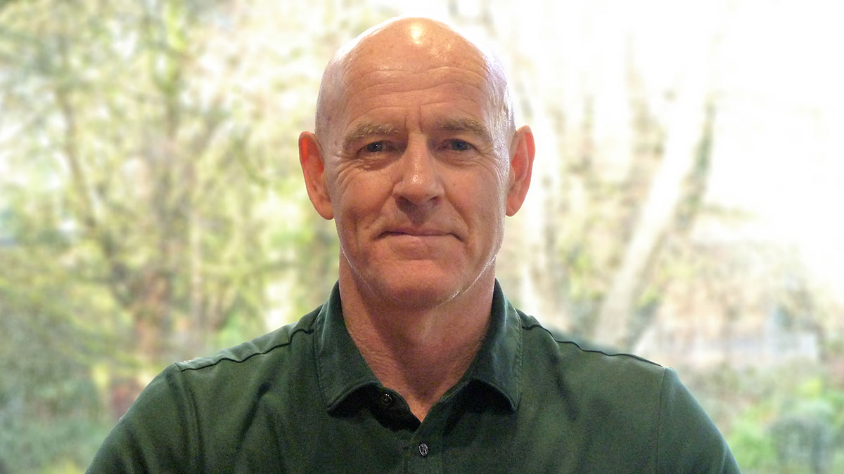

Programme Leader: John McCreadie

email: McCreadj@edgehill.ac.uk

### The purpose of this pre-entry handbook

This Handbook has been developed to help prepare you well to join BSc (HONS) Sports Therapy at Edge Hill University in September 2022. It is divided into two main sections, each with some tasks which you should complete having undertaken some research into the topics explored. The tasks address some very important things which you will be asked to discuss with your Personal Tutor during your induction week and the modules you will study in Semester 1 before the Christmas period.

It is **ESSENTIAL** that you complete all of the tasks in this Handbook **BEFORE** induction week and have the completed version available to you electronically (e.g. on email, a USB or cloud storage system) when you meet your Personal Tutor. You should complete each task electronically as indicated. You will be encouraged to reflect upon your answers to the tasks as part of your meeting and to help begin your studies at Edge Hill.

**SECTION A**

**About Your Degree and Career Aspirations**

1. Your degree is accredited by which professional governing body?
2. What are the five key areas of competency that you will study as part of your degree.
3. What is the main purpose of the professional body?

The answers can be found by accessing the the following link.

<https://society-of-sports-therapists.org/>

**SECTION B**

**About Your First Three Modules**

One of the first modules you will study on programme name at Edge Hill is SPT 1930.

This module aims to provide students with the necessary foundation skills to study at degree level and will include an introduction to the research and study skills required to investigate issues within the sports therapy domain. Specifically, the module is designed to help students develop essential intellectual and study skills in order to search for published literature, write scientifically and employ clinical reasoning in the analysis and interpretation of published work. An initiation to statistics theory, statistical analysis methods and qualitative methods of research will be explored within this module.

In this module you will address topics such as the sourcing of key academic and scientific texts*.* To help prepare you for this module, you should answer the following questions:

1. What are the four steps of the van Mechelen model of injury prevention?
2. According to the UEFA elite club re-injury study (written by Hagglund et al.), of the 50 injuries per season, how many are re-injuries?

Another module you will study in Semester 1 is SPT 1931. In this module you will develop your understanding of the basic human anatomy and physiology. An introduction to the language of anatomy, the constituent tissue types of the human body and fundamental concepts such as homeostasis are central to this module. It is important that you develop a sound understanding of the physiological systems involved in movement/performance and develop their knowledge of the anatomy and physiology of the Musculo-skeletal system, the nervous system and the endocrine system.

In this module you will address topics such as the ability to identify specific anatomical structures***.*** To help prepare you for this module, you should complete the following tasks:

1. Name the bones of the foot.
2. Name the bones of the wrist and hand.

The final module you will study before Christmas will be SPT 1935. This module is designed to provide you with an introduction to the role of a sports therapist in injury treatment, management, prevention and rehabilitation. The module provides students with the foundation on which they build further knowledge, skills and expertise in the path to becoming qualified sports therapists. A key feature of the module will be the development of examination and assessment skills. In this module you will address topics related to musculoskeletal assessment following injury. To help prepare you for this module, you should answer the following questions:

1. What are the signs and symptoms of an anterior cruciate ligament injury?

2. Name the rotator cuff muscles and their individual functions.